Exercise in Genetic Programming
2025-01-30
Andrea Raaschou

Short summary:
A preciously implemented genetic algorithm is modified towards a GP.
Aim of the exercise:
To understand how GAs and GPs work and how to implement them.
Exercise 2
Polynomials:
$$f_{1}\left(x\right)=-7.5x^{3}+2x^{2}+5x+2$$
$$f_{2}\left(x\right)=7.5x^{3}-2x^{2}-5x+2$$
$$f_{3}\left(x\right)=\left(-2.5x^{3}\right)\left(3x^{2}\right)\left(-5.5x\right)\left(-2.2\right)$$

Table 1. Genes and fitness of the individual with best fitness for each polynomial.
Polynomial | Fitness | Genes
$$f_{1}\left(x\right)$$ | 0.02 | [-7.5 2.05 5.01 1.99 -2.82 -3.57 1.22]
$$f_{2}\left(x\right)$$ | 0.03 | [ 7.63 -1.94 -5.07 -1.97 2.08 0.75 9.62]
$$f_{3}\left(x\right)$$ | 0.01 | [-6.59 1.39 9.91 0.01 -9.31 -5.07 5.71]

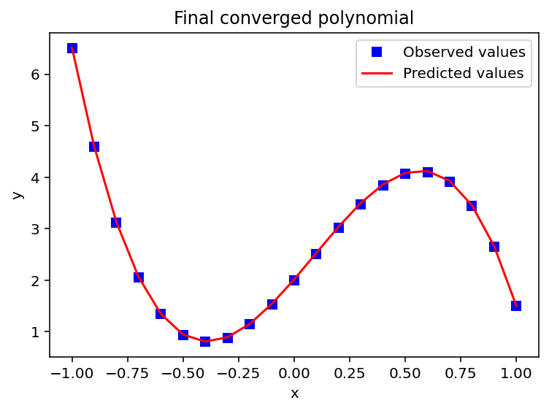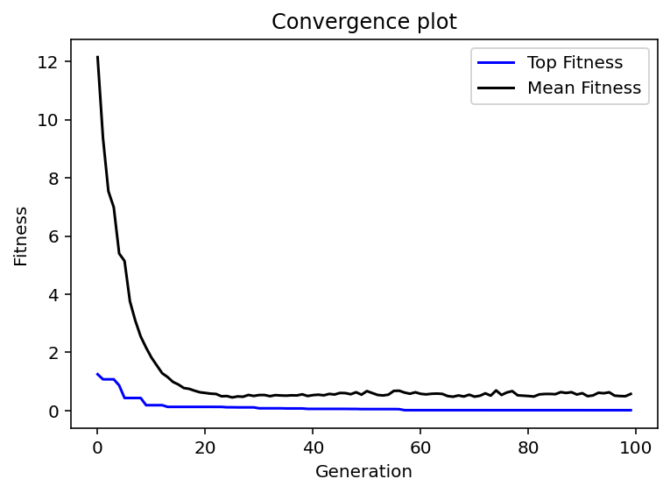
Figure 1. Best solution fitted against $f_{1}\left(x\right)$ (left) and convergence plot of fitness of the best individual and the overall mean fitness (right).

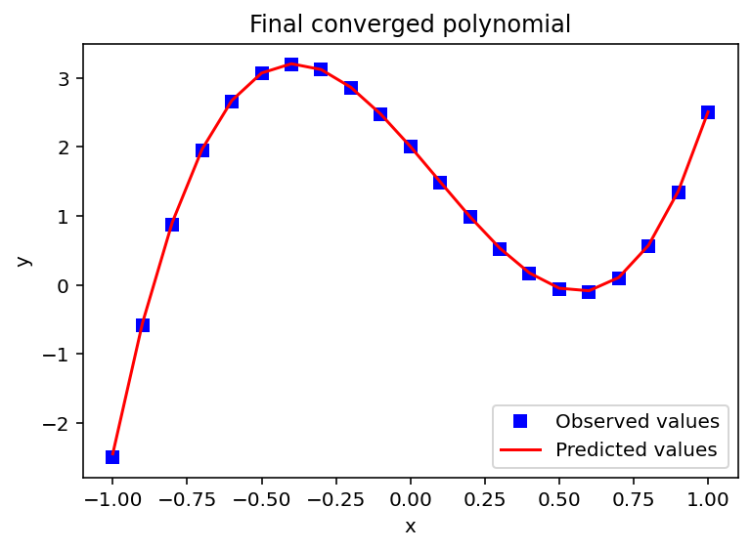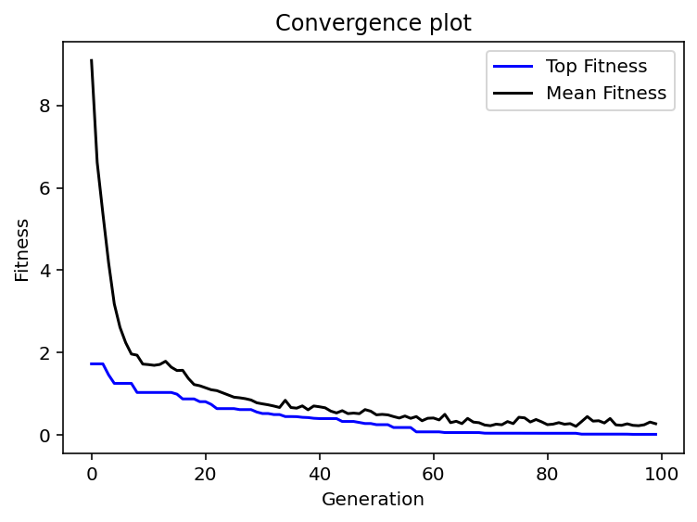
Figure 2. Best solution fitted against $f_{2}\left(x\right)$ (left) and convergence plot of fitness of the best individual and the overall mean fitness (right).

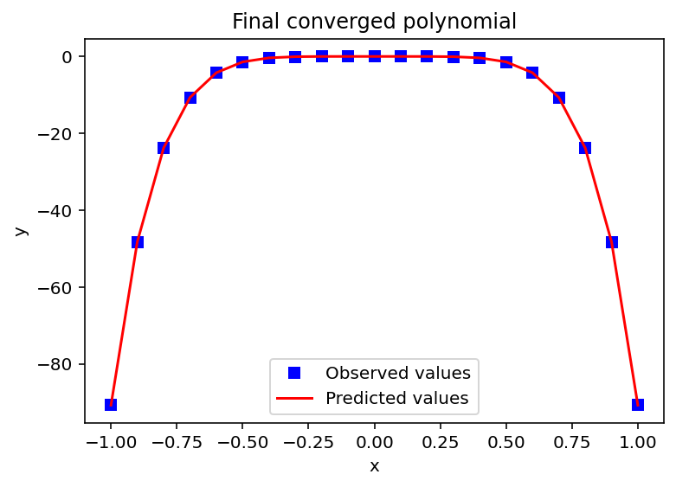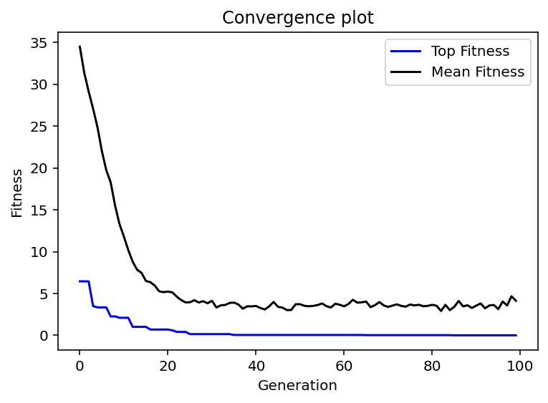
Figure 3. Best solution fitted against $f_{3}\left(x\right)$ (left) and convergence plot of fitness of the best individual and the overall mean fitness (right).

Exercise 3
Polynomials:
$$f_{1}\left(x\right)=-7.5x^{11}+2x^{5}+5x+9$$
$$f_{2}\left(x\right)=x^{2}$$
$$f_{3}\left(x\right)=\left(-2.5x^{11}\right)\left(3x^{4}\right)\left(-5.5x\right)\left(-8\right)$$

Table 2. Genes and fitness of the individual with best fitness for each polynomial.
Polynomial | Fitness | Fitted polynomial | Genes
$$f_{1}\left(x\right)$$ | 0.28 | $$9.03x^{8}+3.94x^{7}+0.0318x^{6}-6.85x^{5}+0.0397x^{4}+\left(-7.36\right)x^{3}+2.6x^{2}⋅1.5x-\left(-0.0082\right)$$ | [ 9.03 1.35 3.94 -0.05 0.03 9.36 6.85 4.95 0.04 -0.85 -7.36 -2.68 2.6 -5.43 1.5 7.21 -0.01]
$$f_{2}\left(x\right)$$ | 0.05 | $$0.62x^{2}⋅9.69×{10}^{-5}x+1.61$$ | [ 0.62 -7.89 0. -4.76 1.61]
$$f_{3}\left(x\right)$$ | 2.49 | $$-1.31x^{6}-0.00115x^{5}+\left(-10\right)x^{4}+7.91x^{3}⋅1.01x^{2}⋅\left(-9.21\right)x⋅4.38$$ | [ -1.31 9.23 0. 1.65 -10. 2.19 7.91 -8.85 1.01 -5.16 -9.21 -7.03 4.38]
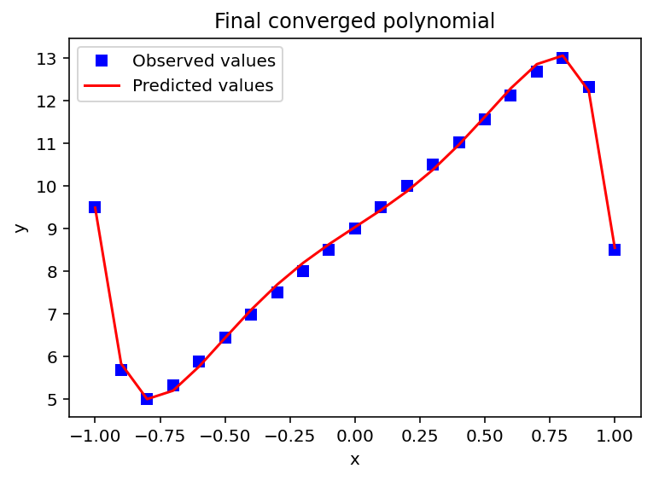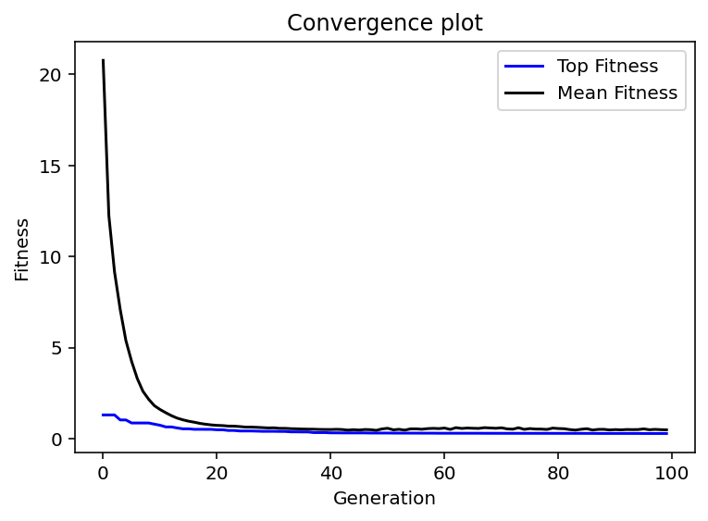
Figure 1. Best solution fitted against $f_{1}\left(x\right)$ (left) and convergence plot of fitness of the best individual and the overall mean fitness (right).

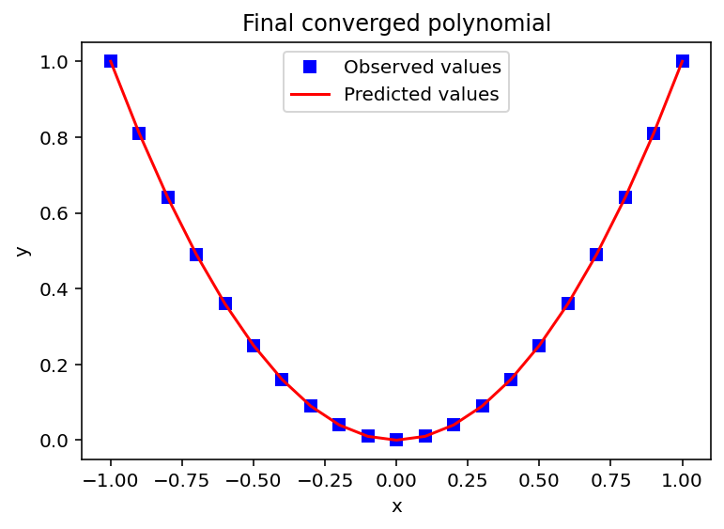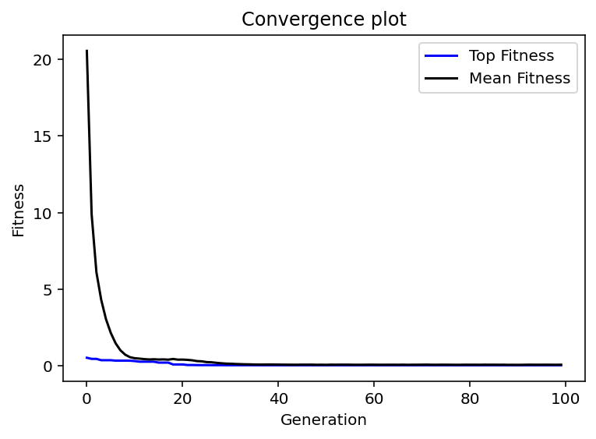
Figure 2. Best solution fitted against $f_{2}\left(x\right)$ (left) and convergence plot of fitness of the best individual and the overall mean fitness (right).

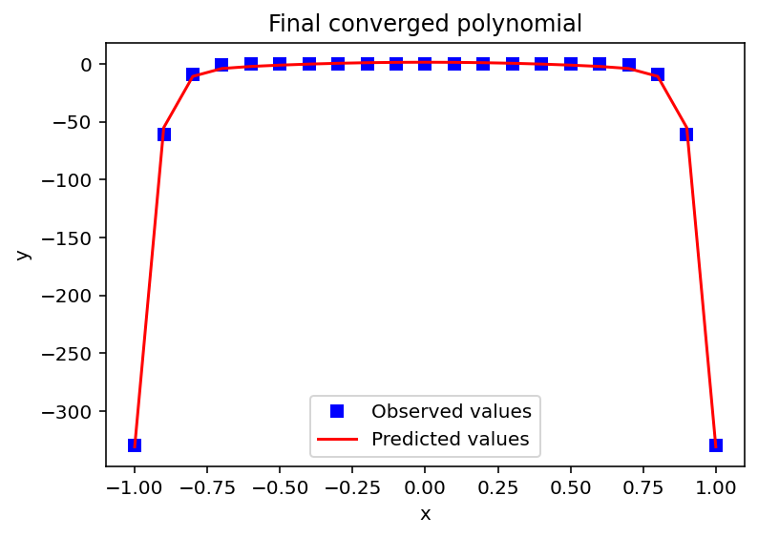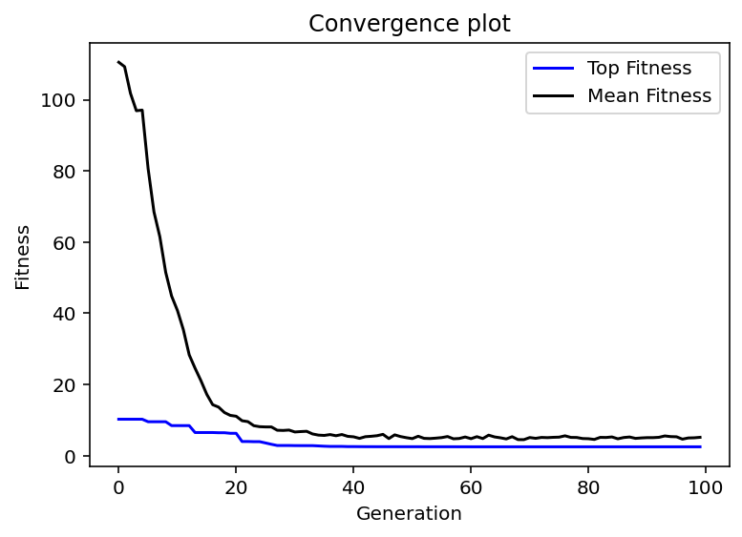
Figure 3. Best solution fitted against $f_{3}\left(x\right)$ (left) and convergence plot of fitness of the best individual and the overall mean fitness (right).

Comments:
I had issues with inconsistent and bad results with smaller population sizes (under 500). That’s the reason for the population size being set to 1000. I’m not sure if that’s how big it should be or if I need to set it this high because of other problems in my implementation?
I have a predetermined, set number of generations that the program goes through, next step would be to implement that the program stops when the population stops improving.
The results were not as good when allowing the chromosomes to have different sizes. The top fitness for exercise 2 ranged from 0.01-0.06 while the top fitness for exercise 3 ranged from 0.05 up to around 4 for some of the worse runs I’ve done.

