EXTQ20: Genetic algorithms
2026-01-22
Andrea Raaschou
Short Summary
Genetic algorithms are inspired by biology and evolution. They can be used to solve problems that other algorithms have a hard time solving. The type of problems that can be appropriate to solve with a GA can have multiple local maxima and are often difficult to solve analytically.

Aim of the exercise
To understand to understand how a GA works and how the different parameters affect outcome and efficiency.

Solution
Q5.
The jagged curve represents the overall mean. The other curve represents the mean top fitness (mean fitness for the top 10 individuals).

Q6.
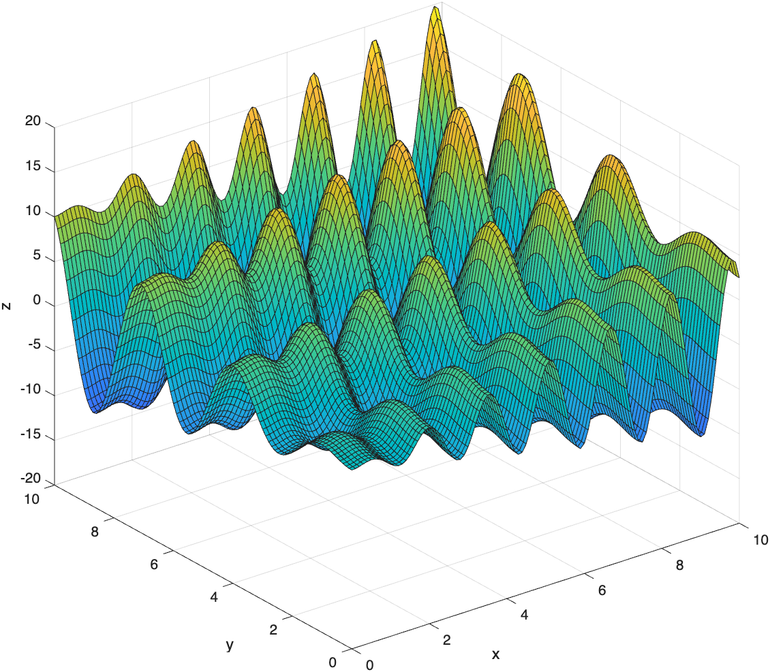
Q7.
I changed the fitness function to use the sinus function instead of the binary calculations to calculate fitness. I changed the reproduce function to use the linear blending method. I added a new function that checks that all x and y values are within the range (0, 10) and truncates to the closest limit if they are out of range. I call this function within the main for-loop, after the reproduce and mutate functions are called and before the sort function.
Q8.
The minimum seems to be around -18.55. The x- and y-values at this point was 9.04 and 8.67, respectively.
Q9.
After around 40 generations, it stabilizes around a minimum – bit it is sometimes a local minimum instead of the global minimum.
Q10.
If a is very low (0.01) – the algorithm becomes worse at escaping local minimums since it won’t take as big steps when it mutates. If a is high (5), the algorithm is much better at escaping the local minimums and will very often find the global maximum. In my algorithm, the algorithm seems to become better as I raise a. Generally, a high mutation size will make the algorithm better at searching the whole landscape and not getting stuck in local minimum points and a low a make the algorithm better at finetuning the solution but worse at escaping local minimum points. (figure 1)
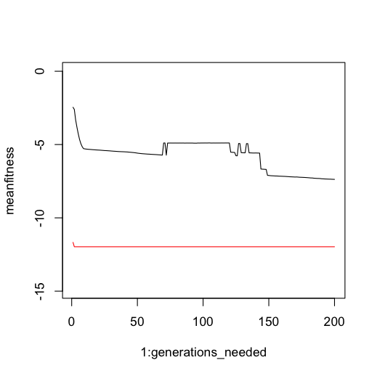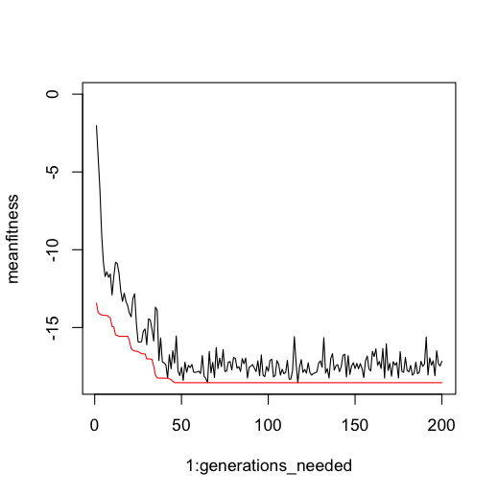
Figure 1. Low mutation size (left) vs high mutation size (right).
When choosing a low num_breed (4), the algorithm becomes slower at converging to the minimum. When choosing a high num_breed (35), the algorithm becomes useless since the reproduce function will start to overwrite the good parents – the good genes will not be saved to the next generation and there will not be any selection on which genes are good enough to be crossed and passed on to the next generation. (figure 2)
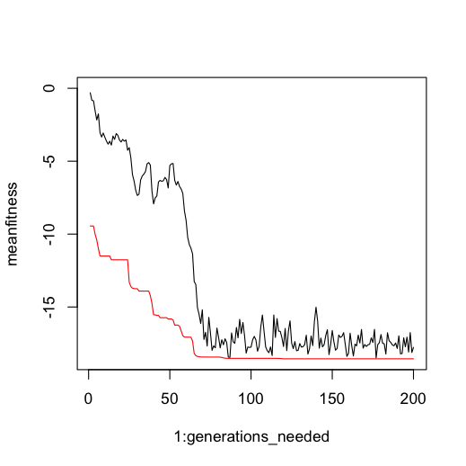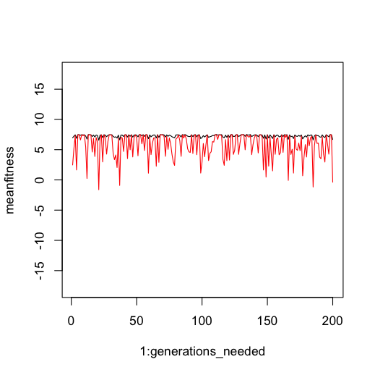
Figure 2. Low num_breed (left) vs high num_breed (right).

Links to code on GitHub:
https://github.com/AndreaRaaschou/BIOS13/blob/main/genetic_algorithms/functions.R
https://github.com/AndreaRaaschou/BIOS13/blob/main/genetic_algorithms/continuous_GA.R

Note: I found one apparent bug with a spelling mistake in the reproduce function. Fixed that. I also increased the mutation size a lot – and this made the algorithm much better than the recommended size at around 0.5-1.

