Exercise report in May’s theory
2025-02-06
Andrea Raaschou

Short summary:
A community matrix can show how different populations in a community affect each other. The diagonal represents intraspecific competition while the non-diagonal values represent interaction between populations. Robert May generated a random Jacobian matrix and got the controversial result that a more complex community is less stable.
Aim of the exercise:
Understand how the community matrix works and how community size, connectance and interactions strength affect community complexity and stability.
Solutions to exercise:

Q1. The results points towards the same conclusion that May had. Low values for complexity are more stable (has negative eigenvalues). The community is locally stable at values of $s \sqrt{nc }< 1$ (Figure 1).
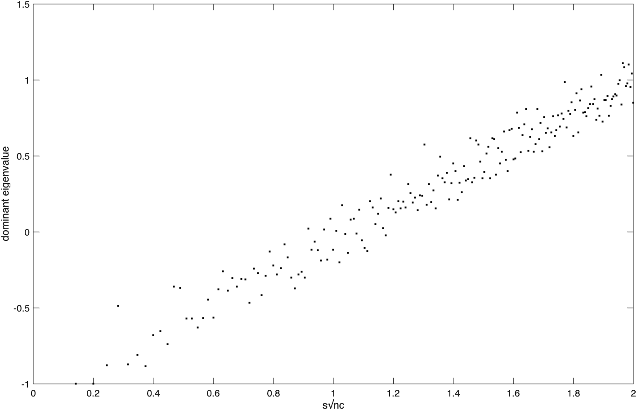
Figure 1. $s \sqrt{nc}$ vs value of the dominant eigenvalue. (n varies from 0 to 200, c = 0.5, s =0.2).

Q2. May is still correct. The community is locally stable at values of $s \sqrt{nc }< 1$ (Figure 2).

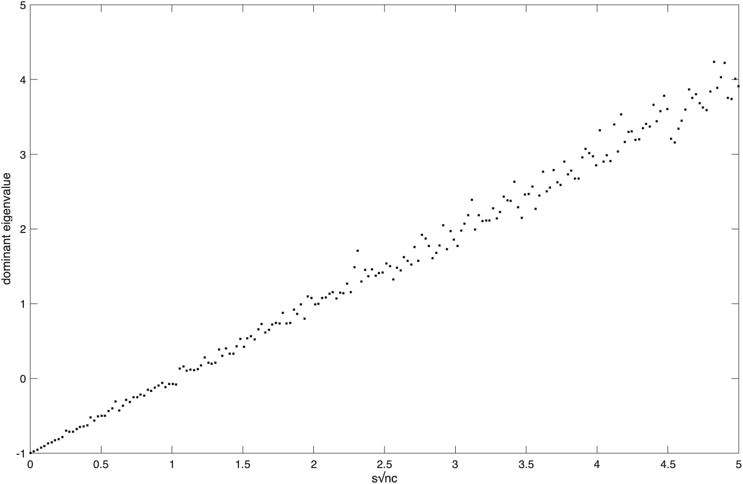
Figure 2. $s \sqrt{nc}$ vs value of the dominant eigenvalue. (n = 200, c = 0.5, s varies from 0 to 0.5).

