Exercise report in Food Chain theory
2025-02-06
Andrea Raaschou

Short summary:
A community contains many food chains with resources, consumers and predators. This exercise uses the Rosenzweig-MacArthur model to model on such food chain.
Aim of the exercise:
Understand resource-consumer-predator dynamics in a food chain, model and analyze isocline and stability of food chains.
Solutions to exercise:
1a)
See code
1b)
The two populations first oscillate but quickly reach an equilibrium where both populations stay steady (figure 1 and 2). The resource isocline has the same overall shape but get slightly lower (≈ -0.1). The consumer isocline, which is a vertical line, crosses the resource isocline before the recourse isocline reaches its maximum instead of after.

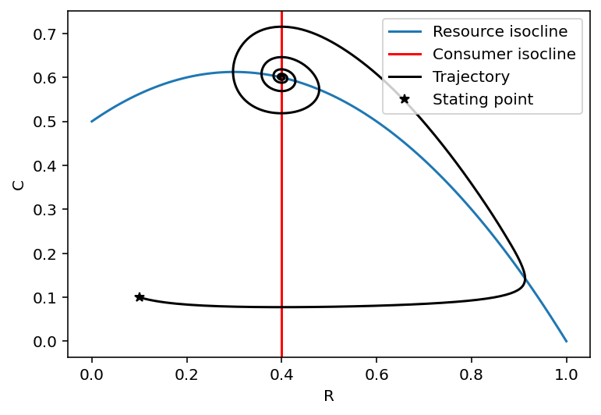
Figure 1. Isoclines for the Rosenzweig-MacArthur model with a simulated trajectory.
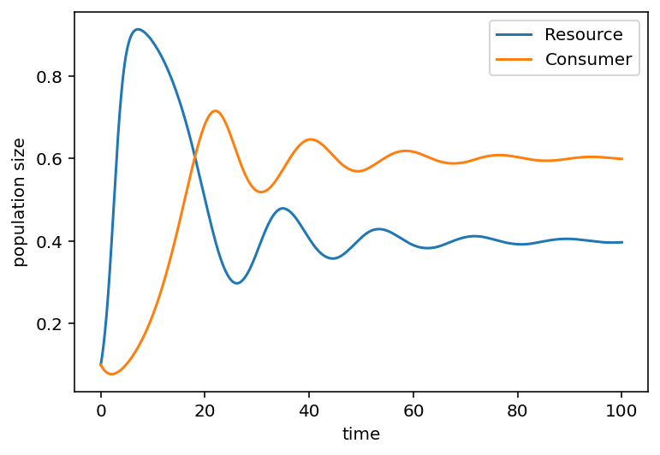
Figure 2. Simulation of two populations using the Rosenzweig-MacArthur model.

1c)
The equilibrium becomes unstable, as we can see on the trajectory (figure 3) and the population size simulation (figure 4). The populations continue oscillating and doesn’t reach a stable equilibrium. The resource isocline keeps the same shape but has the maximum slightly lower than before (≈ -0.1), which in biological terms means that the resource population will be more suppressed by the increased consummation with the increased attack rate. The consumer isocline is still a vertical line, but it crosses the resource isocline before instead of after the resource isocline maxima. When this happens, the equilibrium becomes unstable and the populations keep oscillating, which can be seen in figure 4.

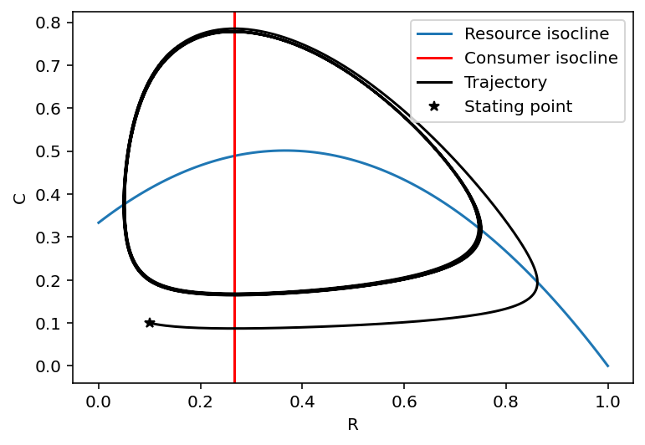
Figure 3. Isoclines for the Rosenzweig-MacArthur model with a simulated trajectory (a_{C} = 3).

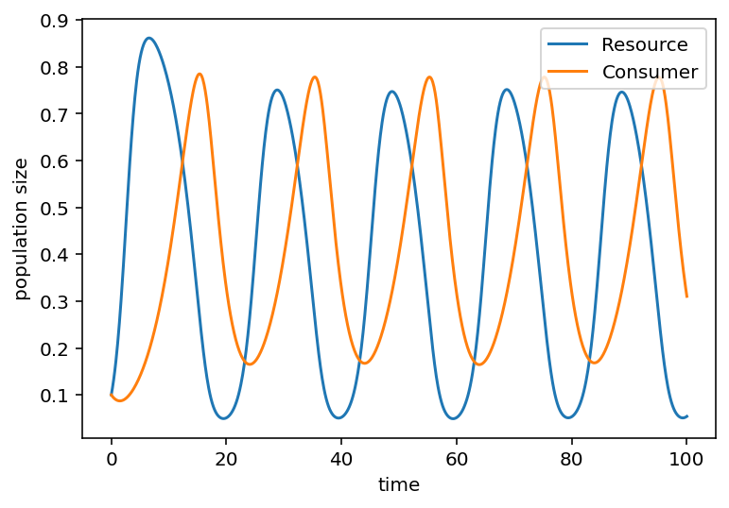
Figure 4. Simulation of two populations using the Rosenzweig-MacArthur model (a_{C} = 3).

1d)
The equilibrium population sizes are:
- Resource population size: 0.40
- Consumer population size: 0.60

2a)
Equilibrium population sizes (time interval = (0, 700))
- Resource population size: 0.53
- Consumer population size: 0.54
- Predator population size: 0.31
The trophic cascade effect is clear if one compares the predator population size with the two other population sizes (figure 5).

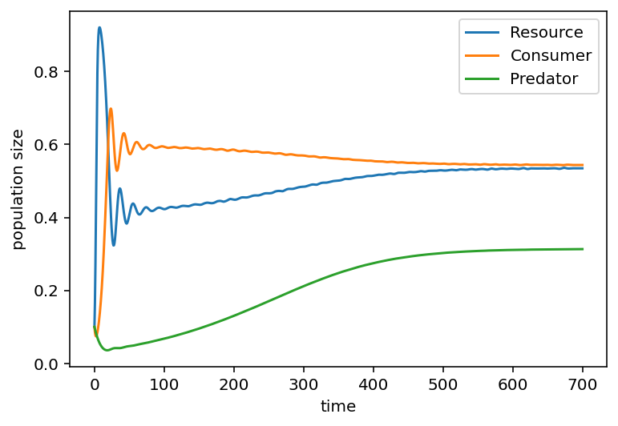
Figure 5. Population size simulation with three populations using the Rosenzweig-MacArthur model (K_{R} = 1).

2b)
With a small increase in resource carrying capacity (K_{R} = 1.2), the oscillations in the beginning are much larger and the system takes longer to converge to a stable equilibrium (figure 6). In a more realistic scenario with stochastic events constantly pushing the different population sizes away from their equilibriums, this would create a less stable food chain that takes longer to return to stable states and with big fluctuation in population sizes.
With a bigger increase in resource carrying capacity (K_{R} = 2), the system will not converge but keeps oscillating with very large fluctuations (figure 7). This results in a very unstable ecosystem with a high risk of extinction for the species involved. In this simulation, the predator population goes extinct.
This is an example of the paradox of enrichment that takes place when resource abundance increases in an ecosystem – the whole ecosystem becomes unstable and might reach a tipping point where it completely changes, often to less favorable conditions. An example of this is eutrophication of lakes where increased nutrient input promotes algal blooms that destabilize the ecosystem, reducing water clarity and oxygen levels and leading to biodiversity loss.
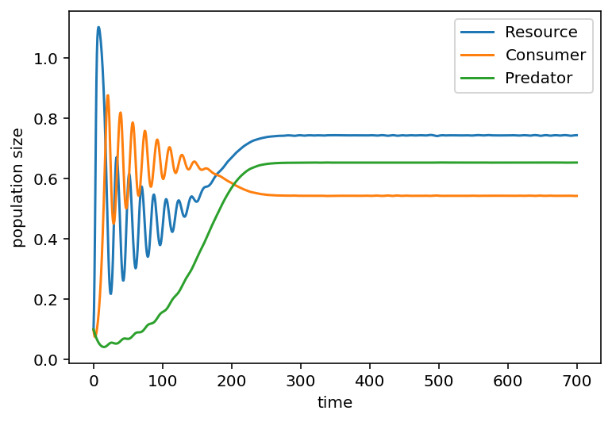
Figure 6. Population size simulation with three populations using the Rosenzweig-MacArthur model (K_{R} = 1.2).

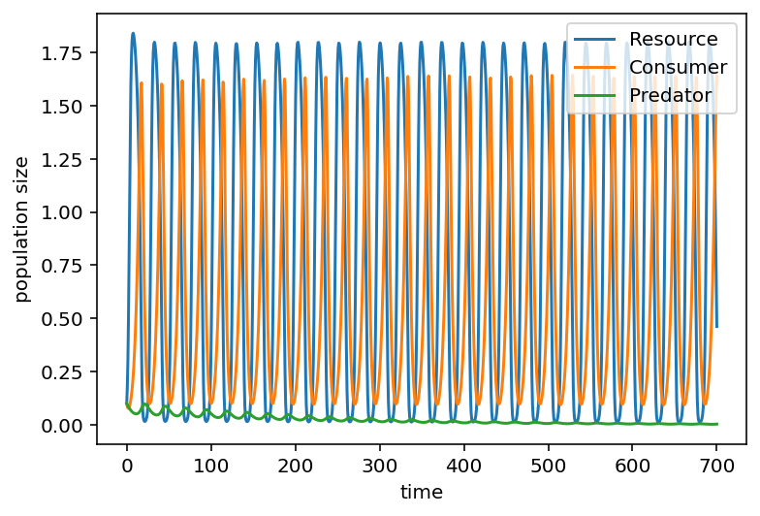
Figure 7. Figure 5. Population size simulation with three populations using the Rosenzweig-MacArthur model (K_{R} = 2).

