First_Assignment.R

ASUS

2021-11-21

##### FIRST ASSIGNMENT   
  
## Andrea Scalenghe - 913359  
## Matteo Morabito - 918551  
  
  
#Exercise 1  
  
  
Yvariable <- function(beta, gamma, sigma, h) {  
 Y<-vector()  
 Y[1]<-0  
 Z<-rnorm(T/h+1,mean=0,sd=sqrt(h))  
 for(i in 2:(T/h+1)) Y[i]<- Y[i-1]-beta*(Y[i-1]-gamma)*h+sigma*Z[i-1]  
 return(Y)  
}  
  
T<-15  
  
Y_1<-Yvariable(2,1,3,0.01)  
Y_2<-Yvariable(2,1,3,0.1)  
  
plot(seq(0,T,0.01), Y_1, col = "blue", type = "l", xlab = "Time", ylab = "Y(t)")  
lines(seq(0,T,0.1), Y_2, col = "red", type = "l")

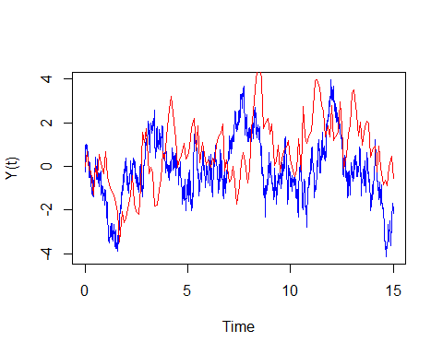

#Exercise 2  
  
X<-matrix(nrow = 1501, ncol = 4, byrow = FALSE)  
g<-seq(2,5)  
for(i in 2:5) {  
 X[,i-1]<-Yvariable(2,i,3,0.01)  
}  
  
plot(seq(0,T,0.01), X[,1], type = "l", xlab = "Time", ylab = "Y(t)", col = "red")  
lines(seq(0,T,0.01), X[,2], col = "magenta")  
lines(seq(0,T,0.01), X[,3], col = "green")  
lines(seq(0,T,0.01), X[,4], col = "blue")

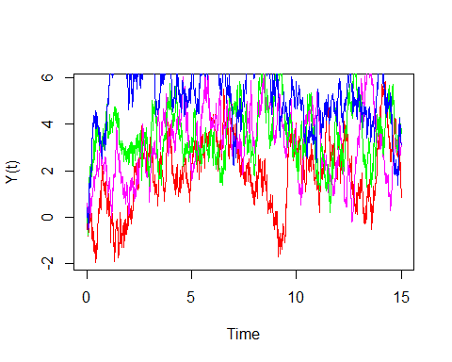

#We can see that as gamma increases the value of the process also increases  
  
  
  
#Exercise 3  
  
beta<-1  
gamma<-0  
sigma<-1  
  
#The theory states that Y(5) is distributed as a normal random variable with   
#mean=0 and variance=(1-e^(-10))/2. I verify that simulating 10000 Y(5) and   
#analyzing the results with the theoretical distribution.  
  
T<-5  
  
#Simulated random variable. We already prepare the random variable X_{2.5} for   
#the fourth exercise  
  
simul<-c()  
X_2dot5<-c()  
for(i in 1:10000) {  
 Y<-Yvariable(beta, gamma, sigma, 0.01)  
 simul<-c(simul, Y[T/0.01+1])  
 X_2dot5<-c(X_2dot5, Y[T/0.02+1])  
}  
  
simul_mean<-mean(simul)  
simul_sd<-sd(simul)  
#Theoretical quantities  
  
theor_mean<-gamma*(1-exp(-beta*T))  
theor_sd<-sigma*sqrt(((1-exp(-2*beta*T))/(2*beta)))  
theor_sample<-rnorm(10000,theor_mean,theor_sd)  
  
#Descriptive analysis  
  
mean_err<-abs(theor_mean-simul_mean)  
sd_err<-abs(theor_sd-simul_sd)  
print("Mean error of the simulated sample of size n=10000")

## [1] "Mean error of the simulated sample of size n=10000"

mean_err

## [1] 0.004203888

print("Standard deviation error of the simulated sample of size n=10000")

## [1] "Standard deviation error of the simulated sample of size n=10000"

sd_err

## [1] 0.0005654987

#We can also use the qqnorm function and plot an histogram and a boxplot of simul   
qqnorm(simul)

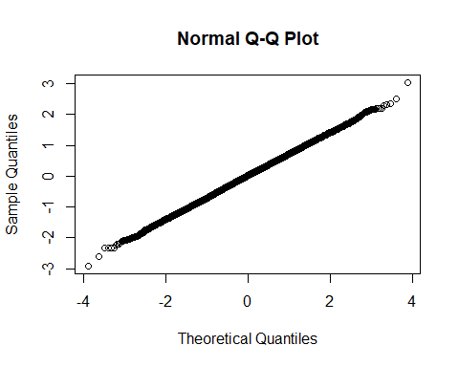

par(mfrow=c(1,2))  
boxplot(simul)  
hist(simul, freq = F, col = "blue")

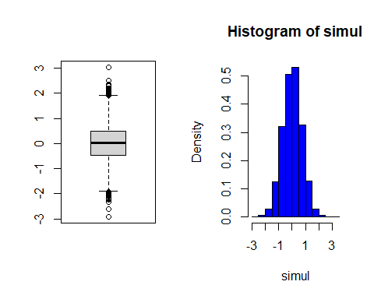

#For a visually effective comparison we plot the two densities  
  
par(mfrow=c(1,1))  
plot(density(theor_sample), col = "red")  
lines(density(simul), col = "blue")

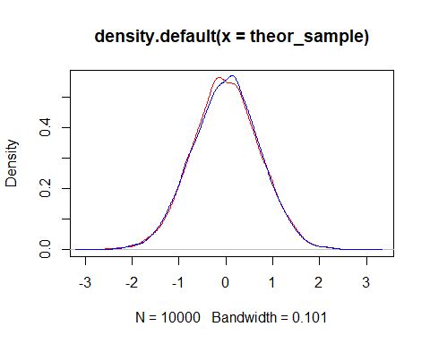

#Exercise 4  
  
X_5<-simul  
  
P<-sum(X_5<X_2dot5)/10000  
P

## [1] 0.4928