# In-silico study of the effect of Ritonavir on Human Ventricle Cells

Professor:

Matas Jose Felix Rodriguez

Students:

Andrea Scarpellini, 223360 - andrea1.scarpellini@mail.polimi.it😊

Saina Charkas

Table of Contents

In-silico study of the effect of Ritonavir on Human Ventricle Cells 1

Introduction 3

Dataset 3

Ritonavir 4

Methods 4

APD90 4

First condition 5

Second condition 5

Third condition 5

Results 5

Discussion 8

References 8

## Introduction

The evaluation of cardiotoxicity is a crucial aspect of drug development. Current regulatory guidelines for drug safety require the measurement of IKr channel block in vitro and QT interval prolongation in vivo to assess the arrhythmic risk of a drug. However, it has become evident that these markers alone are insufficient to predict cardiotoxic behavior accurately. A new paradigm has been proposed, which combines in vitro studies that measure the drug's effect on different ionic channels and in-silico models of cardiac myocyte electrophysiology. This report evaluates the cardiotoxicity of Ritonavir using the MATLAB program provided.

The findings of this study will contribute to the existing knowledge on the pharmacodynamics of the drug under investigation and enhance our understanding of its impact on cardiac electrophysiology. Ultimately, this information can aid in the development of safer and more effective drug therapies, as well as guide regulatory decision-making regarding drug dosage and usage.

## Dataset

The dataset provided for this project involves an in-silico study of the potential cardiotoxicity of a drug on human ventricle cells using a combination of in vitro studies and in-silico models of cardiac myocyte electrophysiology. Specifically, the project focuses on evaluating the effect of Ritonavir on the different ionic channels using a pore block model that reduces the channel conductance based on the available half-maximal inhibitor concentration, IC50, and Hill coefficient, n.

|  |  |  |
| --- | --- | --- |
| Modified channels & EFTPCmax | | |
| Gna | Hill Coeff. | 1 |
| IC50 (μM) | 27.96163 |
| GNaL | Hill Coeff. | 0.7 |
| IC50 (μM) | 7.175 |
| GKr | Hill Coeff. | 1 |
| IC50 (μM) | 5.157 |
| GCaL | Hill Coeff. | 1.3 |
| IC50 (μM) | 8.228 |
| EFTPCmax (μM) | | 0.4369 |

The electrophysiological variability inherent to the cardiac tissue is considered by means of a population of models approach using a file called "mask.mat".

The evaluation of the cardiotoxic effect is carried out by analyzing the effect of the drug on 10 different models of ventricular myocytes for four different concentrations of the drug (1x, 2x, 10x, 100x [EFTPC]). The stimulation protocol involves stimulating with a current 1.5x the stimulation threshold 500 times with a BCL=800ms and analyzing the last three beats, with pro-arrhythmic behavior considered if certain conditions are met.

### Ritonavir

Ritonavir is a medication primarily used in the treatment of HIV/AIDS. It is a protease inhibitor that works by blocking the enzyme responsible for the replication of the virus. Common side effects of ritonavir include nausea, vomiting, diarrhea, headache, and fatigue. It may also cause changes in blood sugar levels and lipid metabolism. In the medical field, ritonavir is often used in combination with other antiretroviral drugs to suppress the HIV virus and prevent progression to AIDS. Ritonavir is not typically considered an inductive arrhythmic drug. In fact, it is not commonly associated with significant cardiovascular side effects. However, it has been associated with an increased risk of cardiac events such as heart attack and arrhythmias in some patients, particularly those with pre-existing heart conditions. Therefore, the cardiotoxicity of ritonavir and its potential to cause pro-arrhythmic effects in the heart have to be considered in its use[1].

## Methods

For each of the ten models, the effect of Ritonavir was evaluated for four different concentrations: 1x, 2x, 10x, and 100x [EFTCP] (a total of 40 simulations). The stimulation protocol consisted of stimulating with a current 1.5x the stimulation threshold 500 times with a BCL=800ms and analyzing the last three beats. A pro-arrhythmic behavior was considered if:

* alternans in the APD90 were observed.
* abnormal repolarizations appeared.
* APD prolongation of more than 25% (with respect to control).

### APD90

The APD90 is the interval of time between the point of maximum variation of the transmembrane potential and the 90% repolarization point. Fig. 1 displays an example of the three action potentials of the respective APD90 time windows. As calculated for the subject 1 the APD90 was calculated for all the other subjects.

Figure 1: Example of the three APD90 intervals, and their fiducial points: the point of maximum inclination, the maximum depolarization point and the 90% point of repolarization.

|  |
| --- |
|  |

### First condition

What did we do?

Why? –>references

### Second condition

What did we do?

Why?-->references

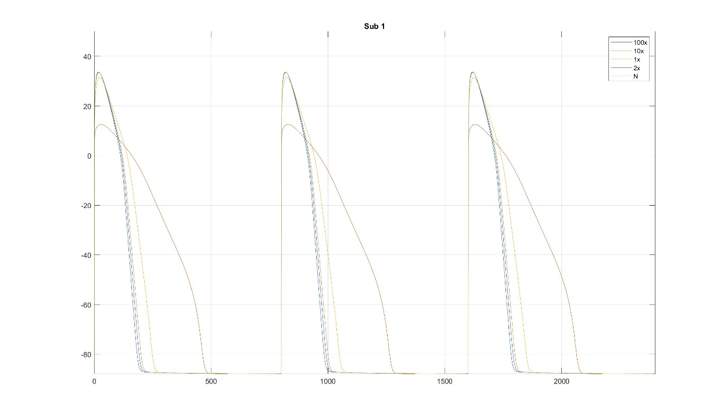

### Third condition

What did we do?

Why?-->references

### General trends

Figure : a) APD90 Boxplot of all subjects, b) APD90 boxplots of non-arrhythmic subjects

Figure : a) APD90 Mean and Standard deviation of all subjects, b) APD90 mean and standard deviation of non-arrhythmic subjects

## Results

By plotting the average APD90 as a function of the drug concentration, we will observe the overall trend and ascertain whether there is a concentration-dependent effect on cardiac repolarization. Additionally, incorporating the standard deviation in the plot will provide insights into the data dispersion, highlighting the variability across the drug concentrations.

For calculation the arrhythmic risk as the probability of observing arrhythmic behavior for each concentration over the ten models we made the following steps:

* **Observation of alternans in the APD90**

For each concentration, if the absolute values of last three consecutive differences between of ADP90 of each subject was more than 10, then the subject would show pro-arrhythmic behavior.

|  |
| --- |
|  |
| 1. Observation of alternans in the ADP90 |

**Results:**

Pro-arrhythmic behavior probabilty - dose 100 is: 0.00%,

Pro-arrhythmic behavior probabilty - dose 10 is: 0.00%,

Pro-arrhythmic behavior probabilty - dose 1 is: 0.00%,

Pro-arrhythmic behavior probabilty - dose 2 is: 0.00%,

* **APD prolongation of more than 25% (with respect to control)**

For each concentration, if the absolute value of difference between last(third) ADP90 of each subject was more than 25% of the normal value, then the subject would show pro-arrhythmic behavior.

|  |
| --- |
|  |
| 1. Observation of APD90 prolongation |

**Results:**

Pro-arrhythmic behavior probabilty - dose 100 is: 90.00%,

Pro-arrhythmic behavior probabilty - dose 10 is: 40.00%,

Pro-arrhythmic behavior probabilty - dose 1 is: 0.00%,

Pro-arrhythmic behavior probabilty - dose 2 is: 0.00%,

* **Abnormal repolarizations appeared.**

For observing abnormal repolarizations, we plotted the last three ADP90 for each subject at each concentration.

|  |
| --- |
|  |
| 1. Observation of abnormal repolarization |

According to the plots, we had no abnormal repolarization within subjects at different concentrations.

## Discussion

Figure : Comparison between boxplots of all subjects and non-arrhythmic subjects.

## References

[1] “Ritonavir | C37H48N6O5S2 - PubChem.” https://pubchem.ncbi.nlm.nih.gov/compound/Ritonavir (accessed May 14, 2023).