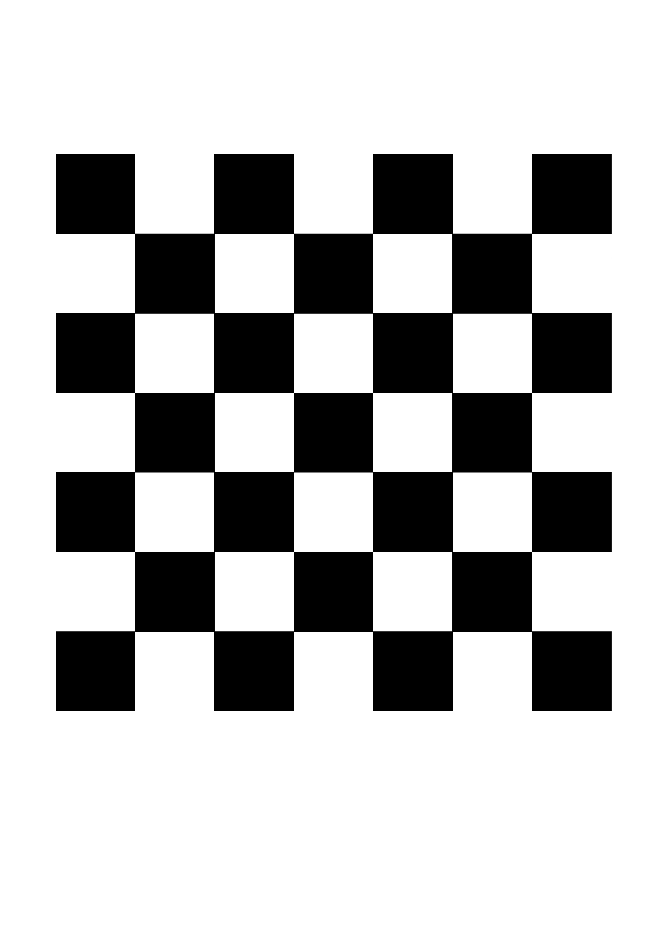
Everything started by sketching a quick a4 paper with a 7x7 chessboard (technically, 6x6, since opencv only sees intersections strictly inside the chessboard) with a 2.5mm side for each square.
After printing it, I immediately used the opencv tools to detect those intersections (called corners).
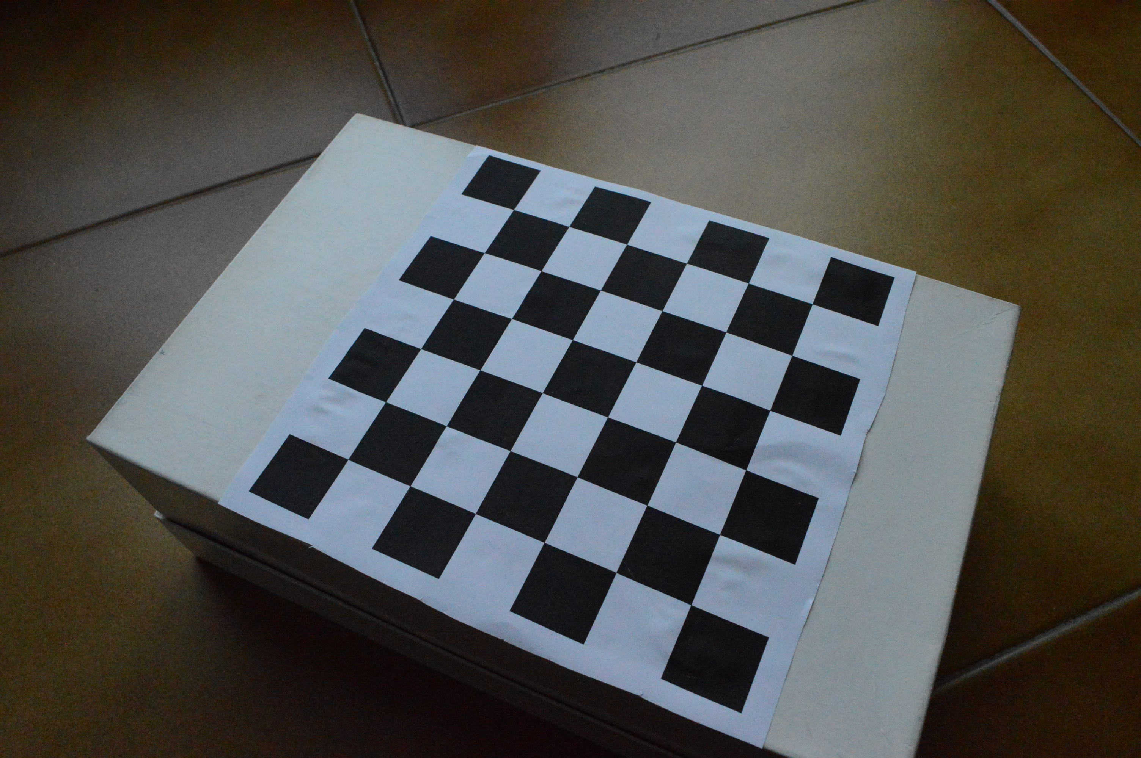
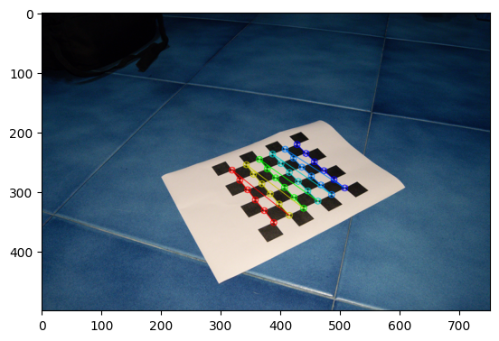
I attached it on a shoebox, taking pictures of it with my DSLR, set to 18mm, with the distortion corrections disabled. Running it through the calibrate_dslr_pics python script, all the “corners” are found again.

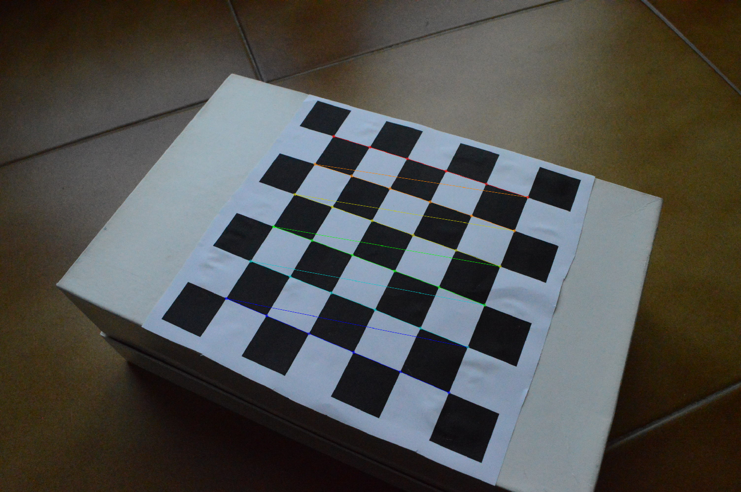
After seeing all the 10 images I gave it, opencv estimates the camera's focal length in millimeters by using the intrinsic camera matrix obtained from calibration and the known physical sensor size (APS-C or Full Frame). Since my camera has an APS-C sensor, the 17.61mm focal length guess is very close to the ground truth.
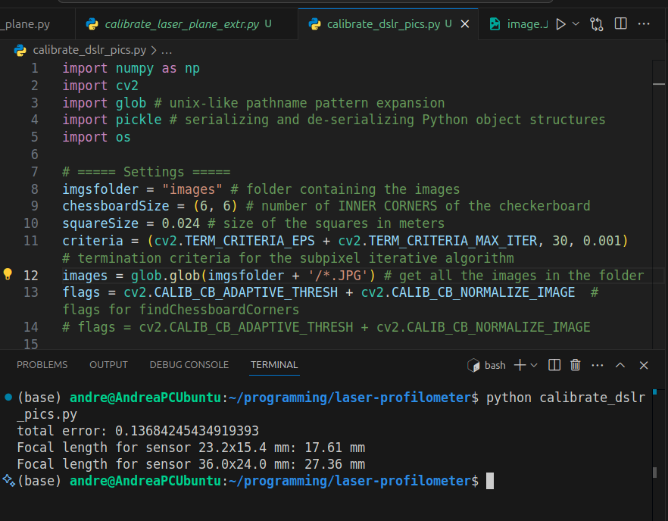

It will “pickle” (save) the camera intrinsics, or intrinsic camera matrix, into a “calibration.pkl” file, for eventual later use.
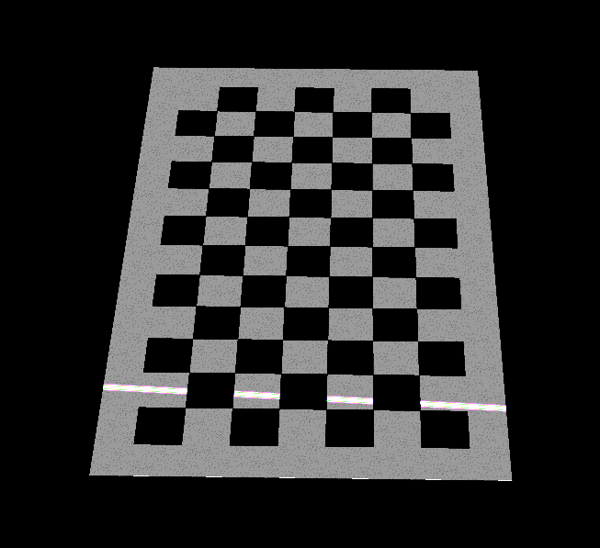
Seeing all this working, I decided to attack the main problem: extracting the laser plane equation, knowing its position relative to the camera is stationary and it is only visible on projected chessboards. All this, starting from no calibration. The image to the side here is cropped and brightened for better visualization.
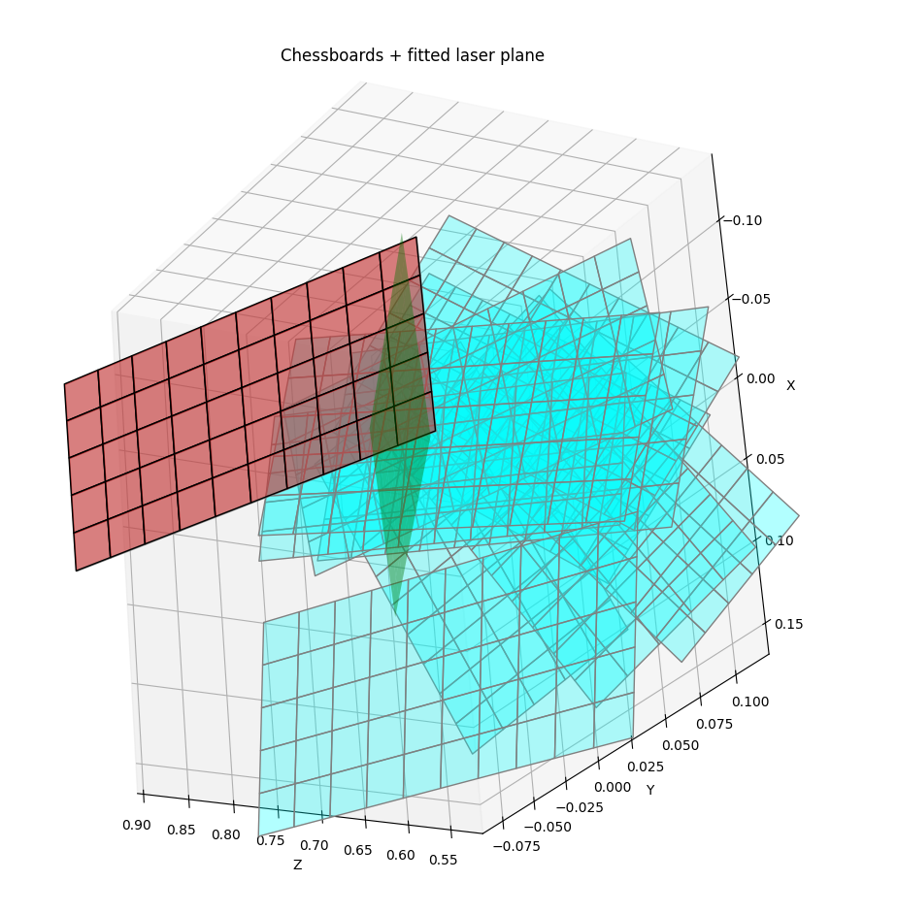
Well, the new “laser_plane_overlay_printing” python software can look at those images and ESTIMATE (because the laser has speckling – it’s not a perfect, uniform line) the laser plane equation, then printing all chessboards + the laser plane in 3d space using mplot3d. It is clear that the selected chessboard is exactly the one shown in the picture, and it’ll be the same for all the others.
The next step will be to reconstruct a 3d object after calibration, always done with a chessboard, starting from images like the one below.


