**TVML**

IP-516_AppleTV App

**Version number:** 0.1  
**Main author:** AZ, JB  
**Last revision:** 19.11.2016  
**Status:** in work  
**Filename:** TVML.doc  
**Client:** Michael Keller, UPC

Authors

|  |  |
| --- | --- |
| **Name** | **Initials** |
| Andrea Zirn | AZ |
|  |  |
|  |  |

Revision list

| **Version** | **Date** | **Comment** | **Author** |
| --- | --- | --- | --- |
| 0.1 | 19.11.2016 | Initial version | AZ |
|  |  |  |  |
|  |  |  |  |

Table of Content

Authors 2

Revision list 2

Table of Content 3

1 Heading 1 3

1.1 Heading 2 3

1.1.1 Heading 3 3

# About TVML[1][2]

The Apple TVML, Television Markup Language, provides the service to create individual pages inside of a client-server application. It is an easy possibility to create apps for Apple TV using TVMLKit JavaScript (TVMLKit JS), TVML, and the TVMLKit framework.

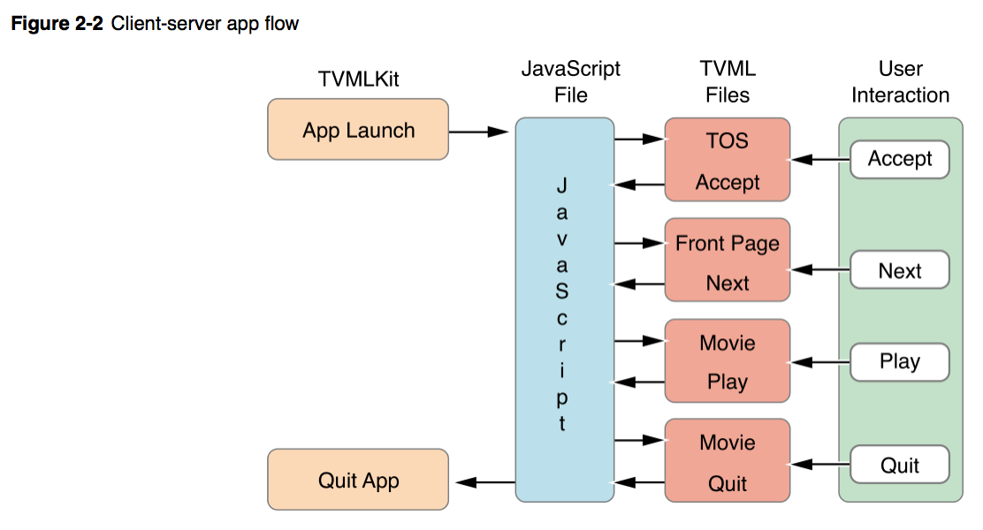[3]

1. <https://developer.apple.com/library/content/documentation/TVMLKitJS/Conceptual/TVMLProgrammingGuide/index.html#//apple_ref/doc/uid/TP40016718-CH6-SW1>
2. <https://developer.apple.com/library/content/documentation/LanguagesUtilities/Conceptual/ATV_Template_Guide/index.html#//apple_ref/doc/uid/TP40015064>
3. <https://developer.apple.com/library/content/documentation/General/Conceptual/AppleTV_PG/YourFirstAppleTVApp.html#//apple_ref/doc/uid/TP40015241-CH3-SW1>