DFA to GNFA to Regular Expression (CONVERT Algorithm)
Demonstration using Figure 1.6

Comp 382 – Language, Computation and Machine
Instructor: Russell Campbell
Students:
Jang Toor - 300211868
Andrea Pezzella - 300179475
University of the Fraser Valley
January 20, 2026

We decided to choose this topic because we wanted to focus on a part of the course that emphasizes understanding and reasoning rather than heavy coding. The DFA-to-GNFA conversion felt like a good balance between being technical and being conceptual as it allowed us to work directly with the theory from the book and show that we truly understand how automata are transformed step by step, instead of relying on large amounts of code to do the work for us. Moreover, this topic is very well-covered by online sources, enabling us to get an even better understanding of the transitions' operations and of the concept itself.

We started with a DFA (a machine), and our goal is to find a regular expression that matches the exact same language, basically the same set of strings accepted. To do that, we first convert the DFA into a special GNFA, and then we delete states one by one until only the new start and new accept states remain. Then the final label becomes a regular expression. (Sipser, 2013)

Starting DFA from Figure 1.6:
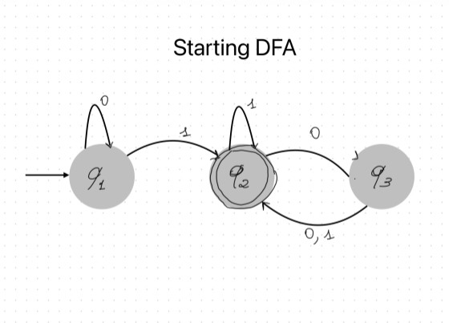

The DFA has three states: q1, q2, q3. It reads symbols from the alphabet {0,1}. The start state is q1 and the accept state is q2 (double circle). (Sipser, 2013)

GNFA Step 1:

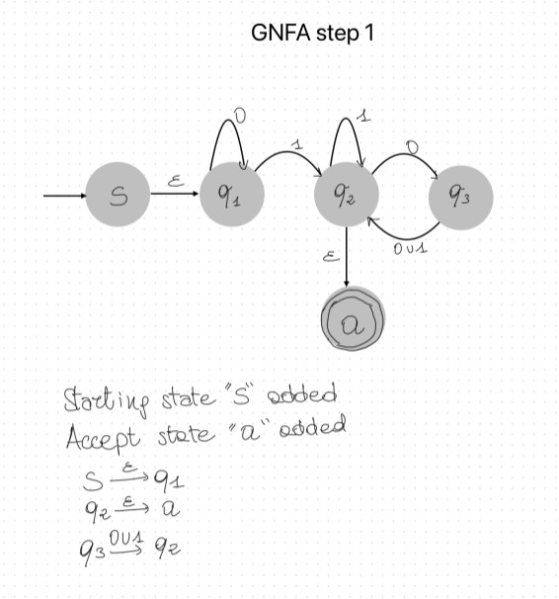

In a special GNFA, we added a new start state called S and a new accept state called a and then we connect them using ε-moves (empty transition), which means move without reading any symbol.
- From S, the machine can go to q1 using ε so it starts the old DFA without reading anything.
- If the machine is in q1 and reads 0, it stays in q1.
- If the machine is in q1 and reads 1, it moves to q2.
- If the machine is in q2 and reads 1, it stays in q2.
- If the machine is in q2 and reads 0, it moves to q3.
- From q2, the machine can go to the new accept state a using ε, because q2 was the accept state in the original DFA.
- If the machine is in q3, it goes back to q2 by reading either 0 or 1, so we label that transition as (0 ∪ 1). (Sipser, 2013)

Delete state q3 (GNFA Step 2):

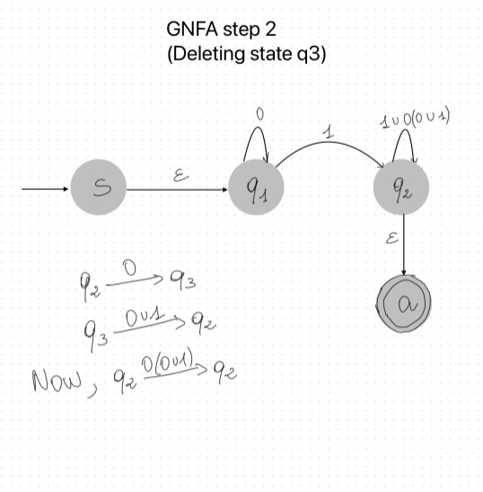

Now we remove state q3. When we delete a state, we don’t lose the language. Instead, we combine paths that state into a new regex edge. Here’s the important path that used q3 from q2, reading 0 takes us to q3 and from q3, reading 0 or 1 takes us back to q2. So going from q2 back to q2 through q3 means we read first a 0, then (0 or 1). That becomes the regex: 0(0∪1) but q2 already had a loop on 1 (q2 stays on 1). So, after deleting q3, the loop at q2 becomes (1∪0(0∪1)) which means from q2 we can loop by reading either 1OR 00 OR 01. (Sipser, 2013)

Delete State q1 (GNFA Step 3):

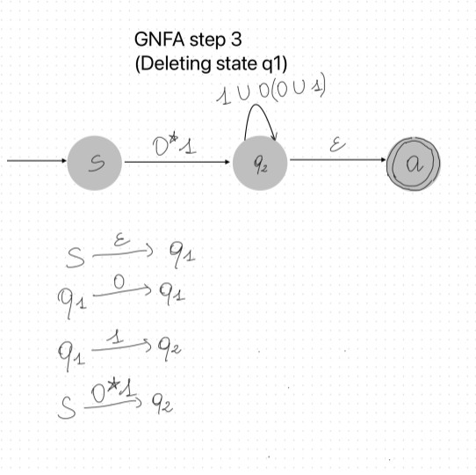

Now we deleted state q1. We look at how to go from S to q2 using q1 from S, we go to q1 without reading anything (ε). At q1, we can read 0 and stay in q1 as many times as we want and then when we read a 1, we go from q1 to q2. Reading any number of 0s is written as 0*. So, the combined way from S to q2 becomes 0∗1 that means read zero or more 0s, then read 1, and you reach q2. After this step, the GNFA is basically S goes to q2 with 0*1 and q2 loops with (1 ∪ 0(0 ∪ 1)) and q2 goes to a with ε.

Delete state q2 (GNFA Step 4):

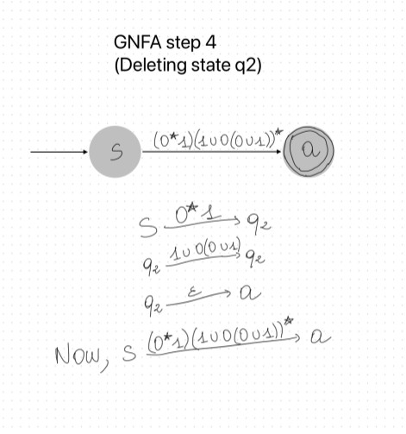

Now we delete q2, leaving only S and a. To accept a string, the machine must go from S to q2 using 0*1 and loop at q2 any number of times using (1 ∪ 0(0 ∪ 1)) and then go from q2 to a using ε. Looping any number of times means using the star *. So, we get: $(0^{*}1)(1∪0(0∪1))^{*}$ and this is our final Regular Expression. (Sipser, 2013; Randolph, 2022; Dasari, 2020).
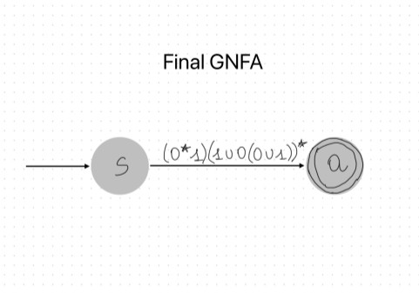

References:
Sipser, M. (2013). Introduction to the theory of computation (3rd ed.). Cengage Learning.
Randolph, T. (2022, May 26). Example 3: From DFA, to GNFA, to Regular Expression [Video]. YouTube. https://youtu.be/B_sWA0Kx2Jc?si=FLMWzYDyPTae_U1Y
Dasari, R. (2020, September 27). 5.3 DFA to GNFA to Regular Expression [Video]. YouTube. https://youtu.be/XFKNg6u3Luw?si=kxBV01nzQcmVmw-A
Enas. (2019, November 3). GNFA and Qrip part2 [Video]. YouTube. https://youtu.be/VsZaZkuy6uY?si=t-M7sQ0JjWa2y9cz

