

**CONCEPT SHEET: REGIONAL ANALYSES**

|  |  |
| --- | --- |
| **Steering Group approval date:** | *(To be added by UCT data centre)* |
| **Tracking number:** | *(To be added by UCT data centre)* |
| **Title:** | Post-traumatic stress disorder as a causal risk factor for cardiovascular disease |
| **Lead author:**  **Email:** | Cristina Mesa Vieira (ISPM)  Cristina.mesavieira@ispm.unibe.ch |
| **IeDEA senior investigator:**  **Email:** | Andreas Haas (ISPM)  [andeas.haas@ispm.unibe.ch](mailto:andeas.haas@ispm.unibe.ch) |
| **Statisticians:**  **Email:** |  |
| **Data manager:**  **Email:** | Nicky Maxwell (IeDEA data centre at UCT)  nicky.maxwell@uct.ac.za |
| **Where will statistical analyses be done?** | ISPM, University of Bern |
| **Required variables:** |  |
| **Target journal:** |  |
| **Ethics:** | *Select as appropriate:*  This concept uses only the IeDEA-SA standard dataset and is covered by the core IeDEA-SA ethics approvals.  This concept requires additional collection of health-related data, measurements or tests, or sampling of biological material not included in the IeDEA-SA standard dataset. Additional ethics approval is required.* (Describe ethical considerations for any additional data collection here, including responsible IRBs.) |
| **Milestones:** | *Circulation of concept sheet: April 1, 2022*  *Ethics approval (for additional data collection): <date>*  *Circulation of mature draft paper: <date>*  *Submission to target journal: <date>* |
| **Abstract:** (about 100 words) | **Background:**  **Aims and objectives:**  **Methods:** |

* If additional ethics approvals are required, a copy must be sent to the ISPM Program Manager before data collection can begin.

**1. Background**

Posttraumatic stress disorder (PTSD) is a maladaptive reaction to a traumatic event, and it is present in about 7% of the population (1). The current scientific literature shows an association between PTSD and CVD risk factors (2) and cardiovascular disease (CVD). For example, a recent systematic review (3) reported that persons with PTSD had a largely increased risk of subsequent myocardial infection (aHR 1.49, 95% CI 1.31-1.69).

Two pathways might explain the increased incidence of CVD in persons with PTSD. PTSD can lead to unhealthy behaviours such as substance use, physical inactivity, sleep disorders and dietary changes that lead to common cardiovascular risk factors (hypertension, diabetes, high cholesterol), which can cause CVD (2). An alternative explanation is that PTSD generates an inflammatory state that can cause CVDs such as myocardial infarction, unstable angina and stroke (2). This hypothesis is supported by studies showing that PTSD is independently associated with an increased risk of coronary heart disease even after adjusting for depression and cardiovascular risk factors, such as high cholesterol, hypertension and high blood pressure (3).

The relationship between PTSD and CVD is bidirectional. Evidence suggests that a cardiovascular event can cause PTSD. For example, Edmonson found a 12% prevalence of PTSD secondary to acute coronary syndromes. PTSD, in turn, doubles the risk for recurrent acute coronary syndromes and mortality. The mechanisms through which CVD causally relates to PTSD are under study (2).

While evidence on the association between PTSD and CVD is emerging, there is little empirical support for causal links between PTSD and CVD. We aim to examine PTSD as a causal risk factor for CVD and quantify the mediating effect of PTSD on CVD through CVD risk factors.

**2. Objectives**

1. To describe the incidence of cardiovascular risk factors and major cardiovascular events in persons with and without PTSD
2. To examine PTSD as a causal risk factor for CVD (total effect)
3. To quantify the mediating effect of PTSD through CVD risk factor or inflammation on CVD (indirect effect via mediators).

**3. Study design**

We will conduct a cohort study of South African adults using routine data from a large South African medical insurance scheme.

**3.1 Eligibility criteria**

Adults aged 18 years or older who had insurance coverage with the medical insurance scheme at any point between January 1, 2011, and July 30, 2020, are eligible for analysis. Persons with unknown sex or age will be excluded.

**3.2 Data sources**

We will use data from a large South African private-sector medical insurance scheme.29 Data include sociodemographic information, reimbursement claims, laboratory results, and information of the vital status of beneficiaries of the medical scheme.

**3.3 Key variables**

* Sociodemographic data: age, sex, ethnicity
* Hospital claims contain the date of admission, date of discharge, International Classification of Diseases, 10th Revision (ICD-10), National Reference Price List (NRPL) codes, and Current Procedural Terminology (CPT) codes.
* Outpatient claims contain ICD-10 diagnoses.
* Pharmacy claims contain information on the active ingredients of drugs coded according to the Anatomical Therapeutic Chemical (ATC) classification system, the drug strengths, the dispensed amount, and the date of dispensing.
* Laboratory data contain the date of specimen collection, the type of laboratory test, the laboratory result, and the unit of measurement.
* Mortality data from the medical scheme records and the National Population Register (NPR): date of death and cause of death (natural/unnatural).
* Administrative data on the start and end of beneficiaries’ medical insurance coverage and the health care plan

**3.4. Assumptions**

The assumptions about the relationship between relevant variables are shown in a directed acyclic graph (DAG) (Figure 1). Ethnicity and associated socioeconomic disparities affect the risk of PTSD (4) and depression (5), and lifestyle factors (e.g. smoking, substance use, alcohol use, diet, and physical activity) (6). Lifestyle factors increase cardiovascular risk factors (e.g. high blood pressure, obesity, high cholesterol, and diabetes) that may cause CVD (7). Ethnicity and socioeconomic disparities are risk factors for HIV (8). HIV is a risk factor for CVD (9). PTSD and depression may lead to lifestyle changes that might lead to cardiovascular risk factors (10). Conversely, after a cardiovascular event, lifestyle might change and thus the cardiovascular risk factors. Depression, PTSD (11), and smoking (12), could also lead to an inflammatory state that increases the risk of CVD. This inflammatory state can also cause PTSD or depression after CVD (13).

**3.5 Measures**

**Outcome:** The primary outcome is a major cardiovascular event.

**Exposures:** The primary exposure is an ICD-10 diagnosis of PTSD (F43.1). The secondary exposure is an ICD-10 diagnosis of a major depressive disorder (F32, F33, F34.1). Exposure variables will be defined as time-varying variables. Persons will be considered “exposed” from the date of their first diagnosis onwards.

**Sociodemographic characteristics**

We will group age into six categories (18-29, 30-39, 40-49, 50-59, 60-69, and ≥70 years). Population groups will be defined as Black African, Indian/Asian, mixed ancestry [“coloured”], white, or unknown, and sex as male and female.

**HIV:**

**Cardiovascular risk factors**

*Hypertension:*

*Dyslipidaemia:*

*Diabetes mellitus:*

*Obesity:*

**Inflammatory markers:** :

* 1. **Statistical methods**

*Descriptive analysis:* We will use descriptive statistics to analyze characteristics of participants with PTSD that belong to both private- and public-sector ART programs. Descriptive analysis will be stratified by sector (public/private) and history of cardiovascular disease treatment utilization (yes/no).

*Objective i:* We will calculate adjusted incidence rate ratios with 95% confidence intervals (CI), comparing the incidence of cardiovascular admissions between public- and private-sector ART programs using Poisson regression.31 Patients will be followed from PTSD diagnosis to their last documented clinic visit. We will model the number of hospital admissions recorded in patients with PTSD using Poisson regression). Models will be adjusted for current age, type of health insurance, gender and ethnicity and will use person-years at risk as an offset.

*Objective ii:* We will use causal inference to quantify the effect of PTSD on cardiovascular disease. The target quantity of interest in this analysis is the average treatment effect. The average treatment effect is defined as the expected outcomes under the counterfactual scenario where everyone was continuously affected by PTSD (always exposed) compared to the expected outcome under the scenario where nobody was affected (never exposed). Adjustment variables will be selected based on a direct acyclic graph (DAG) developed based on an extensive literature review and in consultation with domain experts. The target quantity will be estimated using longitudinal targeted maximum likelihood estimation (LTMLE). LTMLE is a state-of-the-art causal inference method for appropriate handling of time-depend exposures in the presence of time-dependent confounding affected by prior exposure. LTMLE reduces the chances of model miss-specification because it can incorporate flexible machine learning methods while retaining valid statistical inference.Risk of bias due to limitations of our data (e.g. unmeasured confounding) will be critically evaluated.

**3.7 Ethical considerations**

The Human Research Ethics Committee of the University of Cape Town, South Africa, and the Cantonal Ethics Committee Bern, Switzerland, authorised the analysis of the database. Beneficiaries of the medical insurance scheme or their guardians provided consent for their data to be used in research.

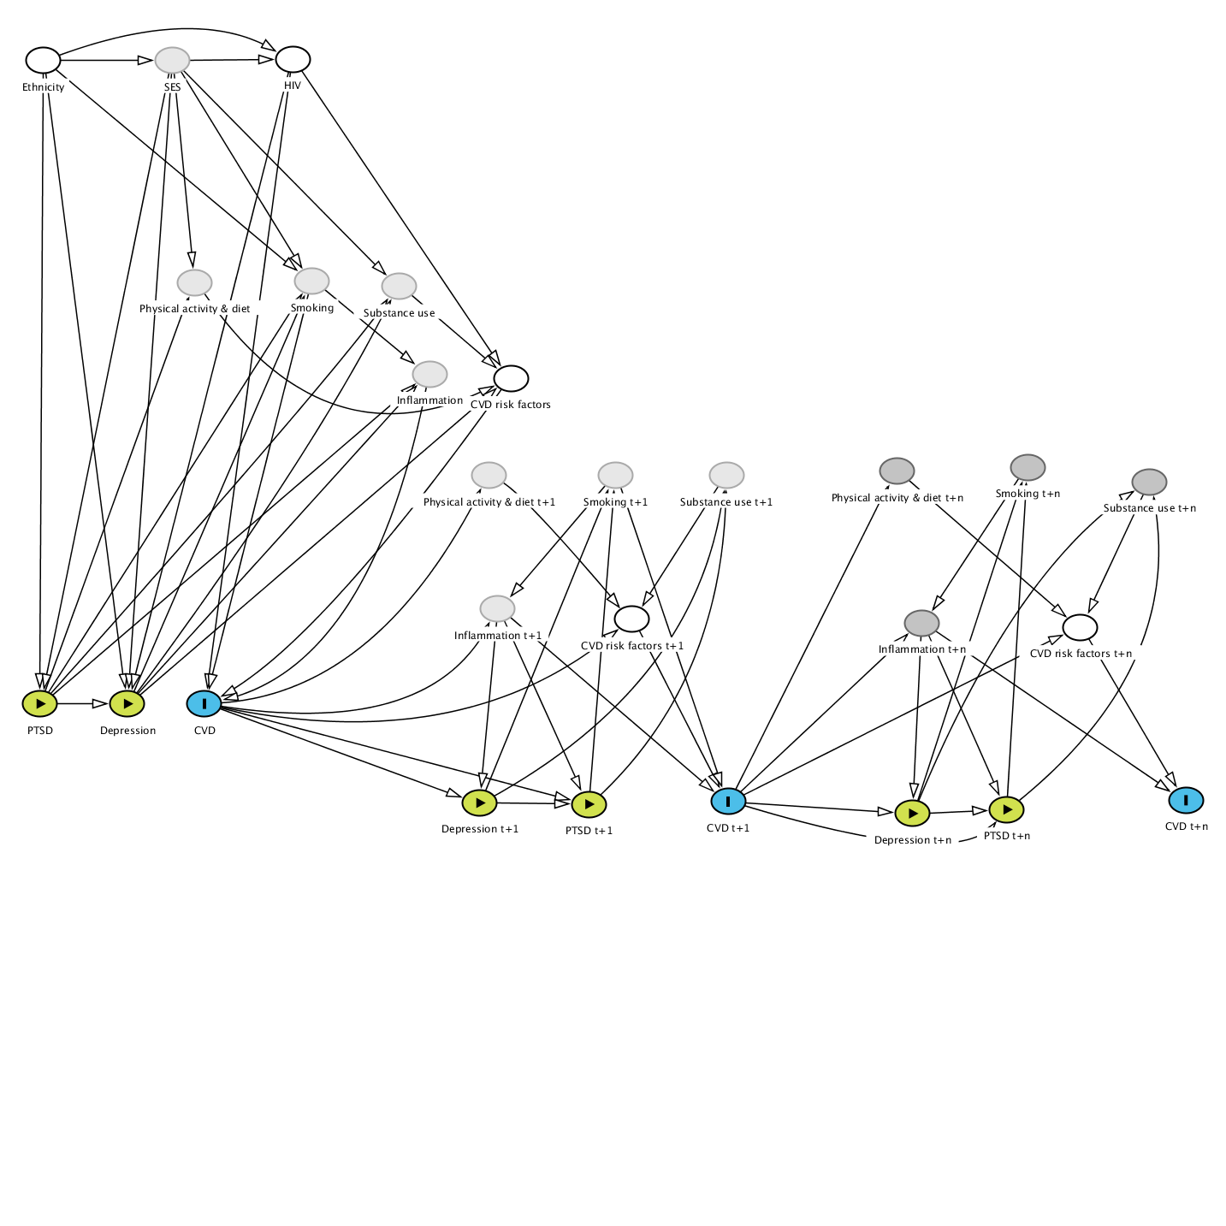

**4. References**

1. O’Donnell CJ, Schwartz Longacre L, Cohen BE, Fayad ZA, Gillespie CF, Liberzon I, et al. Posttraumatic Stress Disorder and Cardiovascular Disease: State of the Science, Knowledge Gaps, and Research Opportunities. JAMA Cardiol. 2021;6(10):1207-16.

2. Edmondson D, von Kanel R. Post-traumatic stress disorder and cardiovascular disease. Lancet Psychiatry. 2017;4(4):320-9.

3. Jacquet-Smailovic M, Brennsthul MJ, Denis I, Kirche A, Tarquinio C, Tarquinio C. Relationship between Post-traumatic Stress Disorder and subsequent myocardial infarction: a systematic review and meta-analysis. J Affect Disord. 2022;297:525-35.

4. Polimanti R, Ratanatharathorn A, Maihofer AX, Choi KW, Stein MB, Morey RA, et al. Association of Economic Status and Educational Attainment With Posttraumatic Stress Disorder: A Mendelian Randomization Study. JAMA Netw Open. 2019;2(5):e193447.

5. Assari S. Social Determinants of Depression: The Intersections of Race, Gender, and Socioeconomic Status. Brain Sci. 2017;7(12).

6. Mukong AK, Van Walbeek C, Ross H. Lifestyle and Income-related Inequality in Health in South Africa. Int J Equity Health. 2017;16(1):103.

7. Zhang YB, Pan XF, Chen J, Cao A, Xia L, Zhang Y, et al. Combined lifestyle factors, all-cause mortality and cardiovascular disease: a systematic review and meta-analysis of prospective cohort studies. J Epidemiol Community Health. 2021;75(1):92-9.

8. Mabaso M, Makola L, Naidoo I, Mlangeni LL, Jooste S, Simbayi L. HIV prevalence in South Africa through gender and racial lenses: results from the 2012 population-based national household survey. Int J Equity Health. 2019;18(1):167.

9. Hyle EP, Mayosi BM, Middelkoop K, Mosepele M, Martey EB, Walensky RP, et al. The association between HIV and atherosclerotic cardiovascular disease in sub-Saharan Africa: a systematic review. BMC Public Health. 2017;17(1):954.

10. De Hert M, Detraux J, Vancampfort D. The intriguing relationship between coronary heart disease and mental disorders. Dialogues Clin Neurosci. 2018;20(1):31-40.

11. Yuan N, Chen Y, Xia Y, Dai J, Liu C. Inflammation-related biomarkers in major psychiatric disorders: a cross-disorder assessment of reproducibility and specificity in 43 meta-analyses. Transl Psychiatry. 2019;9(1):233.

12. Salahuddin S, Prabhakaran D, Roy A. Pathophysiological Mechanisms of Tobacco-Related CVD. Glob Heart. 2012;7(2):113-20.

13. Jacquet-Smailovic M, Tarquinio C, Alla F, Denis I, Kirche A, Tarquinio C, et al. Posttraumatic Stress Disorder Following Myocardial Infarction: A Systematic Review. J Trauma Stress. 2021;34(1):190-9.