**Topic 8: Energy Matters & Environment_Going green**

Writing tasks …

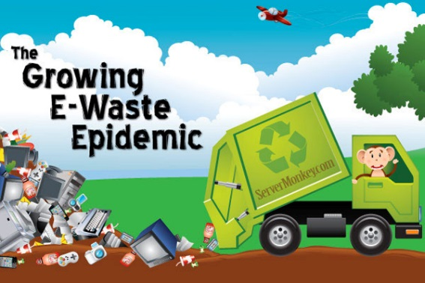

1. **A blog post about e-waste**

While cleaning up your room, you find several electronic products you no longer use. You decide to take them to a collection point so they can be recycled properly. At the collection point, you are shocked by the huge amount of discarded items. This makes you think about the challenge of how to cope with the mountains of toxic e-waste and where it all ends up. You decide to write a blog post on this topic.

In your **blog post**, you should

* describe the term e-waste and the dangers it creates for people and the environment
* analyse the reasons for the increasing amount of e-waste in our society
* suggest ways how individuals can help to reduce the amount of e-waste.

Give your blog post a title and write about 250 words.

1. **A blog post: Dumpster Diving**

You have recently found out about a new trend in your area: dumpster diving. This means looking for treasure in someone else’s rubbish; usually you find food in the garbage bins outside supermarkets. For several weeks, you have been dumpster diving yourself and found it very interesting.

You have decided to start a blog discussing this topic.



In your **blog post**, you should

* describe this new trend suggest the advantages of dumpster diving
* advise your readers about avoiding the dangers of dumpster diving
* persuade your readers to try dumpster diving

Write about 200 words and give your blog a title.

1. **A leaflet to go green**

You work as an intern in a large IT company in the USA. The company is very wasteful with resources and there seems to be no environmental policy. You decide to propose to the manager to create a leaflet for the company with suggestions for running the company in a more environmentally-friendly way.

In your **leaflet**, you should

* outline the current situation
* propose new environmentally-friendly measures
* bring forward their advantages (by estimating the costs and the long-term

financial benefits)

Divide your **leaflet** into sections and give them headings. Write about 250 words.

1. **A blog comment on environmental priorities**



<http://www.natureonline.uk>

**Should tackling climate change trump protecting nature?**

Planners have given permission for a solar farm to be built at Rampisham Down, a Site of Special Scientific Interest in West Dorset, England. However, nature experts have attacked the decision which would involve tens of thousands of panels being built on protected, wildlife-rich grassland. Is stopping biodiversity loss as important as stopping global warming?

**Tell me what you think below.**

A prominent environmentalist has published the above blog post and asked his readers for their thoughts.

Write a **blog comment**, in which you

* speculate about the impact the solar panels will have
* compare and contrast the need to tackle climate change with the need to protect wildlife
* explain and justify the decision you would have made if you had been on the planning team.

Write about 250 words.

1. **Article**

Write an **article** for the Austrian Energy Agency (AEA) to publish on their English website explaining why Austria does not have any nuclear power plants. Research your article on the internet.

You should

* describe the current situation
* give a brief account of historical developments
* explain public opinion on the issue
* make a prediction for the future

Write 250 words. (The LanguageBox in Best Shots 4/5, p.178 may help you).

