**The Favorites page**

The favorites page contains a table of the favorite products of the user, together with information about these products. For each one of the favorite products, the page shows the product’s name and its price. The layout of the page is created by using the *table* tag of HTML5 and *tr* and *td* tags to declare the rows and the content of all the cells of the table. A user can visit the favorites page when he/she clicks on the small heart shown on the right side of the header of all pages.

A screenshot of the page is shown in the following figure:

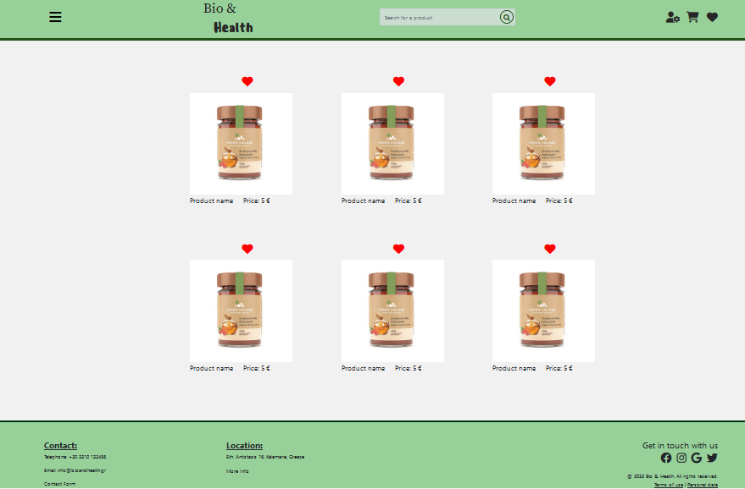

When the user clicks on the picture of a products, then the page containing detailed information about the program appears, as it is described below.

**The product information page**

The product information page contains detailed information about a product, as is shown in following figure:

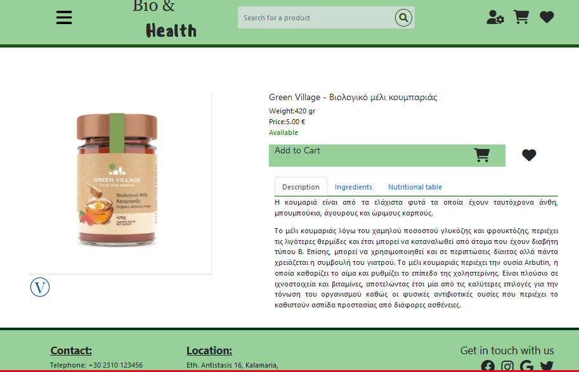

The information contains the product’s picture on the left side and other useful information about the product on the right side. For every product, the information depicted contains elements like the product’s name, the weight and the price of the product, together with the description, the ingredients and the Nutritional table of the product. This information is shown in a tabbed layout, so that the user has to select the name of a tab in order to read the related information.

The user can click the cart picture to add the product to the cart or the heart picture in order to add the product to the favorites or to remove it from the favorites list. The layout of the page was developed by using the Bootstrap library and the same library was used to create the tabs that contain the information.

