1
a)
Inserting F B T Z R V U J P into an initially empty table with separate chaining and the hash function h(k) = (13*k) % 5 will give the following result:
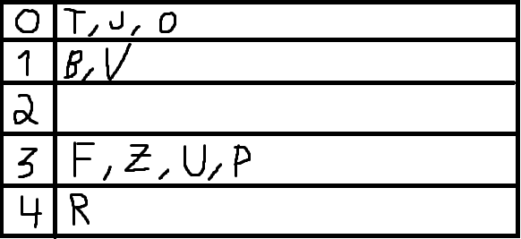

b)Inserting F B T Z R V U J P into an initially empty table with linear probing and the hash function h(k) = (13*k) % 5 will give the following result:

