# Manual Setup

We recommend you install as Administrator if you encounter any issues. To do that, save the installer to disk, then use your right-mouse button to choose “Run as Administrator”. That will usually fix most issues. Especially when running into issues on Vista.

You should see the EntitySpaces Add-In for Visual Studio under the Visual Studio “Tools” menu listed as “EntitySpaces”. If you do not see it there after installing EntitySpaces 2010 the fix is easy, just follow these simple steps.

* Within Visual Studio choose “**Tools**” and then “**Options**” to show the options window (shown below)

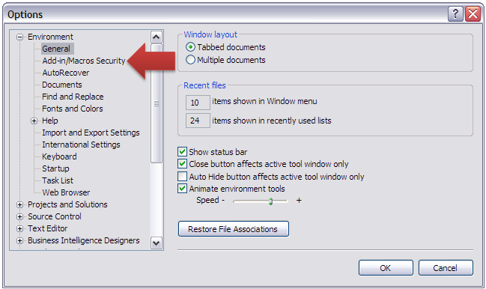

* Now select the “**Add-in/Macros Security**” node and you will see the Add-In paths (shown below)

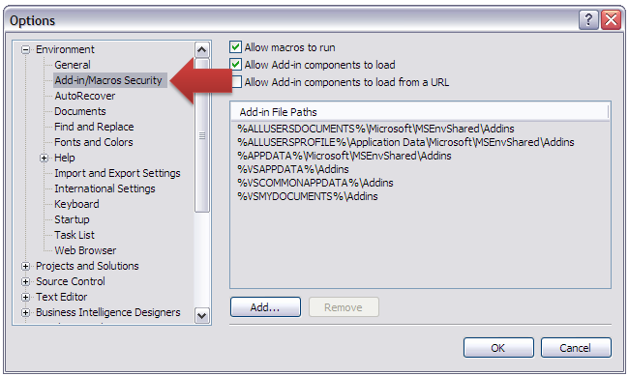

* Click on the “**Add …** ” button and add a path to the “**EntitySpaces.AddIn**” file. If you accepted the default installation this would be in your “**C:\Program Files\EntitySpaces 2010\CodeGeneration\Bin**” folder on a Windows XP machine (shown below)

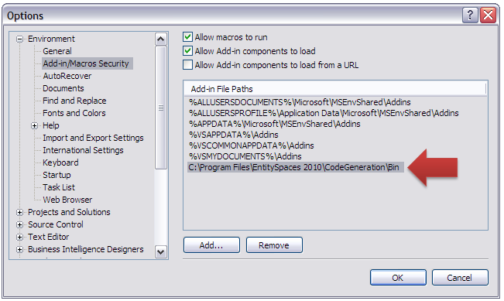

* Click “OK”.
* Now close and restart Visual Studio and you should see “EntitySpaces” under the “Tools” menu.