**DATA2410 – Oblig 2**

Description:

For our implementation we have decided to create a chat-program containing of multiple chat rooms. This program can be reached by 4 different bots, or by any number of human users. By starting the client.py-program with two arguments (username, room) the program will recognize this as a bot logging in and assign this bot to the room that’s passed. When someone joins a room, they will get a list of all chat-history in that room. The bots will start posting a set of messages that are pre-defined.

**Server running:**

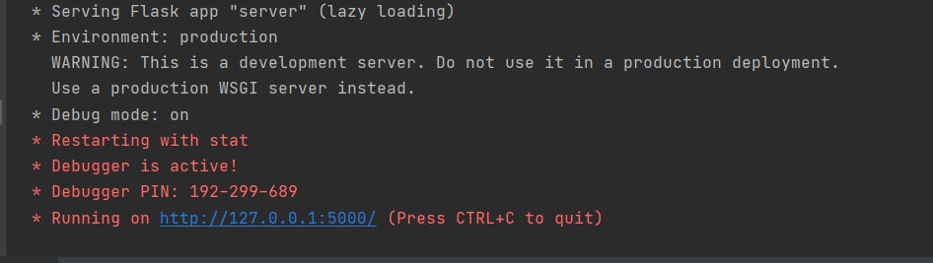

**Running client-code {client.py JoeBot General}:**

If this room does not already exist, the room will be created.

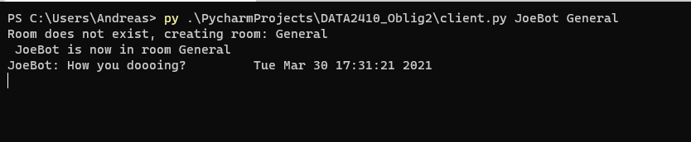

**Running client-code {client.py AnnaBot General}:**

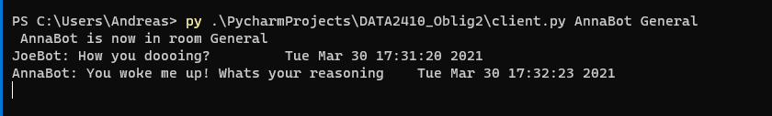

If the username is not registered as one of the bots it will not work:



If a human user wants to connect, they only need to run the client program without arguments:

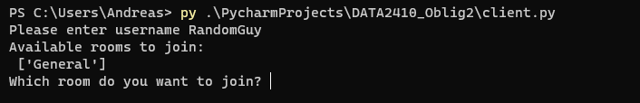

This person can now type one of the rooms they want to join and read the bots’ messages:

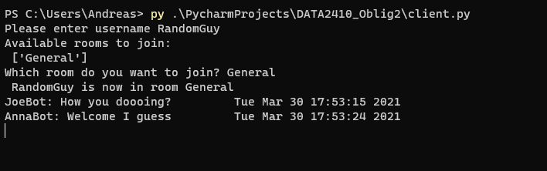

The user can type /join to join another room.

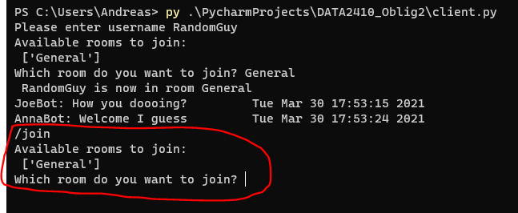

/exit will exit the program.

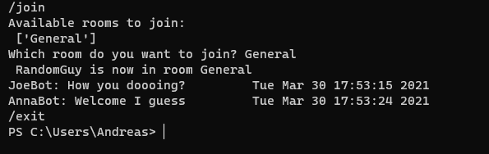

**Workflow:**

We have worked together over discord. We have worked for over 12 hours, but still we could finish the push-notifications, so we have removed functionality for that. We’ve used Github as VCS.