CAN – Bus
Quelle: https://docs.arduino.cc/learn/communication/can/
Im Unterricht wird folgende Library für die Arduino 2560 in Verbindung mit den MCP2515 Boards verwendet:
https://github.com/sandeepmistry/arduino-CAN
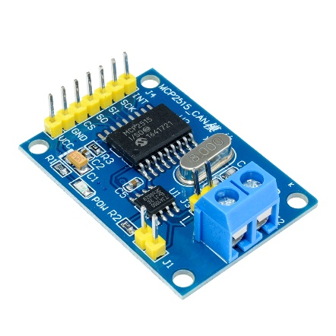
Suche der Library in Arduino Studio: „CAN by Sandeep Mistry“

Introduction
Controller Area Network (CAN) is a robust and versatile communication protocol that can be used to send data between an Arduino board and other devices in a networked environment without a host computer. Originally developed by Bosch for automotive applications, CAN bus offers advantages in scenarios demanding robust, noise-resistant, and error-checked data transmission.

History of CAN
The CAN bus, or Controller Area Network, was developed by the German company Bosch in the 1980s. Its primary purpose was to streamline communication within vehicles, enabling various microcontrollers and devices to communicate with each other without the need for a central host computer. This innovation significantly enhanced the efficiency and reliability of automotive systems, allowing for real-time data exchange and coordinated control across different vehicle components. CAN's robustness and noise immunity made it particularly suitable for harsh environments such as cars.

How CAN Works
CAN operates by transmitting data through a structured series of bits called frames. These frames ensure reliable and efficient communication between nodes on a network by encapsulating various fields that serve specific purposes such as message identification, data transmission, and error checking.

Shared Bus and Absence of a Central Master Node
One of the unique features of a CAN bus system is its use of a shared communication bus without a central master node. Instead, it operates on a decentralized protocol, where each node on the network has equal rights and can initiate communication as needed. This architecture enhances reliability because there isn't a single point of failure. Each node can communicate directly with any other node on the bus, making the system both flexible and scalable.

Differential Signaling
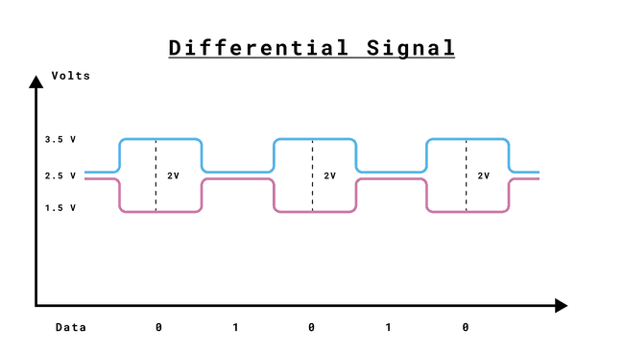
CAN uses a differential signal scheme, meaning data bits are represented by the difference in voltage between two wires: CAN_H (CAN High) and CAN_L (CAN Low). This differential nature makes CAN highly resistant to electrical noise, ensuring robust communication over long distances and in noisy environments typical of automotive and industrial applications.

Practical Example: CAN in Automotive Systems
Imagine a modern car where multiple sensors and actuators are connected throughout the vehicle. These include components such as the Anti-lock Braking System (ABS), Engine Control Unit (ECU), and various sensors for monitoring engine performance or temperature. To connect all these devices, a significant number of wires run across the car, often in close proximity to high-power electrical systems like the ignition system or the alternator.
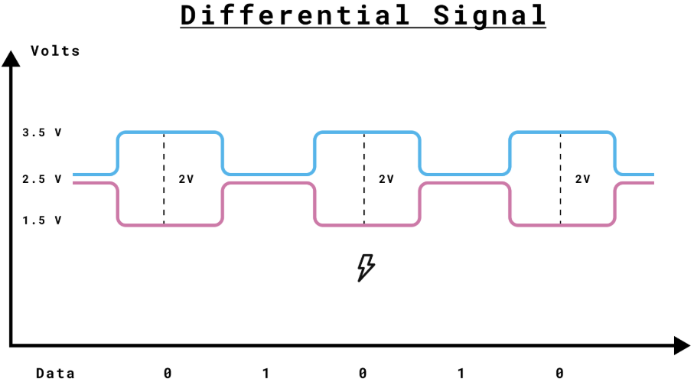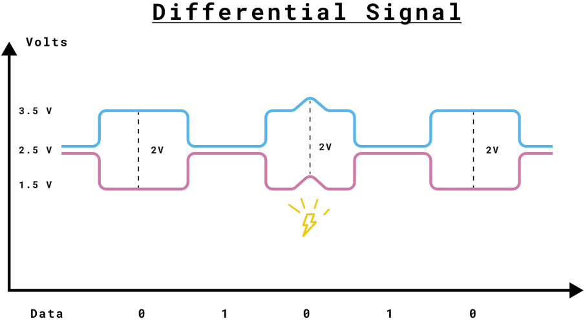
Even if the CAN signal is increased, decreased, or corrupted by external noise, the difference between CAN_H and CAN_L remains the same, preserving the integrity of the communication.

Ground Wire Considerations
Technically, CAN's differential nature means that a ground wire is not strictly necessary for data transmission, as the data is conveyed through the voltage difference between CAN_H and CAN_L. However, in practical applications, it is advisable to include a ground wire for the following reasons:
- Common Ground Potential: Including a ground wire helps keep all nodes in the CAN network at a similar ground potential, reducing the risk of large ground potential differences, which can cause issues with the physical layer transceivers.
- Safety and Reliability: In an automobile, the chassis often serves as the common ground, ensuring that all devices operate at compatible voltage levels, reducing the chance of communication errors and improving overall system stability.

Example of Collision and How CAN Handles Bus Arbitration
CAN bus uses a non-destructive bitwise arbitration method to handle collisions. When two nodes attempt to send messages simultaneously, the node with the highest priority (lowest CAN ID) wins, and the other node backs off and retries.

CAN Frame Structure
Each CAN message is encapsulated in a frame made up of several fields:

Frame Format
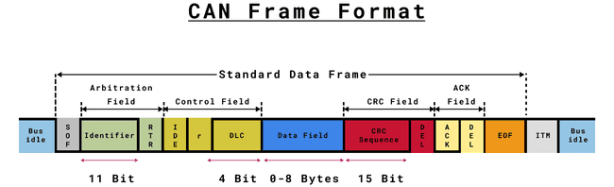

Standard and Extended CAN IDs
CAN frames come in two formats: Standard and Extended. The primary difference between these two formats is the length of the identifier field.
- Standard CAN ID: Uses an 11-bit identifier, allowing for 2,048 unique message IDs.
- Extended CAN ID: Uses a 29-bit identifier, offering a significantly larger address space with 536,870,912 unique message IDs.

Termination Resistors
Termination resistors are essential for the proper functioning of a CAN bus network. These resistors prevent signal reflections that can cause communication errors. Typically, a 120-ohm resistor is placed between CAN_H and CAN_L at each end of the bus.

Connecting Termination Resistors
To add termination resistors, connect a 120-ohm resistor between the CAN_H and CAN_L lines at both ends of the CAN bus. This ensures that the electrical signals are properly terminated, preventing reflections and maintaining signal integrity.
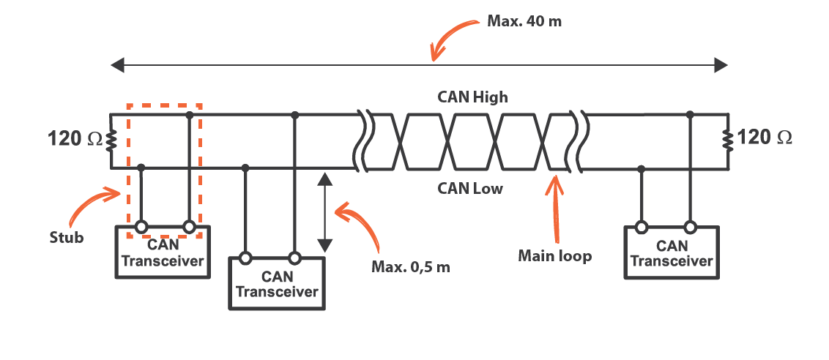

Advanced Information

CAN Frame Description
A typical CAN frame consists of the following fields:
1 | Start of Frame (SOF) | Marks the beginning of the frame with a dominant bit, synchronizing all nodes to the start of the message.
2 | Arbitration Field | Identifier: A unique value used to identify the message and determine its priority during arbitration.  RTR (Remote Transmission Request): Differentiates between data frames and remote frames (requests data).
3 | Control Field | IDE (Identifier Extension): Indicates whether the identifier field is standard (11 bits) or extended (29 bits).  r (Reserved bit): Reserved for future use, should always be dominant.  DLC (Data Length Code): Specifies the number of bytes of data (0 to 8 bytes).
4 | Data Field | Contains the actual payload data, from 0 to 8 bytes.
5 | CRC Field | CRC Sequence: Holds the Cyclic Redundancy Check value for error detection.  CRC Delimiter (DEL): A single recessive bit separating the CRC field from the acknowledgment field.
6 | ACK Field | ACK Slot: Indicates successful receipt of the message by setting a dominant bit.  ACK Delimiter (DEL): Follows the acknowledgment bit and is recessive.
7 | End of Frame (EOF) | Consists of seven recessive bits marking the end of the frame.
8 | Interframe Space (ITM) | A period of bus inactivity between consecutive data frames ensuring the bus is idle before the next message.

These structured fields enable CAN to provide robust and error-resilient communication, making it highly suitable for automotive and industrial applications where reliability is crucial.

Timing and Synchronization
Timing and synchronization are crucial aspects of CAN communication. Unlike synchronous serial protocols such as SPI and I2C, CAN operates asynchronously, meaning it doesn't rely on a shared clock signal. Instead, it uses predefined bit rates to determine the timing of data bits.

Bit Timing Phases
Despite being asynchronous, CAN ensures precise timing synchronization between nodes through a mechanism called bit timing, which consists of the following phases:
- Sync Segment: Used for synchronizing nodes. All nodes recognize the start of a message by identifying the transition from a recessive to a dominant bit.
- Propagation Segment: Accounts for physical delay times within the network.
- Phase Segment 1 (PS1): Helps compensate for phase edge errors.
- Phase Segment 2 (PS2): Provides further compensation for phase errors.
Bit timing is divided into Time Quanta (TQ), which are the smallest units of time in CAN communication. The total number of TQ in a bit period defines the bit timing, adjusted to ensure high reliability in communication.

