My Research Paper

A. Researcher

2023/06/06

# Extended Abstract

This is an example of a research pipeline. The original data covered 36 individuals. The subset, in which we focused on the female sex contained 17 individuals. The mean income for this group was 33823.53 units. We can also use citations in this pipeline, for example as part of a literature review or discussion (Andersson 2004).

# A Figure

That is the relation between income and age for the studied female subset:

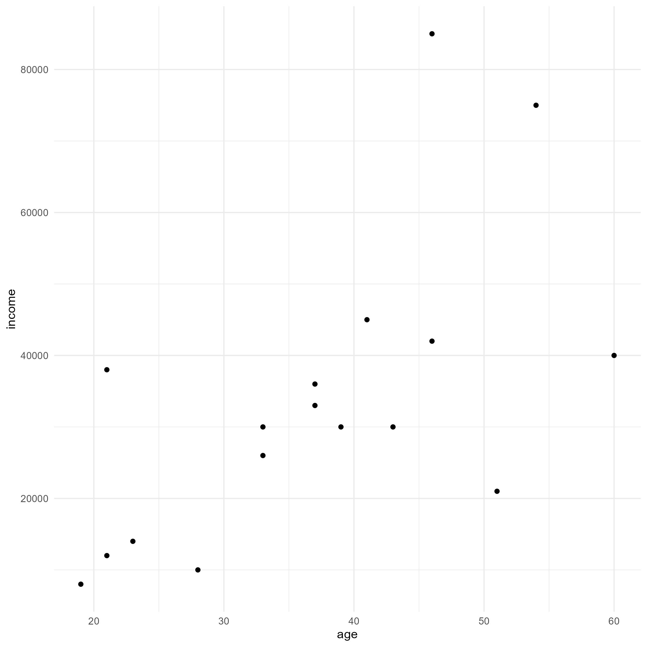

Figure 1: This is a long title for which we split over two lines in our code to meet code formatting requirements.

# A Table Example

And that’s a table for the subset.

Table 1: Overview of the Study Population. Another long title which we split over two lines in our code.

| Summary | Value |
| --- | --- |
| Individuals | 17 |
| Mean Age | 37.18 |
| Mean Income | 33823.53 |

# References

Andersson, G. (2004). Childbearing after migration: Fertility patterns of foreign-born women in sweden. *International migration review*, *38*(2), 747–774.