Hello R Markdown
John Doe
27.10.2021

An Example of an Output
This is an example where we pull on objects which we created previously in a sourced analysis file. And this is actually a quote (Andersson 2004).
The original data set contained 36 individuals. We carried out an analysis of 19 individuals. The mean income for this group was 38250.00 units.

A Figure Example
That is the relation between income and age for the subset:
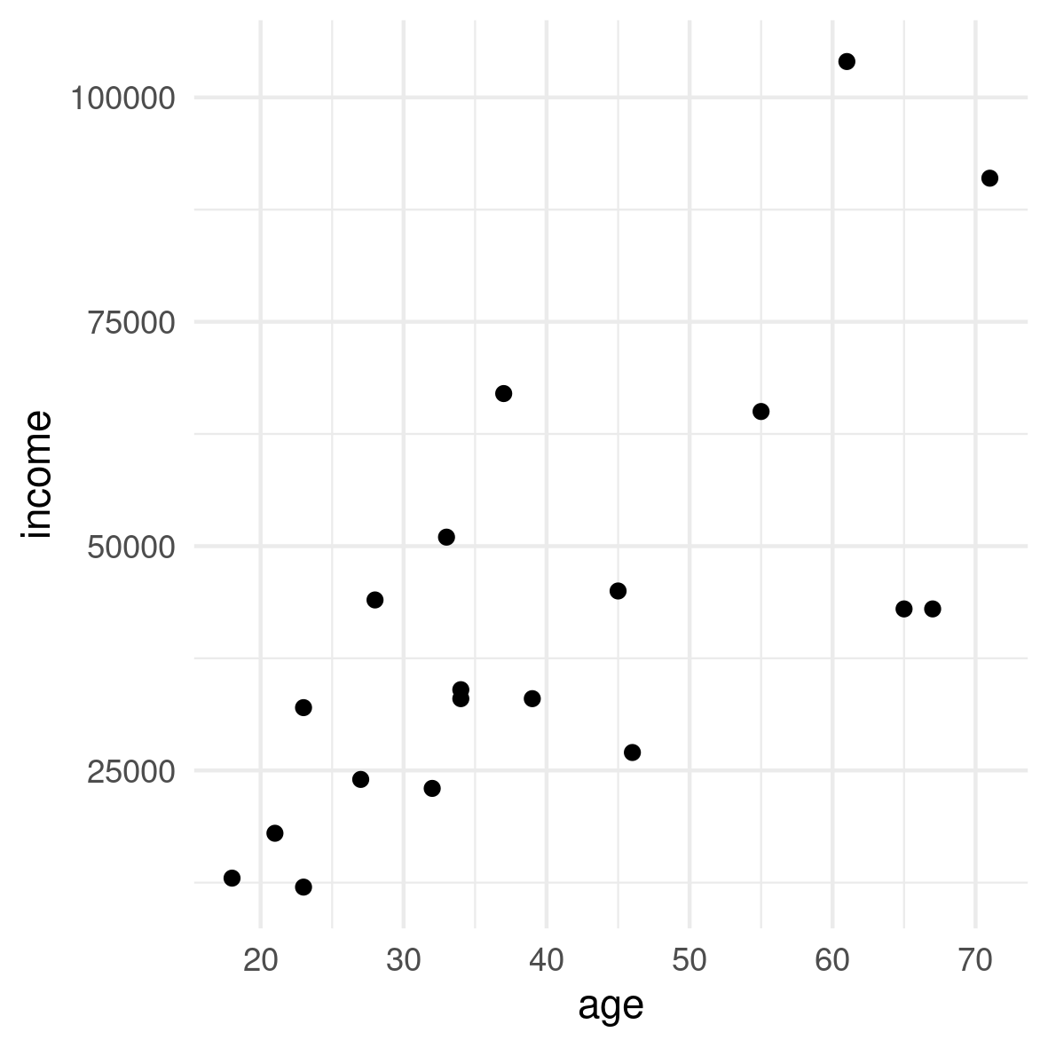
Figure 1: This is a very long title for plot number and this is why we split the line when we code it. In the manuscript there won’t be any line breaks.

A Table Example
And that’s a table for the subset.
Table 1: Overview of the Study Population. A title that suddenly became quite long as well suddenly.
Summary | Value
Individuals | 19
Mean Age | 39.95
Mean Income | 42210.53

References
Andersson, G. (2004). Childbearing after migration: Fertility patterns of foreign-born women in sweden. International migration review, 38(2), 747–774.

