View Creation for DCA_Padel_Club

View Single Booking Details

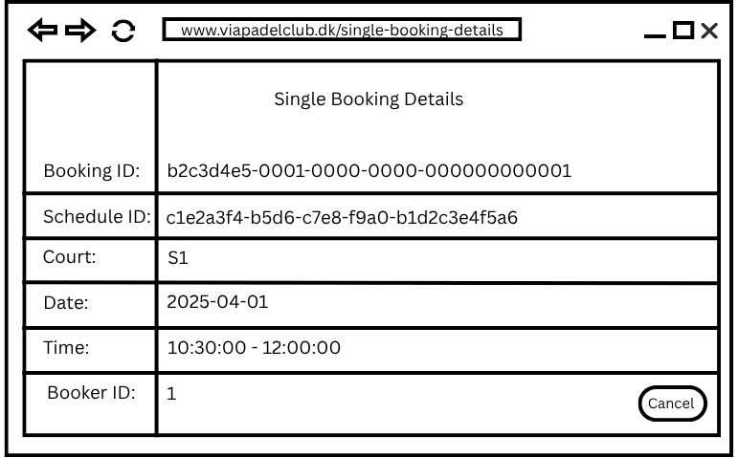

Description
Here the manager can see details about a single booking.
We can see details about:
Booking ID, Schedule ID, Court , Date, Time and the Booker ID which reserved the court.
The manager is also allowed to cancel the booking in advance before 24 hours in case of an emergency or issues with the booker.

