**Raport Laborator 5**

**The 8-puzzle problem:**

I implemented the Manhattan distance heuristic function for the 8-puzzle problem. It calculates the distance between two points with the formula abs(x1 - x2)+ abs(y1 - y2). I am using s/3 and s%3 to transform the number at which the point is found in the list in x1,y1. I attach a screen with the implementation, in the code there are also attached comments.

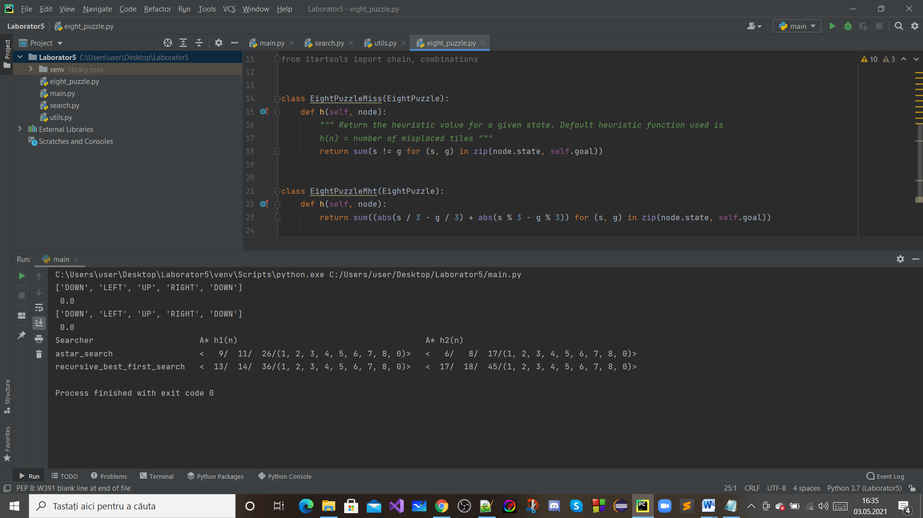

**Fig.1- Implementarea functiei**

I overwrote the h method to return the sum of the Manhattan distances of all plates related to the target state.

Using the code main.py, I try to compare different heuristic functions for the problem with 8 puzzles. I attach a screen with the implementation.

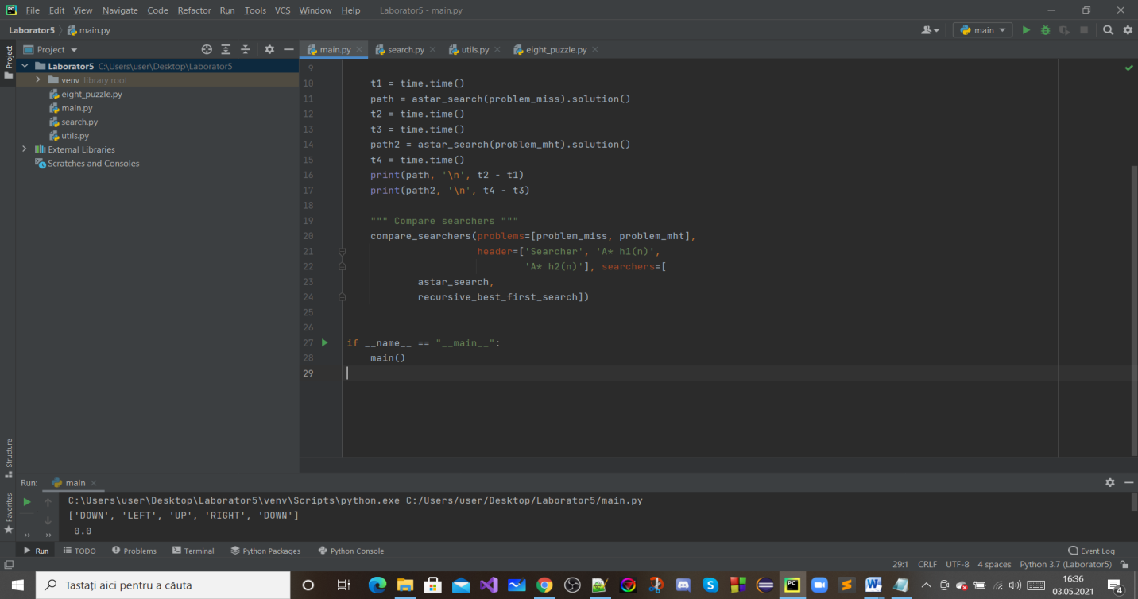

**Fig.2- main.py for 8-puzzle problem**

The output represents the list of moves to achieve the goal for each heuristic, the time it takes to solve the problem for each heuristic and the comparison using compare_searchers function. I attach a screen with the run test ( results ).

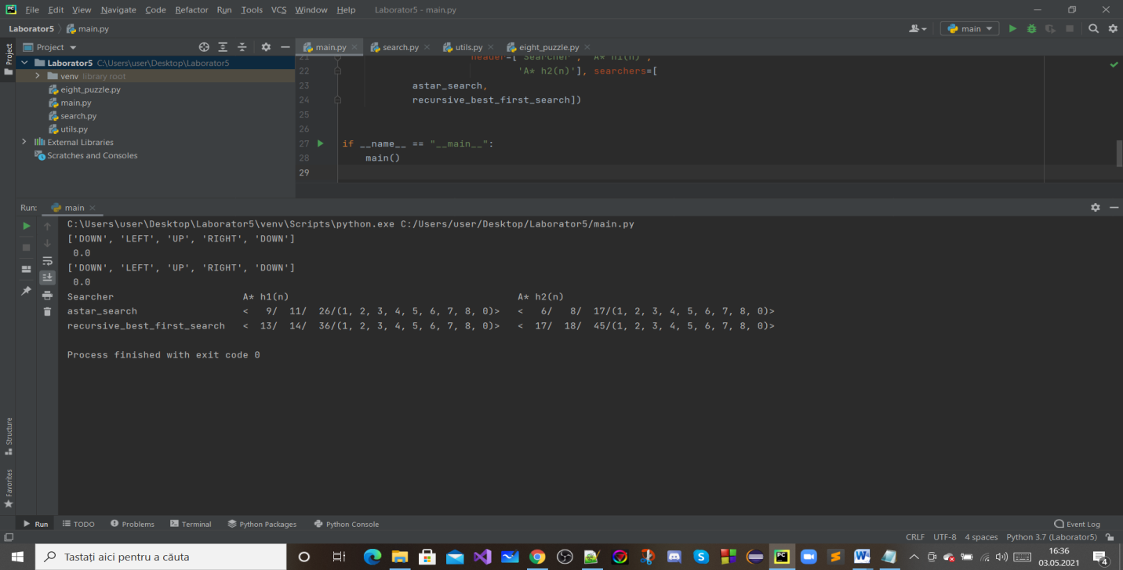

**Fig.3- run test**

**The 15-puzzle problem:**

For this problem i have adapted the EightPuzzle class to the Puzzle15 class by changing the numbers. For example in the actions function i have modified the numbers so it can work on the 15-puzzle by using %4 instead of %3 and so on.

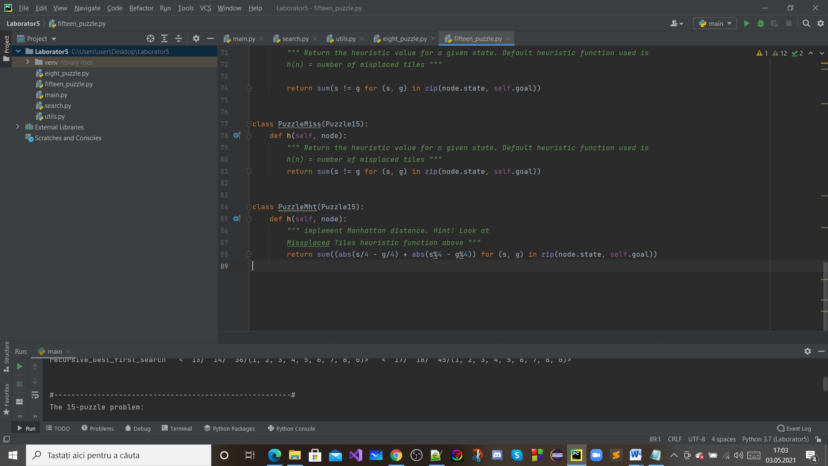

**Fig.4-Implementarea functiilor**

**Misplaced:** It counts the number of misplaced tiles.

**Manhattan Distance:** It calculates the distance between two points with the formula abs(x1 - x2) + abs(y1 - y2).I am using s/4 and s%4 to transform the number at which the point is found in the list in x1,y1.

Using the code main.py, I try to compare different heuristic functions for the problem with 15-puzzles. I attach a screen with the implementation.

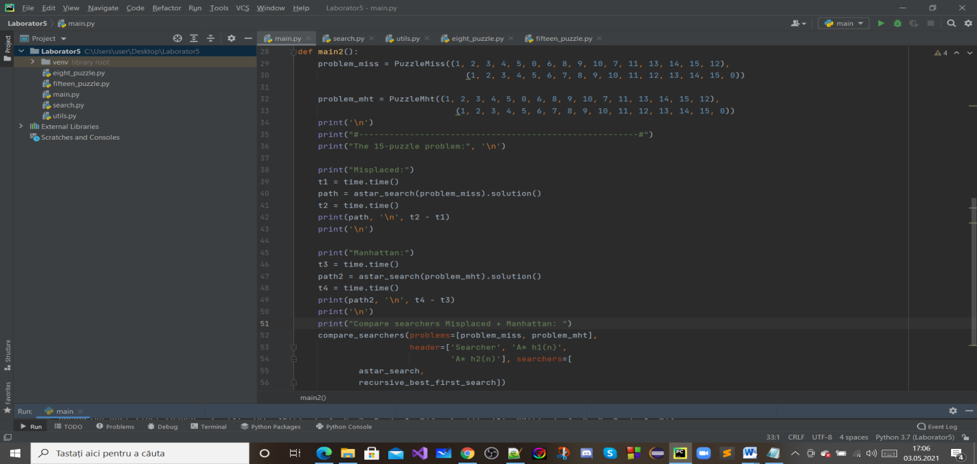

**Fig.5- main.py for 15-puzzle problem**

The output represents the list of moves to achieve the goal for each heuristic, the time it takes to solve the problem for each heuristic and the comparison using compare_searchers function. I attach a screen with the run test ( results ).

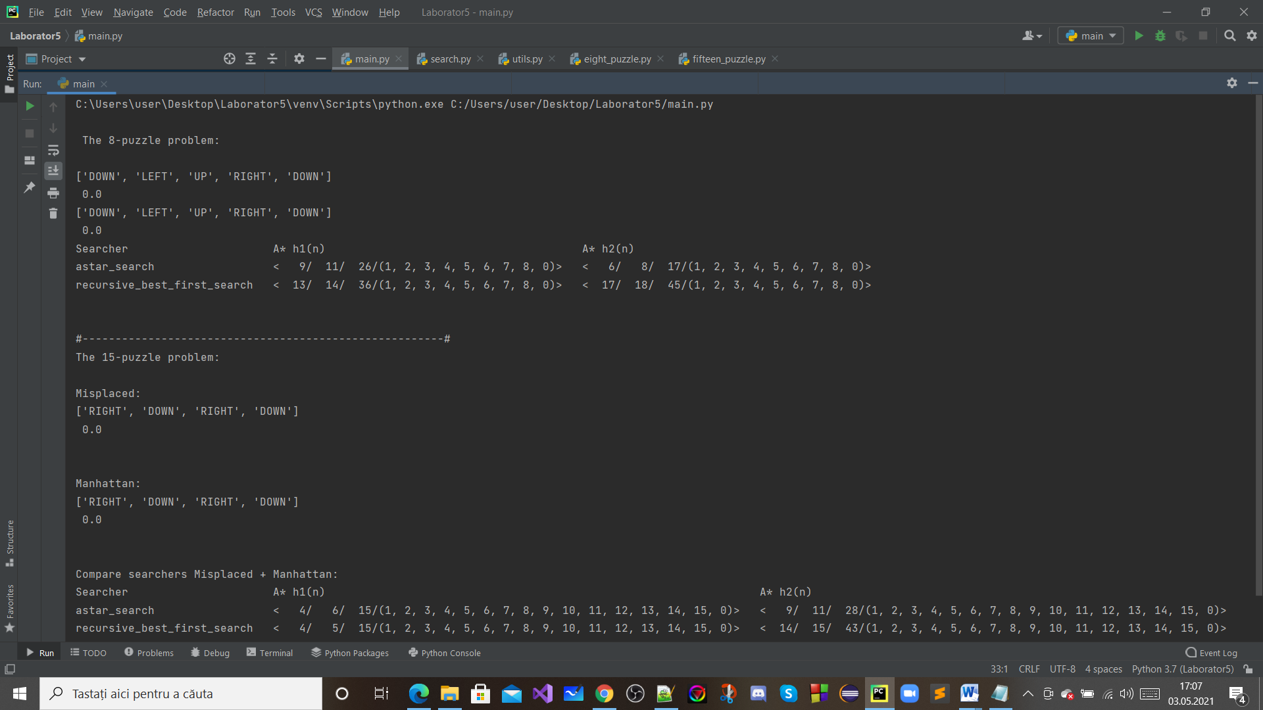

**Fig.6- run test**