# Lucrarea de Laborator nr.5 Databases and the Doctrine ORM

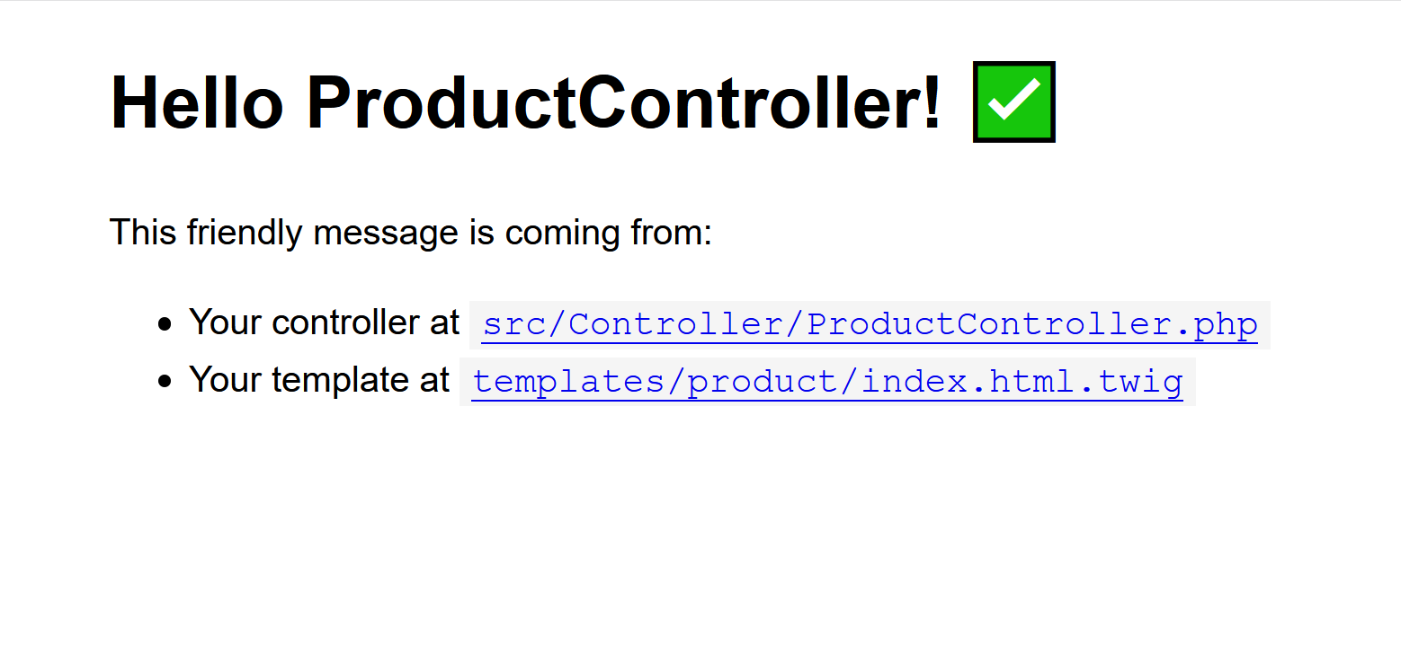

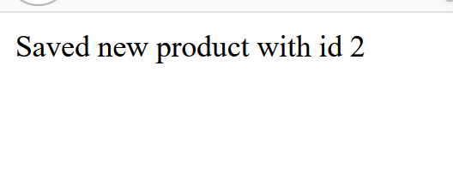  
<http://localhost:8000/product>

## **Fetching Objects from the Database**

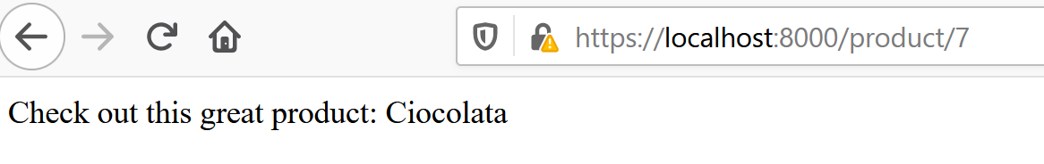

<https://localhost:8000/product/7>

## **Updating an Object**

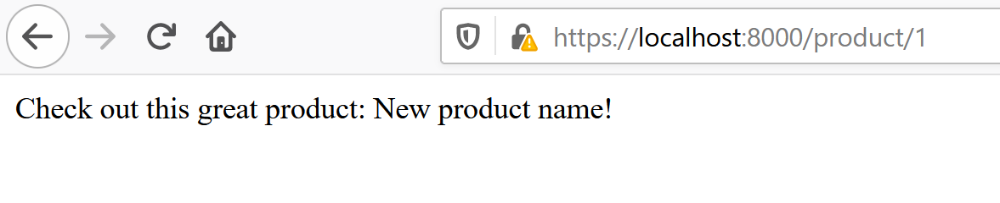

<https://localhost:8000/product/edit/1>

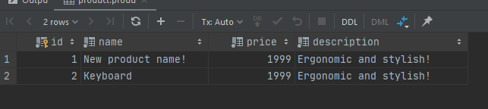

## **Deleting an Object**

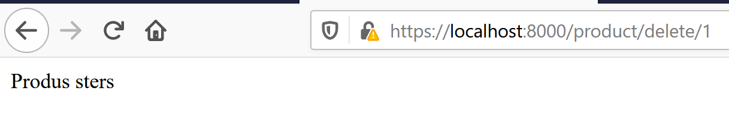

<https://localhost:8000/product/delete/1>

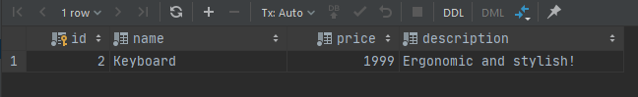

### **Querying for Objects: The Repository (Querying with the Query Builder)**

  
pretul mai mare ca 50