**TENNIS EXCHANGE (MARKET OFFERING & RULES)**

**Match Odds (UK):** *Who will win this match? At the start of play all unmatched bets will be cancelled and this market will be turned in-play. If the first set is not completed all bets on this market will be void.*

**(ITA) Match Odds:** *Who will win this match? If a player withdraws before the end of the match, all bets will remain unchanged. If a player withdraws before taking the field, all bets will be void.*

**Set Betting (UK):***What will be the set score in this match? If a player retires before the completion of the match all bets will be void.*

**(ITA) Set Betting:***The bet consists in predicting the exact score (expressed in sets) with which the match will end. If a tennis player withdraws before taking to the court or during the match, accepted bets will be refunded.*

**Set 1 Winner (UK):** *Who will win the stated set in this match? If the stated set is not completed all bets on this market will be void.*

**Set 2 Winner (UK):** *Who will win the stated set in this match? If the stated set is not completed all bets on this market will be void.*

**Handicap (UK):** *Who will win this match with the game handicap applied?**If a player retires before the completion of the match all bets will be void.*

**Total Games (UK):** *How many games in total will be played in this match? If a player retires before the completion of the match all bets will be void.*

*If a player or pairing retires or is disqualified in any match, the player or pairing progressing to the next round (or winning the tournament in the case of a final) will be deemed the winner. However if less than one set has been completed at the time of the retirement or disqualification then all bets relating to that individual match will be void.*



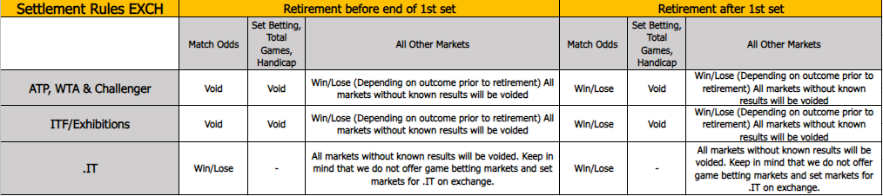

**Market Offering**

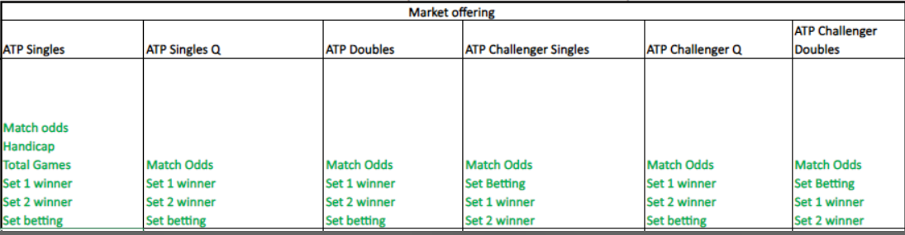

**Betradar Exceptions**

**Retirement 1st set**

[**https://livedataclient.betradar.com/matches/44695132**](https://livedataclient.betradar.com/matches/44695132)

**Retirement 2nd set**

[**https://livedataclient.betradar.com/matches/44687186**](https://livedataclient.betradar.com/matches/44687186)

**Walkover/Cancelled**

[**https://livedataclient.betradar.com/matches/44723960**](https://livedataclient.betradar.com/matches/44723960)

**Not covered\*** (we have not an example yet)

**Coverage abandoned\***

[**https://livedataclient.betradar.com/matches/44731186**](https://livedataclient.betradar.com/matches/44731186)

*For these situations we need to have an alert for tracking the event