Cheile din Dictionar:

EventName

EventId

Event\_Schedule

MatchOdds\_inPlay

MatchOdds\_MarketId

MatchOdds\_HomeRunnerName

MatchOdds\_HomeRunnerSelectionID

MatchOdds\_AwayRunnerName

MatchOdds\_AwayRunnerSelectionId

MarketTemplateType (Classic/Extra)

MatchOddsItaly\_MarketId

MatchOddsItaly\_HomeRunnerSelectionID

MatchOddsItaly\_AwayRunnerSelectionId

Set1Winner\_MarketId

Set1Winner\_HomeRunnerName

Set1Winner\_HomeRunnerSelectionId

Set1Winner\_AwayRunnerName

Set1Winner\_AwayRunnerSelectionId

Set2Winner\_MarketId

Set2Winner\_HomeRunnerName

Set2Winner\_HomeRunnerSelectionId

Set2Winner\_AwayRunnerName

Set2Winner\_AwayRunnerSelectionId

SetBetting\_MarketId

SetBetting\_Home2-0SelectionId

SetBetting\_Home2-1SelectionId

SetBetting\_Away2-0SelectionId

SetBetting\_Away2-1SelectionId

Additional keys from Betradar:

betradarID

playerOne

playerTwo

scheduledTime

status

match\_status

home\_score

away\_score

home\_runnerId

away\_runnerId

winner\_id

console\_action\_type(TIP, )

set1\_winner(home/away)

number\_of\_sets

Tipurile de mesaje ce vin din Betradar:

Cand inca nu a inceput

Machine generated alternative text:
qualifier= " away 
<reference ids> 
<reference id 
< / competitor > 
competitors > 
(venue venue: 58984" 
(venue venue: 58984" 
value= 
country_code— 
country_code— 

About to start

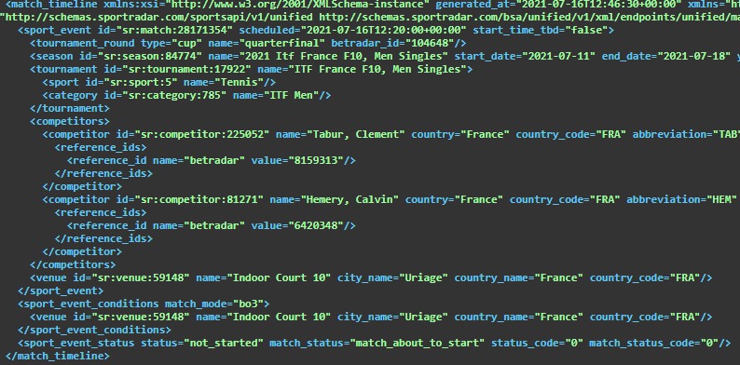

Cand deja joaca al2lea set

Machine generated alternative text:
compet itors> 
(venue 
match 
mode= "b03" > 
<venue 
3" 
c ity_nane— 
c ity_nane— 
" 2nd_ 
time= 
tine— 
tine— 
tine— 
tine— 
tine— 
tine— 
set" 
(timeline> 
(event it-"931197716 
" started" 
(event it-"931197718" 
(event it-"931199694" 
(event 
(event 
(event 
(event it-"931210244 
type=" period_ 
type=" period_ 
co unto' _name= Portugal " 
co unto' _name= Portugal " 
away _ 
: 48 
: 44*ea. 
: 54: 47+03: •e " 
start" 
score" 
score" 
score" 
score" 
score" 
2a21-e7-e8Ta8 
-"2a21-e7-e8Ta8 
-"2a21-e7-e8Ta8 
-"2a21-e7-e8Ta8:57 :12+ea 
home 
home 
home 
home 
home 
set" 
away _ 
away _ 
away _ 
away _ 
away _ 

Cand deja e finished

Machine generated alternative text:
competitors > 
<venue 
< / sport_event) 
match 
mode= "b03" > 
<venue 
match 
match status 
away _ score= "4" 
away _ score = " 
away _ score= "6 " 
"Nur-SuItan" 
"Nur-SuItan" 
hone 
type= " regular_period" 
type= " regular_period" 
" sr : competitor: 50915" 
match status 
match status 
match status code— 
set" 
status 
<event 
<event it-"931128582" 
<event it-"931129226" 
started" 
type=" period_start" 
type=" period_score" 
time= 
tine— 
tine— 

Tot cand e deja finished

Machine generated alternative text:
< sport_event > 
<venue id="sr:venue:33922" 5" 
status="ended" 
match_status="ended" 289B3 
" status 

Cand ii intrerupt

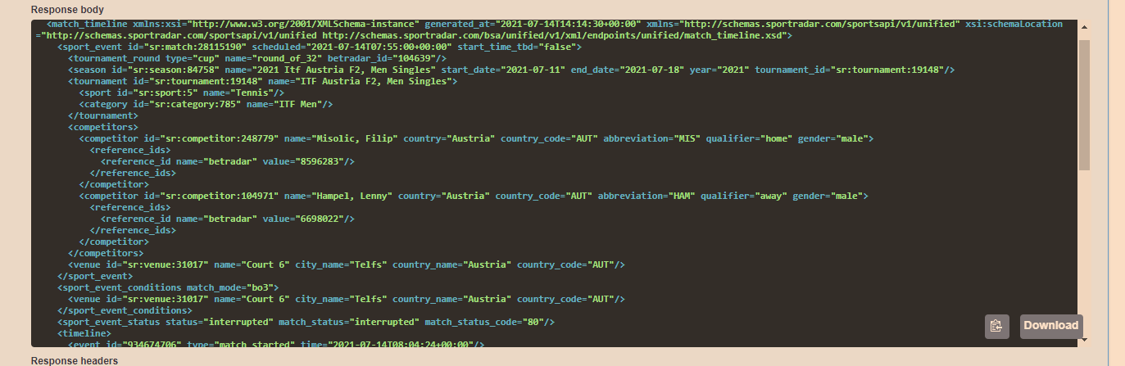

Cand cineva s a retras

Machine generated alternative text:
<cc.mpetitor competitor : 287625" 
<reference ids> 
(reference id 
< / competitor> 
competitors> 
(venue venue: 31623" 4" 
{venue 4" 
away _ 
Cuyper, Julien" 
co nce" 
co nce" 
abbreviation= "DE 
count " FRA" / > 
count " FRA" / > 
:213168" > 
(timeline> 
{event 
started" 
time= 

Special situation - coverage abandoned, match\_status not present in the HTTP response:

Machine generated alternative text:
<venue id="sr:venue:43688" 4" city_name="Les Contamines-Montjoie" 
< sport_event > 
<venue id="sr:venue:43688" 4" city_name="Les Contamines-Montjoie" 
period=-ø" 
" France" 
" France" 

Abandoned:

<venue id="sr:venue:43678" 3" city_name="Les Contamines-Montjoie" 
natch timeline> 

Match Ids din Betradar:

Match status ID:

<match\_status id="0" description="Not started">

<match\_status id="8" description="1st set" period\_number="1">

<match\_status id="9" description="2nd set" period\_number="2">

<match\_status id="10" description="3rd set" period\_number="3">

<match\_status id="11" description="4th set" period\_number="4">

<match\_status id="12" description="5th set" period\_number="5">

? <match\_status id="20" description="Started">

<match\_status id="22" description="About to start">

? <match\_status id="35" and "36" description="Awaiting penalties">

? <match\_status id="51" and "52" description="Penalties">

<match\_status id="61" description="Start delayed">

<match\_status id="70" description="Cancelled">

<match\_status id="80" description="Interrupted">

<match\_status id="81" description="Suspended">

<match\_status id="90" description="Abandoned">

<match\_status id="91" description="Walkover">

<match\_status id="92" description="Retired">

<match\_status id="93" description="Walkover, player 1 won">

<match\_status id="94" description="Walkover, player 2 won">

<match\_status id="95" description="Player 1 retired, player 2 won">

<match\_status id="96" description="Player 2 retired, player 1 won">

? <match\_status id="99" description="Only Result">

<match\_status id="100" description="Ended">

? <match\_status id="111" description="AOT">