Лабораторная работа 3. Андреев Степан ПМИ-32

1. Выборка из одной таблицы.
1.1
- Сортировка клиентов по названию фирмы по возрастанию и ID по убыванию
SELECT * FROM Client
ORDER BY company_name ASC, ID DESC;
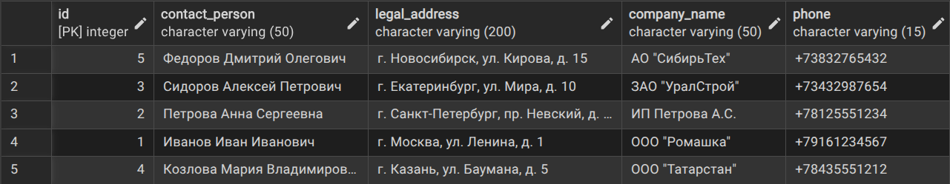

- Сортировка кредитных договоров по сумме (по убыванию) и дате начала (по возрастанию)
SELECT * FROM Credit_Contract
ORDER BY amount DESC, start_date ASC;
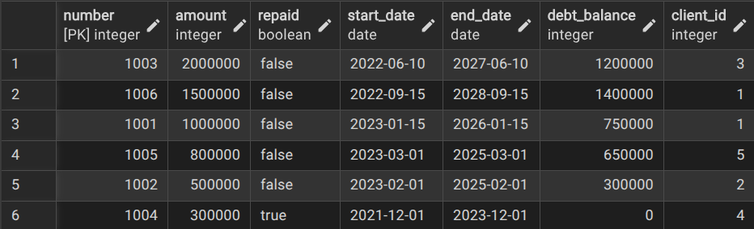
- Сортировка начислений по типу (по возрастанию) и дате (по убыванию)
SELECT * FROM Accruals
ORDER BY type ASC, accrual_date DESC;

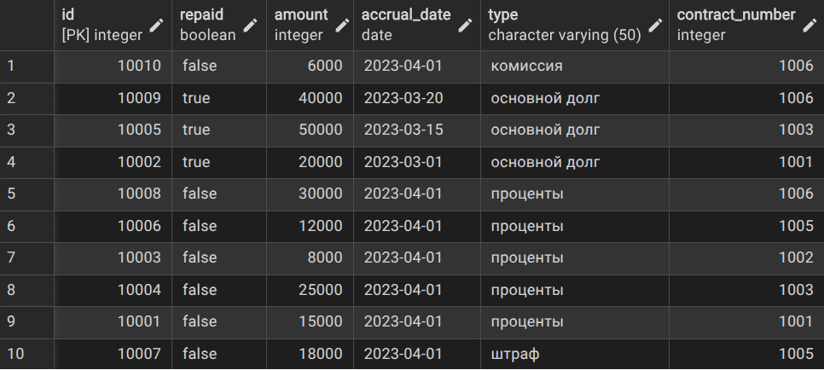
- Выбор клиентов из Москвы
SELECT * FROM Client
WHERE legal_address LIKE '%Москва%';

- Выбор непогашенных кредитных договоров на сумму больше 500000
SELECT * FROM Credit_Contract
WHERE repaid = FALSE AND amount > 500000;
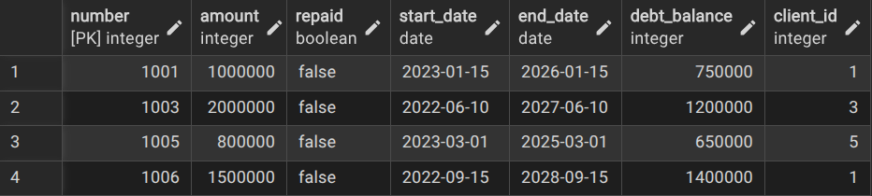
- Общая сумма всех кредитных договоров
SELECT SUM(amount) as total_credit_amount FROM Credit_Contract;


- Количество уникальных клиентов с кредитной историей
SELECT COUNT(DISTINCT client_id) as unique_clients FROM Credit_History;


- Сумма кредитов по каждому клиенту
SELECT client_id, SUM(amount) as total_client_credit
FROM Credit_Contract
GROUP BY client_id;
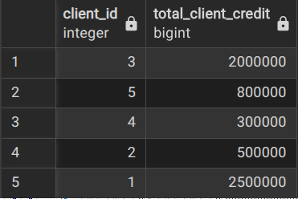

- Количество кредитных договоров по статусу погашения
SELECT repaid, COUNT(*) as contract_count
FROM Credit_Contract
GROUP BY repaid;
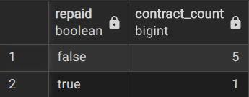

- Сумма начислений по типам и статусу погашения с подытогами
SELECT
type,
repaid,
SUM(amount) as total_amount,
COUNT(*) as count_accruals
FROM Accruals
GROUP BY ROLLUP(type, repaid)
ORDER BY type, repaid;
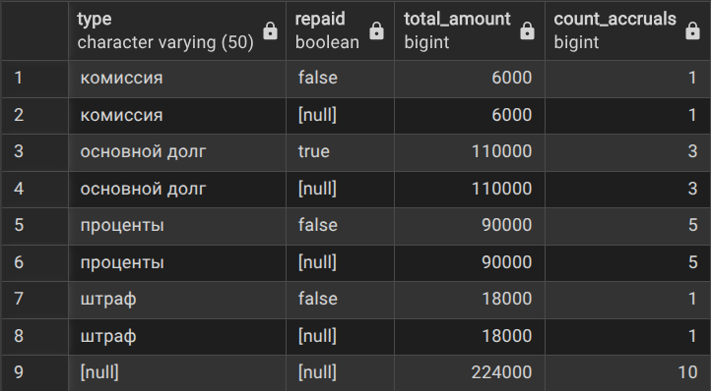

- Количество кредитных договоров по клиентам и статусу с итогами
SELECT
client_id,
repaid,
COUNT(*) as contract_count,
SUM(amount) as total_amount
FROM Credit_Contract
GROUP BY ROLLUP(client_id, repaid)
ORDER BY client_id, repaid;
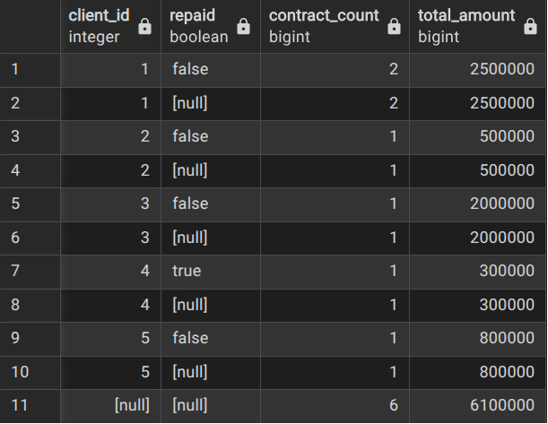

- Анализ платежей по типам и датам (все комбинации)
SELECT
type,
EXTRACT(YEAR FROM date) as payment_year,
EXTRACT(MONTH FROM date) as payment_month,
COUNT(*) as payment_count,
SUM(amount) as total_paid
FROM Payment
GROUP BY CUBE(type, EXTRACT(YEAR FROM date), EXTRACT(MONTH FROM date))
ORDER BY type, payment_year, payment_month;
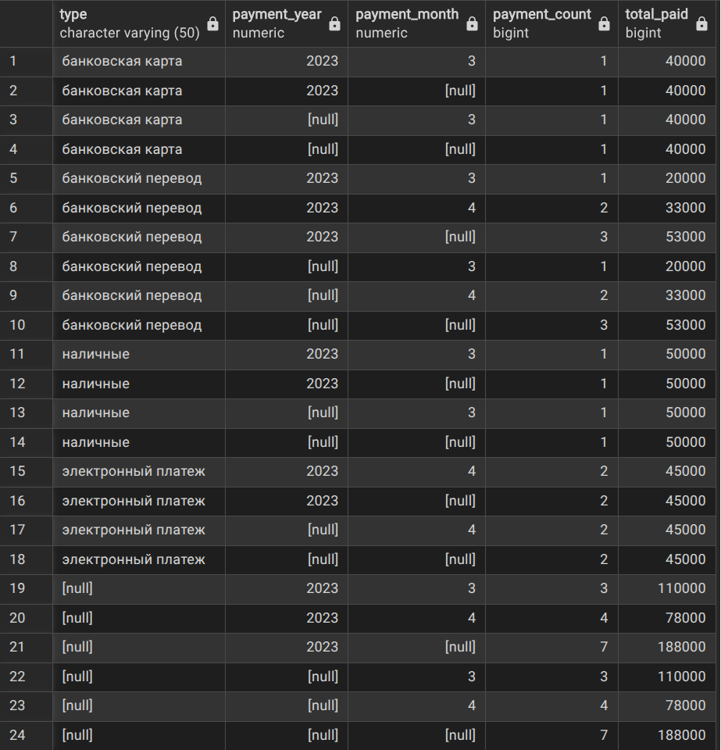

- Анализ кредитной истории по банкам и статусу погашения
SELECT
bank_name,
repaid,
COUNT(*) as history_count,
AVG(amount) as avg_amount
FROM Credit_History
GROUP BY CUBE(bank_name, repaid)
ORDER BY bank_name, repaid;
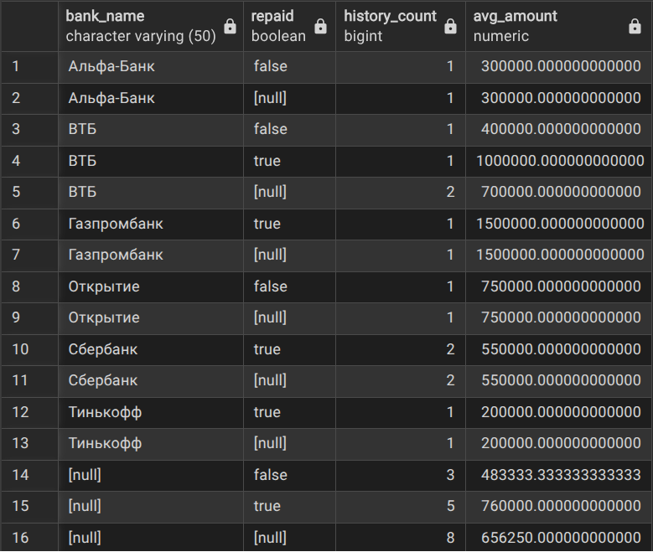

- Клиенты, в названии фирмы которых нет "ООО"
SELECT * FROM Client
WHERE company_name NOT LIKE '%ООО%';
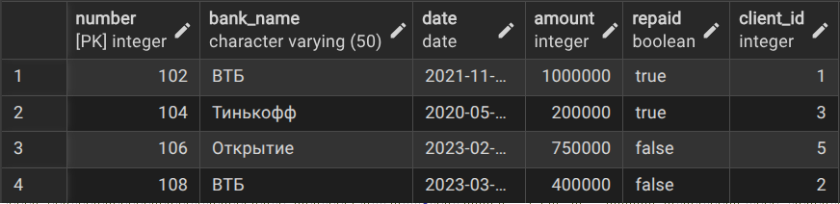
- Банки в кредитной истории, в названии которых нет "банк" (без учета регистра)
SELECT * FROM Credit_History
WHERE bank_name NOT ILIKE '%банк%';
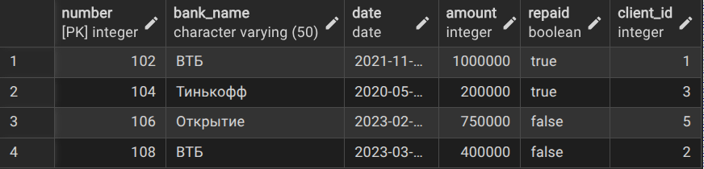

1.2
- Информация о кредитных договорах с названием фирмы клиента
SELECT
cc.number as contract_number,
cc.amount,
cc.start_date,
cc.end_date,
cc.debt_balance,
c.company_name,
c.contact_person
FROM Credit_Contract cc, Client c
WHERE cc.client_id = c.ID;
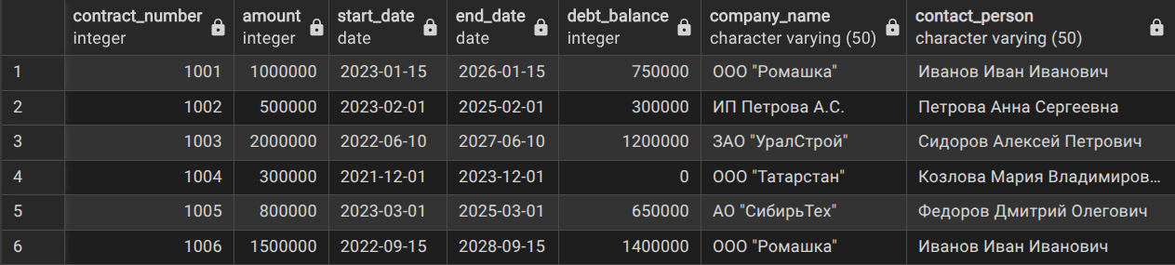
- Начисления с информацией о договоре и клиенте
SELECT
a.ID as accrual_id,
a.amount,
a.accrual_date,
a.type,
cc.number as contract_number,
cc.amount as contract_amount,
c.company_name
FROM Accruals a, Credit_Contract cc, Client c
WHERE a.contract_number = cc.number
AND cc.client_id = c.ID;
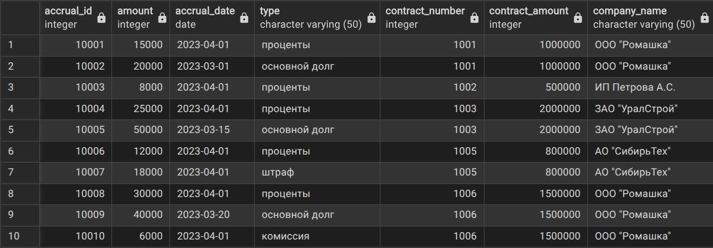

- Кредитные договоры с информацией о клиенте и кредитном продукте
SELECT
cc.number as contract_number,
cc.amount as contract_amount,
cc.start_date,
cc.end_date,
c.company_name,
cp.name as product_name,
cp.interest_rate
FROM Credit_Contract cc
INNER JOIN Client c ON cc.client_id = c.ID
INNER JOIN Credit_Product cp ON cc.number = cp.contract_number;
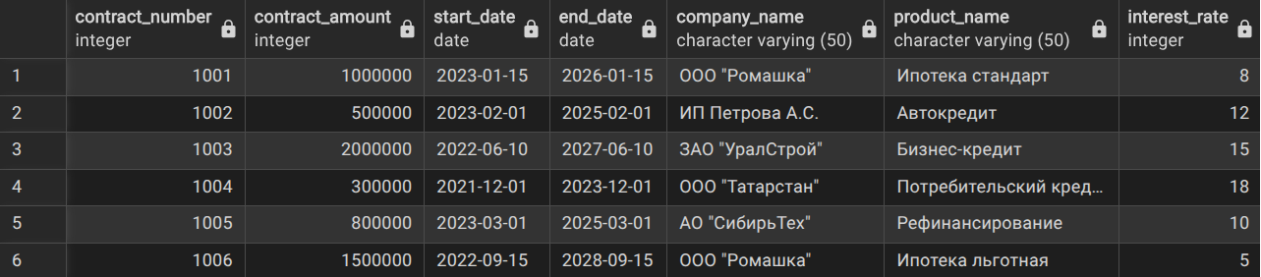
- Все платежи с информацией о начислении и договоре
SELECT
p.ID as payment_id,
p.type as payment_type,
p.date as payment_date,
p.amount as payment_amount,
a.type as accrual_type,
a.accrual_date,
cc.number as contract_number
FROM Payment p
INNER JOIN Accruals a ON p.accrual_id = a.ID
INNER JOIN Credit_Contract cc ON a.contract_number = cc.number;
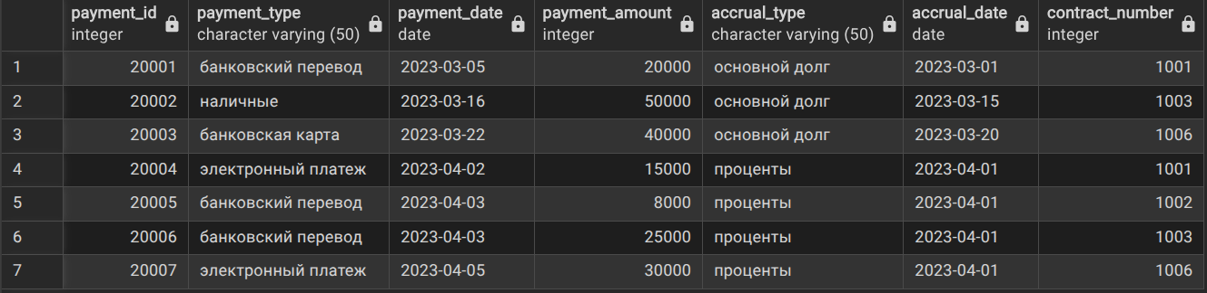

- Все клиенты, даже если у них нет кредитных договоров
SELECT
c.ID,
c.company_name,
c.contact_person,
cc.number as contract_number,
cc.amount,
cc.start_date
FROM Client c
LEFT JOIN Credit_Contract cc ON c.ID = cc.client_id
ORDER BY c.company_name;
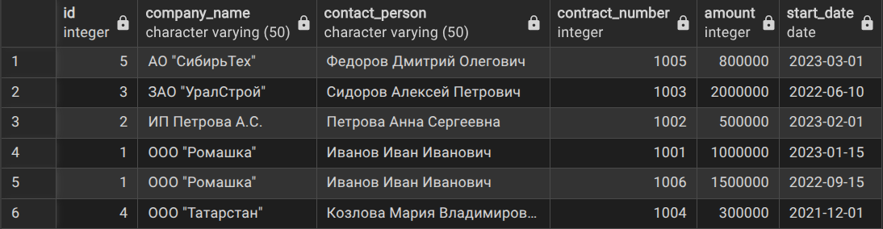
- Все кредитные договоры с информацией о продукте (если есть)
SELECT
cc.number,
cc.amount,
cc.start_date,
cc.end_date,
cp.name as product_name,
cp.interest_rate
FROM Credit_Contract cc
LEFT JOIN Credit_Product cp ON cc.number = cp.contract_number;
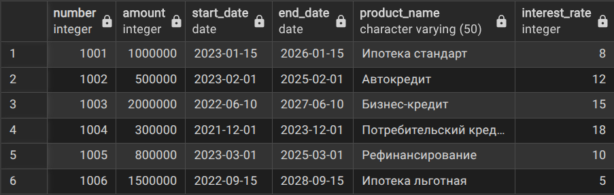

- Все кредитные продукты с информацией о договоре (обратный порядок)
SELECT
cp.name as product_name,
cp.interest_rate,
cp.max_amount,
cc.number as contract_number,
cc.amount as contract_amount,
cc.start_date
FROM Credit_Product cp
RIGHT JOIN Credit_Contract cc ON cp.contract_number = cc.number;
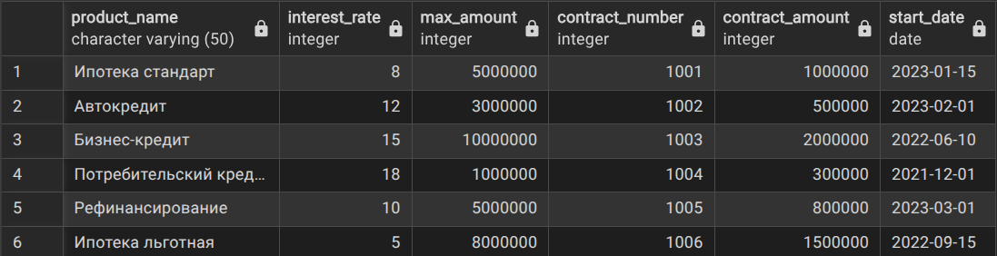
- Все платежи и соответствующие начисления (включая начисления без платежей)
SELECT
p.ID as payment_id,
p.type as payment_type,
p.amount as payment_amount,
a.ID as accrual_id,
a.type as accrual_type,
a.amount as accrual_amount
FROM Payment p
RIGHT JOIN Accruals a ON p.accrual_id = a.ID
WHERE a.repaid = FALSE;
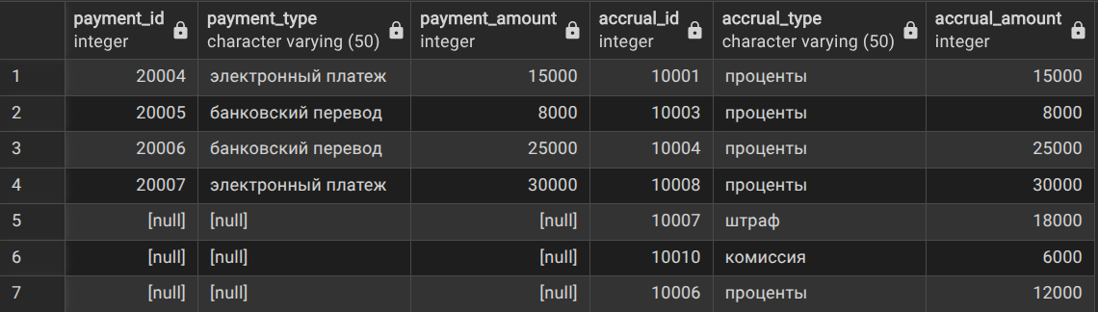

- Клиенты с общей суммой кредитов больше 1 млн
SELECT
c.company_name,
SUM(cc.amount) as total_credit_amount,
COUNT(cc.number) as contract_count
FROM Client c
INNER JOIN Credit_Contract cc ON c.ID = cc.client_id
GROUP BY c.ID, c.company_name
HAVING SUM(cc.amount) > 1000000
ORDER BY total_credit_amount DESC;
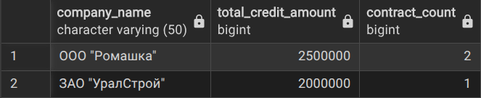
- Банки, у которых более 1 кредита в истории
SELECT
bank_name,
COUNT(*) as loan_count,
AVG(amount) as avg_loan_amount
FROM Credit_History
GROUP BY bank_name
HAVING COUNT(*) > 1
ORDER BY loan_count DESC;
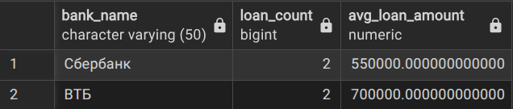
- Клиенты, у которых есть непогашенные кредитные договоры
SELECT *
FROM Client
WHERE ID IN (
SELECT DISTINCT client_id
FROM Credit_Contract
WHERE repaid = FALSE
);
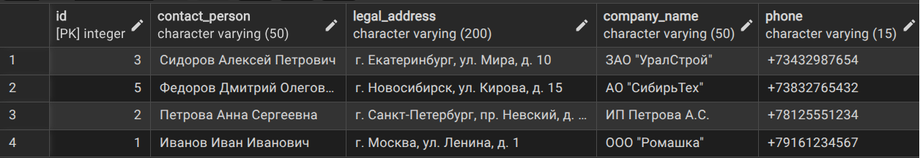
- Кредитные договоры, по которым есть начисления типа "штраф"
SELECT *
FROM Credit_Contract cc
WHERE EXISTS (
SELECT 1
FROM Accruals a
WHERE a.contract_number = cc.number
AND a.type = 'штраф'
);
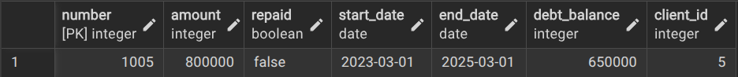
- Клиенты, у которых нет кредитной истории в Сбербанке
SELECT *
FROM Client c
WHERE NOT EXISTS (
SELECT 1
FROM Credit_History ch
WHERE ch.client_id = c.ID
AND ch.bank_name = 'Сбербанк'
);
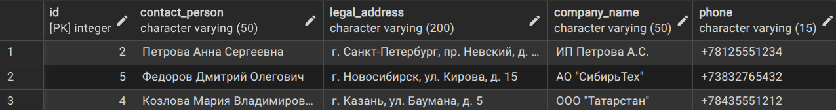
- Кредитные продукты, которые используются в договорах на сумму больше 500000
SELECT *
FROM Credit_Product cp
WHERE contract_number IN (
SELECT number
FROM Credit_Contract
WHERE amount > 500000
);
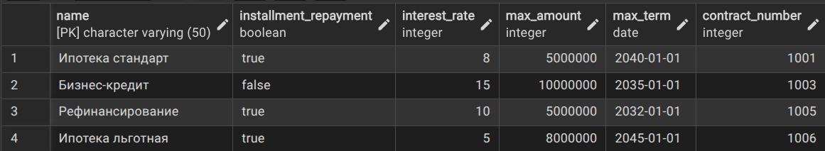

1.3
-Активные кредиты клиентов
CREATE VIEW Active_Credits AS
SELECT
c.company_name,
c.contact_person,
c.phone,
cc.number as contract_number,
cc.amount as total_amount,
cc.debt_balance as current_debt,
cc.start_date,
cc.end_date,
cp.name as credit_product,
cp.interest_rate
FROM Client c
JOIN Credit_Contract cc ON c.ID = cc.client_id
JOIN Credit_Product cp ON cc.number = cp.contract_number
WHERE cc.repaid = FALSE
ORDER BY c.company_name, cc.start_date;
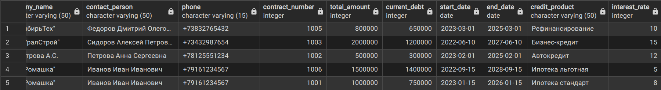

- Анализ кредитного положения клиентов
WITH Client_Credit_Analysis AS (
SELECT
c.ID,
c.company_name,
COUNT(DISTINCT cc.number) as active_contracts_count,
SUM(cc.debt_balance) as total_debt,
AVG(cp.interest_rate) as avg_interest_rate,
MAX(cc.amount) as max_credit_amount
FROM Client c
LEFT JOIN Credit_Contract cc ON c.ID = cc.client_id AND cc.repaid = FALSE
LEFT JOIN Credit_Product cp ON cc.number = cp.contract_number
GROUP BY c.ID, c.company_name
),
Payment_Analysis AS (
SELECT
cc.client_id,
SUM(p.amount) as total_payments_last_month
FROM Payment p
JOIN Accruals a ON p.accrual_id = a.ID
JOIN Credit_Contract cc ON a.contract_number = cc.number
WHERE p.date >= CURRENT_DATE - INTERVAL '1 month'
GROUP BY cc.client_id
)
SELECT
cca.company_name,
cca.active_contracts_count,
cca.total_debt,
cca.avg_interest_rate,
COALESCE(pa.total_payments_last_month, 0) as recent_payments
FROM Client_Credit_Analysis cca
LEFT JOIN Payment_Analysis pa ON cca.ID = pa.client_id
ORDER BY cca.total_debt DESC;
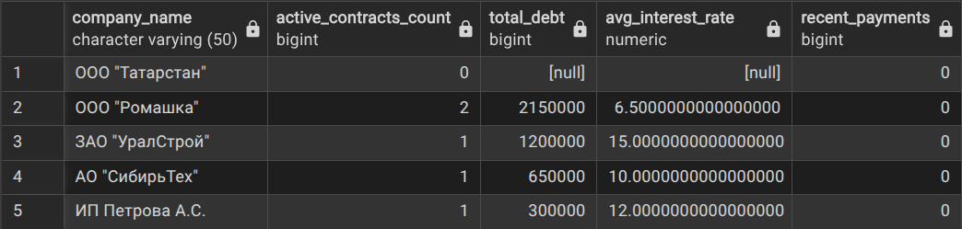

- Расчет среднего чека по типам платежей с нарастающим итогом
WITH Monthly_Payments AS (
SELECT
EXTRACT(YEAR FROM p.date) as payment_year,
EXTRACT(MONTH FROM p.date) as payment_month,
p.type as payment_type,
SUM(p.amount) as monthly_amount,
COUNT(*) as payment_count
FROM Payment p
WHERE p.date >= '2023-01-01'
GROUP BY EXTRACT(YEAR FROM p.date), EXTRACT(MONTH FROM p.date), p.type
),
Cumulative_Summary AS (
SELECT
payment_year,
payment_month,
payment_type,
monthly_amount,
payment_count,
SUM(monthly_amount) OVER (
PARTITION BY payment_type
ORDER BY payment_year, payment_month
) as cumulative_amount_by_type,
SUM(monthly_amount) OVER (
ORDER BY payment_year, payment_month
) as cumulative_total_amount
FROM Monthly_Payments
)
SELECT
payment_year,
payment_month,
payment_type,
monthly_amount,
ROUND(monthly_amount / payment_count, 2) as avg_payment_amount,
cumulative_amount_by_type,
cumulative_total_amount
FROM Cumulative_Summary
ORDER BY payment_year, payment_month, payment_type;
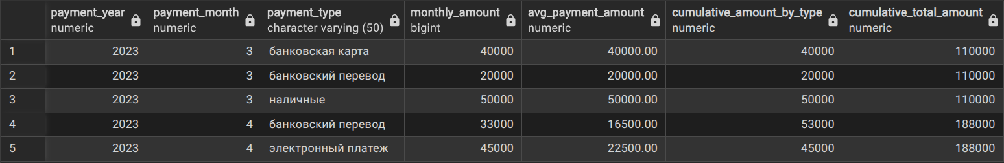

1.4
- Ранжирование кредитов по сумме (без PARTITION BY)
SELECT
cc.number as contract_number,
c.company_name,
cc.amount as credit_amount,
cc.debt_balance,
ROW_NUMBER() OVER (ORDER BY cc.amount DESC) as row_num_by_amount,
RANK() OVER (ORDER BY cc.amount DESC) as rank_by_amount,
DENSE_RANK() OVER (ORDER BY cc.amount DESC) as dense_rank_by_amount
FROM Credit_Contract cc
JOIN Client c ON cc.client_id = c.ID
WHERE cc.repaid = FALSE
ORDER BY cc.amount DESC;
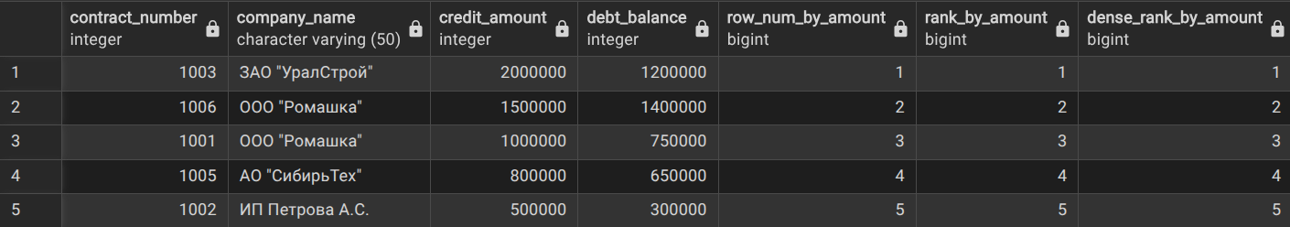
- Ранжирование внутри каждого клиента (с PARTITION BY)
SELECT
c.company_name,
cc.number as contract_number,
cc.start_date,
cc.amount,
cc.debt_balance,
ROW_NUMBER() OVER (
PARTITION BY c.ID
ORDER BY cc.amount DESC
) as client_contract_row_num,
RANK() OVER (
PARTITION BY c.ID
ORDER BY cc.start_date
) as contract_chronological_rank,
DENSE_RANK() OVER (
PARTITION BY c.ID
ORDER BY EXTRACT(YEAR FROM cc.start_date)
) as year_dense_rank
FROM Credit_Contract cc
JOIN Client c ON cc.client_id = c.ID
ORDER BY c.company_name, cc.amount DESC;
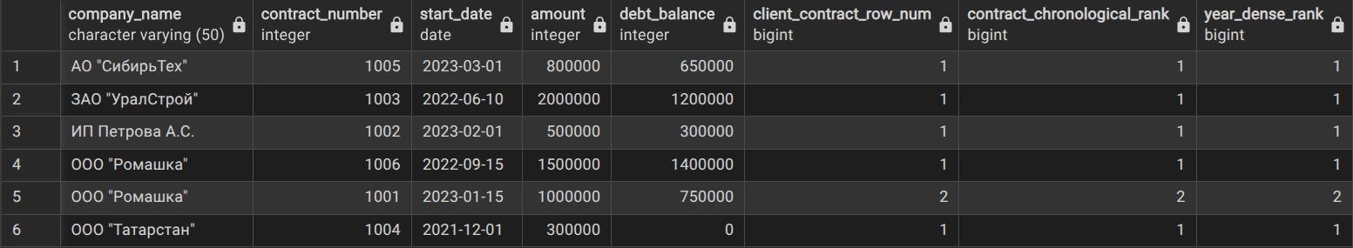
- Рейтинг клиентов по количеству договоров и общей сумме
SELECT
c.company_name,
COUNT(cc.number) as contract_count,
SUM(cc.amount) as total_credit_amount,
SUM(cc.debt_balance) as total_debt,
ROW_NUMBER() OVER (ORDER BY COUNT(cc.number) DESC, SUM(cc.amount) DESC) as row_num,
RANK() OVER (ORDER BY SUM(cc.amount) DESC) as rank_by_total_amount,
DENSE_RANK() OVER (ORDER BY COUNT(cc.number) DESC) as dense_rank_by_contract_count
FROM Client c
LEFT JOIN Credit_Contract cc ON c.ID = cc.client_id AND cc.repaid = FALSE
GROUP BY c.ID, c.company_name
ORDER BY contract_count DESC, total_credit_amount DESC;
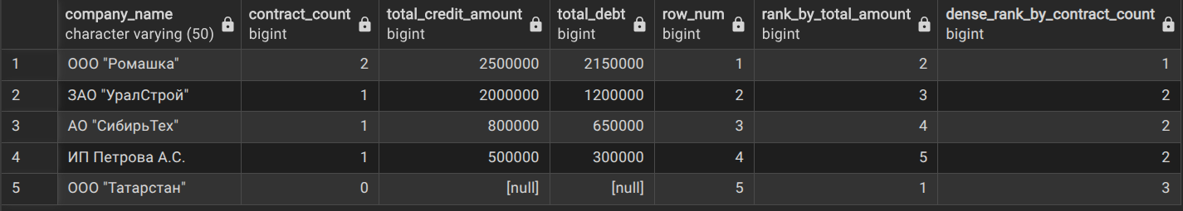
- Ранжирование платежей по договорам с анализом
WITH Contract_Payments AS (
SELECT
cc.number as contract_number,
c.company_name,
p.date as payment_date,
p.amount as payment_amount,
p.type as payment_type,
a.type as accrual_type,
SUM(p.amount) OVER (
PARTITION BY cc.number
ORDER BY p.date
) as cumulative_payments
FROM Payment p
JOIN Accruals a ON p.accrual_id = a.ID
JOIN Credit_Contract cc ON a.contract_number = cc.number
JOIN Client c ON cc.client_id = c.ID
)
SELECT
contract_number,
company_name,
payment_date,
payment_amount,
payment_type,
accrual_type,
cumulative_payments,
ROW_NUMBER() OVER (
PARTITION BY contract_number
ORDER BY payment_date
) as payment_sequence,
RANK() OVER (
PARTITION BY contract_number, accrual_type
ORDER BY payment_amount DESC
) as amount_rank_by_type,
DENSE_RANK() OVER (
ORDER BY EXTRACT(MONTH FROM payment_date), EXTRACT(YEAR FROM payment_date)
) as month_dense_rank
FROM Contract_Payments
ORDER BY contract_number, payment_date;
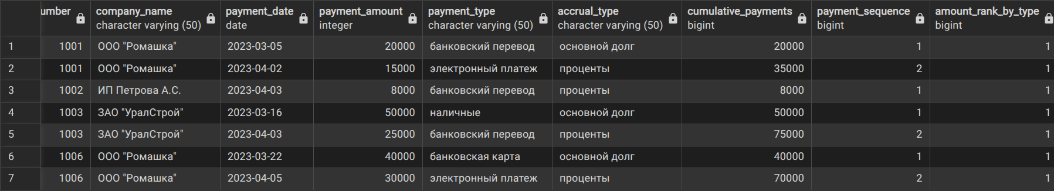

1.5
- Все уникальные контакты из клиентов и банков из кредитной истории
SELECT
contact_person as name,
phone,
'Клиент' as type
FROM Client
WHERE phone IS NOT NULL

UNION ALL

SELECT
bank_name as name,
NULL as phone,
'Банк' as type
FROM Credit_History
WHERE bank_name IS NOT NULL

ORDER BY type, name;
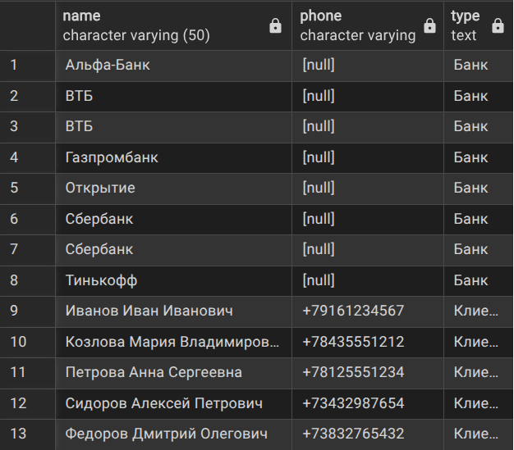

- Клиенты, которые брали кредиты в определенных банках
SELECT DISTINCT
c.ID,
c.company_name,
c.contact_person,
'Сбербанк' as preferred_bank
FROM Client c
JOIN Credit_History ch ON c.ID = ch.client_id
WHERE ch.bank_name = 'Сбербанк'

UNION

SELECT DISTINCT
c.ID,
c.company_name,
c.contact_person,
'ВТБ' as preferred_bank
FROM Client c
JOIN Credit_History ch ON c.ID = ch.client_id
WHERE ch.bank_name = 'ВТБ'

ORDER BY preferred_bank, company_name;
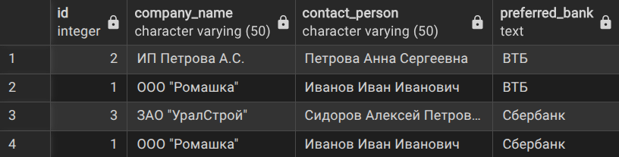
- Клиенты, у которых есть и активные и закрытые договоры
SELECT DISTINCT c.ID, c.company_name
FROM Client c
JOIN Credit_Contract cc ON c.ID = cc.client_id
WHERE cc.repaid = FALSE

INTERSECT

SELECT DISTINCT c.ID, c.company_name
FROM Client c
JOIN Credit_Contract cc ON c.ID = cc.client_id
WHERE cc.repaid = TRUE

ORDER BY company_name;

- Клиенты без просроченных начислений
SELECT DISTINCT c.ID, c.company_name
FROM Client c

EXCEPT

SELECT DISTINCT c.ID, c.company_name
FROM Client c
JOIN Credit_Contract cc ON c.ID = cc.client_id
JOIN Accruals a ON cc.number = a.contract_number
WHERE a.repaid = FALSE
AND a.accrual_date < CURRENT_DATE - INTERVAL '30 days'

ORDER BY company_name;



1.6
- Анализ клиентов по категориям задолженности
SELECT
c.company_name,
c.contact_person,
SUM(cc.amount) as total_credit_amount,
SUM(cc.debt_balance) as total_debt,
CASE
WHEN SUM(cc.debt_balance) = 0 THEN 'Нет задолженности'
WHEN SUM(cc.debt_balance) <= 500000 THEN 'Маленькая задолженность'
WHEN SUM(cc.debt_balance) <= 2000000 THEN 'Средняя задолженность'
ELSE 'Большая задолженность'
END as debt_category,
CASE
WHEN COUNT(cc.number) = 0 THEN 'Без договоров'
WHEN COUNT(cc.number) = 1 THEN 'Один договор'
WHEN COUNT(cc.number) <= 3 THEN 'Несколько договоров'
ELSE 'Много договоров'
END as contract_category
FROM Client c
LEFT JOIN Credit_Contract cc ON c.ID = cc.client_id AND cc.repaid = FALSE
GROUP BY c.ID, c.company_name, c.contact_person
ORDER BY total_debt DESC;
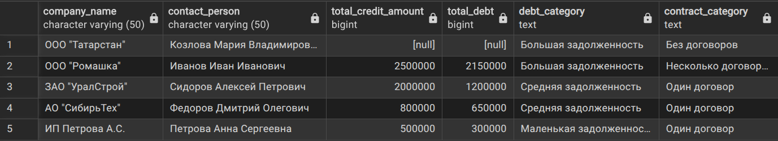
- Сводка платежей по месяцам с использованием CASE
SELECT
EXTRACT(YEAR FROM p.date) as year,
EXTRACT(MONTH FROM p.date) as month,
SUM(CASE WHEN p.type = 'банковский перевод' THEN p.amount ELSE 0 END) as bank_transfer_total,
SUM(CASE WHEN p.type = 'наличные' THEN p.amount ELSE 0 END) as cash_total,
SUM(CASE WHEN p.type = 'банковская карта' THEN p.amount ELSE 0 END) as card_total,
SUM(CASE WHEN p.type = 'электронный платеж' THEN p.amount ELSE 0 END) as electronic_total,
SUM(p.amount) as total_amount,
COUNT(CASE WHEN p.type = 'банковский перевод' THEN 1 END) as bank_transfer_count,
COUNT(CASE WHEN p.type = 'наличные' THEN 1 END) as cash_count,
COUNT(CASE WHEN p.type = 'банковская карта' THEN 1 END) as card_count,
COUNT(CASE WHEN p.type = 'электронный платеж' THEN 1 END) as electronic_count,
ROUND(AVG(p.amount), 2) as avg_payment
FROM Payment p
WHERE p.date IS NOT NULL
GROUP BY EXTRACT(YEAR FROM p.date), EXTRACT(MONTH FROM p.date)
ORDER BY year DESC, month DESC;

- Сводка платежей по типам по месяцам
SELECT
TO_CHAR(p.date, 'YYYY-MM') as month_year,
SUM(CASE WHEN p.type = 'банковский перевод' THEN p.amount ELSE 0 END) as "Банковский перевод",
SUM(CASE WHEN p.type = 'наличные' THEN p.amount ELSE 0 END) as "Наличные",
SUM(CASE WHEN p.type = 'банковская карта' THEN p.amount ELSE 0 END) as "Банковская карта",
SUM(CASE WHEN p.type = 'электронный платеж' THEN p.amount ELSE 0 END) as "Электронный платеж",
SUM(p.amount) as "Общая сумма"
FROM Payment p
WHERE p.date IS NOT NULL
GROUP BY TO_CHAR(p.date, 'YYYY-MM')
ORDER BY month_year DESC;
