GH_CALCPAD
Calcpad, developed by Proektsoftbg, is free software for mathematical and engineering calculations. It is a modern and flexible programmable calculator with HTML report generation. It combines ease of use with advanced features such as consistent unit handling, a clear worksheet structure, and formatted export.

GH_Calcpad (V2.0.0) is a Grasshopper plugin that embeds Calcpad as a computation engine inside parametric workflows, adding optimization capabilities. It currently supports loading and executing.cpd sheets, selective variable modification, real-time execution, filtered result extraction, multi-objective optimization, and professional export to HTML, PDF, and Word.
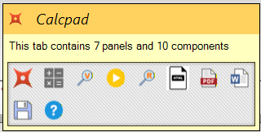
-_-_-_-_-_-_-_-_-_-_-_-_-_-_-_-_-_-_-_-_-_-_-_-_-_-_-_-_-_-_-_-_-_-_-_-_-_-_-_
📋 Information & Diagnostics

└── Calcpad Info
📁 File Loading
└── Load CPD
Download Calcpad
🔧 Variable Modification
└── Search Variables
Download GH_Calcpad
⚡ Execution & Optimization
└── Play CPD
🔍 Result Filtering
└── Search Results

💾 Saving & Export
├── Save CPD/TXT
Visited:
├── Export HTML
Calcpad
├── Export PDF
└── Export Word
GH_Calcpad
❓ Help & Support
└── Calcpad Help

INSTALLATION
Prerequisites:
  - Rhino 8 with Grasshopper
  - Calcpad installed (optional but recommended to validate .cpd sheets)
  - .NET Framework 4.8 (normally already present on Windows)
Steps
- Download
Go to: https://www.food4rhino.com/en/app/calcpad and download the GH_Calcpad ZIP.
- Extract
Unzip the file. Keep the GH_Calcpad folder structure intact (do not move DLLs out).
- Copy to the Grasshopper components directory
Copy the entire GH_Calcpad folder to:
C:\Users\YOUR_USER\AppData\Roaming\Grasshopper\Libraries
(You can open this path from Grasshopper via: File > Special Folders > Components Folder).
- Restart Rhino
Close Rhino (if it was open) and launch it again. Then open Grasshopper.
- Quick verification
The “Calcpad” tab should appear. Test:
  - Place “Load CPD”
  - Provide a valid .cpd file path
  - Add “Play CPD” → results should be generated.

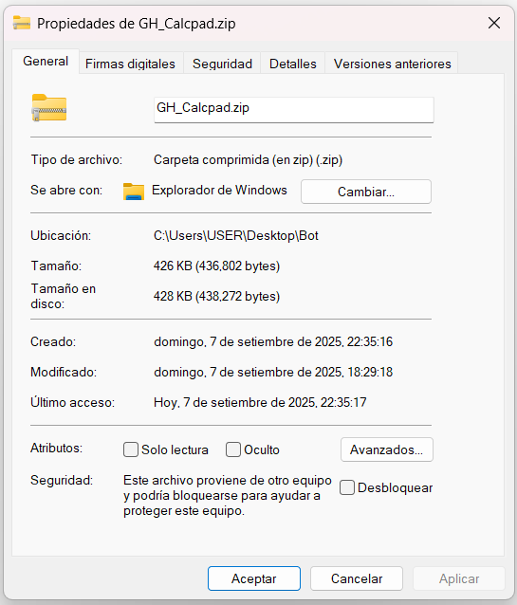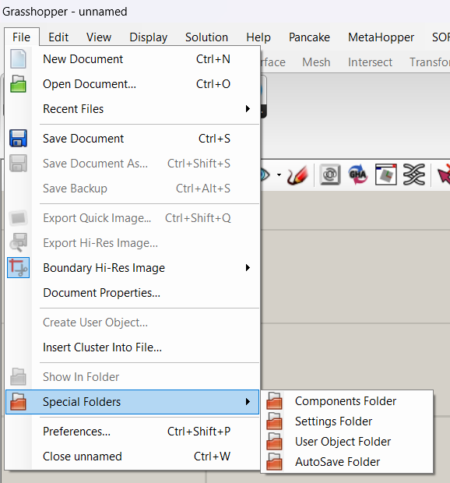

Notes:
  - If the tab does not appear (rare case), check file properties of GH_Calcpad.gha / DLLs to see if Windows blocked them (Unblock option).
  - Do not rename the .gha or the associated DLLs.

COMPONENTS GH_CALCPAD

Calcpad Info
Plugin information panel. Reads the worker's vendored Calcpad.Core.dll metadata directly (no in-process reference to Calcpad), so it always reflects the version the worker actually calculates with.
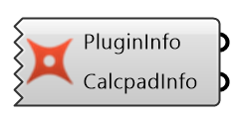
INPUTS:
- (none)
OUTPUTS:
- PluginInfo: Item · string — GH_Calcpad version + author (Andrei Damian Pacheco)
- CalcpadInfo: Item · string — Calcpad.Core version + author / copyright

Load CPD
Reads a .cpd/.txt file and extracts variables, values and units. Detects both the explicit 'var = ?{val}unit' placeholder format and plain literal assignments in a single pass (both are always recognized). Watches the file on disk and auto-refreshes when it changes.
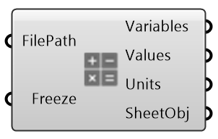
INPUTS:
- FilePath: full path to the .cpd/.txt file
- Freeze: if True, blocks all output (no data passes downstream) and stops reading/watching the file (default = false)
OUTPUTS:
- Variables: names of variables found, in file order
- Values: numeric values, 1:1 with Variables
- Units: units, 1:1 with Variables
- SheetObj: CalcpadSheet instance for other components

Search Variables
Sets specific variables on a Sheet by name, before Play CPD. Clones the incoming Sheet before writing to it, so wiring the same upstream Sheet into more than one branch never lets one branch overwrite another's values.
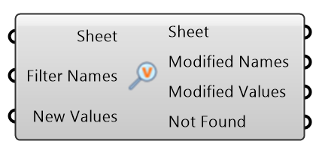
INPUTS:
- Sheet: CalcpadSheet (from Load CPD)
- Filter Names: names to modify; leave empty/unconnected to auto-select every variable prefixed 'gh_'
- New Values: new values, 1:1 with Filter Names (or with the auto-selected 'gh_' variables, in file order, if Filter Names is empty)
OUTPUTS:
- Sheet: independent copy of the input Sheet with the requested variables set → connect to Play CPD
- Modified Names: names of variables that were modified successfully
- Modified Values: corresponding modified values (for visualization/debug)
- Not Found: requested names not present in the Sheet

Play CPD
The calculation engine. Takes a fully-prepared Sheet and runs it through Calcpad (the worker process). Clones the incoming Sheet before calculating.
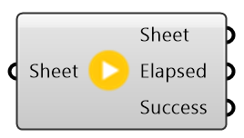
INPUTS:
- Sheet: CalcpadSheet to calculate (from Load CPD or Search Variables)
OUTPUTS:
- Sheet: calculated CalcpadSheet → connect to Search Results and/or Export
- Elapsed: calculation time in milliseconds
- Success: true if calculation succeeded — check before trusting downstream results, especially inside an optimization loop

Search Results
Reads specific computed results from a calculated Sheet by name, straight from the worker's authoritative result set (no source-text scanning for values/units).
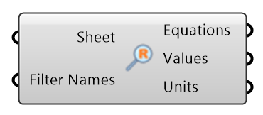
INPUTS:
- Sheet: calculated Sheet (from Play CPD)
- Filter Names: names to read; leave empty/unconnected to auto-select every result prefixed 'ghc_'
OUTPUTS:
- Equations: 'Name = expression' for each match (falls back to 'Name = value unit' when no source formula exists, e.g. plain inputs)
- Values: numeric result values, 1:1 with Equations
- Units: units, 1:1 with Values

Save CPD/TXT
Writes the Sheet's current code to a .cpd or .txt file. Safe write (temp file + replace); skips rewriting if the target file's content is already identical.
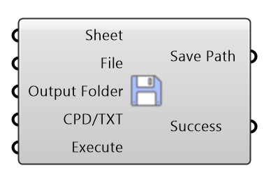
INPUTS:
- Sheet: CalcpadSheet to save (from Play CPD or Search Variables)
- File: base name (without extension), optional
- Output Folder: destination folder path, optional
- CPD/TXT: false = .cpd (default), true = .txt, optional
- Execute: true = save (default = false)
OUTPUTS:
- Save Path: complete path of the saved file
- Success: true if file was saved successfully

Export HTML
Exports Calcpad's own rendered HTML report — the same worksheet template/CSS the real Calcpad desktop app and CLI use.
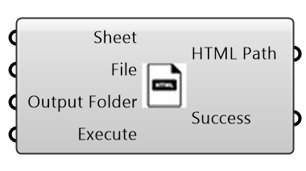
INPUTS:
- Sheet: CalcpadSheet to export (from Play CPD or Search Variables)
- File: base name (without extension), optional
- Output Folder: destination folder, optional
- Execute: true = export (default = false)
OUTPUTS:
- HTML Path: path of the generated .html file
- Success: true if .html was generated

Export PDF
Same rendered report exported to PDF via wkhtmltopdf.exe (vendored — the same binary and CLI arguments Calcpad's own CLI uses).
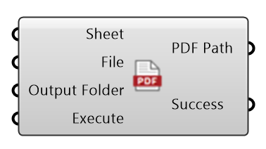
INPUTS:
- Sheet: CalcpadSheet to export (from Play CPD or Search Variables)
- File: base name (without extension), optional
- Output Folder: destination folder, optional
- Execute: true = export (default = false)
OUTPUTS:
- PDF Path: path of the generated PDF file
- Success: true if PDF was generated

Export Word
Same rendered report exported to a native .docx via Calcpad.OpenXml.OpenXmlWriter (real OMath equations — no Word installation or COM automation).
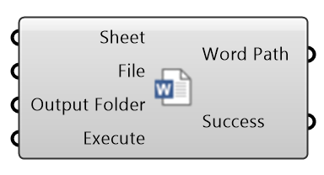
INPUTS:
- Sheet: CalcpadSheet to export (from Play CPD or Search Variables)
- File: base name (without extension), optional
- Output Folder: destination folder, optional
- Execute: true = export (default = false)
OUTPUTS:
- Word Path: path of the generated .docx file
- Success: true if .docx was generated

Calcpad Help
Static, always-available quick reference: workflows, one line per component, best practices and examples.
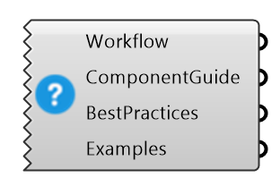
INPUTS:
- (none)
OUTPUTS:
- Workflow: step-by-step workflow guide
- ComponentGuide: description of each component and purpose
- BestPractices: best practices and usage tips
- Examples: common usage examples and scenarios

WORKFLOW INTEGRATION

BASIC WORKFLOW:

Load CPD → Play CPD → Export/Save

SELECTIVE WORKFLOW:
Load CPD → Search Variables → Play CPD → Export/Save

FULL WORKFLOW:
Load CPD → Search Variables → Play CPD → Search Results → Export/Save

OPTIMIZATION WORKFLOW:
Load CPD → Search Variables → Play CPD → Search Results → external optimizer (Galapagos / Wallacei / Octopus): leave both Filter Names empty (auto-detect 'gh_' / 'ghc_') and wire Search Variables' New Values to the optimizer's genome and Search Results' Values to its fitness. Check Play CPD's Success output to penalize failed iterations.

