**Silent Installer for Essential Software [REVAMPED]**

Project Overview

**15/02/2025 – 3/03/2025**

**1. Overview**

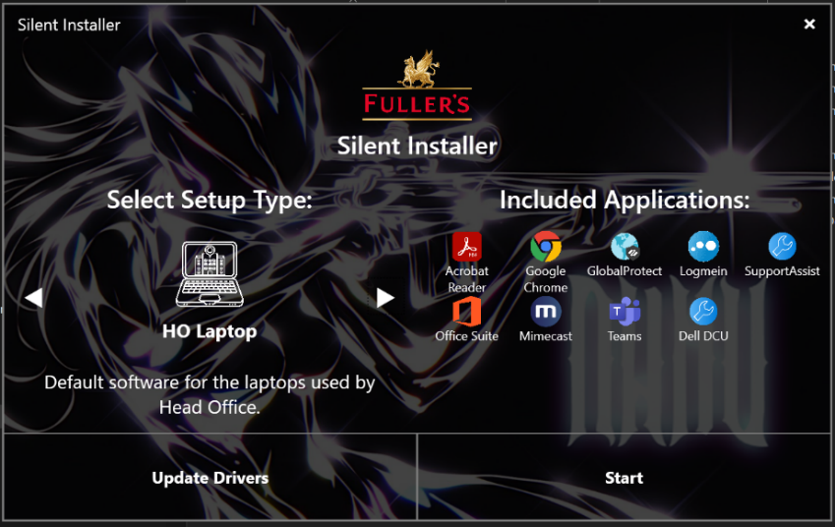The **Silent Installer** is a Windows-based application designed to streamline the installation of multiple software applications in an **automated, efficient, and intuitive manner**. It is particularly useful for the **IT Department**, enabling quick deployment of predefined software configurations based on different **device types and user needs**.

This tool ensures that **essential applications** are installed without requiring user interaction, making it ideal for **new device setup, system reinstalls, and corporate standardization** without the need for additional licensing or costs.

**2. How It Works**

The Silent Installer follows a **step-by-step process** to install applications:

1. **User runs the executable as an administrator**.
2. **User either selects a category** (e.g., "MH Laptop" or "HO Laptop") or to **update drivers**.
   1. *Note: To update drivers,* ***Dell DCU needs to be installed****, which is included in both category setups.*
3. **The application retrieves predefined installation steps** based on the selected category.
4. **Each application is installed silently** using its corresponding command-line arguments.
5. **Progress is logged in real-time**, showing installation status.
6. **User can abort the process at any time**, stopping all remaining installations.
7. **Once installation is complete**, an option to restart the system is available.

**3. Features & Capabilities**

✔️ **Automated Batch Installation** – Reduces manual effort for IT teams.  
✔️ **Silent Mode Execution** – Applications install in the background without user prompts.  
✔️ **Predefined Setup Categories** – Different configurations for different user roles.  
✔️ **Abort and Logging Functionality** – Users can stop installations anytime, with logs for debugging.  
✔️ **GUI-Based Selection** – User-friendly interface for category selection.  
✔️ **Post-Installation Actions** – Includes system restart options.  
✔️ **Multi-App Installation** – Installs multiple applications sequentially.

**4. Applications Installed**

|  |  |  |
| --- | --- | --- |
| **Applications Installed** | **MH Laptop** | **HO Laptop** |
| Acrobat Reader | Yes | Yes |
| Google Chrome | Yes | Yes |
| GlobalProtect | Yes | Yes |
| SupportAssist | Yes | Yes |
| LogMeIn (MH) | Yes | No |
| LogMeIn (HO) | No | Yes |
| Office Suite | No | Yes |
| Mimecast for Outlook | No | Yes |
| Microsoft Teams | No | Yes |
| Dell CommandUpdate | Yes | Yes |

**5. Technologies & Resources Used**

**Programming Languages & Frameworks**

* **C# (.NET Framework - WPF)** – Used for GUI development.
* **XAML** – Defines the UI layout.
* **Windows Batch Scripting** – Used to execute silent installation commands.

**Resources Used**

* **MahApps.Metro Framework** – For modern UI styling.
* **Windows Presentation Foundation (WPF)** – UI framework.
* **System.Diagnostics.Process** – Handles process execution for silent installations.
* **Windows Shell Commands** – Used to launch installers and execute commands.

**File Paths & Dependencies**

* Application Installer Path: C:\\Users\\asta\\OneDrive\\SilentInstaller\\Installers
  + *Note: This can be modified anytime depending on the needs of the department, it represents the current installer path at the date of writing this documentation*
* Required Installation Files:
  + Acrobat\\acrsetup.exe
  + Chrome\\GoogleStandaloneSetup64.msi
  + PaloAlto\\GlobalProtect64-6.2.2.msi
  + SupportAssist\\SupportAssistx64.msi
  + LMI\\logmein.msi and LMI\\LMI Head Office.msi
  + Office\\setup.exe and Office\\configuration.xml
  + Mimecast\\Mimecast.msi
  + Teams\\teamsbootstrapper.exe and Teams\\MSTeams-x64.msix
  + SupportAssist\\Dell-Command-Update-Windows-Universal-Application_9M35M_WIN_5.4.0_A00.EXE

**6. Future Enhancements**

If possible and upon requests, I am considering further developing the application in the following areas:

**🔹 Expanded Setup Categories**

* Additional device-specific configurations (e.g., "Finance Team Laptop," "Avondata/ Hotel PC", etc.).
  + *Note: The only potential issue I can imagine regarding achieving this is if any of the required software do not* ***have an .msi or standalone offline installer .exe*** *version of the software, which will render silent installation unachievable.*
* Dynamic loading of categories via a **config file** or **database** instead of hardcoding them.

**🔹 Custom Installation Profiles**

* Users can select/deselect individual applications before starting installation.
* Option to install additional software beyond predefined categories.

**🔹 Remote Deployment Features**

* Ability to deploy software to multiple machines on a network.
* Integration with other components of our IT ecosystem to further facilitate processes.

**🔹 Logging & Reporting Enhancements**

* More detailed installation logs (timestamps, errors, success rates).

**🔹 Unattended Deployment**

* Scheduled silent installations at specific times or via a startup script.
* Option to **run silently without GUI** (e.g., executed via a command line with parameters).

**🔹 GUI Enhancements & User Experience**

* **Progress Bar for Each Installation** – Better visualization of installation progress.
* **Better GUI** – Improved UI customization.
  + **Custom Themes**, for accessibility reasons.
  + **Animations and Interactions** for improved user experience.
* **Application Search & Filtering** – Easier selection of apps, if the application will be significantly expanded.

**7. Requirements & Constraints**

**System Requirements**

🖥️ **OS:** Windows 7+ (64-bit)  
🔧 **Admin Rights:** Required for system-wide installation  
📡 **Network:** Required for accessing the installation folders if on the file server

**Framework:** .Net 8.0 Framework installed

**Constraints**

❌ **Requires Administrator Permissions** – Some installations may fail without admin rights.  
❌ **No Mac/Linux Support** – Designed specifically for Windows environments.  
❌ **Dependent on Installer Files** – Missing files will cause installations to fail.

❌ **SupportAssist no GUI** – This version of SupportAssist is not a standalone app but allows automatic detection of the device on the Dell webpage.

* *The MSI version provided by Dell does not install the* standalone *version in silent mode.*
* *Note: I noticed however, that after a short time the SupportAssist desktop app becomes available.*

**8. Testing**

**Test Case Set 1: General Installation Scenarios**

| **Test Case #** | **Test Description** | **Steps** | **Expected Result** | **Status** |
| --- | --- | --- | --- | --- |
| **TC01** | Verify successful installation of all applications for **HO Laptop** category | 1. Launch the app 2. Select "HO Laptop" 3. Click "Start Installation" 4. Wait for completion | All listed apps install successfully without errors | ✅ Pass |
| **TC02** | Verify successful installation of all applications for **MH Laptop** category | 1. Launch the app 2. Select "MH Laptop" 3. Click "Start Installation" 4. Wait for completion | All listed apps install successfully without errors | ✅ Pass |
| **TC03** | Ensure installation continues even if one application fails | 1. Corrupt one installer file 2. Start installation 3. Observe behavior | The failed app is logged, but other apps continue installing | ✅ Pass |
| **TC04** | Check what happens when installation is **aborted midway** | 1. Select category 2. Start installation 3. Click "Abort" | The installation should stop, and logs should reflect aborted status | ✅ Pass |
| **TC05** | Ensure installer **skips already installed software** | 1. Pre-install some apps 2. Run Silent Installer | Already installed apps should be skipped | ✅ Pass |

**Test Case Set 2: UI & User Experience**

| **Test Case #** | **Test Description** | **Steps** | **Expected Result** | **Status** |
| --- | --- | --- | --- | --- |
| **TC06** | Ensure **GUI displays categories correctly** | 1. Launch the app 2. Observe the category dropdown | All expected categories appear | ✅ Pass |
| **TC07** | Verify that the **installation progress updates correctly** | 1. Start installation 2. Observe progress messages/logs | Real-time updates should show in UI/logs | ✅ Pass |
| **TC08** | Ensure the **"Abort" button works immediately** | 1. Start installation 2. Click "Abort" during an active install | Installation stops immediately without hanging | ✅ Pass |
| **TC09** | Verify that **logs are generated correctly** | 1. Start installation 2. Check log file after completion | Logs should list installed apps, skipped apps, and errors | ✅ Pass |
| **TC10** | Ensure that **the installer UI remains responsive** during installs | 1. Start installation 2. Interact with the UI | UI should not freeze during the process | ✅ Pass |

**Test Case Set 3: Error Handling & Edge Cases**

| **Test Case #** | **Test Description** | **Steps** | **Expected Result** | **Status** |
| --- | --- | --- | --- | --- |
| **TC11** | Test with **missing installer files** | 1. Delete some installer files 2. Run Silent Installer | Errors should be logged, but other installations continue | ✅ Pass |
| **TC12** | Verify behavior when **internet-dependent apps install without a connection** | 1. Disable internet 2. Start installation | Cloud-based installs (e.g., Office) should fail gracefully | ✅ Pass |
| **TC13** | Check if the installer **handles invalid command-line arguments correctly** | 1. Modify an installer argument 2. Run Silent Installer | Invalid arguments should be logged as errors | ✅ Pass |
| **TC14** | Test how the installer behaves if **the process is killed mid-way** | 1. Start installation 2. Kill the process in Task Manager | Installation should stop without leaving broken installs | ✅ Pass |
| **TC15** | Check compatibility with **Windows Defender / Antivirus settings** | 1. Enable strict Windows Defender settings 2. Start installation | Defender should not block safe installations | ✅ Pass |
| **TC16** | Test system behavior if **multiple instances of the installer are run** | 1. Start installation 2. Open another instance of the app | Should prevent multiple instances from running simultaneously | ✅ Pass |

**Test Execution Summary**

|  |  |
| --- | --- |
| Status | Count |
| ✅ Pass | 16 / 16 |
| ❌ Fail | 0 / 20 |

**9. Conclusion**

The **Silent Installer** is an efficient, reliable and user-friendly tool for the **IT department** to facilitate and standardize software installations across multiple machines. With **future enhancements**, it can evolve into a tool used on a wider scale, integrating **remote deployment, custom software selection, and security features**.

🚀 **Next Steps:**

* Gather user feedback to identify improvements.
* Implement **custom profiles & remote deployment features**.
* Enhance **logging, reporting, and security measures**.