ModemBoxSimulator
Andrei Errapart / andrei@errapartengineering.com / 56 692 469
Tallinn, 2007

Introduction

This document gives all information required for building and using ModemBoxSimulator.

ModemBoxSimulator is a test tool / developing aid for following programs:
- GpsViewer
- GpsServer
- ModemBox firmware (special mode).

In addition it has packet generation capabilities.

Installation

Installer is made with NSIS.

Installation creates the following items in the windows Start menu:
- ModemBoxSimulator.
- Configuration file.
- Run profile 1.
- Run profile 2.
- Run profile 3.
- Run profile 4.
- Run profile 5.

Running/Startup

Command line syntax allows specifying startup profile number:
ModemBoxSimulator [ProfileName/ProfileNumber]
Default startup profile is number 1.

Configuration file

Configuration file stores profile information.

Sections are named “Profile N”, where N – profile number in the range 1…N+1.

Table 1: Profile fields.
Name | Type | Description
Name | String | Name of the profile.
IMEI | String | Mobile phone IMEI.
FirmwareVersion | String | ModemBox firmware version. Supported versions:  - 0.9
FirmwareDate | String | Firmware build date. Format:  "YYYY-MM-DD HH:MM:SS"
FirmwareBuildInfo | String | Firmware build configuration, free format.
BluetoothPort | Portname,Speed | Bluetooth serial port name.
Server | Ip:Portnumber | GpsServer address.
GPS1 | X;Y | Position of GPS1, in local coordinates.
GPS2 | X;Y | Position of GPS2, in local coordinates.
SupplyVoltage | Float | Supply voltage, volts.

Configuration file example:

Main window

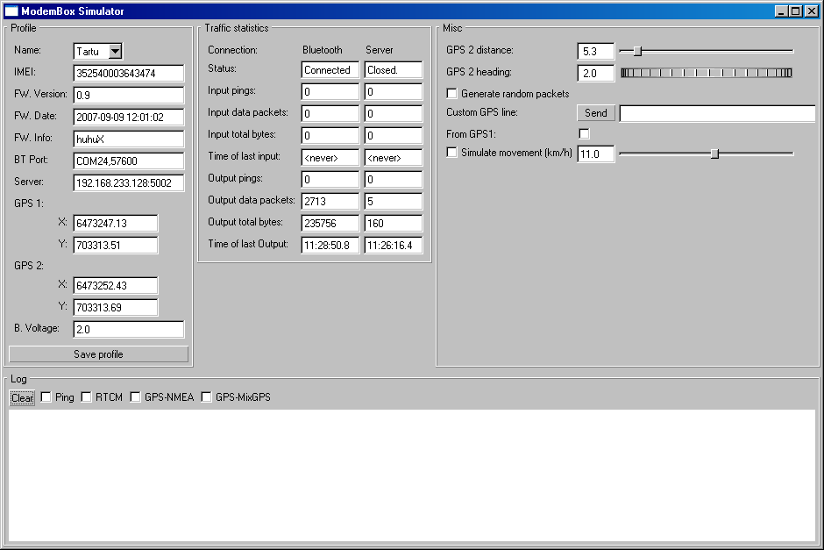
Figure 1: Main window.

Group “Profile”

Listbox “Name”: changes profile.

Button “Save profile”: stores profile in the initialization file.

Group “Traffic statistics”

Displays statistics at the packet/byte level.

Group “Misc”
Miscellaneous controls.
- GPS2 distance: GPS2 distance from GPS1 in meters
- GPS2 heading: heading of GPS2 in degrees
- Generate random packets: send random packets to TCP and BT connections
- Custom GPS line: Send entered text as a line coming from GPS. If tick is set then send from GPS2 else send from GPS1
- Simulate movement: change GPS coordinates as if ship would be moving with given speed in knots. Takes ship heading from GPS2 heading control. Does not take GPS positions relative to ship into account.

Group “Log”

Displays data logger.

Button “Clear” clears the log.

Joypad controls

One can move ship with attached joypad. Turning and acceleration is done with left analog stick. Button 7 initiates “turbo” mode where speed is multiplied by 5. Buttons 1-4 change voltages (11, 15, 24, 30 respectively). Button 10 toggles between movement simulation. When not in movement simulation mode one cannot move ship with controller. Voltage modification always works no matter what mode is selected.

