

**Final Degree Project**

**DEGREE IN COMPUTER SCIENCE**

**Facultat de Matemàtiques i Informàtica**

**Universitat de Barcelona**

**PREDICTING THE BRAIN DISTRIBUTION OF CONSEQUENCE BY MATHEMATICAL MEANS**

SUPPLEMENTARY MATERIAL

**Andrei Moldoveanu**

Directors: Dr. Ignasi Cos**, Universitat de Barcelona**

Dr. Mihaela Breaban**, University “Alexandru Ioan Cuza“ Iasi**

Realitzat a: Departament de Matemàtiques i Informàtica

Barcelona, 13 de Juny de 2022

|  |  |  |  |  |  |  |  |  |  |  |  |
| --- | --- | --- | --- | --- | --- | --- | --- | --- | --- | --- | --- |
| **Cluster ID** | **1** | **2** | **3** | **4** | **5** | **6** | **7** | **8** | **9** | **10** | **11** |
| **Center of Mass** | (44, -47, 44) | (39, 43, 20) | (31, 5, 54) | (32, 22, -1) | (1, 19, 46) | (-22, -66, 44) | (-27, 2, 53) | (-31, 22, -1) | (-37, -52, 46) | (-36, 51, 5) | (-44, 6, 28) |
| **Beneventi et al-An fMRI study of working memor..** | 0 | 0 | 1 | 1 | 1 | 0 | 0 | 1 | 1 | 0 | 1 |
| **Carrion et al-Frontal Hypoactivation on Func..** | 2 | 1 | 0 | 2 | 1 | 2 | 2 | 2 | 3 | 2 | 0 |
| **Di et al-Anterior cingulate cortex diff..** | 0 | 0 | 1 | 0 | 0 | 1 | 1 | 1 | 0 | 2 | 1 |
| **Drobyshevsky et al-A Rapid fMRI Task Battery for ..** | 1 | 0 | 1 | 0 | 1 | 1 | 1 | 0 | 1 | 0 | 0 |
| **Duggirala et al-Stimulus-dependent modulation ..** | 0 | 2 | 0 | 6 | 4 | 0 | 1 | 4 | 9 | 0 | 4 |
| **Lee et al-Abnormal neural activity in pa..** | 1 | 0 | 0 | 1 | 3 | 1 | 2 | 1 | 2 | 2 | 1 |
| **Padilla et al-Long-term brain effects of N-b..** | 3 | 0 | 1 | 0 | 3 | 0 | 2 | 1 | 1 | 1 | 1 |
| **Pochon et al-The neural system that bridges..** | 0 | 0 | 0 | 0 | 0 | 0 | 0 | 0 | 0 | 0 | 0 |
| **Rodger et al-Inhibit switch and update - ..** | 2 | 1 | 2 | 0 | 0 | 0 | 0 | 1 | 1 | 1 | 0 |
| **Schmidt et al-No gender differences in brain..** | 0 | 0 | 1 | 0 | 2 | 0 | 1 | 1 | 1 | 0 | 0 |
| **Seo et al-Working Memory Impairment in F..** | 1 | 0 | 1 | 1 | 4 | 1 | 0 | 1 | 1 | 0 | 1 |
| **Taylor et al-A functional neuroimaging stud..** | 0 | 2 | 1 | 0 | 3 | 0 | 2 | 0 | 2 | 2 | 0 |

Table 1 Each report contribution to significant clusters resulted in the meta-analysis for n-back task with visual stimuli experiment. The center values are in MNI reference space.

|  |  |
| --- | --- |
| **Cluster ID** | **1** |
| **Center of Mass** | (40, 20, -8) |
| **Cohen et al-Individual differences in extr..** | 0 |
| **John O Doherty et al-Neural Responses during Antici..** | 0 |
| **Kirscg et al-Anticipation of reward in a no..** | 2 |
| **Knutson et al-A region of mesial prefrontal ..** | 1 |
| **Knutson et al-Anticipation of Increasing Mon..** | 0 |
| **Knutson et al-Dissociation of reward anticip..** | 1 |
| **Koeneke et al-Individual preferences modulat..** | 1 |
| **Spreckelmeyer et al-Anticipation of monetary and s..** | 0 |

Table 2 Each report contribution to significant clusters resulted in the meta-analysis for contrast “Reward > No Reward” in the anticipation phase. The center values are in MNI reference space.

|  |  |  |  |  |
| --- | --- | --- | --- | --- |
| **Cluster ID** | **1** | **2** | **3** | **4** |
| **Center of Mass** | (12, 10, -3) | (2, 24, 28) | (-11, 8, -2) | (-20, -14, -14) |
| **Abler et al-From uncertainty to reward - B..** | 1 | 1 | 3 | 0 |
| **Croxson et al-Effort-Based Cost Benefit Valu..** | 1 | 0 | 1 | 0 |
| **Jarcho et al-Developmental effects of decis..** | 0 | 0 | 1 | 0 |
| **Knutson et al-Anticipation of Increasing Mon..** | 2 | 2 | 2 | 0 |
| **Knutson et al-Distributed Neural Representat..** | 3 | 1 | 3 | 1 |
| **Smith et al-Neural substrates of reward ma..** | 0 | 0 | 0 | 2 |
| **Spreckelmeyer et al-Anticipation of monetary and s..** | 6 | 2 | 7 | 0 |
| **Tobler et al-Reward Value Coding Distinct F..** | 1 | 0 | 2 | 1 |

Table 3 Each report contribution to significant clusters resulted in the meta-analysis for contrast "High > Low Reward" in the anticipation phase. The center values are in MNI reference space.

|  |  |
| --- | --- |
| **Cluster ID** | **1** |
| **Center of Mass** | (16, 11, -7) |
| **Christakou et al-Right Ventromedial and Dorsola..** | 0 |
| **Fujiwara et al-Segregated and Integrated Codi..** | 0 |
| **Greck et al-Is our self based on reward - ..** | 1 |
| **Lawrence et al-Distinct Roles of Prefrontal C..** | 0 |
| **Vassena et al-Dissociating contributions of ..** | 4 |
| **Xue et al-Functional Dissociations of Ri..** | 1 |

Table 4 Each report contribution to significant clusters resulted in the meta-analysis for contrast "Win > Lose" in the outcome phase. The center values are in MNI reference space.

|  |  |  |  |  |
| --- | --- | --- | --- | --- |
| **Cluster ID** | **1** | **2** | **3** | **4** |
| **Center of Mass** | (32, 25, -2) | (15, 11, -3) | (-1, 49, -7) | (-14, 9, -5) |
| **Abler et al-From uncertainty to reward - B..** | 1 | 1 | 1 | 3 |
| **Akitsuki et al-Context-dependent cortical act..** | 0 | 0 | 2 | 1 |
| **Christakou et al-Right Ventromedial and Dorsola..** | 0 | 0 | 0 | 1 |
| **Cohen et al-Individual differences in extr..** | 0 | 1 | 0 | 1 |
| **Cox et al-Learning to Like A Role for H..** | 0 | 0 | 0 | 1 |
| **Delgado et al-Tracking the Hemodynamic Respo..** | 0 | 2 | 0 | 4 |
| **Elliott et al-Dissociable Neural Responses i..** | 0 | 0 | 1 | 1 |
| **Elliott et al-Instrumental responding for re..** | 0 | 0 | 1 | 0 |
| **Glascher et al-Determining a Role for Ventrom..** | 1 | 0 | 1 | 0 |
| **Greck et al-Is our self based on reward - ..** | 0 | 2 | 0 | 1 |
| **Hauser et al-Role of the Medial Prefrontal ..** | 0 | 0 | 0 | 0 |
| **Jarcho et al-Developmental effects of decis..** | 3 | 1 | 0 | 0 |
| **John O Doherty-Dissociating Valence of Outcom..** | 0 | 2 | 0 | 1 |
| **Koeneke et al-Individual preferences modulat..** | 0 | 1 | 0 | 0 |
| **Lawrence et al-Distinct Roles of Prefrontal C..** | 1 | 0 | 2 | 0 |
| **Nieuwenhuis et al-Activity in human reward-sensi..** | 0 | 0 | 0 | 2 |
| **Schonberg et al-Decreasing ventromedial prefro..** | 0 | 0 | 1 | 1 |
| **Sescousse et al-The Architecture of Reward Val..** | 1 | 0 | 1 | 2 |
| **Smith et al-Distinct Value Signals in Ante..** | 1 | 0 | 6 | 2 |
| **Vassena et al-Dissociating contributions of ..** | 2 | 4 | 0 | 4 |
| **Winston et al-Brain systems for assessing fa..** | 0 | 0 | 0 | 0 |
| **Xue et al-Functional Dissociations of Ri..** | 0 | 1 | 3 | 4 |

Table 5 Each report contribution to significant clusters resulted in the meta-analysis for Decision Making in the outcome phase. The center values are in MNI reference space.

|  |  |  |
| --- | --- | --- |
| **Cluster ID** | **1** | **2** |
| **Center of Mass** | (-9, 6, 1) | (-19, -14, -15) |
| **Abler et al-From uncertainty to reward - B..** | 3 | 1 |
| **Cohen et al-Individual differences in extr..** | 0 | 0 |
| **Jarcho et al-Developmental effects of decis..** | 1 | 0 |
| **Koeneke et al-Individual preferences modulat..** | 0 | 0 |
| **Rosell-Negre et al-Monetary reward magnitude effe..** | 1 | 0 |
| **Smith et al-Neural substrates of reward ma..** | 0 | 2 |
| **Tobler et al-Reward Value Coding Distinct F..** | 3 | 1 |

Table 6 Each report contribution to significant clusters resulted in the meta-analysis for Decision Making in the anticipation phase. The center values are in MNI reference space.

## Group by experiment - contrast "Reward > No Reward" in the outcome phase

|  |  |
| --- | --- |
| **Cluster ID** | **1** |
| **Center of Mass** | (28, -3, -23) |
| **Cohen et al-Individual differences in extr..** | 1 |
| **Elliott et al-Differential Response Patterns..** | 1 |
| **Elliott et al-Instrumental responding for re..** | 2 |
| **John O Doherty et al-Neural Responses during Antici..** | 0 |
| **Knutson et al-A region of mesial prefrontal ..** | 0 |
| **Knutson et al-Dissociation of reward anticip..** | 0 |
| **Koeneke et al-Individual preferences modulat..** | 0 |
| **Schienle et al-Binge-Eating Disorder Reward ..** | 1 |
| **Sescousse et al-The Architecture of Reward Val..** | 0 |
| **Smith et al-Distinct Value Signals in Ante..** | 0 |

Table 7 Each report contribution to significant clusters resulted in the meta-analysis for contrast "Reward > No Reward" in the outcome phase. The center values are in MNI reference space.

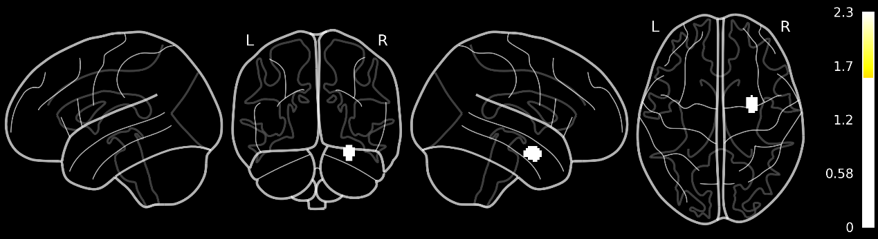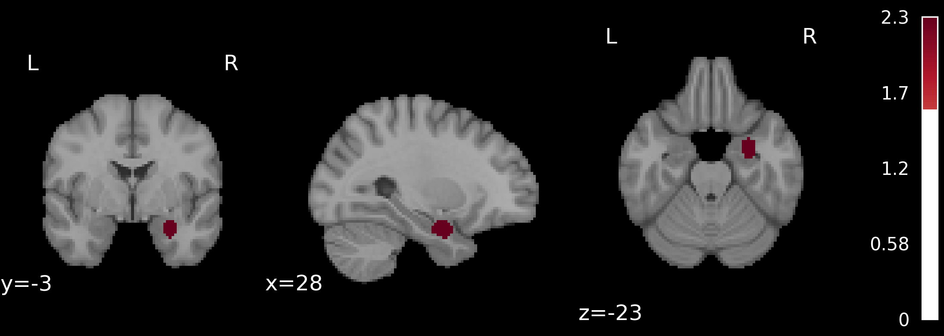

Figure 1 Significant clusters from the Activation Likelihood Estimation Meta-Analysis for contrast "Reward > No Reward" in the outcome phase, p < 0.05 corrected. On top is the z-map using a glass brain and down are the coronal, sagittal and axial sections of the chosen center. The maps are displayed using MNI152 Nonlinear template in MNI reference space and the values are for z-score one-tailed

|  |  |  |  |  |  |  |
| --- | --- | --- | --- | --- | --- | --- |
| Brain Areas | Cluster Index | #Voxels | z-score | COG X | COG Y | COG Z |
| (mm) | (mm) | (mm) |
| Temporal Lobe | 1 | 146 | 2.33 | 28.2 | -3.08 | -23.5 |

Table 8 Significant clusters for contrast "Reward > No Reward" in the outcome phase

## Group by experiment - contrast "High > Low Reward" in the outcome phase

|  |  |
| --- | --- |
| **Cluster ID** | **1** |
| **Center of Mass** | (1, 36, 9) |
| **Abler et al-From uncertainty to reward - B..** | 0 |
| **Cloutier et al-Are Attractive People Rewardin..** | 2 |
| **Delgado et al-Dorsal striatum responses to r..** | 0 |
| **Elliott et al-Dissociable Neural Responses i..** | 0 |
| **Jarcho et al-Developmental effects of decis..** | 0 |
| **Knutson et al-Dissociation of reward anticip..** | 0 |
| **Nieuwenhuis et al-Activity in human reward-sensi..** | 0 |
| **Signe Bray and John O'Doherty-Neural Coding of Reward-Predic..** | 1 |
| **Winston et al-Brain systems for assessing fa..** | 1 |

Table 9 Each report contribution to significant clusters resulted in the meta-analysis for contrast "High > Low Reward" in the outcome phase. The center values are in MNI reference space.

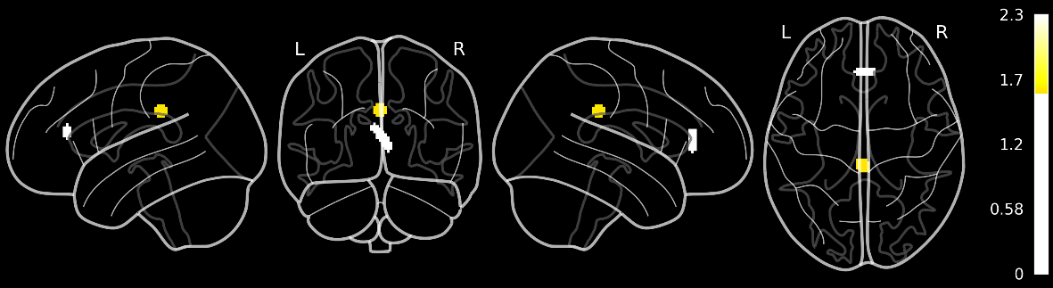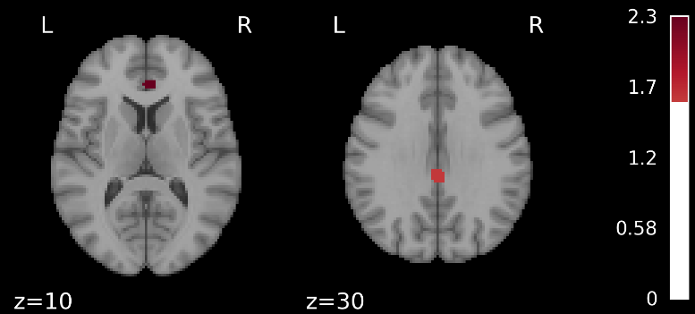

Figure 2 Significant clusters from the Activation Likelihood Estimation Meta-Analysis for contrast "High > Low Reward" in the outcome phase, p < 0.05 corrected. On top is the z-map using a glass brain and down are the axial sections for different values of z. The maps are displayed using MNI152 Nonlinear template in MNI reference space and the values are for z-score one-tailed

|  |  |  |  |  |  |  |
| --- | --- | --- | --- | --- | --- | --- |
| Brain Areas | Cluster Index | #Voxels | z-score | COG X | COG Y | COG Z |
| (mm) | (mm) | (mm) |
| Frontal Lobe, Parietal Lobe | 2 | 97 | 2.33 | 1.71 | 36 | 9.96 |
| 1 | 83 | 1.64 | -5.34E-05 | -32 | 30 |

Table 10 Significant clusters for contrast "High > Low Reward" in the outcome phase

## Group by experiment – Decision making in the decision phase

|  |  |
| --- | --- |
| **Cluster ID** | **1** |
| **Center of Mass** | (32, 24, 1) |
| **Lawrence et al-Distinct Roles of Prefrontal C..** | 0 |
| **Rogers et al-Distinct Portions of Anterior ..** | 1 |
| **Schonberg et al-Decreasing ventromedial prefro..** | 1 |
| **Vassena et al-Dissociating contributions of ..** | 1 |

Table 11 Each report contribution to significant clusters resulted in the meta-analysis for Decision Making in the decision-making phase. The values are in MNI reference space.

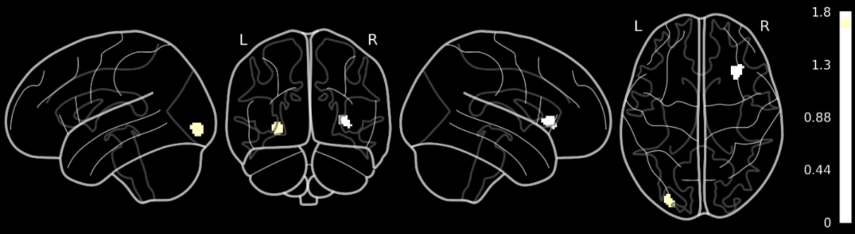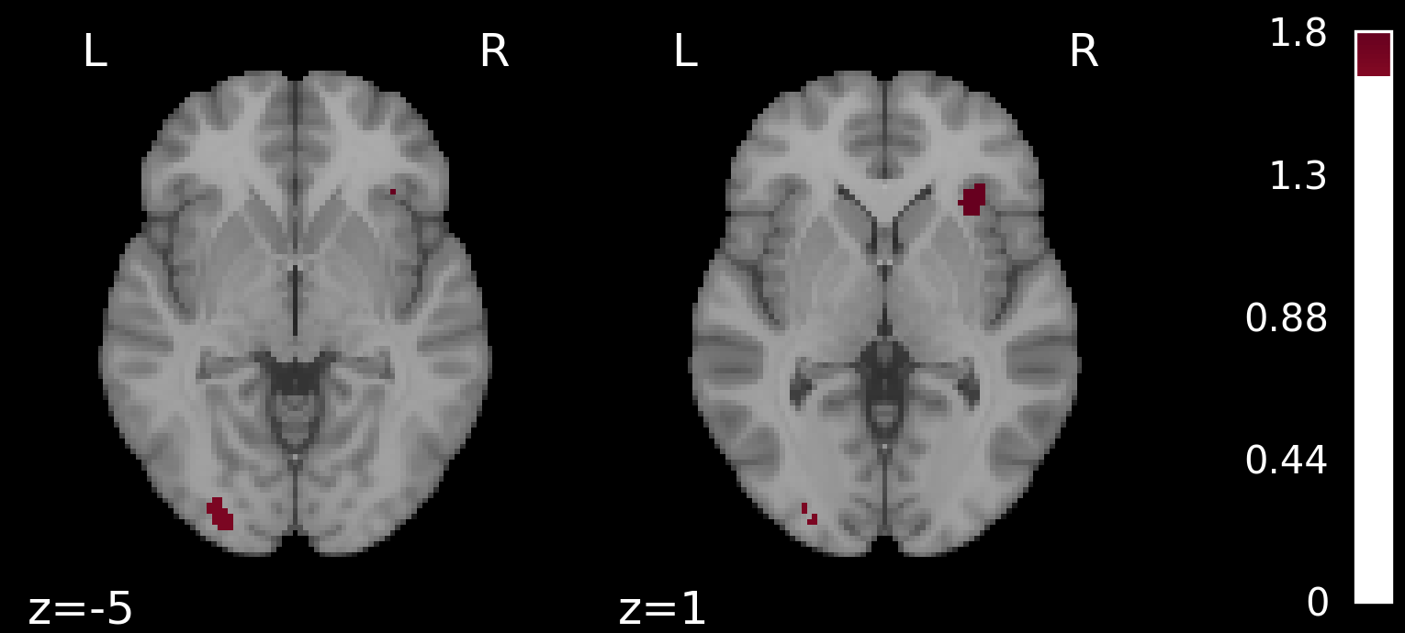

Figure 3 Significant clusters from the Activation Likelihood Estimation Meta-Analysis for decision making in the decision phase, p < 0.05 corrected. On top is the z-map using a glass brain and down are the axial sections for different values of z. The maps are displayed using MNI152 Nonlinear template in MNI reference space and the values are for z-score one-tailed

|  |  |  |  |  |  |  |
| --- | --- | --- | --- | --- | --- | --- |
| Brain Areas | Cluster Index | #Voxels | z-score | COG X | COG Y | COG Z |
| (mm) | (mm) | (mm) |
| Frontal Lobe, Insula, Occipital Lobe, Putamen | 2 | 91 | 1.75 | 32.2 | 24.6 | 1.82 |
| 1 | 78 | 1.64 | -27.9 | -91.6 | -4.77 |

Table 12 Significant clusters for Decision making in the decision phase