**Database Project**

**Project theme: Dispositive service**

1. **Design stage**

Defining tables, creating links between them, creating interface plus login and sign up. Performing the plug-in, update and deleting but also performing simple and complex queries.

1. **Description of tables**

The database consists of 6 tables of which one is related.

1. The employee table that continues ID_Angajat, the name and surname of the employee and his/her Email. The primary key to the table is ID_Angajat
2. The client table that continues the primary key ID_Client but also the specific fields of each client such as Name, Surname, Phone, Email, Address, City, County but also the Password with which they can connect on the site.
3. The corresponding link table that continues the Date primary key and the secondary keel ID_Client, ID_Serviciu, ID_Angajat and ID_Dispozitiv
4. The dispositive table that continues the primary key ID_Dispozitiv, Tip_Dispozitiv, Nume_Serviciului that applies to the device, ID_Client to see who it belongs to and ID_Angajat to see who oversees repairing it.
5. The invoice table that issues an invoice for each repaired device having a unique ID_Factura and besides that it also has the name and surname of the customer, the name of the repaired device but also the cost of repairing.
6. Table of services that continue all the services available by the site, each having a ID_Serviciu, which is also the primary key, the name of the service performed, the duration and cost of the service but also the id of the employee who handles that service
7. **Relationships between tables**
8. Clients – Devices, one to many. A client can repair several devices. But a device cannot belong to more than one person.
9. Services – Employees, one to many. An employee can do several services, but a service can be done by a single employee.
10. Clients – Bills, one to many. A client may have several invoices but on one invoice there may be only one customer.
11. Clients – Services, Many to many. A client can perform several services and a service can be offered to several clients.
12. Employees – Devices, one to many. A device can be repaired by a single employee, but an employee can repair several devices
13. **Operation of the application**

Customers can register on the site or log in with an email and password.

Customers can enter a data about the device they want to repair in the repair a device section of the main menu.

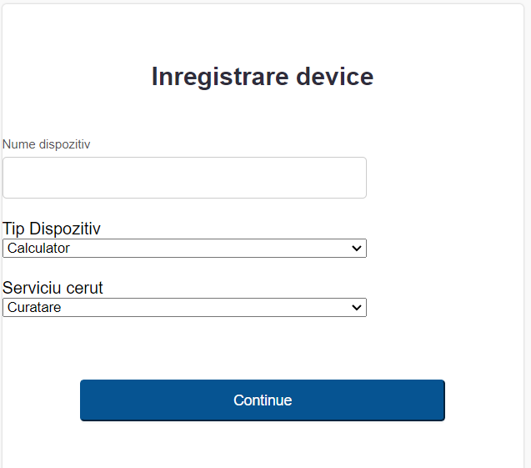

All devices registered by the client can be found in My devices as well as all queries made for this project.

The functionality of the application is also part of changing the password but also deleting an account.

1. **Simple interrogations**
2. Display the employees and all the services practiced for each of the employees: angajati_servicii_query.php:

$sql = "SELECT A.Nume_Angajat, A.Prenume_Angajat, S.Nume_Serviciu FROM angajat A JOIN servicii S ON S.ID_Angajat = A.ID_Angajat ORDER BY A.Nume_Angajat ASC";

1. Display the top 3 clients with the most repaired devices: top.php:

$sql = "SELECT C.textNume, C.textPrenume, COUNT(D.ID_Dispozitiv) AS Nr_dispozitive FROM clienti C JOIN dispozitive D ON C.ID_Client = D.ID_Client GROUP BY C.textNume, C.textPrenumeORDER BY Nr_dispozitive DESC LIMIT 3";

1. Display the name and total cost of repairs made by each employee: name_cost.php.

$sql = "SELECT A.Nume_Angajat, A.Prenume_Angajat, SUM(S.Cost_Serviciu) AS COST FROM angajat A JOIN dispozitive D ON A.ID_Angajat = D.ID_Angajat JOIN servicii S ON D.Nume_Serviciu = S.Nume_Serviciu GROUP BY A.Nume_Angajat, A.Prenume_Angajat ORDER BY COST DESC";

1. Display the name and type of the device with a repair time less than a time entered: dispozitive_tip_query.php

$sql = "SELECT D.Nume_Dispozitiv, D.Tip_Dispozitiv, S.Durata_Reparatie FROM dispozitive D JOIN servicii S ON S.ID_Angajat = D.ID_Angajat WHERE S.Durata_Reparatie < $durata ORDER BY D.Nume_Dispozitiv ASC";

1. Display the total repair cost for all recording devices: costtotal_simple_query.php.

$sql = "SELECT SUM(S.Cost_Serviciu) AS cost FROM servicii S JOIN dispozitive D ON S.Nume_Serviciu = D.Nume_Serviciu WHERE D.ID_Client = '$id_client'";

1. Check if there is an employee with the same name as the one entered from the keyboard: isangajat_simple_query.php

$sql = "SELECT CONCAT(A.Nume_Angajat, ' ', A.Prenume_Angajat) AS full_name FROM angajat A JOIN clienti C ON A.Nume_Angajat = C.textPrenume WHERE A.Nume_Angajat = '$nume'";

1. **Complex interrogations**
2. Display all devices registered by the current user: fetch.php.

$query = "SELECT ".$columnName." FROM $tableName"." WHERE ID_Client =

(SELECT ID_Client FROM clienti WHERE textEmail = '$Email'

ORDER BY ID_Client DESC Limit 1)

ORDER BY Nume_Dispozitiv ASC";

1. Display all services that have a lower cost than the average cost for all available services: fetch2.php

$query = "SELECT ".$columnName." FROM $tableName"."

WHERE Cost_Serviciu < (SELECT AVG(Cost_Serviciu) FROM servicii)

ORDER BY Cost_Serviciu ASC";

1. Display the name of the employee in charge of repairing a certain device: angajat_complex_query.

$query = "SELECT CONCAT(A.Nume_Angajat, ' ', A.Prenume_Angajat) AS full_name

FROM servicii S JOIN dispozitive D ON S.Nume_Serviciu = D.Nume_Serviciu

JOIN angajat A ON A.ID_Angajat = S.ID_Angajat

WHERE S.Nume_Serviciu = (SELECT Nume_Serviciu FROM dispozitive WHERE Nume_dispozitiv = '$Nume_Dispozitiv') AND Nume_dispozitiv = '$Nume_Dispozitiv' ";

1. Display the cost of repair for a device from the client's list: cost_complex_query.php

$query = "SELECT S.Cost_Serviciu FROM servicii S JOIN dispozitive D

ON S.Nume_Serviciu = D.Nume_Serviciu WHERE S.Nume_Serviciu =

(SELECT Nume_Serviciu FROM dispozitive WHERE Nume_dispozitiv = '$Nume_Dispozitiv') AND D.Nume_dispozitiv = '$Nume_Dispozitiv'";

1. **Insert**
2. Insert in the clients table, sign up on the site: registrationpaul.php

$reg = "INSERT INTO clienti (`textNume`, `textPrenume`, `textTelefon`, `textEmail`, `textAdresa`, `textOras`, `textJudet`, `textParola` ) VALUES ('$textNume', '$textPrenume', '$textTelefon', '$textEmail', '$textAdresa', '$textOras', '$textJudet', '$textParola')";

1. Plug-in for the devices you want to repair: devicerepair.php

$reg = "INSERT INTO dispozitive (`Nume_dispozitiv`, `Tip_dispozitiv`, `Nume_Serviciu`, `ID_Client`) VALUES ('$Nume', '$Tip', '$Serviciu', '$id_client')";

1. **Update**
2. Change your password when you're logged in: changepassword.php

$reg = "UPDATE clienti SET textParola = '$confirmpassword' WHERE textEmail = '$connected_email'";

1. Change the name of a device already entered: updatedevices.php.

$reg = "UPDATE dispozitive SET Nume_Dispozitiv = '$newname' WHERE Nume_Dispozitiv = '$oldname'";

1. **Delete**
2. Deleting the account for a client: deleteaccount.php

$reg = "DELETE FROM clienti WHERE textEmail = '$connected_email'";

1. Delete a device according to the name in the list: deletedevices.php.

$reg = "DELETE FROM dispozitive WHERE Nume_Dispozitiv = '$name'";