Technical_documentation_NUTS_enviro

Andrei Wong Espejo

# Introduction:

# Workflow:

Using the NUTS package we can:

* nuts_classify() detects the NUTS version(s) and level(s) of a data set. Its output can be directly fed into the two other functions.
* nuts_convert_version() converts your data to a desired NUTS version (2006, 2010, 2013, 2016, 2021). This transformation works in any direction.
* nuts_aggregate() aggregates data to some upper-level NUTS code, i.e., it transforms NUTS-3 data to the NUTS-2 or NUTS-1 level (but not vice versa).

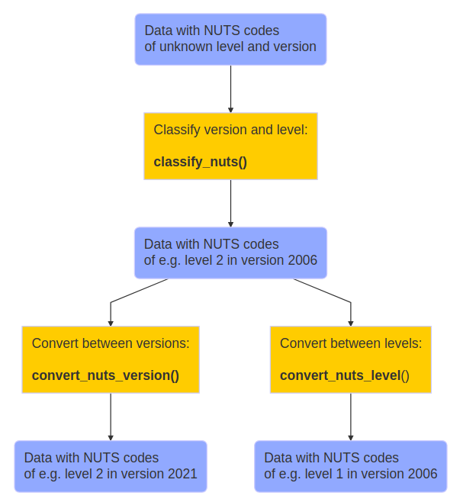

# Obtaining data

# Data cleaning and wrangling

# Data analysis and verification

1 + 1

[1] 2