Rap Music

* [My Beautiful Dark Fwisted Fantasy](mbdtf.htm)

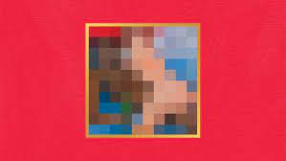

* [Pursuit Of Happiness by Kid Cudi](kid%20cudi.htm)

[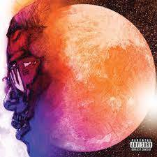](https://www.youtube.com/watch?v=7xzU9Qqdqww)