**Part 1:**

classroom(building,room-number,capacity)

department(dept-name,building,budget)

course(course-id,title,dept-name,credit)

instructor(ID,name,dept-name,salary)

section(course-id,sec-id,semester,year,building,room-number,time-slot-id)

teaches(ID,course-id,sec-id,semster,year)

student(ID,name,dept-name,tot-cred)

takes(ID,course-id,sec-id,semster,year,grade)

advisor(s-ID,i-ID)

time-slot(time-slot-id,day,start-time,end-time)

prereq(course-id, prereq-id)

Exercise. Write the following queries in SQL , using the db schema shown in next figures. (2.5% each) 1. Find the budget of the Music department. 2. Find the salary of the instructor, Mozart. 3. Find the ID and dept_name of the instructor, Mozart. 4. Find the titles of courses in the Comp. Sci. department that have less than 3 credits. 5. Find the ID s of all students who were taught by an instructor named Mozart. 6. Find the students being supervised (advised) by Mozart. 7. Find the courses taught by Mozart in 2010. 8. Find the classroom with the highest capacity. 9. Find the average capacity of the classrooms in Building A. 10. Find the department of the student Jonah. 11. Find the total credit taken by the student Jonah. 12. Find the number of courses that Jonah enrolled in. 13. Find the names of the courses that Jonah enrolled in during 2010. 14. Find the courses that Jonah took, and were taught by the instructor Mozart. 15. Find the average budget of each department. 16. Find the average salary of the instructors. 17. Find the names of the instructors earning above average salary. 18. Find the average total credit taken by students in Music department. 19. Find the lowest salary of the instructors in Computer Science department. 20. Find all instructors earning the lowest salary (there may be more than one with the same salary). 21. Find the course id, course title, section, semester and year, of all courses with enrollment less than 5 students. 22. Find the course id, semester and year, of all courses with enrollment more than 25 students in 2010. 23. Show the number of students being advised by Mozart. 24. Find the department with the highest number of courses. 25. Find the sum of the budgets of all departments. 26. Find the average salary in each department. 27. Find the adviser of the student called, Jonah. 28. Find the instructor with the maximum number of supervised students. 29. Find the average number of students being advised by each instructor. 30. Display the name of instructor and number of courses taught by this instructor in 2010. 31. Decrease the salary of each instructor in the Music. department by 5%. 32. Increase the salary of each instructor in Computer Science department by $100. 33. Delete all courses that were not offered in 2010. 34. Delete all instructors who didn’t teach any course in 2010. 35. Delete all instructors who are not supervisors in 2009 (not advising any students). 36. Delete all courses that have never been offered (that is, do not occur in the section relation). 37. Add the following new instructor: a. ID: 1001 b. Name: Michael c. Department: Computer Science d. Salary: $10,975 38. Insert every student whose tot cred attribute is greater than 150 as an instructor in the same department, with a salary of $9,000. 39. Create the following department: a. Marketing b. MarketII c. $150,000 40. Delete the department History.

**Part 2:**

**Question 1**

Consider the following relational model:

Actor (IDActor, Last Name, First Name, DateofBirth, Address)

Producer (IDProducer, Last Name, First Name, DateofBirth, Address) Movie (IDMovie, title, Year, category, IDProducer*)

Role (IDActor*, IDMovie*, role, salary)

Remark: category represents the movie genre category (action, comedy, drama, fiction, horror...)

Write in relational algebra the following queries:

a. Give the ID of actors who played in the movie "titanic".

b. Give the name of actors (last name and first name) who performed in comedy movies.

c. Give the name of actors (last name and first name) who didn't perform in any movie.

d. Give the name of producers (last name and first name) who produced both fiction and action movies.

e. Give the number of movies played by the actor “Youssef Elkhal”.

**Question 2**

Consider the following collection of relation schemes:

Professor (ProfID, FirstName, LastName, DeptID*)

Department (DeptID, DeptName, Building)

Committee (ComID, ComName)

Participate (ComID*, ProfID*)

a. Create the database using SQL Server with all the constraints, by running DDL SQL statements. Save the DDL files and submit them with your project.

b. Write a query that finds all the professors who are in any one of the committees that professor Piper is in.

c. Write a query that finds all the professors who are in at least all those committees that professor Piper is in.

d. Write a query that finds all the professors who have not offices in any of those buildings that Professor Piper has offices in.

NB: Save the queries and submit them with your project.

**Question 3**

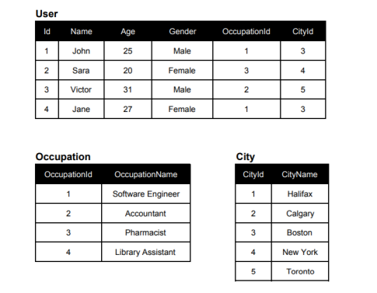

1. Solve the following relational expressions for the above relations.

a. πName (σAge>25 (User))

b. σAge>25ꓦAge!=31 (User

c. σUser.OccupationId=Occupation.OccupationId (User x Occupation)

d. User ⋈ Occupation ⋈ City

e. πName,Gender (σCityName=’Boston’ (User ⋈ City))

2. Create the above relations using SQL server with all the constraints

3. Write SQL statements for relational expressions in question 1. (10 points)

4. Write SQL statement to add occupation “Senior Accountant” to the Occupation relation.

5. Write SQL statement to change the occupation of “Victor” to “Senior Accountant”.

6. Write SQL statement to add “Salary” attribute to the User relation.

NB: Save all the queries and submit them with your project

**Question 4**

Consider the following collection of relation schemes:

Product (ProdID, Description, Price)

Customer (CustID, FirstName, LastName, Phone)

Order (OrderCode, Date, CustID*)

OrderDetails (OrderCode*, ProdID*, Quantity, Discount)

a. Create the database using SQL Server with all the constraints, by running DDL SQL statements. Save the DDL files and submit them with your project.

b. Create a query that returns all the customers information with their total amount of purchases during 2017.

c. Create a query that generates a report listing the products sold in 2017 with their total sold amount ordered in descending order.

d. Generate an invoice for a customer given the date of purchase. The invoice should include the customer info with the total quantity of purchased products, discount applied and total amount before TVA and with TVA.

NB: Save all the queries and submit them with your project.

**Part 3**

**Question 1**

We want to design a database to control sales of food items to restaurants. Consider the following:

• Each food item is identified by an ItemNo, Name and Description.

• A supplier is identified by a Supplier Number, Name and Contact.

• Restaurants are identified by a RestaurantID, Name, and branch. Moreover, we learned that:

• Each supplier in the database may make many sales or may not make any sales at all.

• Each food item may be involved in zero or more sales and restaurants may be involved in one or more sales.

• A sale is identified by a supplier, a restaurant and a food item, a quantity, a price and a sale date.

• Restaurants may have one or more employees, some of whom supervise other employees in the restaurant.

You are required to do the following tasks.

a. Draw E-R diagram with cardinalities and indicate your assumptions.

b. Give the relational model schema of the above ER-Diagram, showing all attributes primary and foreign key representation if exist

c. Draw the relational diagram

**Question 2**

UPS prides itself on having up-to-date information on the processing and current location of each shipped item. To do this, UPS relies on a company-wide information system. Shipped items are the heart of the UPS product tracking information system. Shipped items can be characterized by item number (unique), weight, dimensions, insurance amount, destination, and final delivery date. Shipped items are received into the UPS system at a single retail center. Retail centers are characterized by their type, uniqueID, and address. Shipped items make their way to their destination via one or more standard UPS transportation events (i.e., flights, truck deliveries). These transportation events are characterized by a unique scheduleNumber, a type (e.g, flight, truck), and a deliveryRoute.

• Create an Entity Relationship diagram that captures this information about the UPS system. Be certain to indicate identifiers and cardinality constraints.

**Question 3**

Production tracking is important in many manufacturing environments (e.g., the pharmaceuticals industry, children’s toys, etc.). The following ER diagram captures important information in the tracking of production. Specifically, the ER diagram captures relationships between production lots (or batches), individual production units, and raw materials.

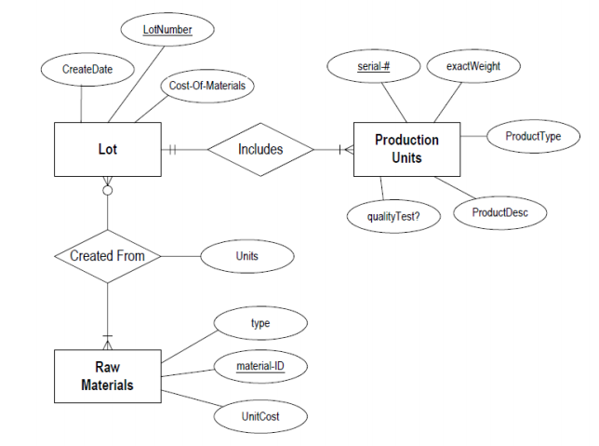

a. Please convert the ER diagram into a relational database schema. Be certain to indicate primary keys and referential integrity constraints.

b. Please identify an attribute in the above ER diagram that might represent a composite attribute, and explain why/how it might represent a composite attribute.

c. Please identify an attribute in the ER diagram that could represent a derived attribute and explain why/how it might represent a derived attribute.

d. The ER diagram/relational database schema contains several instances of data redundancy. Please identify one instance where a data redundancy issue exists.

e. The current ER diagram has the following relationship, “raw materials are used in 0 to many lots.” Please explain, in the context of the manufacturing environment, how the meaning changed if the minimal cardinality is changed to “1” (i.e., the relationship becomes "raw materials are used in 1 to many lots.”)

**Question 4**

We wish to build the database of a company that sells different products.

This company is composed of several agencies.

For each purchase made by a customer, the concerned agency must deliver an invoice which is the sale contract between the agency and the customer.

Every customer has a code, a name and a phone.

A customer can establish several invoices. An invoice has a number, a date and warranty duration.

An invoice concerns one agency and contains one or many products. An invoice is issued by one customer.

Each agency has a code, an address and a phone and has its proper stock.

Each product type has a reference, a designation and a unit price. Each product belongs to a category which has a reference and a VAT code. This company has many suppliers who each have a code, a name and a phone.

A same type of products can be supplied by many suppliers.

We must know the date, quantity and concerned agency by each delivery.

a. Construct the Entity-Relationship Diagram of the above information system.

b. Translate the ERD to Relational Model.