Image Retargeting

Project documentation

Student(s):

* Csatlos-Koncz Andrei

**Group: 30432**

**Contents**

I Project specification 3

II Project description 3

III Bibliography 10

# I Project specification

A C++ implementation of the [seam carving algorithm](https://en.wikipedia.org/wiki/Seam_carving) to perform content-aware image resizing. The algorithm works by searching for the lowest energy 'seam' in the image using dynamic programming techniques, and then removing that seam to reduce the size of the image, as below.

# II Project description

For implementing the algorithm, I used the following steps:

1. Rotate the image is we reduce by height so the height becomes the width.
2. Iterate for every number of times that we want to reduce.
3. Create an Energy Image

We create the energy Image by blurring the image to reduce noise, convert it to grayscale, use Sobel to calculate the gradient and convert the gradients to absolute values and scale them

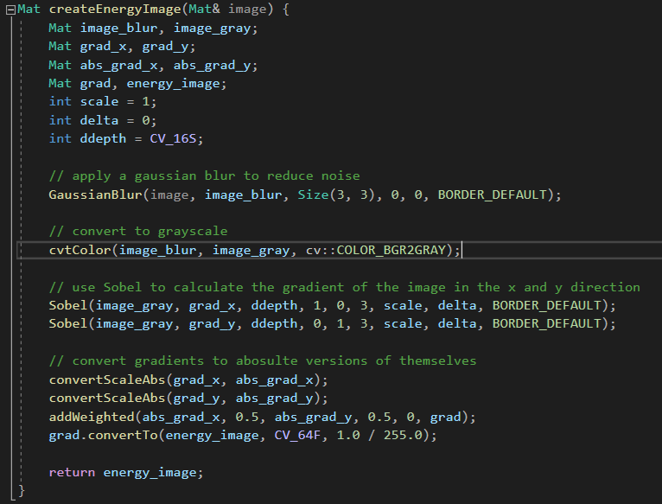

1. Create a Cumulative Energy Map

Create the map by copying the first, take the minimum of the three neighbors and add to total, this creates a running sum that is used to determine the lowest energy path

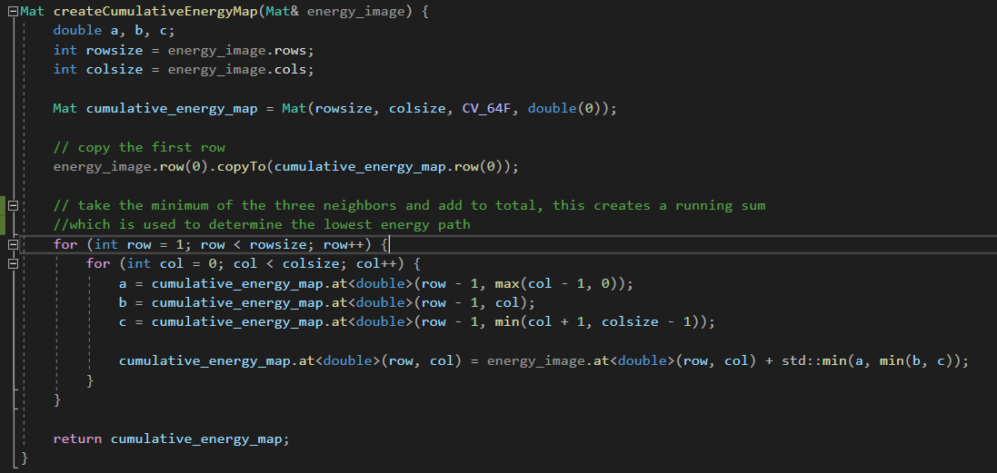

1. Find the optimal Seam and delete it

Copy the data from the last row of the cumulative energy map, get min and max values and locations, starting from the bottom, look at the three adjacent pixels above current pixel, choose the minimum of those and add to the path

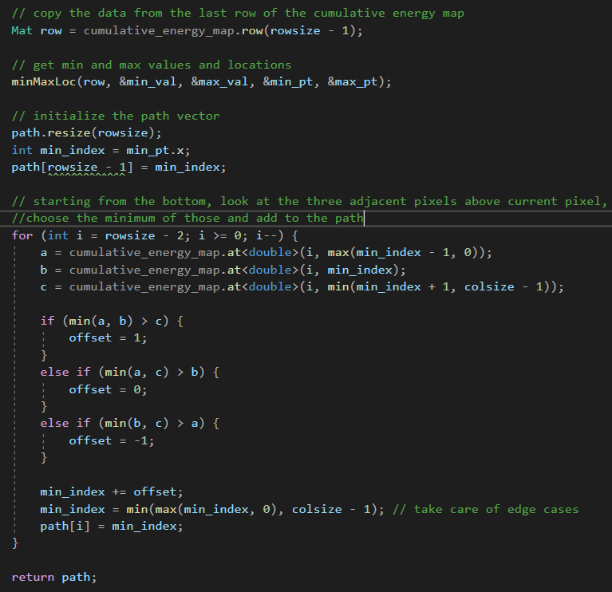

Initial Image:

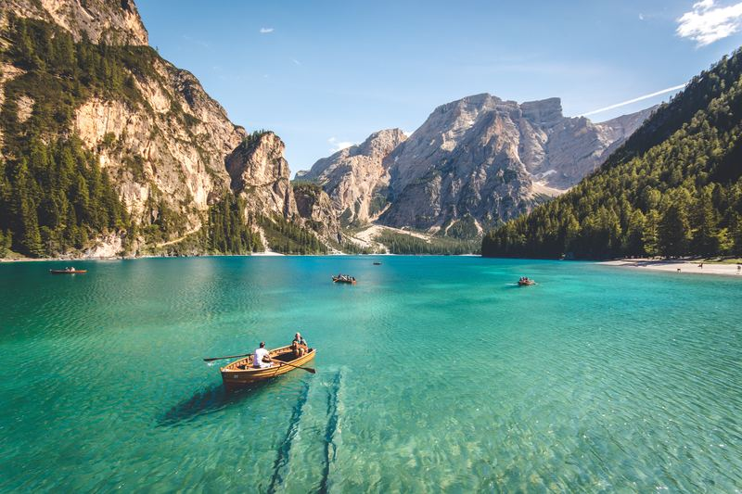

Shrinked Image:

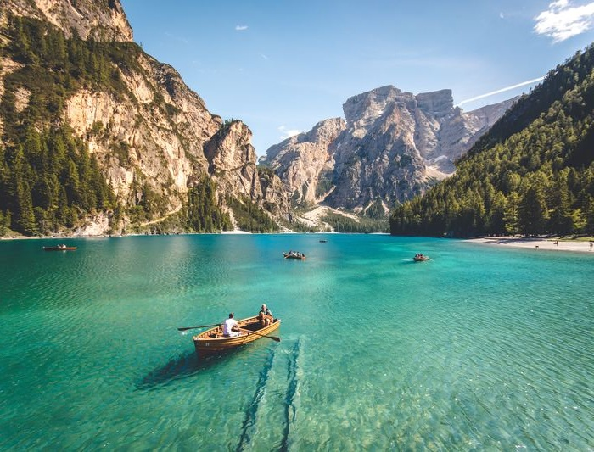

Initial Image:

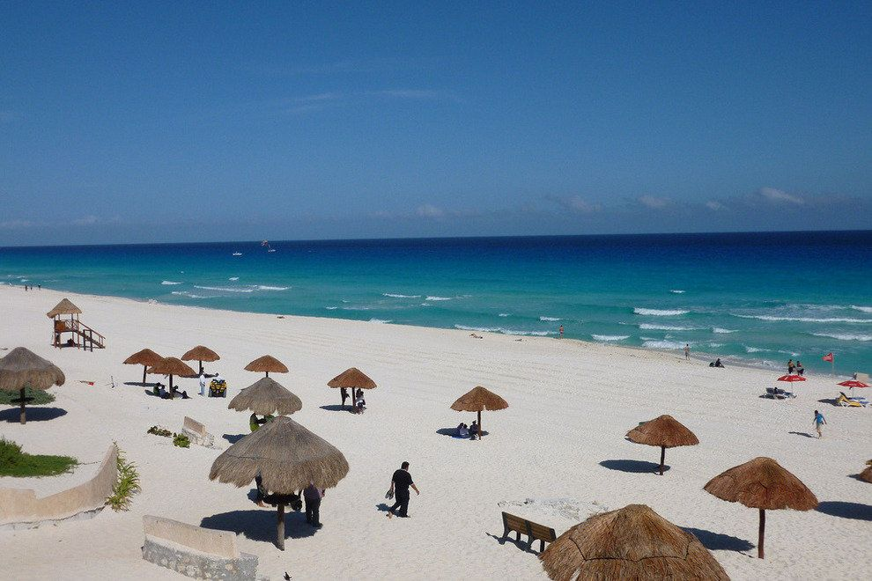

Shrinked by width image:

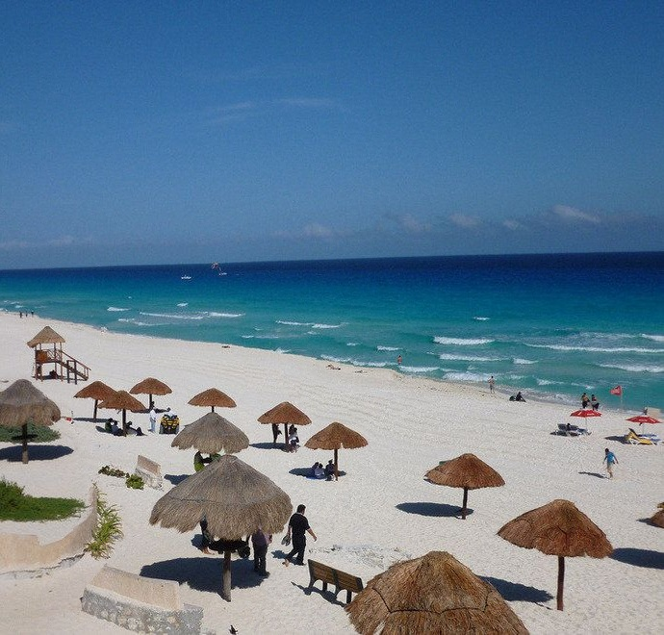

As we can see, there cannot be spotted a difference at the first glance, between the images even though they are shrinked significantly.

# III Bibliography

* <https://stackoverflow.com/>
* <https://reactjs.org/>
* <https://react-bootstrap.github.io/>
* <https://getbootstrap.com/>
* <https://www.baeldung.com/>