Reinforcement Learning Project
  - Kangaroo-v0

Eng. Andrei – Răzvan JOLDEA
Table of Contents
Game Description 3
Algorithms 4
Reinforce 4
SARSA 4
Deep Q-Networks (DQN) 5
Vanilla DQN 5
Double DQN (DDQN) 6
Advantage Actor-Critic (A2C) 6
Proximal Policy Optimization (PPO) 6
Asynchronous Advantage Actor-Critic (A3C) 6
Experimental Results 6
Reinforce 6
SARSA 6
Deep Q-Networks (DQN) 6
Double DQN (DDQN) 6
Advantage Actor-Critic (A2C) 6
Proximal Policy Optimization (PPO) 6
Asynchronous Advantage Actor-Critic (A3C) 6
Conclusions 6
References 6

Game Description
The Kangaroo-v0 environment, provided by the Gymnasium library, is a simulation of the 1983 Atari 2600 platformer game Kangaroo [1]. The primary goal for the agent is to navigate a mother kangaroo through a series of four vertically-arranged levels to rescue her joey. Hostile monkeys populate each level, throwing projectiles such as apples and baskets at the agent. Contact with either a monkey or a projectile results in the loss of one of three initial lives. Successfully reaching the joey at the top of the final stage awards points and resets the environment to the first level, but with an increased rate of projectile throws, thus elevating the difficulty [2].
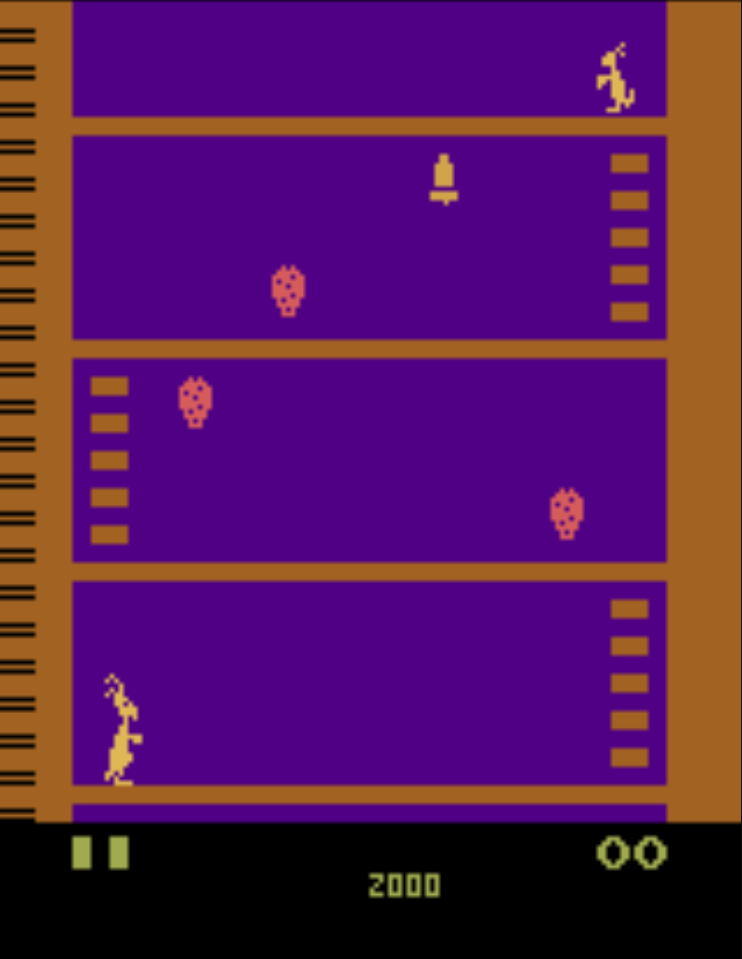
Figure 1: Screenshot from Atari Kangaroo
The action space for this environment is Discrete(18), representing the full range of inputs available from an Atari joystick. The eighteen integer actions correspond to the following joystick movements: 0 = NOOP, 1 = FIRE, 2 = UP, 3 = RIGHT, 4 = LEFT, 5 = DOWN, 6 = UPRIGHT, 7 = UPLEFT, 8 = DOWNRIGHT, 9 = DOWNLEFT, 10 = UPFIRE, 11 = RIGHTFIRE, 12 = LEFTFIRE, 13 = DOWNFIRE, 14 = UPRIGHTFIRE, 15 = UPLEFTFIRE, 16 = DOWNRIGHTFIRE, and 17 = DOWNLEFTFIRE. Game-specific maneuvers are executed through these actions. For instance, jumping is achieved with UP or diagonal UP movements, while punching requires activating the FIRE button in conjunction with a directional input. The NOOP action allows the agent to remain stationary, a useful tactic for timing movements [1].
By default, the observation space consists of 210 × 160 RGB image frames. A collision with an obstacle resets the agent to the bottom of the current screen, while the episode terminates when the agent loses all three of its lives.
The reward signal is derived directly from the in-game scoring system. Points are awarded for events such as punching a monkey (100 points) or collecting fruit (500 points). This score, which is visible in the top-right corner of the game screen, is provided as an incremental reward to the agent immediately following each scoring event [1].

Algorithms

Reinforce
The REINFORCE algorithm is a foundational policy gradient method in reinforcement learning. Its main goal is to learn a parameterized policy (like a neural network) that maps states to a probability distribution over actions.
The main ideas of the REINFORCE algorithms are simple:
- Actions that result in good outcomes (high cumulative rewards) are reinforced, meaning the policy is adjusted to make them more likely in the future.
- On the other hand, actions leading to bad outcomes are made less likely.
The algorithm works as follows:
- The agent uses its current policy to generate a complete episode or trajectory.
- For each step taken in the trajectory, it calculates the return (the sum of all future rewards from that point).
- The policy's parameters are then updated by adjusting them based on the gradient.
REINFORCE is an on-policy algorithm, meaning that the trajectories used to update the policy must have been generated by the most current version of that policy. This makes it a sample-inefficient method.

SARSA
SARSA is an on-policy, value-based reinforcement learning algorithm. The name „SARSA” stands for the sequence of data it uses for updates: State, Action, Reward, next State, next Action.
The main goal of SARSA is to learn the state-action value function, or Q-function, which estimates the value of taking a specific action in a given state.
The steps of the algorithm are:
- Starting in a state $s$, the agent uses its current policy (usually ε-greedy) to choose an action $a$.
- After performing the action, the agent observes the reward $r$ and the next state $s'$.
- Before updating, the agent uses the same policy to select the next action $a'$ it will take from the new state $s'$.
- Finally, it uses the complete $(s, a, r, s', a')$ tuple to update its $Q$-function estimate for the original state-action pair $(s, a)$ using a Temporal Difference (TD) learning update.
Similarly to REINFORCE, SARSA is also an on-policy algorithm. This is because the $Q$-value update for $(s,a)$ depends on the next action $a'$, which is selected by the current policy. As a result, experience gathered with an old version of the policy must be discarded after each update, making the algorithm less sample-efficient.

Deep Q-Networks (DQN)
Deep Q-Networks (DQN) is a value-based, off-policy alogrithm that uses a deep neural network to approximate the $Q$-function. Like SARSA, it is a Temporal Difference (TD) learning method, but it introduces changes that significantly improve stability and sample efficiency.
The main difference between DQN and SARSA is represented by how they calculate the target $Q$-value for an update. The on-policy SARSA algorithm uses the $Q$-value of the next action actually taken by its policy, while the off-policy DQN algorithm uses the maximum possible $Q$-value in the next state, assuming the agent will act optimally from that point on. This change allows the DQN to learn the true optimal $Q$-function regardless of how the data was collected.
DQN uses an Experience Replay buffer to store and sample random batches of past experiences for training. Instead of learning only from the most recent experience, the agent randomly picks experiences from this buffer to train on, meaning the agent doesn’t just learn from one sequence.

DQN with Target Networks
DQN with a target network is an improvement to the vanilla DQN designed to stabilize the algorithm's training process. It addresses is the “moving target” issue in the original DQN. In standard DQN, the same network is used to both estimate the current $Q$-value and calculate the target value for the update. Because this network's weights are updated at every step, the target value is constantly changing, which can lead to instability.
The solution to this problem involves using two separate neural networks: an online network that is updated at every training step, and a target network which is a lagged copy. During an update, the target $Q$-value is calculated using the stable, frozen parameters of this target network, which fixes the optimization goal for a period and makes the training process more stable, similar to standard supervised learning.

Double DQN (DDQN)
Double DQN is an improvement that addresses the overestimation of $Q$-values in standard DQN. It mitigates this issue by separating the process of selecting the best next action from evaluating its value. The algorithm uses the main online network to select the optimal action, but then uses the separate target network to evaluate the value of that chosen action. This leads to more accurate value estimates and improved learning performance.

DQN with Prioritized Experience Replay (DQN PER)
Prioritized Experience Replay (PER) is another improvement to DQN. It replaces the standard uniform random sampling from the replay buffer with a more intelligent, prioritized approach.
The main idea is that an agent learns more from experiences that are „surprising” or unexpected. PER exploits this by assigning a priority to each stored experience based on its Temporal Difference (TD) error. A large TD error signifies a large mismatch between the agent’s prediction and the actual outcome, indicating a valuable learning opportunity.
During training, experiences with a higher priority are more likely to be sampled. This focuses the training process on the examples the agent understands the least, making learning faster.

Advantage Actor-Critic (A2C)
Advantage Actor-Critic (A2C) is a policy gradient algorithm that combines a policy-based Actor with a value-based Critic. The Actor is a policy network that learns which actions to take, while the Critic is a value network that learns how to evaluate those actions. Unlike the REINFORCE algorithm, which uses high-variance Monte Carlo returns to update its policy, A2C uses a more stable, learned reinforcing signal from the Critic. This signal is the advantage function, which quantifies how much better a chosen action is compared to the average action in that state. Using the advantage function reduces the variance in the policy updates, leading to a more stable and efficient learning process.

Estimating Advantage with n-step Returns
The n-step return method estimates the advantage by combining $n$ rewards with the Critic’s value estimate of the state reached $n$ steps later. The choice of $n$ creates a trade-off between the low-variance but biased Critic estimate and the high-variance but unbiased sum of actual rewards.

Estimating Advantage with Generalized Advantage Estimation (GAE)
Generalized Advantage Estimation (GAE) improves the n-step returns by calculating advantage estimates for all possible step lengths. This is controlled by a hyperparameter, λ, which provides a better way to balance the bias-variance trade-off, increasing the chance of more stable and effective training.

Proximal Policy Optimization (PPO)
Proximal Policy Optimization (PPO) is a policy gradient algorithm designed to ensure stable training and improve sample efficiency. It does this by optimizing a surrogate objective function that constrains how much the policy is allowed to change from the version that collected the data.
This constraint is implemented in two ways:
- PPO with Adaptive KL Penalty: It adds a penalty to the update if the new policy tries to become too different from the old one. The strength of this penalty automatically gets stronger if the policy changes too much and weaker if it changes too little, trying to keep the updates within a target safe range. The main disadvantage is that it can be slow because calculating the difference between policies is complex.
- PPO with Clipped Surrogate Objective (PPO-Clip): It discourages large updates by directly clipping the probability ratio between the new and old policies within a small, predefined range. The final objective function then takes the minimum of the normal and clipped values.

Asynchronous Advantage Actor-Critic (A3C)
Asynchronous Advantage Actor-Critic (A3C) is a parallelized version of the A2C algorithm. It uses multiple worker agents, each running in its own environment, to independently collect experience and compute updates. These workers then send their updates asynchronously to a central global network.

Experimental Results

Reinforce

SARSA

Deep Q-Networks (DQN)

Double DQN (DDQN)

Advantage Actor-Critic (A2C)

Proximal Policy Optimization (PPO)

Asynchronous Advantage Actor-Critic (A3C)

Conclusions

References
[1]. https://gymnasium.farama.org/v0.28.1/environments/atari/kangaroo/
[2]. https://atariage.com/manual_html_page.php?SoftwareLabelID=923

