We're using Material Design standards for all design elements of the website.

**Theme overview:**

Our main colours are teal(primary) and red(secondary)

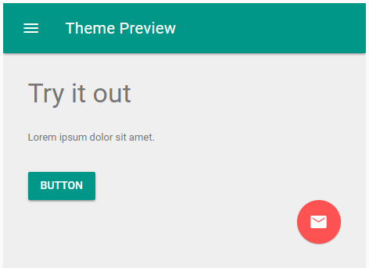

**Header:** 

**Header menu:**

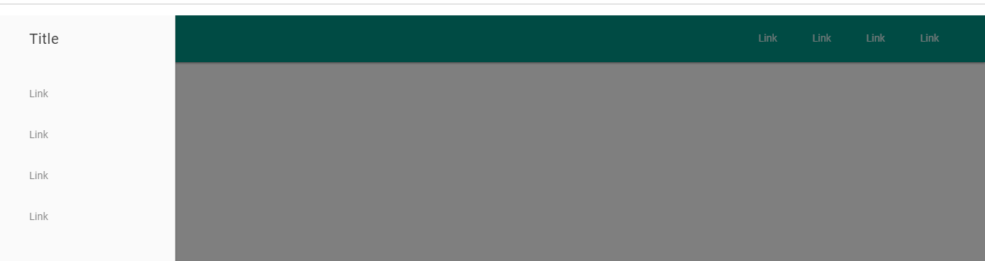

**Footer:**

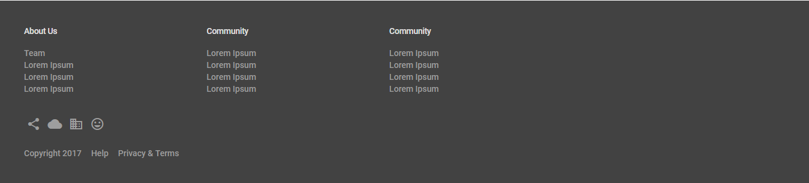

**Sliders:**



**Buttons:**

The first button is a flat button that becomes light grey (no change in font colour) and flashes a dark grey when clicked on.

The second button ripples from the point where it was clicked on.

 

Toggles:



Text boxes:

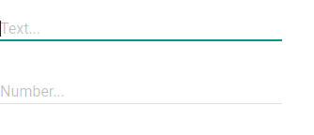

**Typography:**

