

**De La Salle University- Manila**

**Gokongwei College of Engineering**

LBYCPA1

Programming Logic and Design Laboratory

Project Proposal

DICER: A mix of poker and dices

Andrei Sebastian P. Baltazar

Cielbert L. Tan

**Project Description**

A dice game where five dice will be used. There is a scoring system for the points and what makes this unique is the difference in scoring the points. The goal of the game is to hit the limit that you have set. If you get a score below the minus it will go to the negative number the limit of the negative number is -1000. There would also be a bit of the poker rule where it has full-house, straight-flush, two-pair, etc.

**IPO**

Input:

The input for this project would be the player’s name as well as the chosen score limit. Aside from that the player can also input which dice to keep and which ones to roll again. The user's score will also be considered as input for the program.

Process:

The program will evaluate the user's input and perform the following tasks:

1. Calculate the score based on the combination of dice rolls (full-house, straight-flush, two-pair, etc.)
2. Check if the score is above or below the negative number limit
3. Check if the user has reached the goal of the limit
4. Display the score and game status to the user
5. Repeat the process until the user reaches the goal or goes below the negative limit

Output:

The output of the program would be the score and game status, which includes the current points, whether the user has reached the goal, or has gone below the negative limit. The program will also display the options for the user to roll the dice and choose which dice to keep.

The technical objectives of this project can be summarized as follows:

1. Develop a scoring system based on the combination of dice rolls
2. Implement the rules of the game, including the negative limit and the score limit
3. Design a user-friendly interface to display the score and game status
4. Ensure the program can handle user input and display the appropriate output
5. Test the program to identify and fix any bugs or errors

To achieve these objectives, the project will be done using the following steps:

1. Design the scoring system based on the combination of dice rolls
2. Develop the program using a programming language such as Python or JavaScript
3. Implement the game rules and user interface
4. Test the program using different input scenarios to ensure the program is functioning correctly

Refine and optimize the program based on the test results.

**Methodology**

Here is an overall system flowchart that shows how the project will work:

1. The program will start by displaying a welcome message and instructions to the user.
2. The program will ask the user to input their name and score limit and store it as a variable using Python's input() function.
3. The program will initialize the score to zero and create a loop that will continue until the user reaches the score limit or goes below the negative limit.
4. Inside the loop, the program will generate random numbers between 1 to 6 to simulate the dice rolls using Python's random.randint() function.
5. The program will display the dice rolls to the user and ask the user to choose which dice to keep using Python's input() function.
6. The program will calculate the score based on the combination of dice rolls using Python's conditional statements and arithmetic operations.
7. The program will check if the score is below the negative limit and if the user has reached the goal of 10,000 points using Python's conditional statements.
8. The program will display the score and game status to the user using Python's print() function.
9. If the user has reached the goal or has gone below the negative limit, the program will end the loop and display a message to the user.
10. If the user wants to play again, the program will ask the user and start a new game by resetting the score and looping back to step 4.

Python concepts that will be used to develop the project include:

1. Input() function to get user input for their name and which dice to keep
2. Random module to generate random numbers for the dice rolls
3. Conditional statements (if-else) to evaluate the score, check the game status, and end the loop
4. Arithmetic operations to calculate the score
5. Loops (for and while) to repeat the game until the user reaches the goal or goes below the negative limit
6. Print() function to display the score and game status to the user
7. Variables to store the user's name and the score.

**Schedule of Activities**

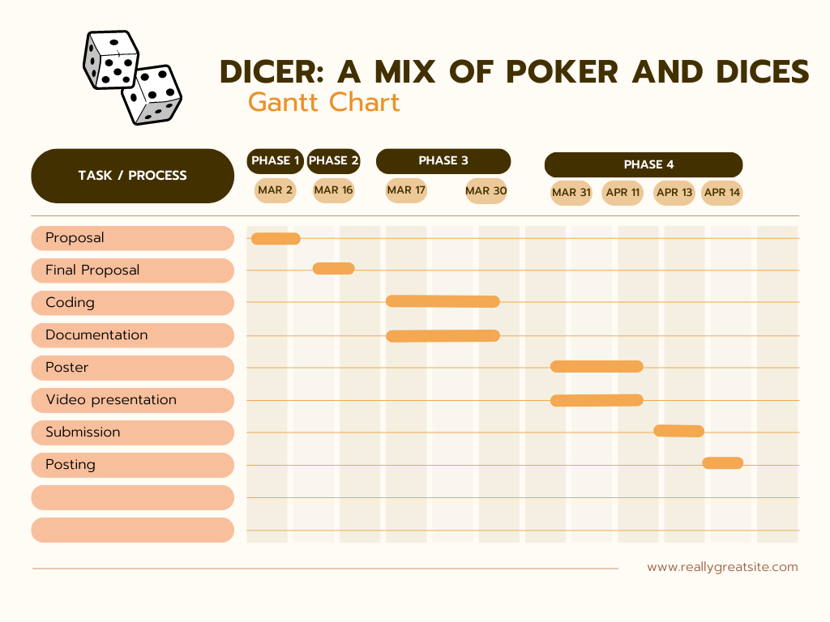

**References**

Cite the resources that will be used for the project.

Google Website or information that will guide or help us, if we ever get stuck or don’t know how to code this part.