Reproducibility Stress-Testing Reveals Fragility of an Alzheimer Disease-ALS ncRNA Biomarker Signature
Austin Liam Bautista
Institution and department to be added before submission
Correspondence: Andrei Lyle Bautista, email to be added before submission
Running title: Stress-testing an AD-ALS ncRNA signature
Keywords: Alzheimer disease; amyotrophic lateral sclerosis; non-coding RNA; lncRNA; biomarker discovery; transcriptomics; reproducibility; machine learning; external validation; GEO; differential expression; transportability

Abstract
Background: Alzheimer disease (AD) and amyotrophic lateral sclerosis (ALS) are clinically distinct neurodegenerative disorders, but both involve progressive nervous-system degeneration and molecular disturbances that include proteostasis, inflammation, and RNA-related biology. Public transcriptomic data provide a practical route for identifying candidate shared signals, yet biomarker claims derived from heterogeneous repositories require stringent reproducibility and validation checks.
Objective: We previously identified a five-ncRNA AD/ALS overlap consisting of MEG9, ZMIZ1-AS1, SLC12A5-AS1, GUSBP1, and STRCP1. The objective of the present study was to reconstruct and stress-test that signature as a methodological reproducibility question rather than as a discovery claim.
Methods: We performed a retrospective computational reproducibility audit using project-generated differential-expression, harmonization, validation, and model-transportability outputs derived from public GEO transcriptomic datasets. The evidence chain was evaluated across dataset provenance, gene-identifier harmonization, FDR thresholding, overlap definition, direction-of-effect consistency, independent AD validation, and bidirectional cross-disease transportability.
Results: The original five-gene overlap was recoverable as a nominal symbol-level overlap under a specific GSE203206 AD plus GSE124439 ALS path using FDR < 0.05. However, interpretation changed after stress-testing. Original reconstruction and Phase 2 fixed-panel validation outputs produced stage-specific estimates rather than interchangeable statistics. GSE48350 provided only 3/5 panel genes after harmonization and did not validate the full panel at FDR < 0.05. Directional review showed same-direction downregulation for MEG9, STRCP1, and ZMIZ1-AS1 in the original AD/ALS path, but opposite AD/ALS directions for SLC12A5-AS1 and GUSBP1. Cross-disease model transfer was near chance: train-AD/test-ALS AUC was 0.5007, and train-ALS/test-AD AUC was 0.4540.
Conclusions: A nominal five-ncRNA AD/ALS overlap can be reconstructed, but the stronger claim of a validated convergent biomarker signature is not supported. The evidence supports exploratory candidate prioritization, particularly MEG9 and STRCP1, with ZMIZ1-AS1 as a secondary candidate. The study provides a practical reproducibility stress-testing framework for public transcriptomic biomarker studies.

1. Introduction

1.1. Neurodegenerative disease and the appeal of shared molecular signatures
Alzheimer disease (AD) is the most common cause of dementia and is biologically characterized by amyloid-beta deposition, tau pathology, synaptic dysfunction, neuroinflammation, and progressive neuronal injury. Amyotrophic lateral sclerosis (ALS) is a fatal motor neuron disease characterized by degeneration of upper and lower motor neurons, with recognized contributions from RNA metabolism, protein aggregation, excitotoxicity, mitochondrial stress, and neuroinflammatory processes [1-3].
Although AD and ALS differ in clinical presentation, tissue vulnerability, and diagnostic framework, neurodegenerative diseases can share downstream stress biology. Transcriptomic studies are attractive in this setting because they provide disease-state measurements across genes, pathways, and regulatory RNA classes, and they can be reanalyzed across public datasets to test whether candidate molecular signals generalize beyond a single cohort [4].

1.2. Non-coding RNAs as candidate regulatory markers
Long non-coding RNAs (lncRNAs), antisense transcripts, and pseudogene-derived transcripts contribute to gene regulation through chromatin-associated, transcriptional, post-transcriptional, scaffold, decoy, and RNA-interaction mechanisms [5-7]. Their tissue specificity and regulatory roles make them biologically plausible candidate markers in neurodegenerative contexts, while their annotation complexity makes them unusually vulnerable to identifier and reference-version effects.
Prior reviews support a role for lncRNAs and other non-coding RNAs in nervous-system development, neuronal homeostasis, and neurodegenerative disease biology, but most disease-specific findings remain context-dependent and incompletely validated [8,9]. Therefore, ncRNA biomarker interpretation requires a clear distinction between differential expression, regulatory plausibility, replicated signal, and clinical biomarker validity.

1.3. Public transcriptomics and biomarker fragility
The Gene Expression Omnibus (GEO) and related transcriptomic resources enable transparent reanalysis of public expression datasets, but repository-based biomarker studies also inherit the limitations of the original submissions, including heterogeneous tissues, platforms, metadata quality, preprocessing decisions, and disease-control definitions [10,11]. These issues are magnified when discovery and validation datasets are not assigned stable roles before analysis.
Batch effects, laboratory effects, and platform effects can create systematic non-biological differences that resemble disease signal or impair prediction across cohorts. Batch correction and normalization can reduce some technical variation, but they do not replace independent validation, careful cohort design, or explicit transportability testing [12-14].
Identifier harmonization is another hidden source of instability. Human gene symbols, Ensembl identifiers, aliases, withdrawn symbols, and transcript annotations change over time, and mapping rules can alter whether a candidate gene is considered present, missing, duplicated, or overlapping across datasets [15-17]. For ncRNAs, where annotation and naming are less mature than for many protein-coding genes, these problems can directly determine whether an overlap appears.

1.4. Rationale for the present study
The initial analysis identified five shared ncRNA candidates across AD and ALS: MEG9, ZMIZ1-AS1, SLC12A5-AS1, GUSBP1, and STRCP1. It also reported a hypergeometric overlap p value of 0.0003, high internal disease-specific AUCs, and pathway enrichment involving neuroinflammation- and autophagy-associated categories. The present manuscript does not treat that result as a final discovery claim. Instead, it reconstructs the evidence chain and evaluates whether the biomarker interpretation remains supported under more conservative reproducibility checks.
The objective of this study was to determine whether a reported five-ncRNA AD/ALS biomarker signature remained supported after reconstruction of the original evidence chain and stress-testing against dataset provenance, identifier harmonization, overlap definition, directionality, independent validation, and cross-disease transportability.

2. Materials and Methods

2.1. Study design
This study was designed as a retrospective computational reproducibility audit and validation stress test of a fixed ncRNA candidate panel. The primary question was not whether new biomarkers could be discovered, but whether a previously reported five-gene AD/ALS overlap remained interpretable as a convergent biomarker signature after reconstruction and independent stress-testing.

2.2. Data sources and project artifacts
The analysis used project-generated differential-expression, harmonization, validation, and machine-learning output tables derived from public GEO transcriptomic datasets. The principal datasets were GSE203206 for AD discovery, GSE48350 for independent AD validation, GSE124439 for ALS reconstruction and Phase 2 validation, and GSE153960 as the public-facing Phase 1 ALS dataset that did not exactly match the original five-gene discovery path. GSE33000 was evaluated as an attempted AD validation dataset but had problematic fixed-panel coverage. Other exploratory datasets, including GSE95587, GSE173955, GSE125583, GSE255982, GSE116622, GSE76220, and GSE53697, were treated as provenance context only.
The core sample counts used in the project outputs were as follows: GSE203206 included 39 AD samples and 8 controls; GSE48350 included 33 AD samples and 140 controls; GSE153960 included 963 ALS samples and 280 controls; and GSE124439 included 145 ALS samples and 17 controls. These counts were used as project-specific values and were not re-estimated from external literature.

2.3. Dataset provenance reconstruction
Dataset provenance was reconstructed by tracking how datasets entered different project stages: early exploration, original five-gene overlap generation, public-facing Phase 1 framing, legacy final outputs, and Phase 2 validation. This provenance reconstruction was necessary because an overlap result can be reproducible under one data path while being incorrectly generalized to a different path.

2.4. Original signature reconstruction
The original five-gene result was reconstructed from the GSE203206 AD differential-expression output, the GSE124439 ALS differential-expression output, and the derived symbol-level overlap output. The reconstructed path used symbol-level harmonization and FDR < 0.05 in both diseases. The five genes were MEG9, GUSBP1, STRCP1, ZMIZ1-AS1, and SLC12A5-AS1.

2.5. Differential expression evidence extraction
For each fixed-panel gene, the extracted variables were gene symbol, biotype, disease dataset, log2 fold change, nominal p value, FDR, presence after harmonization, and observed direction. Direction was defined from the sign of log2 fold change, with negative values interpreted as downregulated in disease relative to control and positive values as upregulated in disease relative to control.

2.6. Identifier harmonization assessment
Identifier harmonization was assessed by distinguishing raw gene identifiers from gene symbols and by tracking whether each fixed-panel feature was present after mapping. Because Ensembl identifiers, HGNC-approved symbols, aliases, and ncRNA annotations may differ across reference releases, symbol-level overlap was interpreted as a harmonized result rather than as an invariant property of the raw matrices [15-17].

2.7. Overlap and sensitivity analysis
Overlap sensitivity was evaluated conceptually across FDR thresholds of <0.05, <0.10, and <0.20; same-direction requirements; effect-size thresholds; independent AD replication requirements; and dataset substitution. Hypergeometric overlap testing was interpreted cautiously because the result depends on the tested background universe, including which genes were measured, mappable, retained after filtering, and eligible for discovery [18,19].

2.8. Phase 2 fixed-panel validation
Phase 2 fixed-panel validation assessed the original five genes in GSE203206, GSE48350, and GSE124439. The validation question was whether each gene was present, directionally consistent, and statistically supported in a fixed-panel context. Fixed-panel FDR was interpreted separately from transcriptome-wide discovery FDR, because the number of tested hypotheses and the scientific question differ between discovery and validation.

2.9. Machine learning and transportability assessment
Machine-learning assessment distinguished internal or pooled discrimination from external transportability. Internal cross-validation and pooled analyses were considered insufficient to establish disease-agnostic validity because model selection, batch structure, class imbalance, feature selection, and cohort composition can lead to optimistic performance estimates if not handled within the resampling design [20,21].
Transportability was assessed bidirectionally by training on AD and testing on ALS, then training on ALS and testing on AD. Reporting was interpreted in the context of prediction-model guidance emphasizing transparent model development, risk-of-bias assessment, external validation, calibration, and careful distinction between model performance and clinical utility [22-26].

2.10. Gene-level classification
After audit, genes were classified into three categories: strongest exploratory candidates, secondary exploratory candidates, and remove or heavily qualify. Classification was based on reconstruction status, validation behavior, direction-of-effect consistency, missingness, and transportability implications.

2.11. Literature and citation strategy
External literature was used to contextualize disease biology, ncRNA regulation, public transcriptomic reanalysis, batch effects, identifier harmonization, multiple testing, overlap testing, machine-learning validation, biomarker standards, and reproducible computational workflows. Project-specific values, including sample counts, log2 fold changes, p values, FDR values, and AUCs, were taken from project outputs and were not replaced by external sources.

3. Results

3.1. Dataset provenance changed across project stages
Dataset tracking showed that the project moved through several dataset definitions. Early exploration included candidate AD and ALS datasets beyond the final evidence chain. The original five-gene overlap traced to GSE203206 for AD and GSE124439 for ALS. Public-facing Phase 1 materials described GSE203206, GSE48350, and GSE153960 as the principal datasets. Later legacy outputs included GSE203206, GSE48350, GSE153960, and GSE95587. Phase 2 validation focused on GSE203206, GSE48350, and GSE124439, with attempted GSE33000 evaluation (Figure 1A).
This instability mattered because the scientific meaning of the five-gene overlap depended on the exact discovery and validation path. The five-gene result was reconstructable, but it was analysis-path dependent.

3.2. The original five-gene overlap was reconstructable under one specific path
The original five-gene overlap was reconstructable as a nominal symbol-level overlap using GSE203206 for AD and GSE124439 for ALS with FDR < 0.05. The reconstructed genes were MEG9, GUSBP1, STRCP1, ZMIZ1-AS1, and SLC12A5-AS1 (Figure 1B). Table 1 reports the original reconstruction evidence from the GSE203206 AD and GSE124439 ALS symbol-level overlap output.
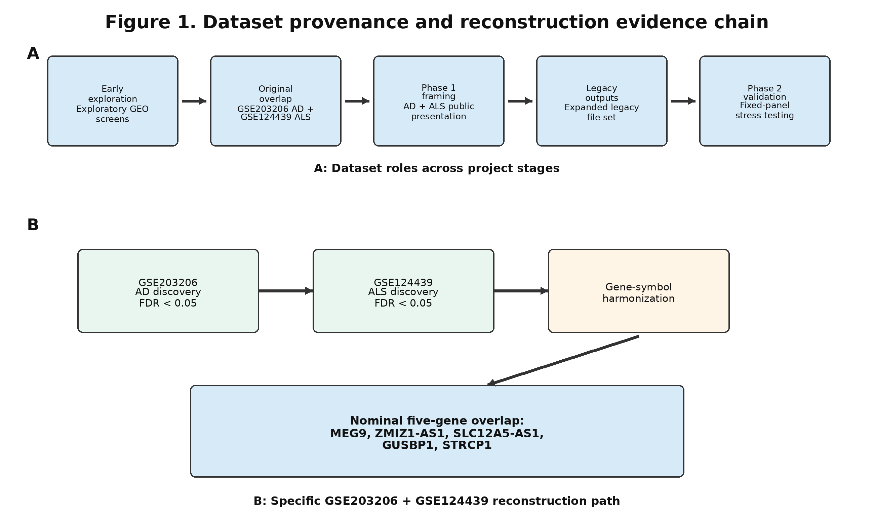
Figure 1. Dataset provenance and reconstruction evidence chain. (A) Dataset provenance timeline showing how datasets entered early exploration, original overlap generation, public-facing Phase 1 framing, legacy outputs, and Phase 2 validation. (B) Original GSE203206 AD plus GSE124439 ALS symbol-level evidence chain that produced the nominal five-gene overlap. The figure distinguishes reconstruction of a specific overlap from validation of a biomarker signature.
Table 1. Original reconstruction evidence for the five-ncRNA overlap.
Gene | AD log2FC | AD FDR | ALS log2FC | ALS FDR | Direction consistency | Conservative interpretation
MEG9 | -1.051 | 9.94e-05 | -0.756 | 0.03992 | Same down | Strongest exploratory candidate; not clinically validated
GUSBP1 | -0.7144 | 1.96e-04 | 0.3135 | 0.04759 | Opposite | Remove or heavily qualify
STRCP1 | -0.5727 | 0.009168 | -0.8831 | 0.02638 | Same down | Strong exploratory candidate; coverage-limited
ZMIZ1-AS1 | -0.5806 | 0.01575 | -0.6245 | 0.01655 | Same down | Secondary exploratory candidate
SLC12A5-AS1 | 0.2848 | 0.04934 | -0.5327 | 0.03208 | Opposite | Remove from strict convergence claim

Note: Original reconstruction values were derived from the GSE203206 AD and GSE124439 ALS symbol-level overlap path. FDR values correspond to the original reconstruction output.

3.3. Original reconstruction and Phase 2 validation produced stage-specific estimates
The original reconstruction table and Phase 2 fixed-panel validation table should not be interpreted as duplicate estimates from an identical pipeline. Although fixed-panel FDR recalculation can change adjusted p values by changing the number of tested hypotheses, it should not alter raw log2FC or nominal p values when the same normalized matrix, sample set, feature definition, and statistical model are used. The observed differences in log2FC and nominal p values between the original reconstruction outputs and Phase 2 fixed-panel validation outputs therefore indicate that the two tables reflect stage-specific analysis paths.
This stage-specific value drift was therefore treated as a reproducibility finding rather than a simple reporting inconsistency. The distinction strengthens the reproducibility interpretation: the project did not merely require reevaluation of adjusted significance thresholds, but also demonstrated pipeline-level drift between discovery reconstruction and validation. Accordingly, Table 1 is interpreted as evidence for reconstructing the original nominal overlap, whereas Table 2 summarizes a later fixed-panel validation framework. The two tables are not treated as directly interchangeable estimates.

3.4. Identifier harmonization and overlap definitions controlled whether the panel survived
The five-gene result depended on harmonization from raw identifiers to gene symbols. At the raw identifier level, AD and ALS outputs did not necessarily share comparable feature names. After symbol-level harmonization, the five genes appeared as overlapping ncRNA features (Figure 2A). This behavior is consistent with known risks in transcriptomic reanalysis, where annotation release, alias handling, and duplicated mappings can alter downstream overlap results [15-17].
The overlap was strongest under the narrow definition that reproduced the original path: GSE203206 plus GSE124439, symbol-level harmonization, and FDR < 0.05. It weakened when additional requirements were imposed, including same-direction effects, independent AD replication, and cross-disease transportability. These analyses separated nominal membership in an overlap from replicated, directionally consistent differential expression (Figure 2B).
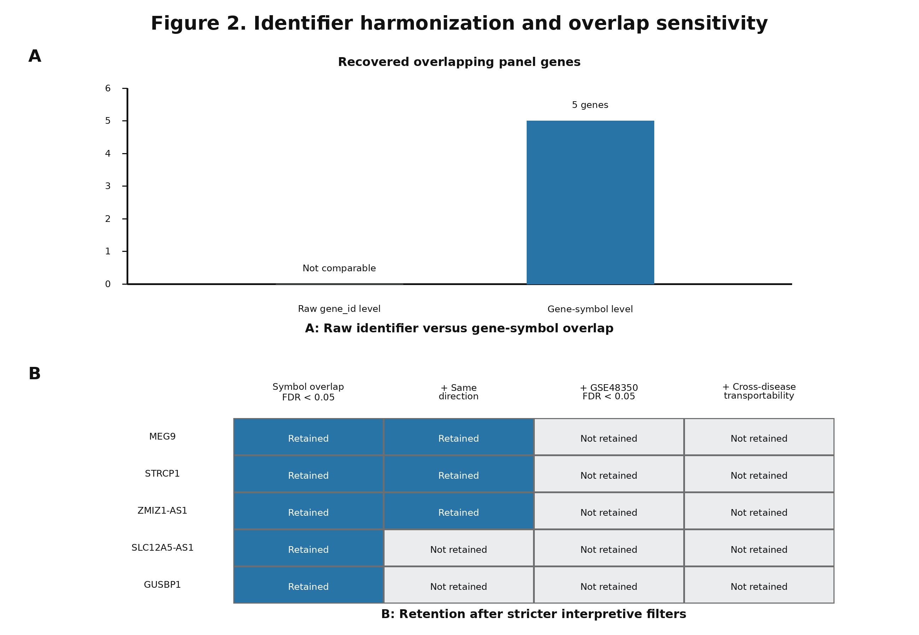
Figure 2. Identifier harmonization and overlap sensitivity. (A) Raw identifier-level comparison versus gene-symbol-level overlap. Symbol-level harmonization recovered the nominal five-gene overlap, emphasizing the importance of documented identifier mapping. (B) Overlap sensitivity under stricter interpretive filters. The full five-gene overlap was retained only under the original nominal symbol-level definition and weakened after directionality, independent validation, and transportability filters.

3.5. Directionality and independent validation weakened the full convergence claim
Direction-of-effect review showed that MEG9, STRCP1, and ZMIZ1-AS1 were downregulated in both original AD and ALS analyses. By contrast, SLC12A5-AS1 and GUSBP1 had opposite directions between AD and ALS in the original evidence chain. The Phase 2 fixed-panel direction matrix showed the same interpretive problem: MEG9 and STRCP1 were directionally consistent where present, ZMIZ1-AS1 was weakened by GSE48350 inconsistency, and SLC12A5-AS1 and GUSBP1 remained opposite-direction features relative to strict convergence (Figure 3A).
Independent AD validation further weakened the full panel. GSE48350 had only three of five genes present after harmonization: MEG9, ZMIZ1-AS1, and GUSBP1. None met FDR < 0.05 in that validation output; MEG9 was directionally down but not significant, ZMIZ1-AS1 was directionally up and not significant, and GUSBP1 was borderline at FDR = 0.05685. SLC12A5-AS1 and STRCP1 were absent. GSE33000 had problematic coverage and did not provide a reliable full-panel validation (Figure 3B).
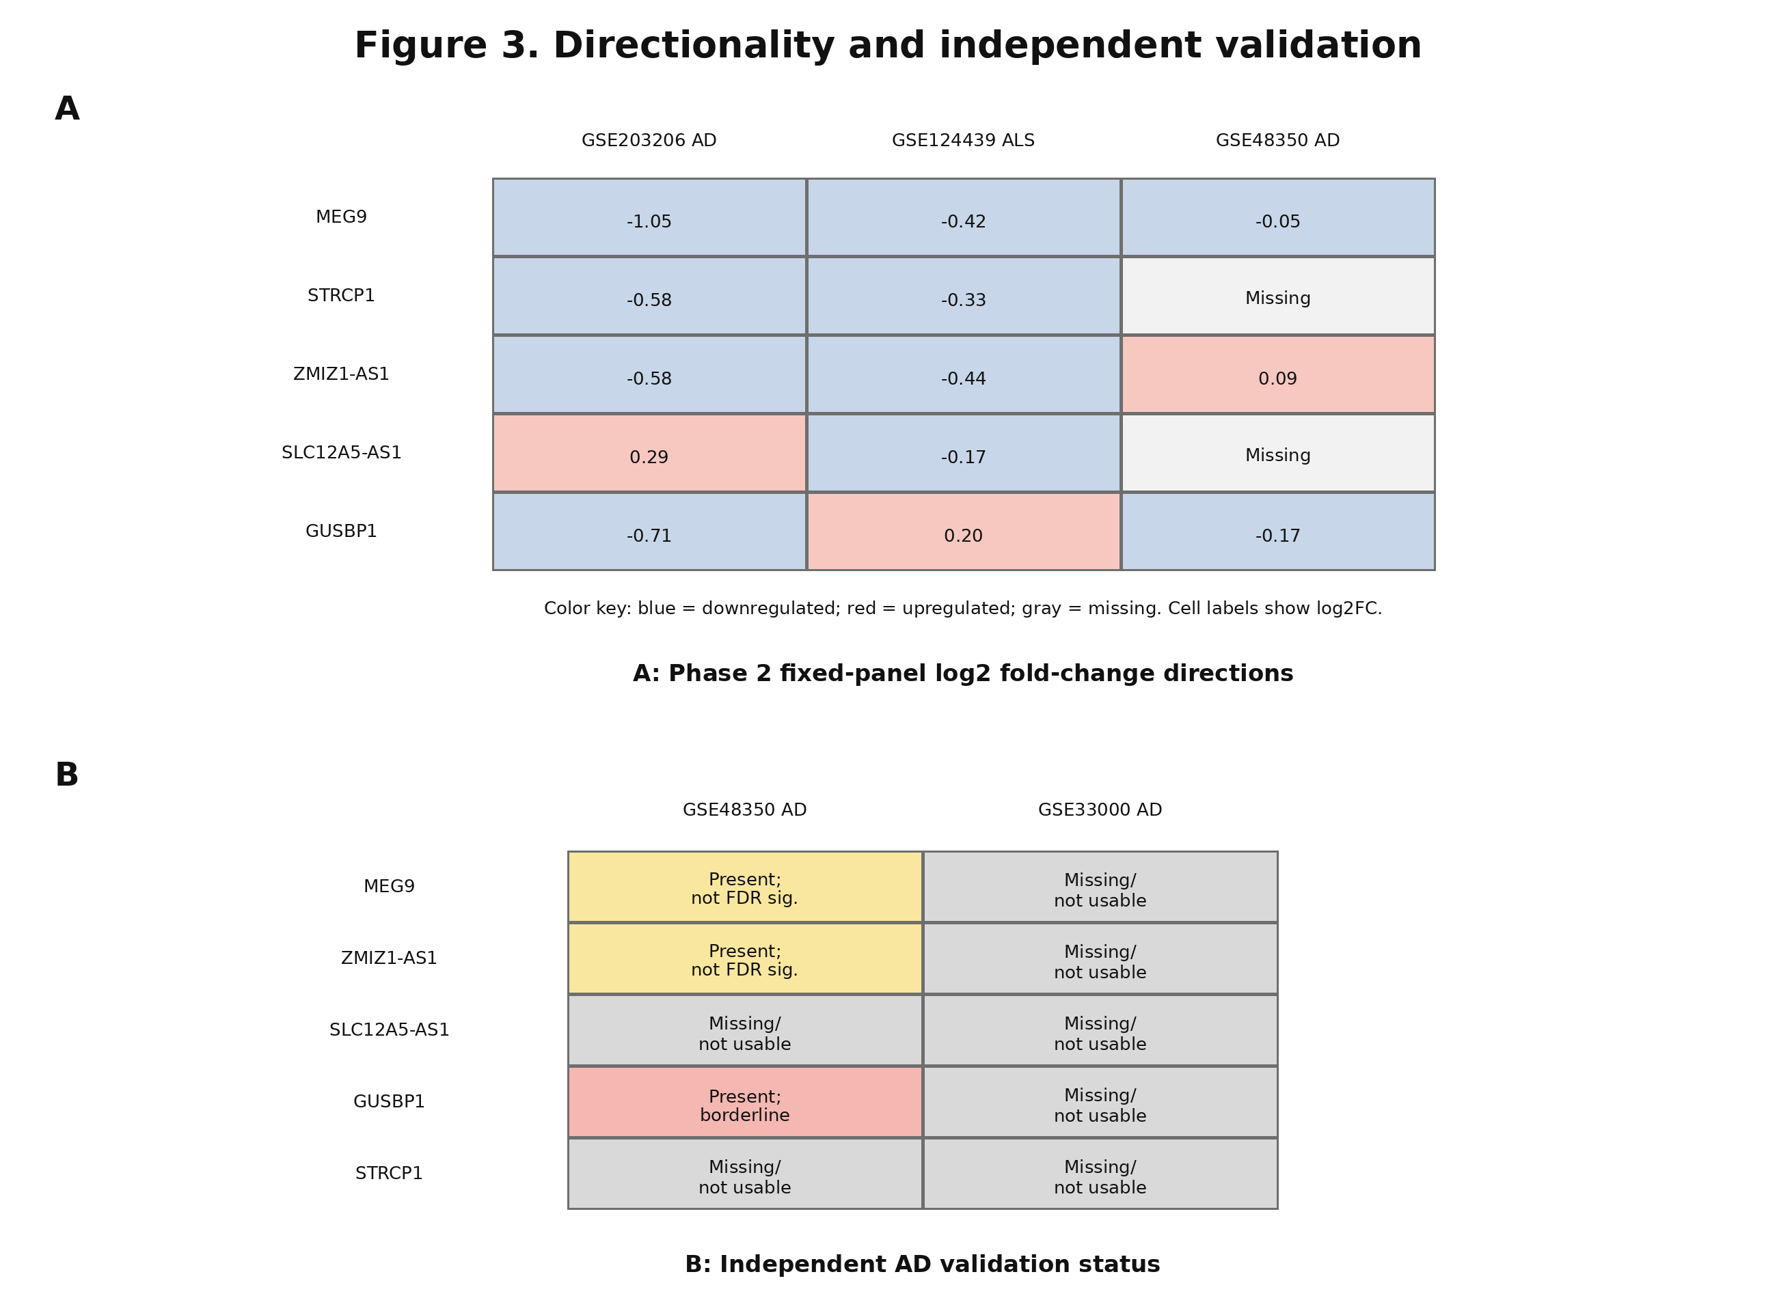
Figure 3. Directionality and independent validation. (A) Direction-of-effect matrix using Phase 2 fixed-panel validation values. Values are stage-specific estimates rather than a single uniformly reprocessed meta-analysis. The matrix highlights same-direction downregulation for MEG9 and STRCP1 where present, mixed validation behavior for ZMIZ1-AS1, and opposite AD/ALS directions for SLC12A5-AS1 and GUSBP1. (B) Independent AD validation matrix showing incomplete panel coverage and lack of full-panel FDR-significant validation in GSE48350 and GSE33000.

Table 2. Phase 2 fixed-panel validation output.
Dataset | Disease | Genes present | FDR-significant genes | Direction summary | Main interpretation
GSE203206 | AD | 5/5 | 5/5 | MEG9, STRCP1, ZMIZ1-AS1 directionally consistent with ALS; SLC12A5-AS1 and GUSBP1 opposite relative to ALS | Original AD path retained the panel but included opposite-direction genes relative to ALS.
GSE48350 | AD | 3/5 | 0/5 at FDR < 0.05 | MEG9 down but not significant; ZMIZ1-AS1 up and not significant; GUSBP1 borderline; SLC12A5-AS1 and STRCP1 missing | Independent AD validation was incomplete and did not validate the full panel.
GSE124439 | ALS | 5/5 | 5/5 | MEG9, STRCP1, ZMIZ1-AS1 down; SLC12A5-AS1 down and GUSBP1 up, opposite relative to original AD evidence | ALS fixed-panel output supported several genes statistically but did not rescue strict convergence for all five.

Note: Values from the Phase 2 fixed-panel validation framework are treated as stage-specific outputs rather than FDR-only recalculations of Table 1. Differences in log2FC or nominal p values across matching dataset/gene pairs may reflect differences in preprocessing, sample inclusion, normalization, feature handling, or statistical testing.

3.6. Internal predictive performance did not translate to cross-disease transportability
The original Phase 1 analysis reported high internal disease-specific AUCs: AD AUC = 0.949 and ALS AUC = 0.918. Phase 2 pooled/internal modeling also showed apparently strong discrimination, with a best fixed-panel model AUC around 0.879. However, bidirectional disease transfer did not support a disease-agnostic classifier: train-AD/test-ALS AUC was 0.5007 (95% CI, 0.4841-0.5130), and train-ALS/test-AD AUC was 0.4540 (95% CI, 0.3975-0.5308). These findings indicate limited cross-disease transportability despite high internal performance (Figure 4).
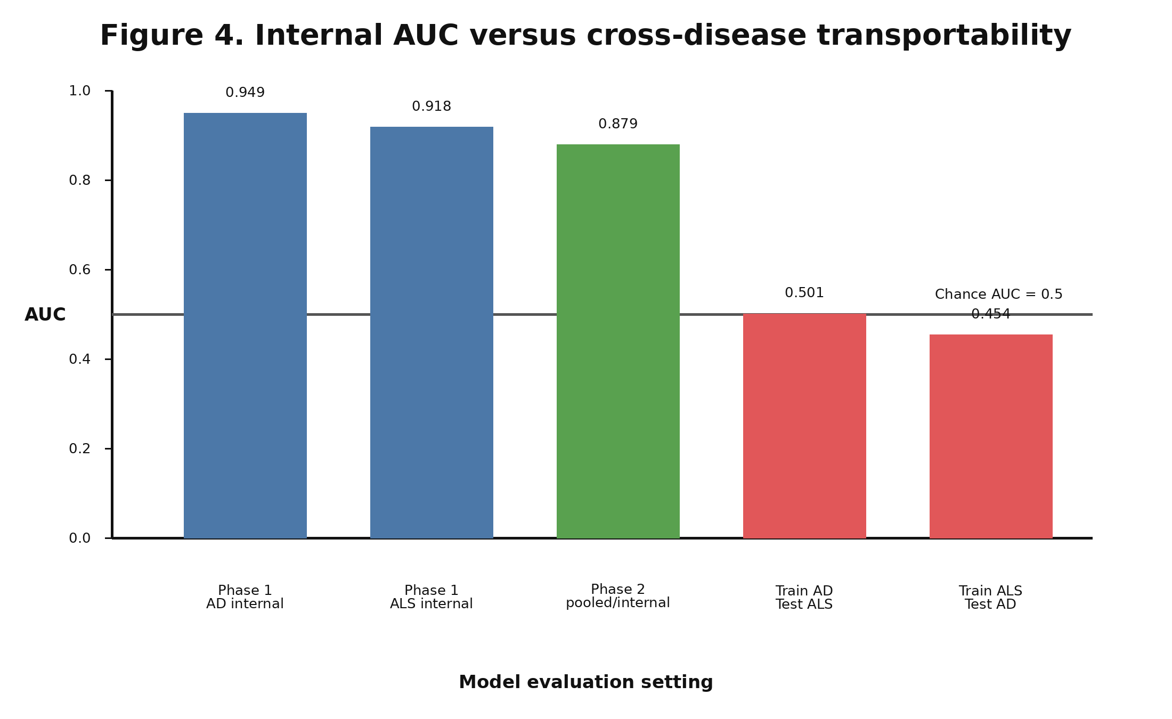
Figure 4. Internal AUC versus cross-disease transportability. Reported Phase 1 and pooled Phase 2 internal AUCs are shown alongside bidirectional cross-disease transportability results. Internal discrimination was high, whereas AD-to-ALS and ALS-to-AD transfer was near chance, indicating that internal or pooled AUC did not establish disease-agnostic generalization.

3.7. Gene-level interpretation downgraded the panel
The final gene-level classification supported a narrower interpretation. MEG9 was the strongest exploratory candidate. STRCP1 was also a strong exploratory candidate but was coverage-limited. ZMIZ1-AS1 remained a secondary exploratory candidate because independent AD validation was directionally inconsistent and not significant. SLC12A5-AS1 and GUSBP1 were removed from the strict convergence claim because their original AD/ALS directions were opposite.

Table 3. Final gene classification.
Gene | Validation behavior | Final classification | Manuscript recommendation
MEG9 | Down in original AD and ALS paths; not significant in GSE48350 | Strongest exploratory candidate | Prioritize for follow-up; avoid biomarker validity language
STRCP1 | Down where present; absent from GSE48350 | Strong exploratory candidate, coverage-limited | Retain as exploratory; require better coverage and orthogonal validation
ZMIZ1-AS1 | Supported in GSE203206 and GSE124439; up and non-significant in GSE48350 | Secondary exploratory candidate | Qualify convergence claim
SLC12A5-AS1 | Opposite original AD/ALS direction; missing in GSE48350 | Remove from strict convergence claim | Discuss as sensitivity failure, not convergent marker
GUSBP1 | Opposite original AD/ALS direction; borderline in GSE48350 | Remove or heavily qualify | Do not use as evidence of shared dysregulation

3.8. Final claim downgrade
The evidence downgraded the initial five-gene shared-biomarker interpretation to exploratory candidate prioritization. The final interpretation distinguishes nominal overlap, statistically enriched overlap, replicated differential expression, directionally consistent dysregulation, predictive signal, cross-disease transportability, and clinical biomarker validity. Only the first two were supported under the original path, and cross-disease transportability was not supported (Figure 5).
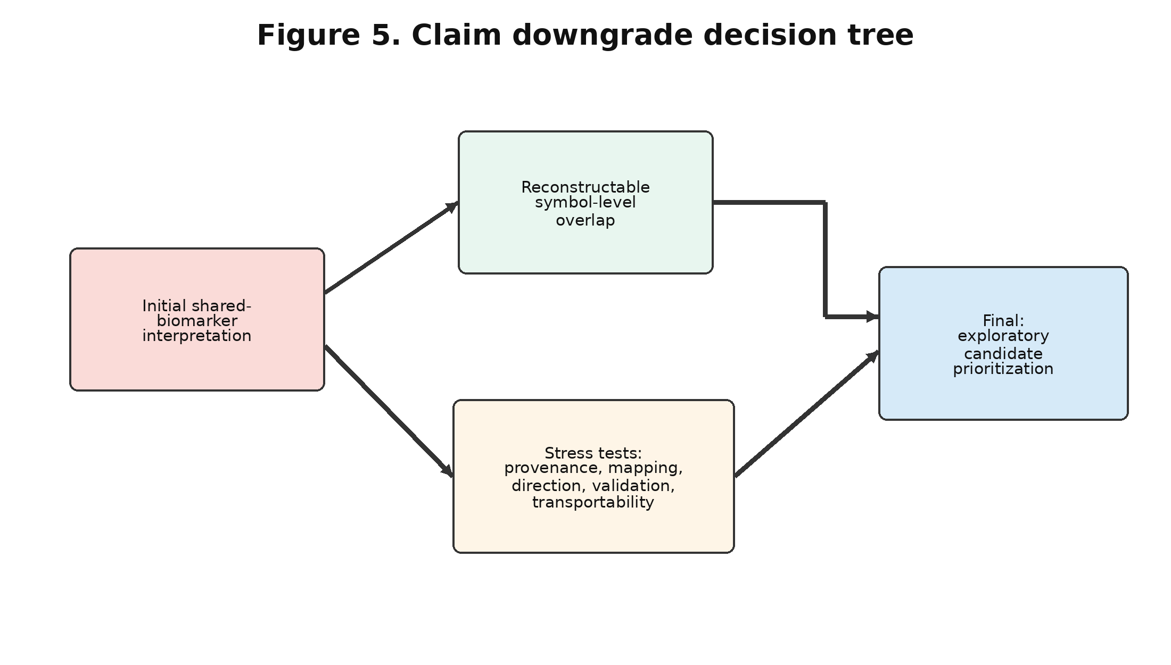
Figure 5. Claim downgrade decision tree. The figure shows the claim downgrade from an initial shared-biomarker panel interpretation to exploratory candidate prioritization after applying provenance, harmonization, directionality, validation, and transportability filters. MEG9 and STRCP1 were prioritized, ZMIZ1-AS1 was retained as secondary, and SLC12A5-AS1 and GUSBP1 were removed from the strict convergence claim.

4. Discussion

4.1. Principal findings
This study reconstructed and stress-tested a reported five-ncRNA AD/ALS biomarker signature. The principal finding is balanced: the original overlap can be recovered, but the biomarker interpretation is fragile. Dataset provenance, stage-specific value drift, symbol-level harmonization, overlap definition, directionality, independent AD validation, and cross-disease transportability all changed the strength of the claim.
The most important quantitative finding was the contrast between internal discrimination and external transfer. A model can perform well in internal or pooled settings and still fail when trained on one disease and tested on another. Here, bidirectional cross-disease AUCs were near chance, which argues against disease-agnostic biomarker performance.

4.2. Why nominal overlap is not equivalent to biomarker validation
A nominal overlap means that the same gene symbols appeared in two disease-associated lists. It does not establish that the genes are clinically useful biomarkers, that the effects replicate independently, or that the panel generalizes across cohorts. Biomarker validation requires a defined test, locked features, independent samples, transparent performance estimates, and an intended use context [22-26].
The present findings therefore support exploratory candidate prioritization rather than clinical validation. This distinction is especially important in high-dimensional transcriptomics, where many features are tested and small changes in filtering, annotation, or cohort composition can alter the candidate list.

4.3. Identifier harmonization as a hidden source of biomarker instability
Identifier harmonization was central to the reconstruction. Gene symbols are human-readable and convenient, but they are not immutable. Ensembl identifiers, HGNC symbols, transcript IDs, aliases, and withdrawn names require versioned mapping, and duplicate or missing mappings must be handled explicitly [15-17].
This issue is particularly important for ncRNAs. Some lncRNAs and pseudogene-derived transcripts have limited functional annotation, incomplete cross-platform coverage, and inconsistent naming across resources. In this project, panel coverage differed across datasets, and GSE48350 lacked SLC12A5-AS1 and STRCP1 after harmonization.

4.4. Multiple testing and overlap universe assumptions
The Phase 1 overlap p value was historically reported as hypergeometric p = 0.0003. Hypergeometric testing is appropriate for overlap enrichment only when the background universe is defined. The relevant universe is not all human genes; it should be the set of genes that were measured, passed filtering, were mappable across datasets, and were eligible for selection [18,19].
Similarly, discovery FDR and fixed-panel validation FDR answer different questions. Transcriptome-wide discovery FDR controls multiplicity across many tested features, whereas fixed-panel FDR controls a much smaller set of prespecified genes. Treating fixed-panel validation significance as equivalent to transcriptome-wide discovery evidence can overstate support.

4.5. Direction-of-effect replication should be required for cross-disease convergence
Shared gene membership alone is insufficient for cross-disease convergence. If a feature is upregulated in one disease and downregulated in another, the result may still be biologically interesting, but it should not be described as a simple shared dysregulation signature unless the reversal is prespecified and mechanistically justified. In this analysis, SLC12A5-AS1 and GUSBP1 failed the strict same-direction criterion.

4.6. Machine learning validation and transportability
The transportability results are consistent with known risks in high-dimensional biomarker modeling. Feature selection performed outside resampling, pooled cross-validation across heterogeneous cohorts, class imbalance, and unmodeled dataset effects can produce optimistic performance estimates [20,21]. Reporting frameworks such as TRIPOD, PROBAST, TRIPOD+AI, and STARD emphasize transparent data partitioning, model specification, validation, and calibration [22-25].
In this study, cross-disease transportability was the decisive stress test. AD-to-ALS and ALS-to-AD transfer produced AUCs of 0.5007 and 0.4540, respectively. These values indicate limited disease-agnostic generalization, even though internal or pooled AUCs appeared high.

4.7. Biological interpretation after audit
MEG9 and STRCP1 showed the most consistent evidence in the available project outputs. MEG9 was downregulated in the original AD and ALS paths and remained directionally down in GSE48350, although without statistical significance. STRCP1 was downregulated where present but was missing from GSE48350, making its validation coverage incomplete.
ZMIZ1-AS1 remained biologically and statistically interesting but was downgraded because it was upregulated and non-significant in GSE48350. SLC12A5-AS1 and GUSBP1 were not retained in a strict convergence claim because each showed opposite direction between original AD and ALS evidence. Mechanistic interpretation of all five genes should remain hypothesis-generating, particularly because gene-specific neurodegeneration literature for several of these ncRNAs is sparse.

4.8. Implications for public transcriptomic biomarker studies
Future public transcriptomic biomarker studies should freeze dataset roles, define discovery and validation cohorts before analysis, document identifier mapping, report missing panel genes, define the overlap universe, and separate transcriptome-wide discovery from fixed-panel validation. When the claim is cross-disease, same-direction replication and explicit train-disease/test-disease transportability should be required.
These practices align with broader gene-expression meta-analysis and computational reproducibility recommendations, including transparent workflows, versioned data and code, recorded intermediate outputs, and reusable data stewardship [27-30]. Uniformly reprocessed resources such as recount3 and curated expression resources such as Expression Atlas can reduce some inconsistency, but they do not eliminate the need for disease-specific metadata review and external validation [31,32].

4.9. Limitations
This study was retrospective and depended on public transcriptomic datasets and available project outputs. Cohorts were heterogeneous, and potential differences in tissue source, platform, preprocessing, metadata completeness, batch structure, and disease-control definitions may affect interpretation. Some validation datasets had incomplete panel coverage, and GSE33000 was not suitable for full fixed-panel validation in the Phase 2 summaries.
No wet-lab validation, qPCR confirmation, single-cell validation, spatial validation, or prospective clinical cohort was included. The analysis therefore cannot establish analytical validity, clinical validity, clinical utility, or mechanistic causality. The gene-level biological interpretation remains exploratory.

4.10. Future directions
Future work should perform full raw-count reprocessing from GEO using a uniform annotation pipeline, prespecified dataset roles, frozen software environments, and transparent file manifests. Candidate genes should then be tested in independent AD and ALS cohorts with same-direction replication, tissue-aware interpretation, and orthogonal qPCR validation.
For modeling, future studies should use nested cross-validation for feature selection, locked external test sets, calibration assessment, decision-curve or threshold analysis when clinically relevant, and explicit leave-one-dataset-out and train-disease/test-disease validation. Prospective validation is required before any clinical biomarker claim.

5. Reproducibility Checklist
Table 4 provides a practical checklist for future cross-disease ncRNA biomarker studies using public transcriptomic data.
Table 4. Reproducibility checklist for future cross-disease transcriptomic biomarker studies.
No. | Checklist item | Implementation requirement
1 | Declare all datasets and roles | State discovery, validation, exploratory, and excluded datasets before analysis.
2 | Report sample counts | Report counts after expression, metadata, disease-label, and harmonization intersections.
3 | Freeze raw data and outputs | Archive raw data, metadata, scripts, software versions, and final tables.
4 | Document identifier mapping | Record Ensembl release, symbol source, unmapped genes, duplicates, and version dates.
5 | Report missing genes | List absent panel genes and duplicate-resolution rules for each dataset.
6 | Use transcriptome-wide FDR | Use appropriate discovery-level multiplicity correction before panel selection.
7 | Separate discovery and validation | Do not reinterpret fixed-panel FDR as transcriptome-wide discovery evidence.
8 | Define overlap universe | Specify the tested and mappable gene background for hypergeometric tests.
9 | Require direction consistency | Treat same-gene opposite-direction effects as failed convergence unless biologically justified.
10 | Use external cohorts | Evaluate independent datasets not used in feature selection or threshold tuning.
11 | Test cross-disease transportability | When claiming cross-disease markers, train on one disease and test on the other.
12 | Nest feature selection | Perform feature selection inside resampling folds to avoid leakage.
13 | Report class imbalance handling | Provide disease/control counts and any weighting, sampling, or threshold strategy.
14 | Report uncertainty | Include confidence intervals, calibration, and decision-threshold behavior.
15 | Avoid clinical claims | Reserve diagnostic or clinical utility language for locked, prospectively validated tests.

6. Conclusions
A nominal five-gene AD/ALS ncRNA overlap can be reconstructed under the original GSE203206 plus GSE124439 symbol-level analysis path. However, the full biomarker claim is fragile. Independent AD validation and cross-disease transportability do not support the five-gene panel as a clinically validated cross-disease biomarker set.
The most defensible conclusion is exploratory candidate prioritization, particularly MEG9 and STRCP1, with ZMIZ1-AS1 as a secondary candidate. SLC12A5-AS1 and GUSBP1 should be removed from any strict convergence claim or discussed only with substantial qualification. This study provides a reproducibility stress-testing framework for public transcriptomic biomarker discovery, emphasizing provenance tracking, annotation transparency, direction-aware replication, and true external validation.

References
1. Scheltens P, De Strooper B, Kivipelto M, Holstege H, Chetelat G, Teunissen CE, et al. Alzheimer's disease. Lancet. 2021;397(10284):1577-1590. doi:10.1016/S0140-6736(20)32205-4. PMID:33667416.
2. van Es MA, Hardiman O, Chio A, Al-Chalabi A, Pasterkamp RJ, Veldink JH, et al. Amyotrophic lateral sclerosis. Lancet. 2017;390(10107):2084-2098. doi:10.1016/S0140-6736(17)31287-4. PMID:28552366.
3. Brown RH, Al-Chalabi A. Amyotrophic lateral sclerosis. N Engl J Med. 2017;377(2):162-172. doi:10.1056/NEJMra1603471. PMID:28700839.
4. Makarious MB, Bandres-Ciga S. Genetic and transcriptomic biomarkers in neurodegenerative diseases: current situation and the road ahead. Cells. 2021;10(5):1030. doi:10.3390/cells10051030. PMID:33925602.
5. Rinn JL, Chang HY. Genome regulation by long noncoding RNAs. Annu Rev Biochem. 2012;81:145-166. doi:10.1146/annurev-biochem-051410-092902. PMID:22663078.
6. Statello L, Guo CJ, Chen LL, Huarte M. Gene regulation by long non-coding RNAs and its biological functions. Nat Rev Mol Cell Biol. 2021;22(2):96-118. doi:10.1038/s41580-020-00315-9.
7. Pink RC, Wicks K, Caley DP, Punch EK, Jacobs L, Carter DRF. Pseudogenes: pseudo-functional or key regulators in health and disease? RNA. 2011;17(5):792-798. doi:10.1261/rna.2658311.
8. Zhang M, He P, Bian Z. Long noncoding RNAs in neurodegenerative diseases: pathogenesis and potential implications as clinical biomarkers. Front Mol Neurosci. 2021;14:685143. doi:10.3389/fnmol.2021.685143. PMID:34421536.
9. Riva P, Ratti A, Venturin M. The long non-coding RNAs in neurodegenerative diseases: novel mechanisms of pathogenesis. Curr Alzheimer Res. 2016;13(11):1219-1231. doi:10.2174/1567205013666160622112234. PMID:27338628.
10. Barrett T, Wilhite SE, Ledoux P, Evangelista C, Kim IF, Tomashevsky M, et al. NCBI GEO: archive for functional genomics data sets--update. Nucleic Acids Res. 2013;41(Database issue):D991-D995. doi:10.1093/nar/gks1193. PMID:23193258.
11. Bagewadi S, Brand C, Belinky F, Hlavacek O, Hofmann-Apitius M, Senger P, et al. NeuroTransDB: highly curated and structured transcriptomic metadata for neurodegenerative diseases. Database (Oxford). 2015;2015:bav099. doi:10.1093/database/bav099. PMID:26475471.
12. Johnson WE, Li C, Rabinovic A. Adjusting batch effects in microarray expression data using empirical Bayes methods. Biostatistics. 2007;8(1):118-127. doi:10.1093/biostatistics/kxj037. PMID:16632515.
13. Leek JT, Scharpf RB, Bravo HC, Simcha D, Langmead B, Johnson WE, et al. Tackling the widespread and critical impact of batch effects in high-throughput data. Nat Rev Genet. 2010;11(10):733-739. doi:10.1038/nrg2825. PMID:20838408.
14. Lazar C, Meganck S, Taminau J, Steenhoff D, Coletta A, Molter C, et al. Batch effect removal methods for microarray gene expression data integration: a survey. Brief Bioinform. 2013;14(4):469-490. doi:10.1093/bib/bbs037. PMID:22851511.
15. Tweedie S, Braschi B, Gray K, Jones TEM, Seal RL, Yates B, et al. Genenames.org: the HGNC and VGNC resources in 2021. Nucleic Acids Res. 2021;49(D1):D939-D946. doi:10.1093/nar/gkaa980. PMID:33152070.
16. Howe KL, Achuthan P, Allen J, Allen J, Alvarez-Jarreta J, Amode MR, et al. Ensembl 2021. Nucleic Acids Res. 2021;49(D1):D884-D891. doi:10.1093/nar/gkaa942. PMID:33137190.
17. Xin J, Mark A, Afrasiabi C, Tsueng G, Juchler M, Gopal N, et al. High-performance web services for querying gene and variant annotation. Genome Biol. 2016;17(1):91. doi:10.1186/s13059-016-0953-9. PMID:27154141.
18. Benjamini Y, Hochberg Y. Controlling the false discovery rate: a practical and powerful approach to multiple testing. J R Stat Soc Series B Stat Methodol. 1995;57(1):289-300. doi:10.1111/j.2517-6161.1995.tb02031.x.
19. Rivals I, Personnaz L, Taing L, Potier MC. Enrichment or depletion of a GO category within a class of genes: which test? Bioinformatics. 2007;23(4):401-407. doi:10.1093/bioinformatics/btl633. PMID:17182697.
20. Ramasamy A, Mondry A, Holmes CC, Altman DG. Key issues in conducting a meta-analysis of gene expression microarray datasets. PLoS Med. 2008;5(9):e184. doi:10.1371/journal.pmed.0050184. PMID:18767902.
21. Ambroise C, McLachlan GJ. Selection bias in gene extraction on the basis of microarray gene-expression data. Proc Natl Acad Sci U S A. 2002;99(10):6562-6566. doi:10.1073/pnas.102102699. PMID:11983868.
22. Collins GS, Reitsma JB, Altman DG, Moons KGM. Transparent Reporting of a multivariable prediction model for Individual Prognosis Or Diagnosis (TRIPOD): the TRIPOD statement. Ann Intern Med. 2015;162(1):55-63. doi:10.7326/M14-0697. PMID:25560714.
23. Wolff RF, Moons KGM, Riley RD, Whiting PF, Westwood M, Collins GS, et al. PROBAST: a tool to assess the risk of bias and applicability of prediction model studies. Ann Intern Med. 2019;170(1):51-58. doi:10.7326/M18-1376. PMID:30596875.
24. Collins GS, Dhiman P, Andaur Navarro CL, Ma J, Hooft L, Reitsma JB, et al. TRIPOD+AI statement: updated guidance for reporting clinical prediction models that use regression or machine learning methods. BMJ. 2024;385:e078378. doi:10.1136/bmj-2023-078378. PMID:38626948.
25. Bossuyt PM, Reitsma JB, Bruns DE, Gatsonis CA, Glasziou PP, Irwig L, et al. STARD 2015: an updated list of essential items for reporting diagnostic accuracy studies. BMJ. 2015;351:h5527. doi:10.1136/bmj.h5527. PMID:26511519.
26. Biomarkers Definitions Working Group. Biomarkers and surrogate endpoints: preferred definitions and conceptual framework. Clin Pharmacol Ther. 2001;69(3):89-95. doi:10.1067/mcp.2001.113989. PMID:11240971.
27. Sandve GK, Nekrutenko A, Taylor J, Hovig E. Ten simple rules for reproducible computational research. PLoS Comput Biol. 2013;9(10):e1003285. doi:10.1371/journal.pcbi.1003285. PMID:24204232.
28. Wilkinson MD, Dumontier M, Aalbersberg IJ, Appleton G, Axton M, Baak A, et al. The FAIR Guiding Principles for scientific data management and stewardship. Sci Data. 2016;3:160018. doi:10.1038/sdata.2016.18. PMID:26978244.
29. Wilson G, Aruliah DA, Brown CT, Chue Hong NP, Davis M, Guy RT, et al. Best practices for scientific computing. PLoS Biol. 2014;12(1):e1001745. doi:10.1371/journal.pbio.1001745. PMID:24415924.
30. Toro-Dominguez D, Villatoro-Garcia JA, Martorell-Marugan J, Roman-Montoya Y, Alarcon-Riquelme ME, Carmona-Saez P. A survey of gene expression meta-analysis: methods and applications. Brief Bioinform. 2021;22(2):1694-1705. doi:10.1093/bib/bbaa019.
31. Wilks C, Zheng SC, Chen FY, Charles R, Solomon B, Ling JP, et al. recount3: summaries and queries for large-scale RNA-seq expression and splicing. Genome Biol. 2021;22(1):323. doi:10.1186/s13059-021-02533-6. PMID:34844637.
32. Petryszak R, Keays M, Tang YA, Fonseca NA, Barrera E, Burdett T, et al. Expression Atlas update--an integrated database of gene and protein expression in humans, animals and plants. Nucleic Acids Res. 2016;44(D1):D746-D752. doi:10.1093/nar/gkv1045. PMID:26481351.

