*Liceul Teoretic Alexandru PapiuI larian*

# Portofoliu la Informatica – C#

**Elev : Berbecar Daniel-Andrei**

*Dej, 2021*

# Cuprins

Portofoliu la Informatica – C# 1

Cuprins 2

1.PbInfo 3

Descriere aproiectului … 3

Codul C# 4

2.Magazin 5

Descrierea Aplicatiei 5

Codul C# 6

3.Soft Educational 8

Descrierea aplicatiei 8

CODUL C# 11

# 1.PbInfo

## Descriere aproiectului …

Prin intermediulacestuiproiect se rezproblema … de pe PbInfo.

Textul problemei …

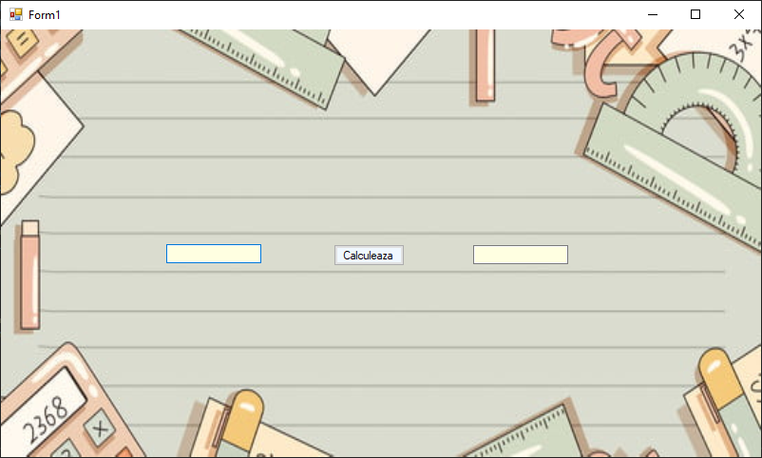

Fig1. Interfata aplicatiei

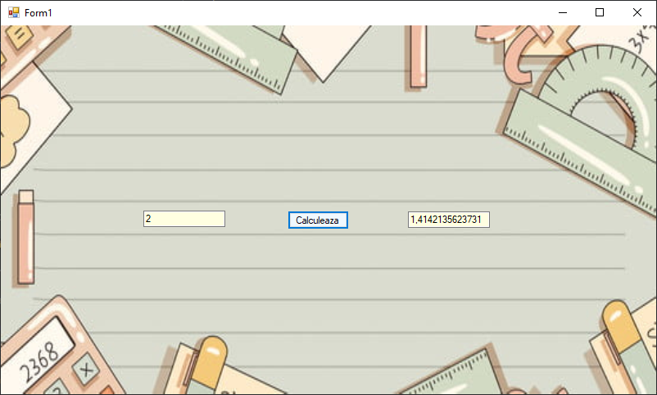

Fig1. Utilitatea aplicatiei

## Codul C#

using System;

using System.Collections.Generic;

using System.ComponentModel;

using System.Data;

using System.Drawing;

using System.Linq;

using System.Text;

using System.Threading.Tasks;

using System.Windows.Forms;

namespace _3

{

public partial class Form1 : Form

{

public Form1()

{

InitializeComponent();

}

private void button1_Click(object sender, EventArgs e)

{

Int64 a = Convert.ToInt64(txt1.Text);

double rad =(double) Math.Sqrt(a);

txt2.Text = rad.ToString();

}

}

}

# 2.Magazin

## Descrierea Aplicatiei

Aplicatia este un magazin online de haine.

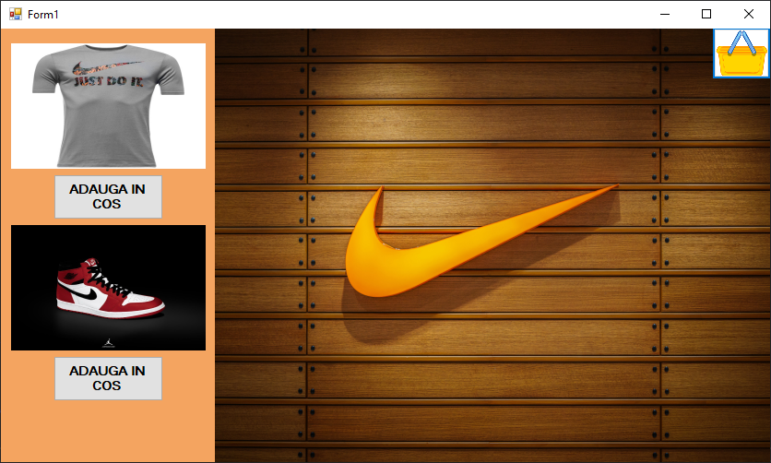

Fig2. Interfata aplicatiei

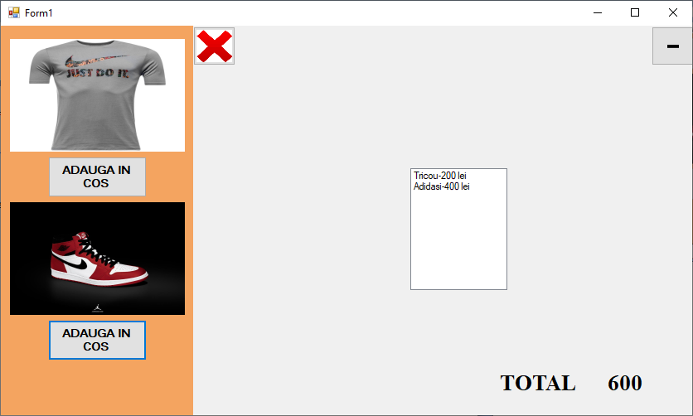

Fig2. Interfata cos cumparaturi

## Codul C#

using System;

using System.Collections.Generic;

using System.ComponentModel;

using System.Data;

using System.Drawing;

using System.Linq;

using System.Text;

using System.Threading.Tasks;

using System.Windows.Forms;

namespace magazinul

{

public partial class Form1 : Form

{

int total;

public Form1()

{

InitializeComponent();

}

private void lstProduse_SelectedIndexChanged(object sender, EventArgs e)

{

}

private void btnTricou_Click(object sender, EventArgs e)

{

lstProduse.Items.Add("Tricou-200 lei");

total =total +200;

lblPret.Text = total.ToString();

}

private void btnAdidas_Click(object sender, EventArgs e)

{

lstProduse.Items.Add("Adidasi-400 lei");

total = total + 400;

lblPret.Text = total.ToString();

}

private void Form1_Load(object sender, EventArgs e)

{

panel2.Visible = true;

lstProdus.Visible = false;

}

private void btnElimina_Click(object sender, EventArgs e)

{

foreach(string s in lstProduse.SelectedItems.OfType<string>().ToList())

{

lstProduse.Items.Remove(s);

}

if(lstProduse.SelectedItem.ToString() == "Adidasi-400 lei")

{

total = total - 400;

lblPret.Text = total.ToString();

}

if(lstProduse.SelectedItem.ToString() == "Tricou-200 lei")

{

total = total - 200;

lblPret.Text = total.ToString();

}

}

private void btnGoleste_Click(object sender, EventArgs e)

{

lstProduse.Items.Clear();

lblPret.Text = " ";

}

private void btnCos_Click(object sender, EventArgs e)

{

lstProdus.Visible = true;

panel2.Visible = true;

lstProdus.Size = new Size(604,474);

lstProdus.Location = new Point(0, 0);

btnCos.Visible = false;

}

}

}

# 3.Soft Educational

## Descrierea aplicatiei

Aceasta aplicatie prezinta informatii despre Europa, plus un test de verificarea cunostintelor.

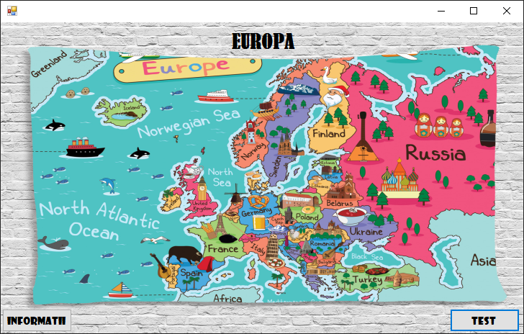

Fig3. Interfata aplicatiei

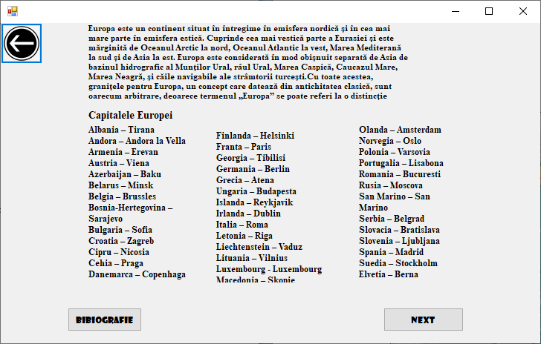

Fig3. Panel-ul cu informatiile

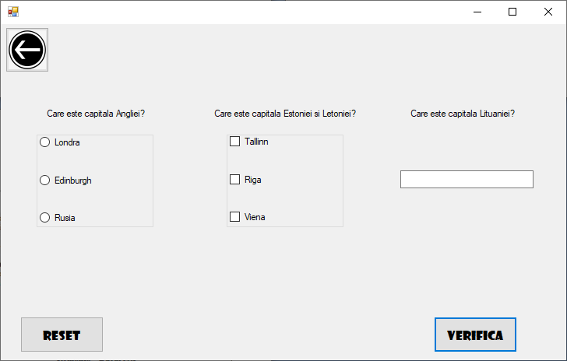

Fig3. Panel-ul cu testul

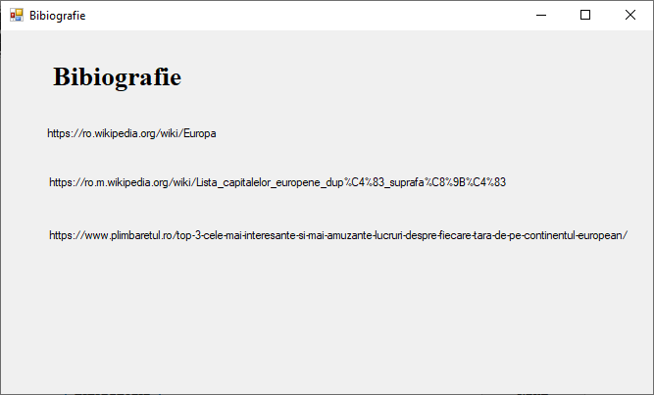

Fig3. Bibiografia

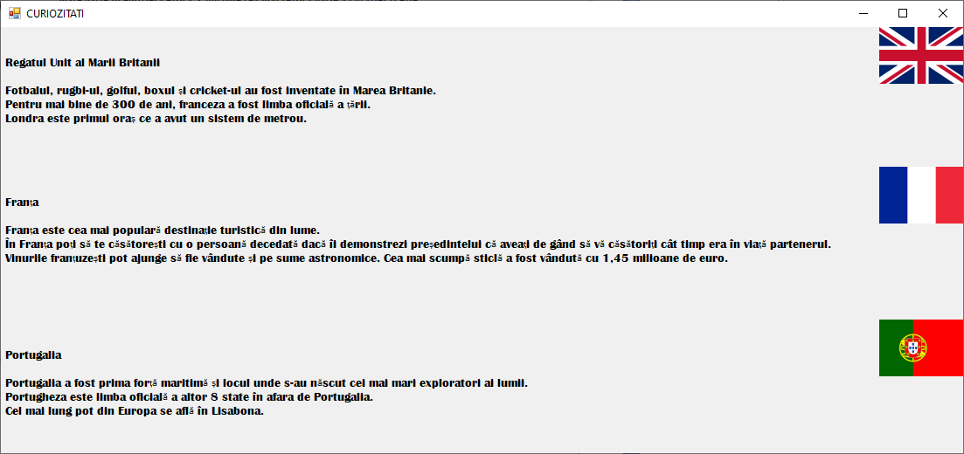

Fig3. Butonul next din panel-ul informatii care prezinta curiozitati

## Codul C#

using System;

using System.Collections.Generic;

using System.ComponentModel;

using System.Data;

using System.Drawing;

using System.Linq;

using System.Text;

using System.Threading.Tasks;

using System.Windows.Forms;

namespace soft_educational

{

public partial class Form1 : Form

{

public Form1()

{

InitializeComponent();

}

private void Form1_Load(object sender, EventArgs e)

{

pnlInformatii.Visible = false;

pnlTest.Visible = false;

}

private void btnInformatii_Click(object sender, EventArgs e)

{

pnlInformatii.Visible = true;

pnlInformatii.Location = new Point(0, 0);

pnlInformatii.Size = new Size(983, 540);

btnInformatii.Visible = false;

btnTest.Visible = false;

lblEuropa.Visible = false;

}

private void btnVerifica_Click(object sender, EventArgs e)

{

if(rdbLondra.Checked==true)

{

if(chbTallinn.Checked==true & chbRiga.Checked==true )

{

if(txtVilnius.Text=="Vilnius")

{

MessageBox.Show("CORECT 3/3");

}

}

}

if (rdbLondra.Checked == true)

{

if (chbTallinn.Checked == true & chbRiga.Checked==true )

{

if (txtVilnius.Text =="Vilnius")

{

MessageBox.Show("CORECT 3/3");

}

else

{

MessageBox.Show("CORECT 2/3");

}

}

}

if (rdbLondra.Checked == true)

{

if (chbTallinn.Checked == false & chbRiga.Checked==false )

{

if (txtVilnius.Text == "Vilnius")

{

MessageBox.Show("CORECT 2/3");

}

}

}

if (rdbLondra.Checked == true)

{

if (chbTallinn.Checked == false & chbRiga.Checked == false )

{

if (txtVilnius.Text == "Vilnius")

{

MessageBox.Show("CORECT 2/3");

}

else

{

MessageBox.Show("CORECT 1/3");

}

}

}

if (rdbLondra.Checked == false)

{

if (chbTallinn.Checked == false & chbRiga.Checked == false & chbViena.Checked == false)

{

if (txtVilnius.Text == "Vilnius")

{

MessageBox.Show("CORECT 1/3");

}

else

{

MessageBox.Show("GRESIT 0/3");

}

}

}

if (rdbLondra.Checked == false)

{

if (chbTallinn.Checked == true & chbRiga.Checked == true )

{

if (txtVilnius.Text == "Vilnius")

{

MessageBox.Show("CORECT 2/3");

}

else

{

MessageBox.Show("CORECT 1/3");

}

}

}

if (rdbLondra.Checked == false)

{

if (chbTallinn.Checked == true & chbRiga.Checked == true)

{

if (txtVilnius.Text == "Vilnius")

{

MessageBox.Show("CORECT 2/3");

}

}

}

if (rdbLondra.Checked == false)

{

if (chbTallinn.Checked == false & chbRiga.Checked == false & chbViena.Checked == false)

{

if (txtVilnius.Text == "Vilnius")

{

MessageBox.Show("CORECT 1/3");

}

}

}

if (rdbLondra.Checked == false)

{

if (chbTallinn.Checked == true & chbRiga.Checked == true )

{

if (txtVilnius.Text == "Vilnius")

{

MessageBox.Show("CORECT 2/3");

}

}

}

if (rdbLondra.Checked == true)

{

if (((chbTallinn.Checked == true || chbRiga.Checked == false)||(chbTallinn.Checked==false || chbRiga.Checked==true)& chbRiga.Checked==true))

{

if (txtVilnius.Text == "Vilnius")

{

MessageBox.Show("CORECT 2/3");

}

}

}

if (rdbLondra.Checked == false)

{

if(((chbTallinn.Checked == true || chbRiga.Checked == false) || (chbTallinn.Checked == false || chbRiga.Checked == true) & chbRiga.Checked==true))

{

if (txtVilnius.Text == "Vilnius")

{

MessageBox.Show("CORECT 1/3");

}

}

}

if (rdbLondra.Checked == false)

{

if (((chbTallinn.Checked == true || chbRiga.Checked == false) || (chbTallinn.Checked == false || chbRiga.Checked == true) & chbRiga.Checked == true ))

{

if (txtVilnius.Text == "Vilnius")

{

MessageBox.Show("CORECT 1/3");

}

else

{

MessageBox.Show("GRESIT 0/3");

}

}

}

}

private void btnTest_Click(object sender, EventArgs e)

{

pnlInformatii.Visible = false;

pnlTest.Visible = true;

pnlTest.Location = new Point(0, 0);

pnlTest.Size = new Size(978, 583);

btnInformatii.Visible = false;

btnTest.Visible = false;

lblEuropa.Visible = false;

}

private void btnBack_Click(object sender, EventArgs e)

{

pnlInformatii.Visible = false;

pnlTest.Visible = false;

btnTest.Visible = true;

btnInformatii.Visible = true;

lblEuropa.Visible = true;

}

private void btnBack1_Click(object sender, EventArgs e)

{

pnlInformatii.Visible = false;

pnlTest.Visible = false;

btnTest.Visible = true;

btnInformatii.Visible = true;

lblEuropa.Visible = true;

}

private void btnNextPage_Click(object sender, EventArgs e)

{

Form2 f2 = new Form2();

f2.Show();

}

private void btnReset_Click(object sender, EventArgs e)

{

txtVilnius.Clear();

rdbEdinburgh.Checked = false;

rdbLondra.Checked = false;

rdbRusia.Checked = false;

chbRiga.Checked = false;

chbTallinn.Checked = false;

chbViena.Checked = false;

}

private void btnBibiografie_Click(object sender, EventArgs e)

{

Bibiografie b = new Bibiografie();

b.Show();

}

}

}

using System;

using System.Collections.Generic;

using System.ComponentModel;

using System.Data;

using System.Diagnostics;

using System.Drawing;

using System.Linq;

using System.Text;

using System.Threading.Tasks;

using System.Windows.Forms;

namespace soft_educational

{

public partial class Bibiografie : Form

{

public Bibiografie()

{

InitializeComponent();

}

private void lblLinks_Click(object sender, EventArgs e)

{

_ = System.Diagnostics.Process.Start("https://ro.wikipedia.org/wiki/Europa");

}

private void lblLinks2_Click(object sender, EventArgs e)

{

_ = System.Diagnostics.Process.Start("https://ro.m.wikipedia.org/wiki/Lista_capitalelor_europene_dup%C4%83_suprafa%C8%9B%C4%83");

}

private void lblLinks3_Click(object sender, EventArgs e)

{

_=System.Diagnostics.Process.Start("https://www.plimbaretul.ro/top-3-cele-mai-interesante-si-mai-amuzante-lucruri-despre-fiecare-tara-de-pe-continentul-european/");

}

}

}