# Network protocols and architectures assignment

SRN:20049583

**Chapter 1: LAN Design Reflection**

**Introduction**

In the context of designing a Local Area Network (LAN) for the main offices of a supermarket chain, the task necessitated an in-depth consideration of network architecture, hardware selection, and redundancy mechanisms to achieve 100% uptime, scalability, and security. This report delves into the rationale behind the hardware choices and architectural decisions, critically evaluating the suitability of each component within the broader network design.

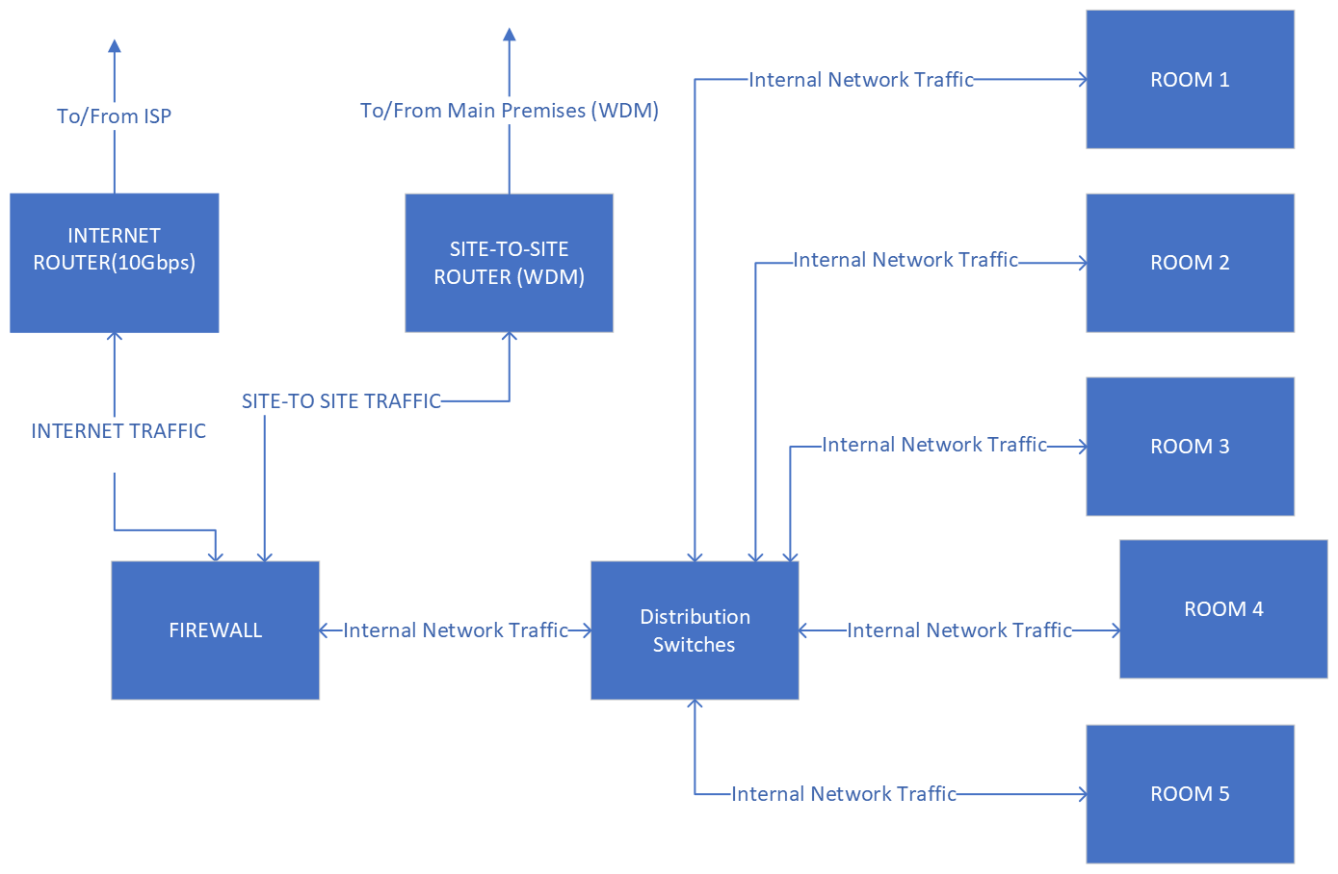

Figure 1:Task1 Logical Diagram

Figure 2: Task1 Physical Diagram

**Network Hardware Selection and Justification**

The design of the LAN was approached with a focus on reliability, scalability, performance, and security. Each piece of hardware was selected based on these criteria:

A. Uninterruptible Power Supply (UPS): APC Smart-UPS SRT 6000VA

The choice of the APC Smart-UPS SRT 6000VA as the backbone of power reliability for the network infrastructure is predicated on its proven performance in power protection and battery backup. Capable of delivering 6000VA/6000W power, it ensures the operational integrity of critical network devices during power disturbances . Its scalable runtime, with advanced battery management, makes it indispensable for protecting high-density network equipment against power irregularities, thus supporting the network's 24/7 uptime requirement.

Potential:

The APC Smart-UPS SRT 6000VA goes beyond simple power backup; it is a smart UPS that supports network manageability. It can communicate with Network Management Systems (NMS) via SNMP for remote monitoring and management, ensuring proactive handling of power issues. This UPS's potential for integration into larger, automated network management solutions presents an opportunity to enhance operational efficiency and reduce downtime through predictive maintenance and alerts.

Possibilities:

Looking ahead, the scalability of the APC UPS could facilitate the deployment of more energy-demanding devices as the network grows. Its compatibility with renewable energy sources and energy storage solutions could also align with sustainability goals, offering a pathway to greener network operations.

B. Routers: Cisco ISR 4431

Cisco's ISR 4431 routers were chosen for both Internet and site-to-site connections, attributable to their robust performance metrics, security capabilities, and modular design. These routers support advanced routing, security features, and service integration that align with the network's needs for efficient WAN connectivity and secure data transmission. The ISR 4431's capability to facilitate future network expansion, owing to its modular slots, ensures that the network's growth can be accommodated without necessitating complete hardware overhauls.

Potential and Protocols:

The Cisco ISR 4431 is not just a router; it's a comprehensive platform that supports a wide array of advanced networking protocols and services. This includes support for next-generation encryption (such as IPsec VPN capabilities for secure remote connections), advanced routing protocols like OSPF, EIGRP, and BGP for efficient network traffic management, and integration capabilities with SD-WAN for optimizing WAN traffic. Its IOS XE operating system enables programmability and automation, crucial for adapting to dynamic networking environments.

Possibilities:

The modular design of the ISR 4431 opens avenues for incorporating additional services such as application optimization, integrated security, and voice/video over IP, supporting a multifaceted approach to network management. Its future-proof architecture is ready for the introduction of 5G services, offering a seamless upgrade path as the telecommunications landscape evolves.

C. Firewall: Palo Alto Networks PA-3250

The selection of the Palo Alto Networks PA-3250 firewall was informed by its comprehensive security functionalities, which include threat prevention, high processing throughput, and detailed traffic visibility. Its deployment is crucial in establishing a robust defence mechanism against emerging cyber threats, safeguarding the LAN's integrity.

Potential:

The PA-3250 is designed with future threats in mind, supporting a wide range of security protocols and services, from advanced threat prevention to decryption for secure traffic inspection. It can adapt to new threat intelligence in real-time, offering a dynamic shield against cyber threats. Its support for automation and integration with third-party systems allows for a unified security posture across the network.

Possibilities:

As IoT devices become more prevalent in retail environments, the PA-3250's ability to segment network traffic and apply strict security policies will be invaluable in mitigating risks associated with these devices. Moreover, its scalability supports the gradual expansion of network security measures without substantial hardware changes.

D. Distribution Switches: Cisco Catalyst 9300-24T

Two Cisco Catalyst 9300-24T switches were selected for the distribution layer, praised for their high performance, redundancy features, and manageability. These switches cater to the network's demand for high-speed data handling between the access and core layers, embodying the scalability and reliability required for the distribution layer's operation.

Potential:

* High Performance: With support for up to 24 non-blocking 10Gbps ports, it provides the throughput necessary for high-demand applications, making it ideal for serving as the core switch in a distribution layer.
* Advanced Security Features: It includes robust security features like encrypted traffic analytics (ETA), Trustworthy Systems for secure boot, and Cisco DNA Centre integration for centralized management.
* Network Versatility: Supports comprehensive Layer 2 and Layer 3 functionalities, including advanced routing protocols like OSPF, EIGRP, and BGP, facilitating complex network topologies and efficient traffic management.
* Automation and Analytics: Leveraging Cisco DNA, it offers automation capabilities for easier network configuration, management, and intelligent analytics for insightful network performance monitoring.

E. Access Switches: Cisco Catalyst 2960X-24TS-L

For connecting end-user devices, Cisco Catalyst 2960X-24TS-L switches were identified as the optimal choice for the access layer. Their reliability, energy efficiency, and ease of use make them well-suited for supporting business applications at the user level, thus ensuring a seamless operational flow within each office.

Potential:

* Energy Efficiency: Features EnergyWise technology for managing energy consumption across the network, making it an eco-friendly choice.
* Layer 2 Features: Provides comprehensive Layer 2 capabilities, including VLANs, Spanning Tree Protocols, and access control lists (ACLs), essential for creating segmented and secure network environments.
* Flexibility: With FlexStack-Plus technology, it allows stacking of up to 8 switches with a throughput of 80 Gbps, enhancing operational flexibility and easing network expansion.
* Resilience: Offers LAN Base or LAN Lite Cisco IOS Software feature sets, providing reliability and security necessary for access layer switches.

F. Patch Panel: TRENDnet 24-Port Cat6A Shielded Patch Panel

Incorporating the TRENDnet 24-Port Cat6A Shielded Patch Panel is a strategic move aimed at enhancing cable management and network organization. The shielded design minimizes EMI/RFI interference, ensuring signal integrity across Cat6A connections. This panel facilitates structured cabling from access switches to the distribution layer, adhering to the best practices in network design for maintainability and scalability.

Potential and Protocols:

* Enhanced Performance: The shielded design minimizes potential electromagnetic interference (EMI), a critical feature in environments with high levels of electrical noise. This ensures signal integrity and reduces packet loss, which is essential for applications requiring high bandwidth and reliability.
* Compatibility: Its compatibility with Cat6A standards means it can support not just current but also emerging network protocols that demand higher bandwidths, including next-generation internet services, cloud computing, and high-definition video streaming.
* Futureproofing: By accommodating up to 10Gbps Ethernet speeds, the TRENDnet patch panel is well-suited for future network expansions or upgrades. It enables businesses to leverage higher-speed internet connections and new technologies without the need for significant infrastructure changes.

**Mirrored Rack Architecture and Redundancy**

A mirrored rack architecture was employed to achieve the LAN's redundancy criteria. This setup involves duplicating key networking devices across two separate racks, ensuring no single point of failure could compromise network availability. Specifically, the network features two routers and two sets of distribution switches, underscoring a commitment to redundancy. This approach not only mitigates downtime but also distributes network load, enhancing overall performance.

The inclusion of two Cat6A cables from each access switch to the patch panel exemplifies this redundancy strategy. By doubling the pathways for data transmission, the network safeguards against cable or port failures, ensuring continuous connectivity for all office devices.

**Critical Evaluation and Reflection**

The LAN design for the supermarket chain's main offices was meticulously crafted, considering the latest in network technology and industry best practices. The selection of APC's UPS, Cisco's routers and switches, Palo Alto's firewall, and TRENDnet's patch panel was driven by a comprehensive evaluation of their performance, reliability, and suitability for the network's specific needs. This hardware ensemble, combined with the mirrored rack architecture, forms a robust foundation capable of supporting the supermarket chain's critical operations and future growth.

Through this design, the project not only adheres to the specifications outlined but also sets a benchmark for high availability, security, and scalability in corporate network environments. The careful consideration of hardware capabilities and redundancy mechanisms ensures that the network is well-equipped to handle the dynamic demands of the supermarket chain, demonstrating a proactive approach to network engineering.

**Chapter 2: WAN Design Reflection**

Figure 3: Task 2 Logical Diagram

**Design Description and Justification**

In developing the WAN design to connect the supermarket chain's main offices in City 1 (Secondary Site) to the main premises in City 4 (Main Premises), I employed a WDM to router model, supplemented with an SDH STM-256 connection. This approach was aimed at maximizing performance, redundancy, and scalability. A cornerstone of my design was the integration of DWDM (Dense Wavelength Division Multiplexing) technology through the Ciena 6500 Packet-Optical Platform, enabling the transmission of multiple data streams over a single optical fiber link to optimize bandwidth and ensure a high-capacity network backbone.

Redundancy:

Ensuring 100% redundancy was a pivotal aspect of my WAN strategy to maintain uninterrupted operations. I achieved this by:

Implementing Dual WDM Routers in both cities, which are prepared for immediate failover, ensuring that secondary routers can seamlessly manage traffic in the event of a primary router failure.

Incorporating an SDH STM-256 connection as an extra redundancy layer, providing a robust backup link that maintains site connectivity, safeguarding against potential DWDM path disruptions.

Scalability:

Anticipating the network's future expansion, I included scalable solutions in my design:

Utilizing DWDM Technology in the Ciena 6500 Packet-Optical Platform allowed me to expand bandwidth by adding new wavelengths to the existing fiber, accommodating increased data traffic without necessitating additional physical infrastructure.

The SDH STM-256 connection offers up to 39.813 Gbps of bandwidth, providing ample capacity for scaling up data traffic between locations.

**Network Hardware Selection**

WDM Routers:

I chose the Cisco ISR 4431 routers for their superior routing capabilities and compatibility with WDM technology, serving as the WAN's backbone. Their reliability and Cisco's comprehensive support ensure the network backbone's robustness and scalability.

WDM Mux/Demux System:

The Ciena 6500 Packet-Optical Platform was selected for its excellence in DWDM technology, making it a perfect fit for the supermarket chain's WAN. Its capability for efficient bandwidth management and support for network expansion made it an indispensable component of my design.

SDH STM-256 Equipment:

The decision to include SDH STM-256 technology was driven by its high bandwidth capacity and reliability, essential for backup and additional capacity needs. Its compatibility with existing telecommunications infrastructure ensured seamless integration and operation.

**Critical Evaluation and Reflection**

My WAN design, integrating the Ciena 6500 Packet-Optical Platform with Cisco ISR 4431 routers and SDH STM-256 technology, aimed to create a network architecture that stands out in performance, reliability, and scalability. The strategic use of DWDM fiber links to connect WDM systems was a deliberate choice, leveraging optical technology to meet the supermarket chain's operational requirements and beyond.

The Ciena 6500 platform was key in maximizing the benefits of DWDM technology, ensuring efficient data transmission and optimal bandwidth utilization. Coupled with the robust routing capabilities of the Cisco ISR 4431 and the redundancy provided by the SDH STM-256 connection, the WAN infrastructure is well-prepared to support current and future data traffic demands.

In conclusion, the WAN architecture I developed for the supermarket chain is a testament to the thoughtful integration of cutting-edge network technologies and hardware. This design ensures a resilient, scalable, and high-capacity network infrastructure, capable of supporting the chain's immediate networking needs and future growth ambitions. Through careful planning and the selection of leading solutions, the WAN setup is a robust foundation for the supermarket chain's networking requirements, guaranteeing operational continuity and the flexibility to adapt to technological advancements.