Hello and welcome

In this file I will show you how to choose and get the needed narrator to respond back

In common projects, people are saying only about index [0] male voice, [1] female voice.

Those are narrators preinstalled with your OS.

Let’s first run the code in voice_index.py

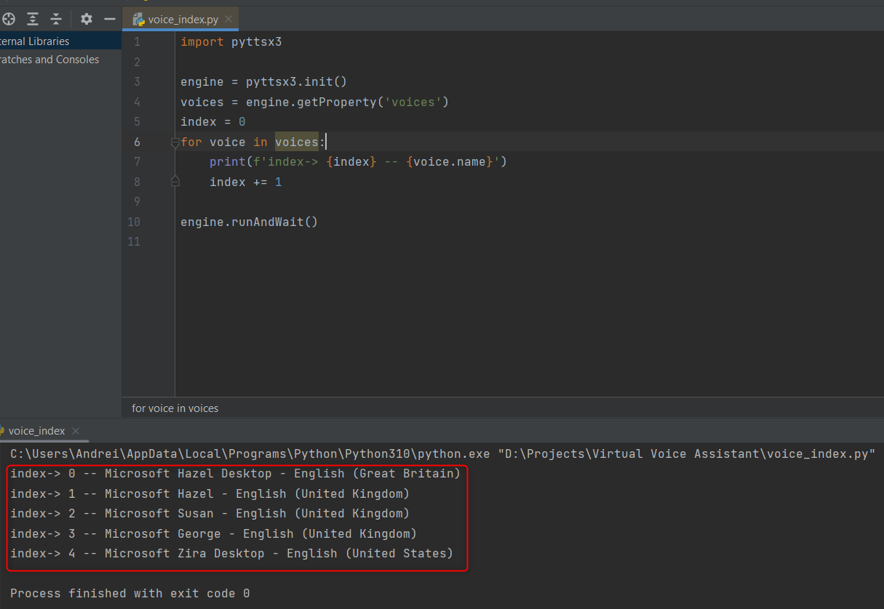

The indexes you see below are the Speech narrators found in Registry Editor at this path

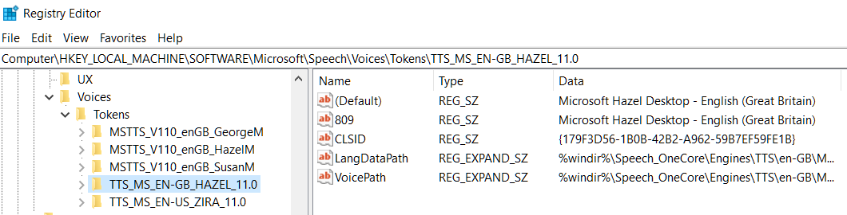

Let’s download a narrator for Romanian language

In the start bar, write narrator and get here

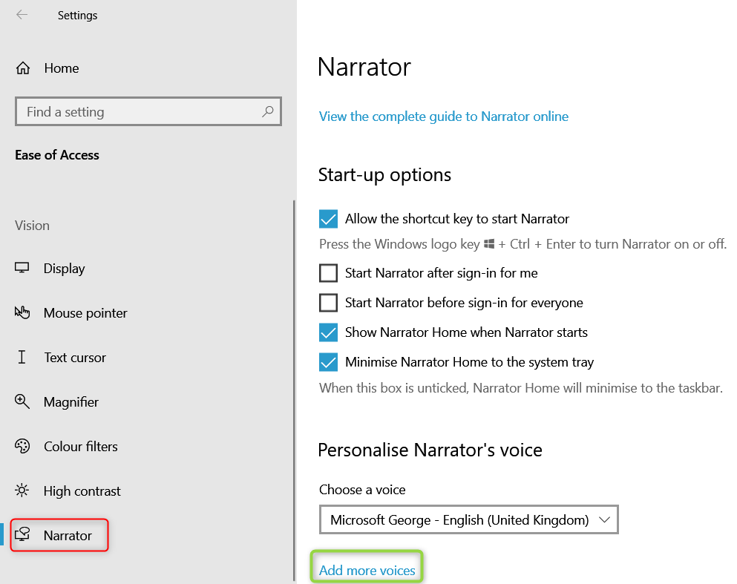

Press Add more voices

Then Press Add more voices

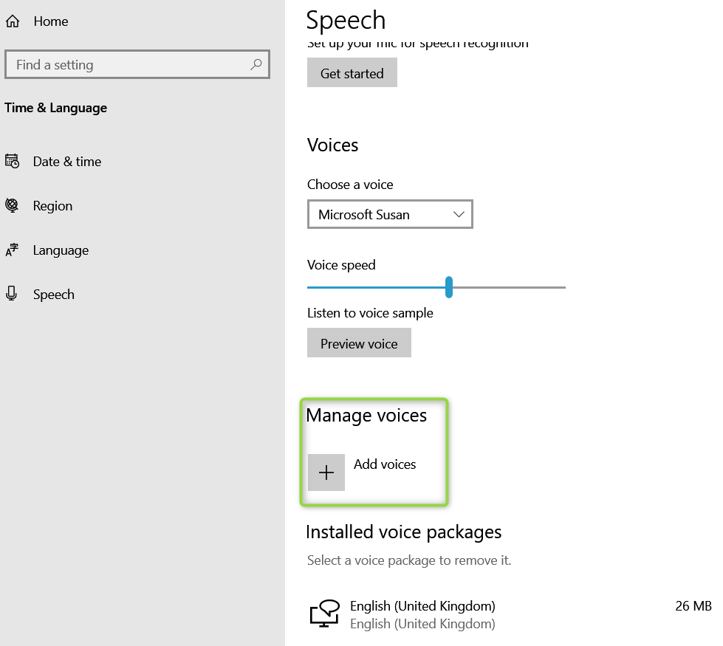

Select your language package and press Add

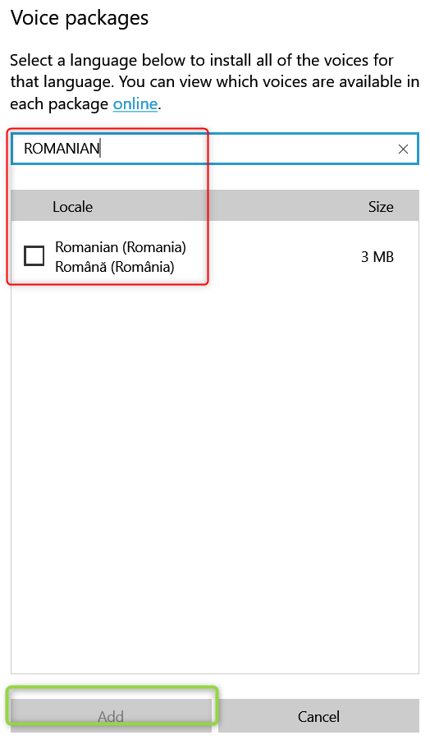

Wait for the download

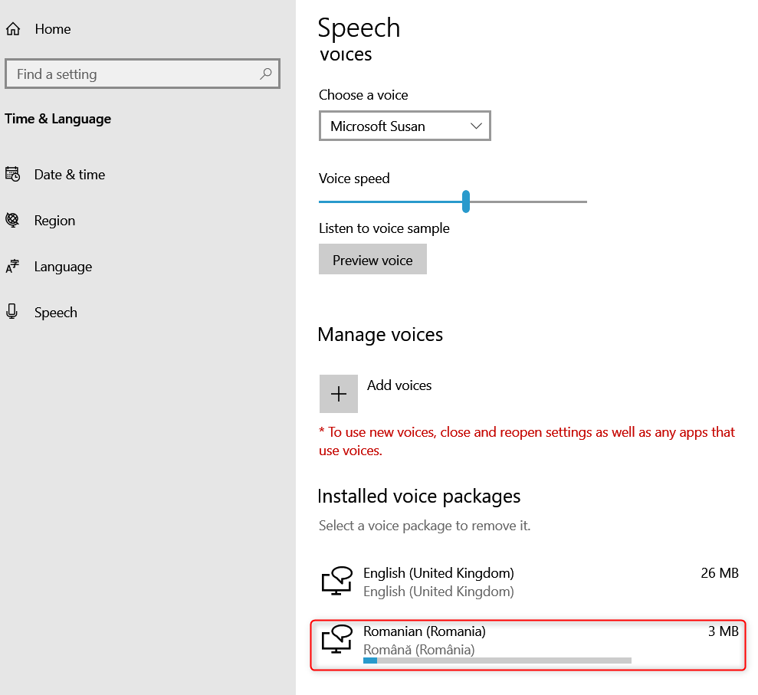

And you check it appeared here on Speech_OneCore but is not the desired Speech simple, so…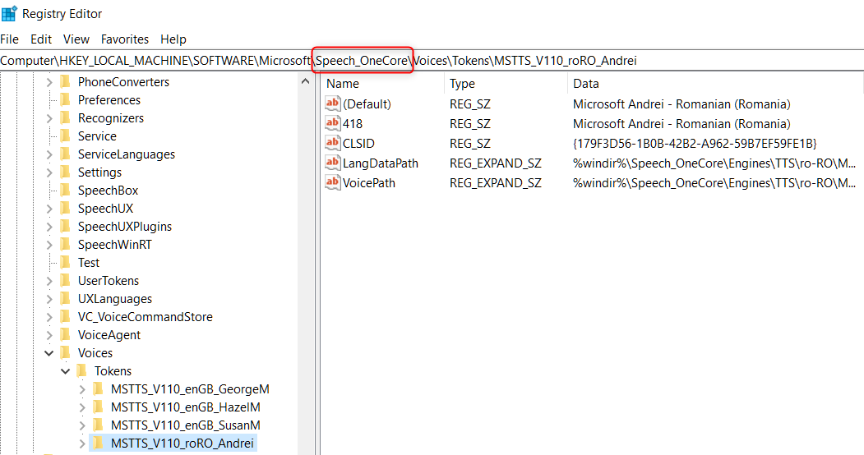

Right click on the language folder in the left field, and choose Export

Choose a name and leave it as .reg, press Save

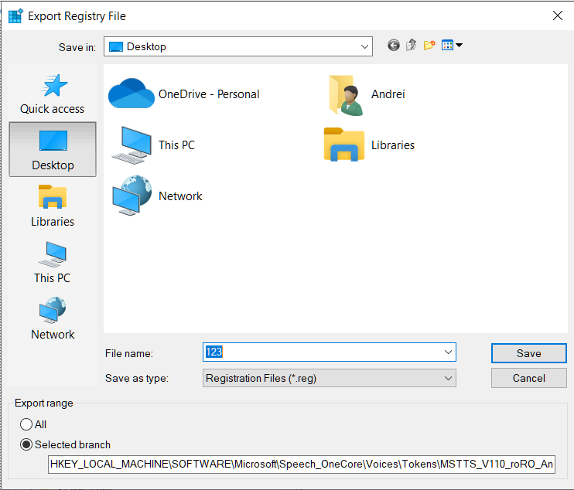

Open it with Notepad



Replace the Speech_OneCore with Speech, replace all

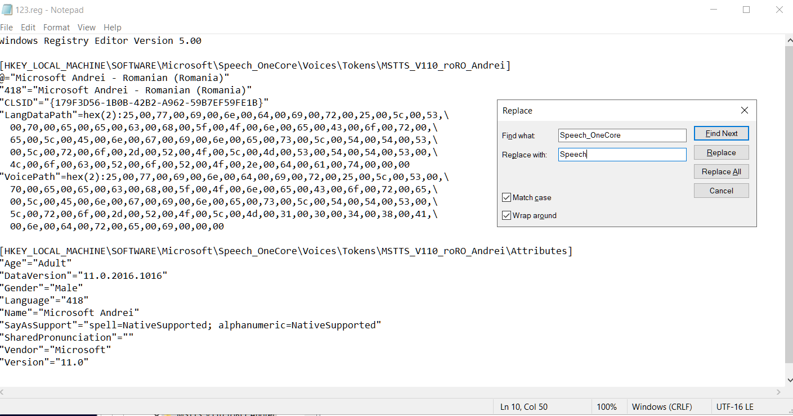

Save and close

Open now normaly the document

Press yes

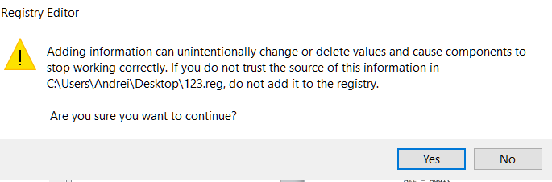

Press Ok

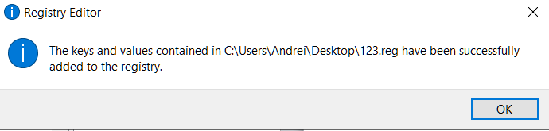

The Narrator was exported correctly in Speech file

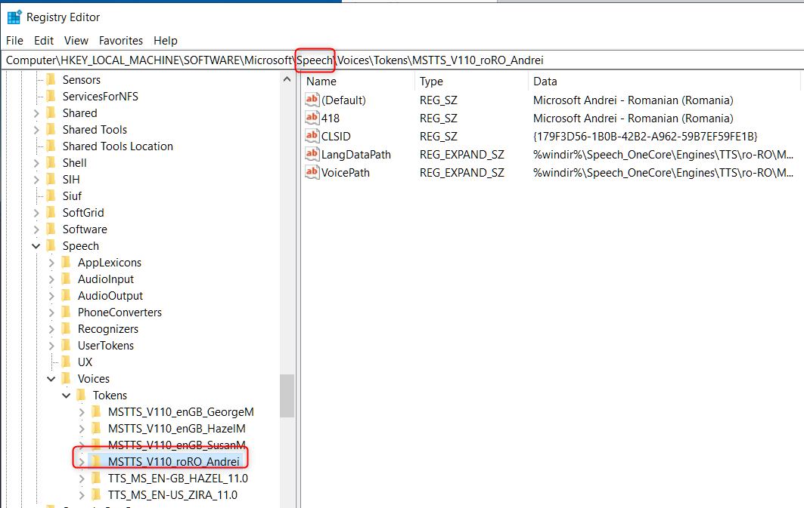

If we run voice_index.py again, we can find the narrator attributed at index 3

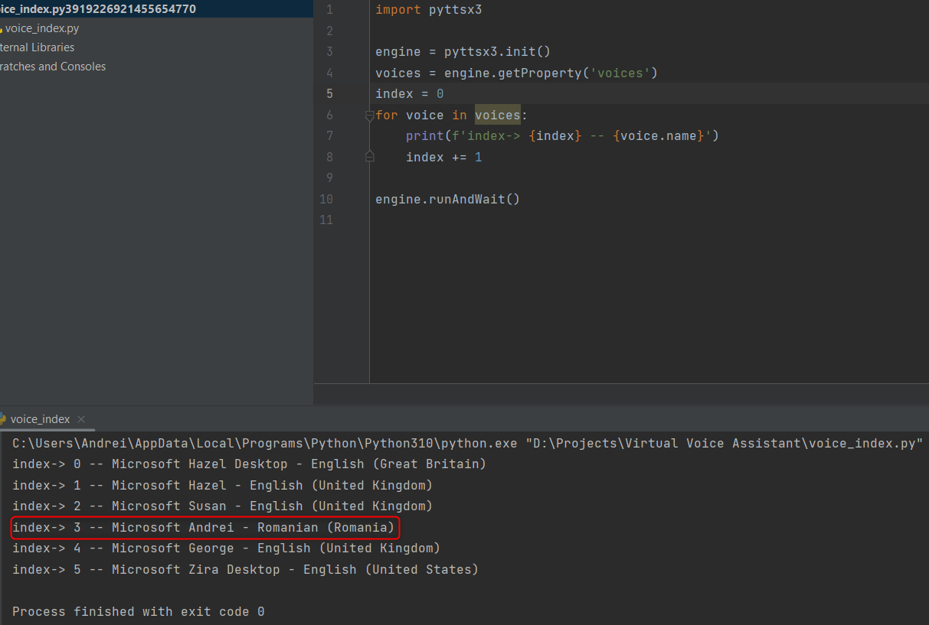

Don’t forget the place where to put the index

voice_assistant.py file

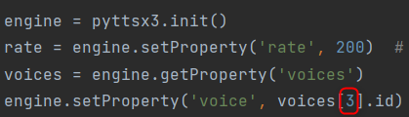

Good luck I hope it was successful

If any problems, contact me as per README file.