Use case:



Sequence (change settings):



Sequence ((1) exit from game):



Sequence ((2) exit from game):



Sequence (start game):



Sequence (view about):



Sequence (view settings):



Sequence (play):



Activity (change settings):



Activity (exit game):



Activity (start game):



Activity (view about):



Activity (view settings):



Activity (play):



Class Diagram :

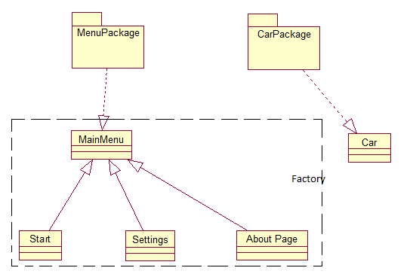

Deployment view:



Component view:



State diagram:

