DOCUMENTATION

ASSIGNMENT 1

STUDENT NAME: EMINOVICI ANDREI-CORNELIU
GROUP: 30423

CONTENTS

1. Assignment Objective 3
2. Problem Analysis, Modeling, Scenarios, Use Cases 3
3. Design 3
4. Implementation 3
5. Results 3
6. Conclusions 3
7. Bibliography 3

Assignment Objective
The main objective of this work is to propose, design and implement a polynomial calculator. More specifically, a polynomial calculator that is able to perform the following operations: addition, subtraction, multiplication, division, integration and differentiation.

Like any calculator, it operates on entry data which is represented by two fields, each describing the polynomial’s coefficients and exponents in a pair, along with the variable “x” communicating with the user through the output data(the polynomial resulted after the calculation) which is displayed after each operation is finished. Moreover, besides the technical calculation part, the user is greeted by a user friendly interface.

The secondary objectives are:
- Use of basic principles of Object Oriented Programming, namely abstractization, encapsulation, inheritance and polymorphism
- Use of the “Map” Collection for storing the polynomials
- Implementation of the aforementioned operations
- Creation of a user interface using Java Swing
- Taking advantage of JUnit for efficient testing

Problem Analysis, Modeling, Scenarios, Use Cases
A polynomial is modelled as a series of monomials(an exponent-coefficient pair), represented as “ax^b”, where a is the coefficient and b is the exponent. In the case of this application, the coefficient can be any real number, represented by the “double” type in code and the exponent can take any real positive integer value, represented by the “int” type in code. As the assignment requirements ask, this was efficiently and flexibily modlled using the Map Collection for storing each monomial into the polynomial.
With that out of the way, the polynomial will be used inside the application in the following manner: the user adds two polynomials(or a single polynomial in case of certain operations) in the text boxes of the application, repsecting the syntax guide also present on the application interface. After pressing any operation button, it will be checked whether the input respects or not the general model of a polynomial by using a method which incorporates Regex for separing the input string into monomials and also checking their correctness.
After the polynomial was successfully processed and now it is stored inside a Polynomial type object, the execution of the desired operation starts via the use of the Operation class which will give as an output another polynomial. This output polynomial will be converted back into a string via the overridden toString() method implemented into the Polynomial class and then displayed onto a JLabel object in the graphical interface.

Design
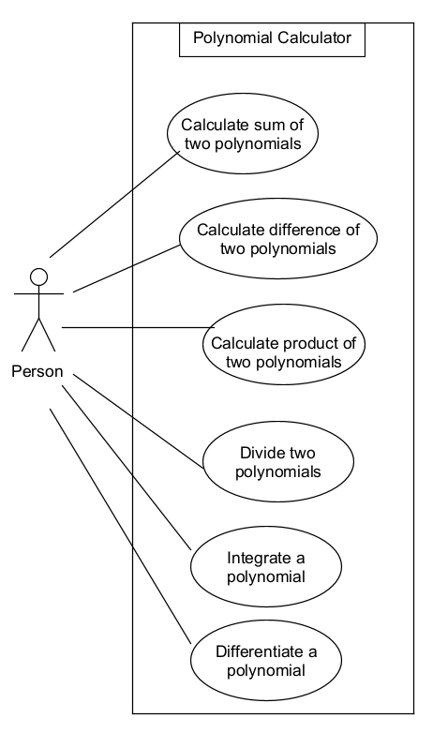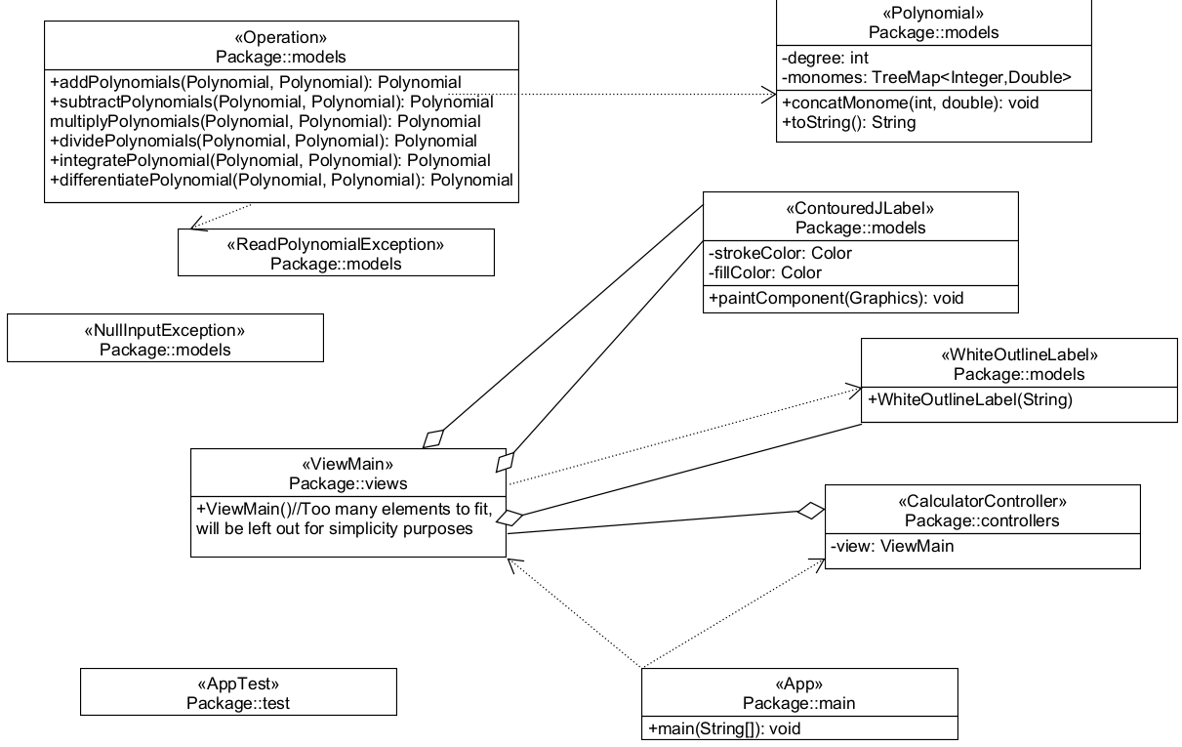

The purpose of the design is to make the code as intuitive and simple as possible. At the heart of the application there are the two classes: Polynomial and Operation. The polynomial is stored into a TreeMap in reverse order. Knowing that the TreeMap already maintains an ordering of the elements, and that we want the polynomial to start from highest degree to zero, the order of the Collection must be reversed. The exponent represents the Key of the map and the coefficient the Value. Having such a compact and flexible data structure, we can save a lot of space as there is no need to store 100 monomials of which 98 are empty if for example we had x^100+1. The beauty of the TreeMap is that we can also have 1+x^100 and it will automatically get ordered back into what it was, so the order of exponents does not matter at all. We can also have two different length and degree polynomials with no issues whatsoever.
The Operations class implements the 6 necessary operations of the application. The implemented methods get either one or two Polynomial objects as input and return another Polynomial as the result.
The “main” packet contains the App class, which is where the application runs from, and three packets: controllers, models and views. The controllers packet contains all the controllers of a given application, in this case there is only one as the application is inherently simple, the models packet contains all of the OOP modelling of each logical component into code, as shown in the diagram and the views contains all of the views, again as the application is relatively simplistic and has only one window, there is also only one class present there, namely ViewMain.
Additionally, I created a new class for a white outlined JLabel which uses the BorderFactory utility in order to make the title label in the graphical interface have a white box surrounding it. Completely optional, but I wanted to have a little fun with the interface part(will further elaborate later) 😊.I also used the internet in order to obtain some more complex code for creating a text label which displays text with a colored stroke effect around it, for making the result more visible.
There are some custom exceptions, such as ReadPolynomialException and NullInputException, as their name suggests to be thrown in specific cases to help with debugging. For division by zero case, I used the already defined ArithmeticException so I didn’t have to create a new one. There swas an attempt to create a PrintPolynomialException, but as the toString() method was overridden in the Polynomial class, that became quite annoying as I would have changed the method signature by adding a throws statement and I already had the toString() called in multiple different places. Even worse is that it wouldn’t give an error as toString() is defined even if not overridden, so I opted to not do this exception in order to avoid headaches and potentially introduce bugs. Instead I just added a new uncategorized exception in the final catch block in order to at least catch whatever goes wrong and is not one of the already mentioned exceptions.

Implementation
The Polynomial class consists of a field “degree”, a Map already discussed to store the monomials and the overridden toString() method for printing the polynomial. Important to mention that the constructor was made to specifically take no arguments and initialize degree to zero and the monomials map to a new TreeMap<Integer,Double> with the wrapper types. Finally, a concatMonome() method is implemented here in order to add into said monomials map monomes one by one. With each additional monome, the exponent of the introduced term is checked against the degree in order to correctly update the degree of the polynomial when it is the case.
The Operation class presents the implementation of all of the six operations described earlier. The addition was done by taking all terms of the first polynomial and adding the coefficients of whatever matched with the exponents of the second polynomial into the final result. Afterwards, whichever term did not match was simply copied into the final result. In order to keep track, a temporary ArrayList of all the added terms is kept. Whatever was not added into the first polynomial will also be taken from the second polynomial and copied into the final result in another for loop iteration through the second polynomial this time.
The subtraction is an addition with a minus instead of a plus for terms when they match and in the second for loop iteration.
The integration and differentiation are trivally implemented by simply incrementing/decrementing the exponent and dividing/multiplying the coefficient of each term.
The multiplication consists of two for loops: first one iterates through first polynomial and takes monome i, second through second polynomial and takes monome j. We then add exponents of i and j and multiply their coefficients before putting the resulting term into the final result. This way, we cover all permutations of all terms and thanks to the treeMap everything falls into place nicely and already sorted.
For the division, the long division algorithm found on the internet was used. It takes multiple polynomials, besides the final result, such as the quotient and remainder. Remainder is initialized as the p1(dividend) input and then a while loop starts, which goes until the degree of remainder becomes lower than that of p2(divisor) or when remainder simply becomes empty. In each iteration, an expDiff is computed which is p1.degree – p2.degree. Another coefficient is computed as the term of the remainder which has its exponent equal to that of the division of the remainder’s degree and divisor’s degree. The quotient is constructed as this new term with said coefficient and exponent. This quotient is added to the final result, then a new Polynomial is created as the multiplication between the divisor and the quotient. Finally, this new multiplication result is subtracted from the remainder, and the while loop repeats.
As for the graphical interface, the absolute layout with no resizability was used. Each label, textbox and button were first declared and then initialized into the constructor. Each element was customized, for example labels containing text were properly dimensioned, assigned a readable font and font size, some even a color. After taking care of all the buttons, writing the syntax instructions as a combination of multiple labels, finding the optimal placements and dimensions via trial and error, another completely unnecessary but funny feature was added, called “Stonk mode”. The user has the option to click a button in order to enable said mode, which adds some cool music and pictures of Lamborghini cars in the background. Additionally, the result gets a nice looking textbox featuring Shrek and many other memes, along with sound and visual effects when clicking on the buttons.

Results

In the Junit testing part, 37 test methods were implemented in order to test everything that there is to test about each read, print, addition and all the other operations. Of course, all of the 37 tests produce the expected output after many hours of debugging in order to make sure the application works as intented.

@Test
public void testReadPrint() {
Polynomial p = null;
try {
Operation operation = new Operation();
p = operation.readPolynomial("3x^2+2x-5");
} catch (ReadPolynomialException e) {
throw new RuntimeException(e);
}
assertEquals("3,00x^2+2,00x-5,00", p.toString());
}
@Test
public void testReadPrintSpaces() {
Polynomial p = null;
try {
Operation operation = new Operation();
p = operation.readPolynomial(" 3 x ^ 2 + 2 x - 5 ");
} catch (ReadPolynomialException e) {
throw new RuntimeException(e);
}
assertEquals("3,00x^2+2,00x-5,00", p.toString());
}
@Test
public void testReadPrintNegative() {
Polynomial p = null;
try {
Operation operation = new Operation();
p = operation.readPolynomial("-3x^2-2x-5");
} catch (ReadPolynomialException e) {
throw new RuntimeException(e);
}
assertEquals("-3,00x^2-2,00x-5,00", p.toString());
}
@Test
public void testReadPrintExplicitSyntax() {
Polynomial p = null;
try {
Operation operation = new Operation();
p = operation.readPolynomial("3.0x^2+2.0x^1-5.0x^0");
} catch (ReadPolynomialException e) {
throw new RuntimeException(e);
}
assertEquals("3,00x^2+2,00x-5,00", p.toString());
}
@Test
public void testReadPrintSingleTerm() {
Polynomial p = null;
try {
Operation operation = new Operation();
p = operation.readPolynomial("3x^2");
} catch (ReadPolynomialException e) {
throw new RuntimeException(e);
}
assertEquals("3,00x^2", p.toString());
}
@Test
public void testReadPrintSingleNegativeTerm() {
Polynomial p = null;
try {
Operation operation = new Operation();
p = operation.readPolynomial("-3x^2");
} catch (ReadPolynomialException e) {
throw new RuntimeException(e);
}
assertEquals("-3,00x^2", p.toString());
}
@Test
public void testReadPrintZeroExponent() {
Polynomial p = null;
try {
Operation operation = new Operation();
p = operation.readPolynomial("-1x^0");
} catch (ReadPolynomialException e) {
throw new RuntimeException(e);
}
assertEquals("-1,00", p.toString());
}
@Test
public void testReadPrintOne() {
Polynomial p = null;
try {
Operation operation = new Operation();
p = operation.readPolynomial("1");
} catch (ReadPolynomialException e) {
throw new RuntimeException(e);
}
assertEquals("1,00", p.toString());
}
@Test
public void testReadPrintEx() {
Polynomial p = null;
try {
Operation operation = new Operation();
p = operation.readPolynomial("x");
} catch (ReadPolynomialException e) {
throw new RuntimeException(e);
}
assertEquals("x", p.toString());
}
@Test
public void testAdditionBasic() {
Polynomial p1 = null;
Polynomial p2 = null;
Polynomial result = null;
try {
Operation operation = new Operation();
p1 = operation.readPolynomial("3x^2+2x+2");
p2 = operation.readPolynomial("4x^2+x+1");
result = operation.addPolynomials(p1, p2);
} catch (ReadPolynomialException e) {
throw new RuntimeException(e);
}
assertEquals("7,00x^2+3,00x+3,00", result.toString());
}
@Test
public void testAdditionNoCommonExponent() {
Polynomial p1 = null;
Polynomial p2 = null;
Polynomial result = null;
try {
Operation operation = new Operation();
p1 = operation.readPolynomial("3x^7+2x+2");
p2 = operation.readPolynomial("4x^2+x+1");
result = operation.addPolynomials(p1, p2);
} catch (ReadPolynomialException e) {
throw new RuntimeException(e);
}
assertEquals("3,00x^7+4,00x^2+3,00x+3,00", result.toString());
}
@Test
public void testAdditionJustEx() {
Polynomial p1 = null;
Polynomial p2 = null;
Polynomial result = null;
try {
Operation operation = new Operation();
p1 = operation.readPolynomial("x");
p2 = operation.readPolynomial("x");
result = operation.addPolynomials(p1, p2);
} catch (ReadPolynomialException e) {
throw new RuntimeException(e);
}
assertEquals("2,00x", result.toString());
}
@Test
public void testAdditionJustConstants() {
Polynomial p1 = null;
Polynomial p2 = null;
Polynomial result = null;
try {
Operation operation = new Operation();
p1 = operation.readPolynomial("1");
p2 = operation.readPolynomial("1");
result = operation.addPolynomials(p1, p2);
} catch (ReadPolynomialException e) {
throw new RuntimeException(e);
}
assertEquals("2,00", result.toString());
}
@Test
public void testAdditionLongScrambledShort() {
Polynomial p1 = null;
Polynomial p2 = null;
Polynomial result = null;
try {
Operation operation = new Operation();
p1 = operation.readPolynomial("3x^2+10x^10+2x+2");
p2 = operation.readPolynomial("1");
result = operation.addPolynomials(p1, p2);
} catch (ReadPolynomialException e) {
throw new RuntimeException(e);
}
assertEquals("10,00x^10+3,00x^2+2,00x+3,00", result.toString());
}
@Test
public void testSubtractionTailEx() {
Polynomial p1 = null;
Polynomial p2 = null;
Polynomial result = null;
try {
Operation operation = new Operation();
p1 = operation.readPolynomial("2x^2+x^6+x");
p2 = operation.readPolynomial("x");
result = operation.subtractPolynomials(p1, p2);
} catch (ReadPolynomialException e) {
throw new RuntimeException(e);
}
assertEquals("x^6+2,00x^2", result.toString());
}
@Test
public void testSubtractionIdentical() {
Polynomial p1 = null;
Polynomial p2 = null;
Polynomial result = null;
try {
Operation operation = new Operation();
p1 = operation.readPolynomial("2x^2+x^6+x");
p2 = operation.readPolynomial("2x^2+x^6+x");
result = operation.subtractPolynomials(p1, p2);
} catch (ReadPolynomialException e) {
throw new RuntimeException(e);
}
assertEquals("0", result.toString());
}
@Test
public void testSubtractionNegativeMiddleEx() {
Polynomial p1 = null;
Polynomial p2 = null;
Polynomial result = null;
try {
Operation operation = new Operation();
p1 = operation.readPolynomial("-2x^2-x^6+x");
p2 = operation.readPolynomial("-x^6");
result = operation.subtractPolynomials(p1, p2);
} catch (ReadPolynomialException e) {
throw new RuntimeException(e);
}
assertEquals("-2,00x^2+x", result.toString());
}
@Test
public void testSubtractionConstants() {
Polynomial p1 = null;
Polynomial p2 = null;
Polynomial result = null;
try {
Operation operation = new Operation();
p1 = operation.readPolynomial("2");
p2 = operation.readPolynomial("2");
result = operation.subtractPolynomials(p1, p2);
} catch (ReadPolynomialException e) {
throw new RuntimeException(e);
}
assertEquals("0", result.toString());
}
@Test
public void testSubtractionExx() {
Polynomial p1 = null;
Polynomial p2 = null;
Polynomial result = null;
try {
Operation operation = new Operation();
p1 = operation.readPolynomial("x");
p2 = operation.readPolynomial("x");
result = operation.subtractPolynomials(p1, p2);
} catch (ReadPolynomialException e) {
throw new RuntimeException(e);
}
assertEquals("0", result.toString());
}
@Test
public void testIntegrationBasic() {
Polynomial p1 = null;
Polynomial result = null;
try {
Operation operation = new Operation();
p1 = operation.readPolynomial("x^2+2x+1");
result = operation.integratePolynomial(p1);
} catch (ReadPolynomialException e) {
throw new RuntimeException(e);
}
assertEquals("0,33x^3+x^2+x", result.toString());
}
@Test
public void testIntegrationSmall() {
Polynomial p1 = null;
Polynomial result = null;
try {
Operation operation = new Operation();
p1 = operation.readPolynomial("1");
result = operation.integratePolynomial(p1);
} catch (ReadPolynomialException e) {
throw new RuntimeException(e);
}
assertEquals("x", result.toString());
}
@Test
public void testIntegrationBig() {
Polynomial p1 = null;
Polynomial result = null;
try {
Operation operation = new Operation();
p1 = operation.readPolynomial("100x^100");
result = operation.integratePolynomial(p1);
} catch (ReadPolynomialException e) {
throw new RuntimeException(e);
}
assertEquals("0,99x^101", result.toString());
}
@Test
public void testIntegrationZero() {
Polynomial p1 = null;
Polynomial result = null;
try {
Operation operation = new Operation();
p1 = operation.readPolynomial("0");
result = operation.integratePolynomial(p1);
} catch (ReadPolynomialException e) {
throw new RuntimeException(e);
}
assertEquals("0", result.toString());
}
@Test
public void testIntegrationNegative() {
Polynomial p1 = null;
Polynomial result = null;
try {
Operation operation = new Operation();
p1 = operation.readPolynomial("-4x^2");
result = operation.integratePolynomial(p1);
} catch (ReadPolynomialException e) {
throw new RuntimeException(e);
}
assertEquals("-1,33x^3", result.toString());
}
@Test
public void testDifferentiationBasic() {
Polynomial p1 = null;
Polynomial result = null;
try {
Operation operation = new Operation();
p1 = operation.readPolynomial("2x^2+3x+2");
result = operation.differentiatePolynomial(p1);
} catch (ReadPolynomialException e) {
throw new RuntimeException(e);
}
assertEquals("4,00x+3,00", result.toString());
}
@Test
public void testDifferentiationEx() {
Polynomial p1 = null;
Polynomial result = null;
try {
Operation operation = new Operation();
p1 = operation.readPolynomial("3x");
result = operation.differentiatePolynomial(p1);
} catch (ReadPolynomialException e) {
throw new RuntimeException(e);
}
assertEquals("3,00", result.toString());
}
@Test
public void testDifferentiationConstant() {
Polynomial p1 = null;
Polynomial result = null;
try {
Operation operation = new Operation();
p1 = operation.readPolynomial("2");
result = operation.differentiatePolynomial(p1);
} catch (ReadPolynomialException e) {
throw new RuntimeException(e);
}
assertEquals("0", result.toString());
}
@Test
public void testDifferentiationZero() {
Polynomial p1 = null;
Polynomial result = null;
try {
Operation operation = new Operation();
p1 = operation.readPolynomial("0");
result = operation.differentiatePolynomial(p1);
} catch (ReadPolynomialException e) {
throw new RuntimeException(e);
}
assertEquals("0", result.toString());
}
@Test
public void testDifferentiationNegative() {
Polynomial p1 = null;
Polynomial result = null;
try {
Operation operation = new Operation();
p1 = operation.readPolynomial("-3x^4-2");
result = operation.differentiatePolynomial(p1);
} catch (ReadPolynomialException e) {
throw new RuntimeException(e);
}
assertEquals("-12,00x^3", result.toString());
}
@Test
public void testMultiplicationBasic() {
Polynomial p1 = null;
Polynomial p2 = null;
Polynomial result = null;
try {
Operation operation = new Operation();
p1 = operation.readPolynomial("3x+2");
p2 = operation.readPolynomial("3x-2");
result = operation.multiplyPolynomials(p1, p2);
} catch (ReadPolynomialException e) {
throw new RuntimeException(e);
}
assertEquals("9,00x^2-4,00", result.toString());
}
@Test
public void testMultiplicationConstant() {
Polynomial p1 = null;
Polynomial p2 = null;
Polynomial result = null;
try {
Operation operation = new Operation();
p1 = operation.readPolynomial("3x+2+1001x^1000");
p2 = operation.readPolynomial("1");
result = operation.multiplyPolynomials(p1, p2);
} catch (ReadPolynomialException e) {
throw new RuntimeException(e);
}
assertEquals("1001,00x^1000+3,00x+2,00", result.toString());
}
@Test
public void testMultiplicationZero() {
Polynomial p1 = null;
Polynomial p2 = null;
Polynomial result = null;
try {
Operation operation = new Operation();
p1 = operation.readPolynomial("0");
p2 = operation.readPolynomial("1");
result = operation.multiplyPolynomials(p1, p2);
} catch (ReadPolynomialException e) {
throw new RuntimeException(e);
}
assertEquals("0", result.toString());
}
@Test
public void testDivisionBasic() {
Polynomial p1 = null;
Polynomial p2 = null;
Polynomial result = null;
try {
Operation operation = new Operation();
p1 = operation.readPolynomial("2x^22");
p2 = operation.readPolynomial("x^3");
result = operation.dividePolynomials(p1, p2);
} catch (ReadPolynomialException e) {
throw new RuntimeException(e);
}
assertEquals("2,00x^19", result.toString());
}
@Test
public void testDivisionIdentical() {
Polynomial p1 = null;
Polynomial p2 = null;
Polynomial result = null;
try {
Operation operation = new Operation();
p1 = operation.readPolynomial("2x^22");
p2 = operation.readPolynomial("2x^22");
result = operation.dividePolynomials(p1, p2);
} catch (ReadPolynomialException e) {
throw new RuntimeException(e);
}
assertEquals("1,00", result.toString());
}
@Test
public void testDivisionUneven() { //Not 100% correct for cases where result ends up containing negative powers as they are left out
Polynomial p1 = null;
Polynomial p2 = null;
Polynomial result = null;
try {
Operation operation = new Operation();
p1 = operation.readPolynomial("2x^6+3x^2");
p2 = operation.readPolynomial("x^2+2x"); //Terms with negative powers of x are ignored in the result
result = operation.dividePolynomials(p1, p2);
} catch (ReadPolynomialException e) {
throw new RuntimeException(e);
}
assertEquals("2,00x^4-4,00x^3+8,00x^2-16,00x+35,00", result.toString());
}
@Test
public void testDivisionConstants() {
Polynomial p1 = null;
Polynomial p2 = null;
Polynomial result = null;
try {
Operation operation = new Operation();
p1 = operation.readPolynomial("2");
p2 = operation.readPolynomial("2");
result = operation.dividePolynomials(p1, p2);
} catch (ReadPolynomialException e) {
throw new RuntimeException(e);
}
assertEquals("1,00", result.toString());
}
@Test
public void testDivisionConstants2() {
Polynomial p1 = null;
Polynomial p2 = null;
Polynomial result = null;
try {
Operation operation = new Operation();
p1 = operation.readPolynomial("20");
p2 = operation.readPolynomial("2");
result = operation.dividePolynomials(p1, p2);
} catch (ReadPolynomialException e) {
throw new RuntimeException(e);
}
assertEquals("10,00", result.toString());
}
}

Conclusions
Regarding what I have learned, there is a lot to say. Firstly, simple Regex operations for working with strings turn out to be incredibly useful for reading and writing data into files at many coding constests such as Catalyst Cloud Flight.
Secondly, having the ability to quickly test tens of scenarios with the press of a button and not have to manually input data and remember each test scenario is a game changer for developing large applications. If I change something in the code, I can quickly rerun all the tests to make sure I didn’t break anything.
Lastly, I have to admit that it’s been a while since I last worked so in depth with polynomials and it feels nice to have refreshed my knowledge about them.
As for future developments, I think that this app could be more complete if it also had the ability to handle decimal and negative exponents. Perhaps even imginary numbers, but that would greatly increase its complexity(no pun intended). Also, the result text label could be scorrable text instead, or maybe change its size to fit on the screen for very large polynomials too large to fit on the standard dimensions I provided.

Bibliography
The references for the project were Google and sites such as GeeksForGeeks, Baeldung and StackOverflow for help with many issues that I encountered along the way.

