DOCUMENTATION

ASSIGNMENT 3

STUDENT NAME: EMINOVICI ANDREI-CORNELIU
GROUP: 30423

CONTENTS

1. Assignment Objective 3
2. Problem Analysis, Modeling, Scenarios, Use Cases 3
3. Design 4
4. Implementation 6
6. Conclusions 7
7. Bibliography 8

Assignment Objective
The main purpose of this work is to develop a warehouse management application. The functionalities of this application will be, at a minimum, the user interaction with a database via a graphical user interface where information can be stored, updated, retrieved and removed.

Like any management application, the design should be intuitive and incorporate features such that the user encounters as little difficulties as possible when utilizing the application.
The secondary objectives are:
- Use of basic principles of Object Oriented Programming, namely abstractization, encapsulation, inheritance and polymorphism
- Use of the jdbc java library for database interaction
- Implementation of the aforementioned features
- Creation of a user interface using Java Swing

Problem Analysis, Modeling, Scenarios, Use Cases
A database is a set of tables. A table is a set of rows, each uniquely identified by a primary key, namely the ID, which will be used to refer to a certain row. The database tables will have to be mirrored by identical java classes, with both their name and order of fields, in order to allow the reflection operations to properly work in identifying each field, correctly displaying table headers and correctly inserting into the database their respective objects. It is mandatory for each of the mirror classes to have an empty constructor, as the reflection procedure will start by calling it to create the empty object which will further be modified via the setter methods to arrive at the final object whenever the need of retrieval from the database arises.
The application will be used in the following manner: the user chooses which table of the database they want to interact with. Then they choose one of the possible CRUD operations and insert the appropriate data into the text fields.
After the fields have been successfully processed, they will either end up as a new row of into the respective table of the database or will replace an already existing row in the case of the update operation. Additionally, the user has the option to insert an ID of an already existing database row and click on the “Copy Fields” button in order to fill in the text fields with the already existing operation. This is handy when an update operation needs to be performed to change just a single column, as it saves many errors and effort from the user which would otherwise have to manually copy the data, which can easily get cumbersome for larger tables with a great amount of columns and lengthy data.
Finally, in order to test the application, there is one last feature. This feature was not asked by the assignment specifications but I implemented it as a really convenient method for quickly populating the database. The “Generate Random” button will generate as many random entries for the table as the user inputs into the “Generate Amount” text field. Please note that values exceeding 100 will take increasingly longer to process and the whole application might freeze or even crash depending on the user’s machine.

Design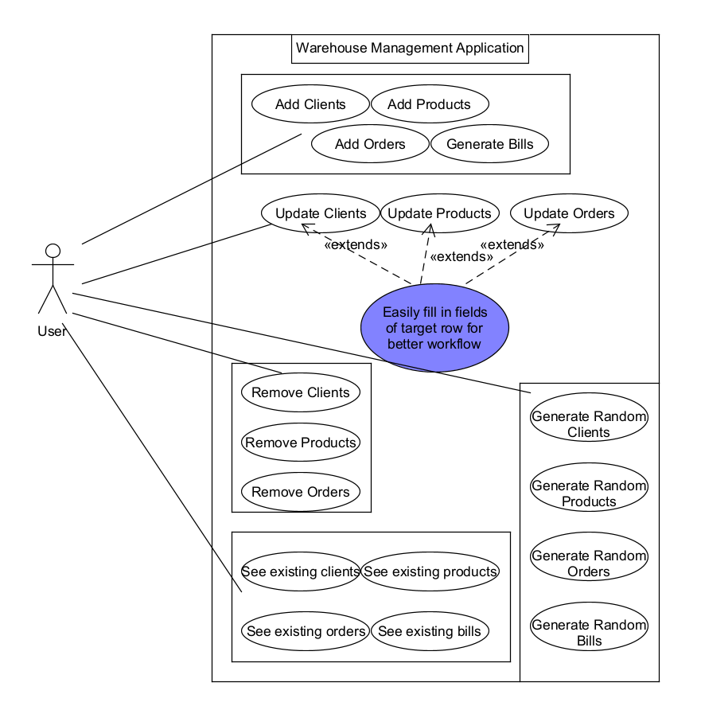

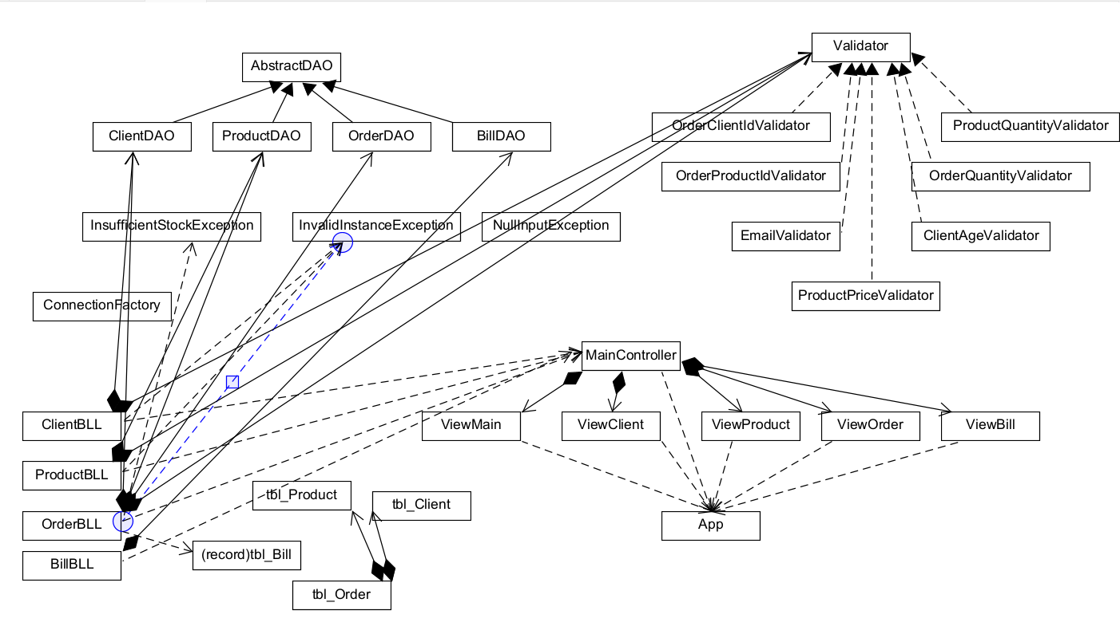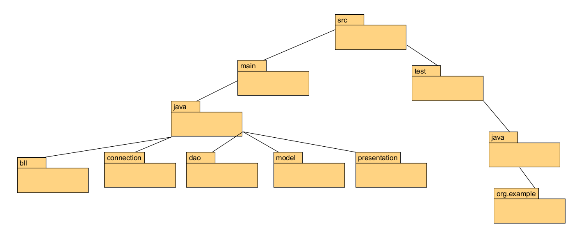

The purpose of the design is to make the code as intuitive and simple as possible. At the heart of the application there is the AbstractDAO class. This class implements the CRUD operations with the DB in a generalized way, such that no matter how many tables the database would have, there would be no need for any additional code besides what there already is. The DAO class is inherited by its respective table DAO object with its object type. All DAO objects are then used by their BusinessLogicLayer objects alongside additional logic such as validation. A validator is an interface, which means it must be implemented by subclasses which will implement the validate() method depending on the desired validations to be done on the given object. BLL objects are then used in the Controller in order to facillitate DB access whenever it is needed. Lastly, this would not be possible without the ConnectionFactory which allows the DAO layer to actually create a connection and interact with the specified database.

Implementation
In order to efficiently use this design pattern, it is mandatory that the table names that are inside the database to match with the names of the mirror objects that are declared in Java. This is because reflection techniques are used, where the name of the class is taken as an input for all queries to be generated.
The AbstractDAO contains a type field which will match the actual class of the intended object when it is called. This is why the AbstractDAO must be inherited by subclasses for each specific type. Then, there is a createSelectQuery() method which either generates a select query looking for a single row in the table specified by the id parameter or it generates a select all rows from the table query which is useful for the findAll() method.
The ConnectionFactory contains methods for sending and receiving information from the database. It facilitates the communication from the DAO classes, after the query has been generated and returns a resultSet which will be further processed depending on the operation.
The BusinessLogicLayer classes aim to be an intermediary between the DAO and the Controller(or caller of said methods) which will add extra validations before the final information is let to pass.
The View classes are instances of JFrame which create the graphical interface shown in the pictures below. The display of database contents is done by creating a JTable and setting its TableModel with the corresponding database information, retrieved with the help of the findAll() method implemented in the AbstractDAO previously mentioned. The findAll() method will be called by the getTableModel() method which will return the table header along with all the rows that are found inside the database. Note that the table header is not taken from the database, rather it is taken from the name of the fields present in the mirror classes in Java. This is the reason why it was mentioned earlier that the names of classes and fields must exactly match those of tables and columns from the database, including the order of declaration.
The MainController puts together the logic behind the BusinessLogicLayer classes along with the Views from the Model package, adding functionality with ActionListeners to each button. The random client generator’s logic is also implemented here, for each table there being an implementation. This random generation is done with the help of the Java Faker library.
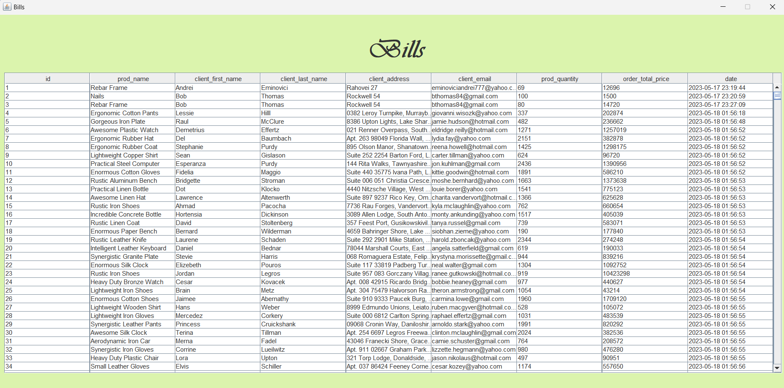
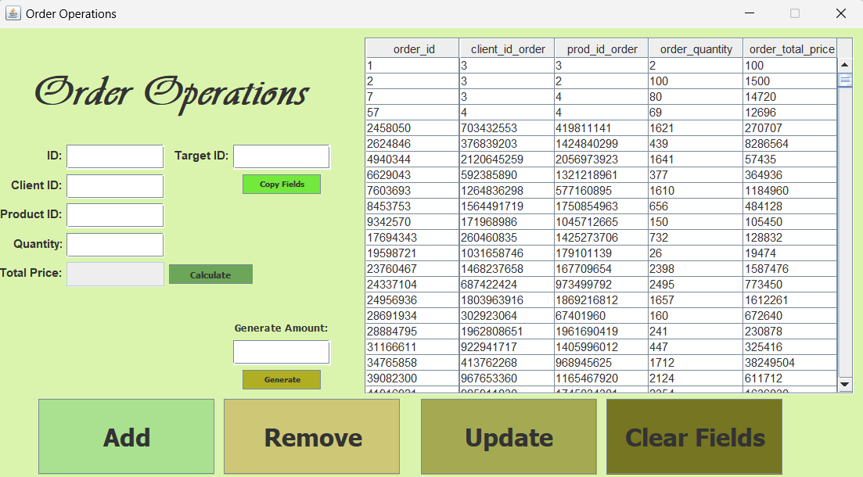
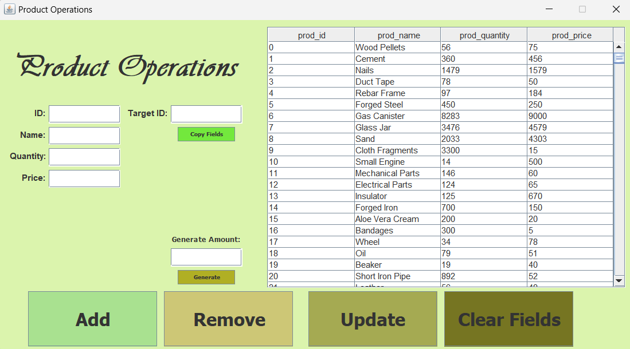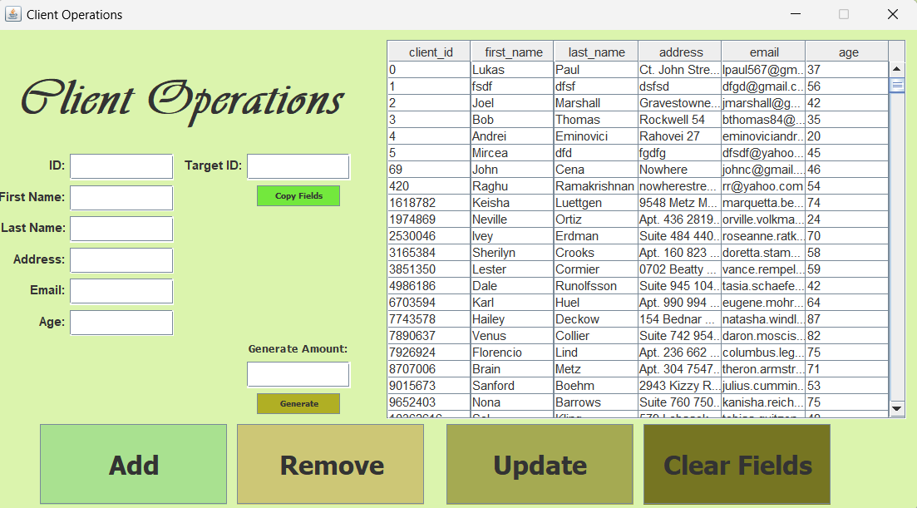


Conclusions
Regarding what I learned, I got familiarized with the concept of reflection and I understood its use cases. Indeed it is a very useful procedure because it allows for very flexible code. I also learned the concept of sqldump and sqlpump of database backup, along with JavaDoc class, method and field documentation.
As for future developments, I think the app is pretty complete and expandable in case of the need for more tables than I have already implemented. I already implemented my future development ideas such as a “Copy Fields” button and a random DB entry generator for each table, so there is little left for me to add here.

Bibliography
The references for the project were Google and sites such as GeeksForGeeks, Baeldung and StackOverflow for help with many issues that I encountered along the way, along with ChatGPT which quickly spotted some of my easier to solve errors and saved me time and headache when debugging. It also suggested to use Java Faker library for random Name, Address and Email generator for the random client generator, which also came in handy.

