MathCAD program for calculation frequency response (50 Hz or 314 radians) of the filter and frequency response curve of the filter. The curve form and max of frequency response are similar to obtained in LTspice. For simulation were supposed: R = 1kOhm, C=1uF.

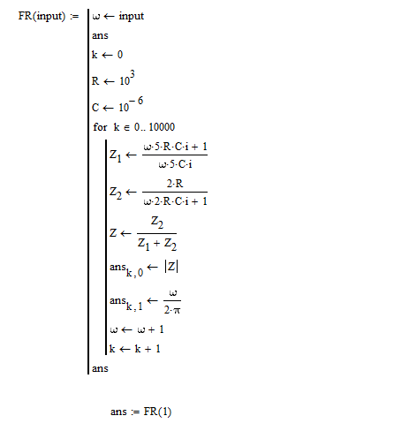

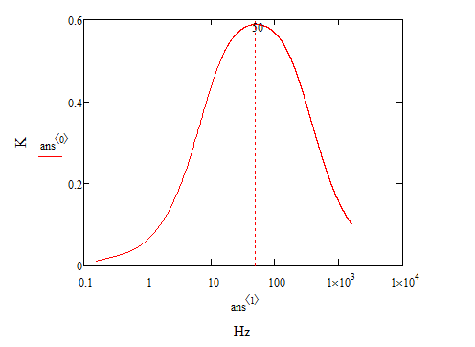

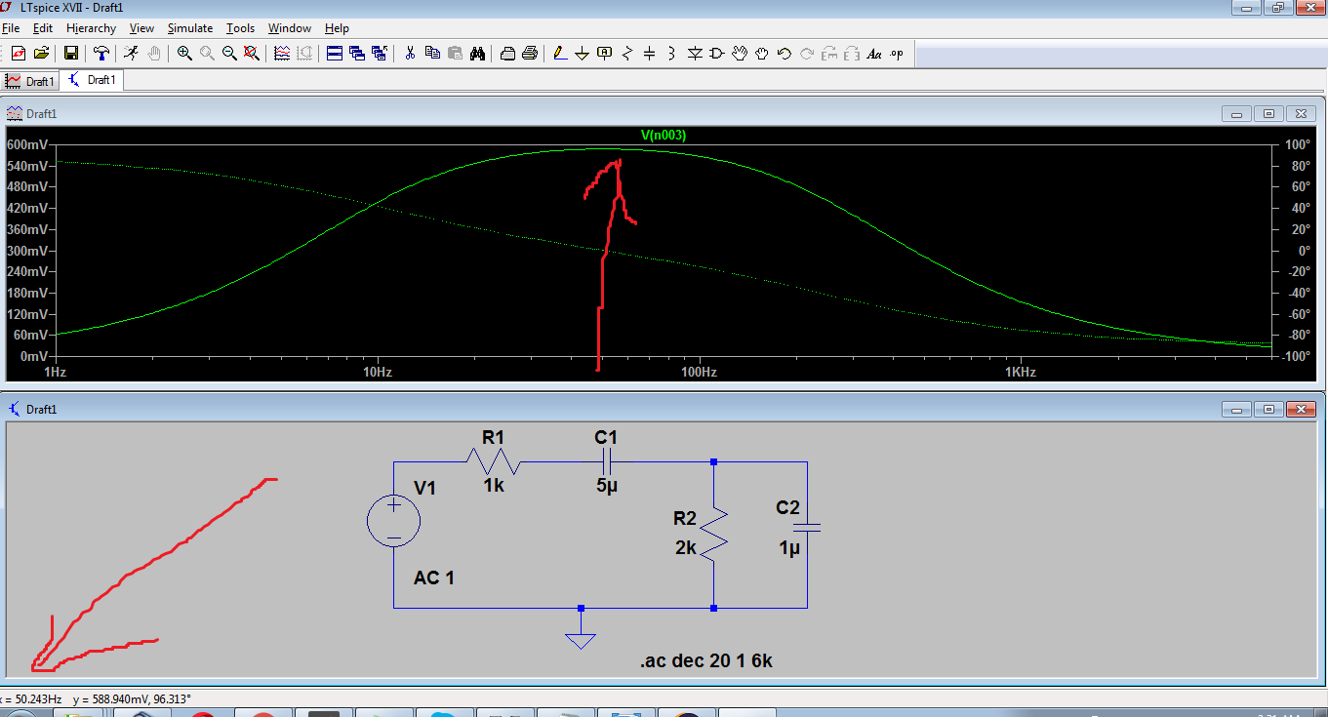

Curve from LTspice