Arduino Project

## student name: lazar andrei - teodor

# concise description of the project

The project consists of a 2D game built in Unity, in which all the inputs are coming from the Arduino Board. The player represents a miner and the main goal of the game is to collect as much gold as possible without freezing.

As mentioned above, the Arduino sends all the inputs of the game. Therefore, the player movement is controlled by two buttons, the state of an elevator is defined by a tilt sensor and the lose condition (i.e. freezing) is determined by the temperature sensor. To be more precise, the in -game temperature decreases at a constant rate and the player must send an increasing amount of heat to the character using the thermistor. Obviously, working in a mine requires light. Thus, the user will have to help his miner by providing light using the light sensor from the Arduino Kit in order to ease the task of finding gold.

The project includes 3 major parts:

1. The Arduino code that reads data from the sensors (the light sensor, the thermistor, a tilt sensor and two buttons) and sends it to the computer via the Arduino Serial Port.
2. The Processing code which is used in order to capture the data sent by the Arduino and to save it as a text file. Moreover, the information is stored in a JSON format for a simpler way to send and parse string data.
3. The Unity C# code that handles most of the project functionalities. There are several scripts, each dealing with separate parts of the game. The InputController.cs script is the most important piece of code because it reads the inputs from the data.json file created by the Processing code and makes them available to all of the other scripts.

# how to set up and run the application

In order to run the application one should follow the succeding steps:

1. 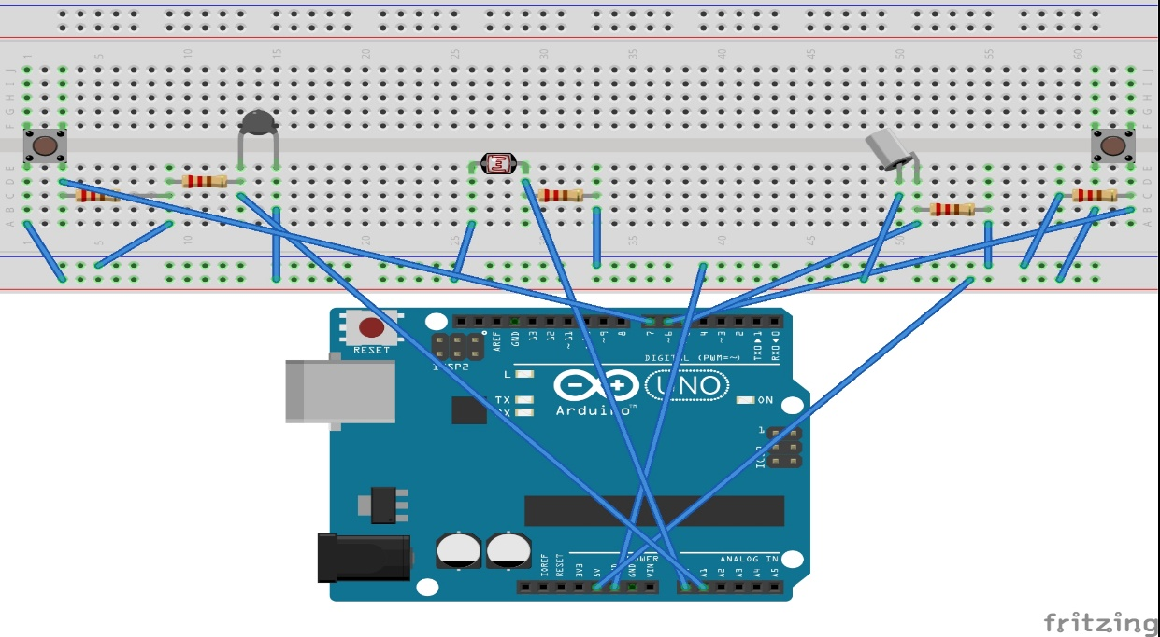Create the following circuit using the Arduino Kit.
2. Connect the board to a computer using the USB cable.
3. Open the *Arduino_Code.ino* file in the Arduino IDE and upload the code to the board.
4. Under the C: directory create a new folder called *Miner_Arduino* and inside that directory create a new folder called *Arduino_to_JSON*.
5. Copy the Processing code file (*Arduino_to_JSON.pde*) into the *Arduino_to_JSON* folder, open the code and run it.
6. Download the archive that contains the Unity build available at: <https://drive.google.com/open?id=1dIm7uuVQFBUHhse-DLm_KSCZacJYtl7r>
7. Unzip the archive and run *themineworker.exe .*

Note: In order to correctly receive the inputs, the *Arudino_to_JSON.pde* must be at the following path: *C:/Miner_Arduino/Arduino_to_JSON/Arduino_to_JSON.pde*

# references

* The graphics pack used in this project is available for free on the Unity Asset Store (<https://assetstore.unity.com/packages/2d/environments/free-platform-game-assets-85838>).
* Inside the Unity project there is a plugin called SimpleJSON, a free to use JSON parser and builder available at: <http://wiki.unity3d.com/index.php/SimpleJSON> .