Academia de Studii Economice

Facultatea de Cibernetica, Statistica si Informatica Economica

**Proiect Baze de Date**

**Gestiunea datelor in domeniul aviatic**

**Profesor coordonator Student**

[CIRNARU Andreea-Alexandra](https://online.ase.ro/user/view.php?id=4568&course=1) Lovin Andrei

Grupa 1054, Seria D

**Cuprins:**

**Creati o baza de date dintr-un domeniu ales de voi care sa contina cel putin 6 tabele, fiecare tabela continand cel putin 10 inregistrari** 3

**Realizati 12 interogari in care sa folositi comenzile alter, select, update, delete** 17

**Realizati 8 interogari in care sa folositi cele 4 tipuri de jonctiuni: left join, right join, inner join, outer join** 21

**Realizati 6 interogari in care sa folositi functiile de grup** 26

**Realizati 6 interogari in care sa folositi structurile ierarhice** 29

**Realizati 4 interogari in care sa folositi comanda CASE/ DECODE** 35

**Realizati 3 interogari in care sa folositi operatorii MINUS, INTERSECT, UNION, cate una cu fiecare** 38

# **Creati o baza de date dintr-un domeniu ales de voi care sa contina cel putin 6 tabele, fiecare tabela continand cel putin 10 inregistrari**

CREATE TABLE TARI_2 (

Id_tara VARCHAR2(5) CONSTRAINT PK_tari PRIMARY KEY,

Nume_tara VARCHAR2(200) NOT NULL);

INSERT INTO TARI_2 (Id_tara, Nume_tara) VALUES ('RO', 'Romania');

INSERT INTO TARI_2 (Id_tara, Nume_tara) VALUES ('DE', 'Germania');

INSERT INTO TARI_2 (Id_tara, Nume_tara) VALUES ('NL', 'Olanda');

INSERT INTO TARI_2 (Id_tara, Nume_tara) VALUES ('GB', 'Marea Britanie');

INSERT INTO TARI_2 (Id_tara, Nume_tara) VALUES ('FR', 'Franta');

INSERT INTO TARI_2 (Id_tara, Nume_tara) VALUES ('IE', 'Irlanda');

INSERT INTO TARI_2 (Id_tara, Nume_tara) VALUES ('PT', 'Portugalia');

INSERT INTO TARI_2 (Id_tara, Nume_tara) VALUES ('IT', 'Italia');

INSERT INTO TARI_2 (Id_tara, Nume_tara) VALUES ('AR', 'Argentina');

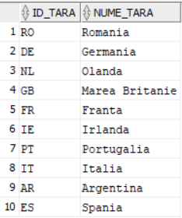INSERT INTO TARI_2 (Id_tara, Nume_tara) VALUES ('ES', 'Spania');

CREATE TABLE AEROPORTURI (

Id_aeroport NUMBER(3) CONSTRAINT PK_aeroporturi PRIMARY KEY,

Nume_aeroport VARCHAR2(200) NOT NULL,

Oras VARCHAR2(200) NOT NULL,

Id_tara VARCHAR2(5) NOT NULL,

Cod_aeroport VARCHAR2(5) NOT NULL,

CONSTRAINT FK_tari FOREIGN KEY (Id_tara) REFERENCES TARI_2 (Id_tara));

INSERT INTO AEROPORTURI (Id_aeroport, Nume_aeroport, Oras, Id_tara, Cod_aeroport)

VALUES (1, 'Aeroportul International Otopeni', 'Bucuresti', 'RO', 'BIO');

INSERT INTO AEROPORTURI (Id_aeroport, Nume_aeroport, Oras, Id_tara, Cod_aeroport)

VALUES(2, 'Aeroportul Henri Coanda', 'Bucuresti', 'RO', 'BHC');

INSERT INTO AEROPORTURI (Id_aeroport, Nume_aeroport, Oras, Id_tara, Cod_aeroport)

VALUES(3, 'Aeroportul International Cluj-Napoca', 'Cluj-Napoca', 'RO', 'CJI');

INSERT INTO AEROPORTURI (Id_aeroport, Nume_aeroport, Oras, Id_tara, Cod_aeroport)

VALUES(4, 'Aeroportul International Timisoara', 'Timisoara', 'RO', 'TIT');

INSERT INTO AEROPORTURI (Id_aeroport, Nume_aeroport, Oras, Id_tara, Cod_aeroport)

VALUES(5, 'Aeroportul International Sibiu', 'Sibiu', 'RO', 'SIS');

INSERT INTO AEROPORTURI (Id_aeroport, Nume_aeroport, Oras, Id_tara, Cod_aeroport)

VALUES(6, 'Aeroportul International Oradea', 'Oradea', 'RO', 'OIO');

INSERT INTO AEROPORTURI (Id_aeroport, Nume_aeroport, Oras, Id_tara, Cod_aeroport)

VALUES(7, 'Aeroportul International Mihail Kogalniceanu', 'Constanta', 'RO', 'CMK');

INSERT INTO AEROPORTURI (Id_aeroport, Nume_aeroport, Oras, Id_tara, Cod_aeroport)

VALUES(8, 'Aeroportul International Iasi', 'Iasi', 'RO', 'III');

INSERT INTO AEROPORTURI (Id_aeroport, Nume_aeroport, Oras, Id_tara, Cod_aeroport)

VALUES(9, 'Aeroportul International Craiova', 'Craiova', 'RO', 'CIC');

INSERT INTO AEROPORTURI (Id_aeroport, Nume_aeroport, Oras, Id_tara, Cod_aeroport)

VALUES(10, 'Aeroportul International Bacau', 'Bacau', 'RO', 'BIB');

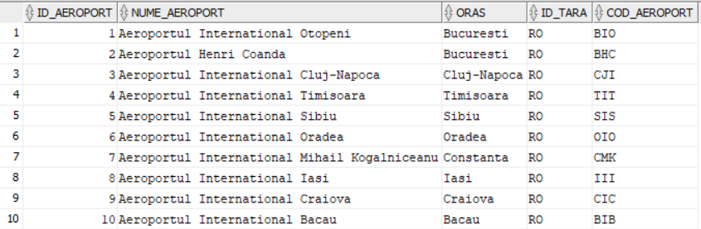

CREATE TABLE COMPANII_AERIENE (

Id_companie NUMBER(3) CONSTRAINT PK_companii PRIMARY KEY,

Nume_companie VARCHAR2(200) NOT NULL,

Nume_tara VARCHAR2(200) NOT NULL,

An_fondare NUMBER(4) NOT NULL);

INSERT INTO COMPANII_AERIENE (Id_companie, Nume_companie, Nume_tara, An_fondare) VALUES (1, 'Tarom', 'Romania', '1954');

INSERT INTO COMPANII_AERIENE (Id_companie, Nume_companie, Nume_tara, An_fondare) VALUES (2, 'Wizz Air', 'Romania', '2003');

INSERT INTO COMPANII_AERIENE (Id_companie, Nume_companie, Nume_tara, An_fondare) VALUES (3, 'Blue Air', 'Romania', '2004');

INSERT INTO COMPANII_AERIENE (Id_companie, Nume_companie, Nume_tara, An_fondare) VALUES (4, 'Lufthansa', 'Germania', '1926');

INSERT INTO COMPANII_AERIENE (Id_companie, Nume_companie, Nume_tara, An_fondare) VALUES (5, 'KLM', 'Olanda', '1919');

INSERT INTO COMPANII_AERIENE (Id_companie, Nume_companie, Nume_tara, An_fondare) VALUES (6, 'British Airways', 'Marea Britanie', '1974');

INSERT INTO COMPANII_AERIENE (Id_companie, Nume_companie, Nume_tara, An_fondare) VALUES (7, 'Air France', 'Franta', '1933');

INSERT INTO COMPANII_AERIENE (Id_companie, Nume_companie, Nume_tara, An_fondare) VALUES (8, 'Ryanair', 'Irlanda', '1985');

INSERT INTO COMPANII_AERIENE (Id_companie, Nume_companie, Nume_tara, An_fondare) VALUES (9, 'TAP Portugal','Portugalia', '1945');

INSERT INTO COMPANII_AERIENE (Id_companie, Nume_companie, Nume_tara, An_fondare) VALUES (10, 'Alitalia', 'Italia', '1947');

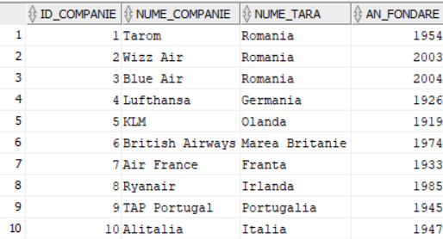

CREATE TABLE CURSE (

Id_cursa NUMBER(3) CONSTRAINT PK_curse PRIMARY KEY,

Aeroport_plecare VARCHAR2(200) NOT NULL,

Aeroport_sosire VARCHAR2(200) NOT NULL,

Durata_cursa NUMBER(5) NOT NULL,

Id_companie NUMBER(3) NOT NULL,

CONSTRAINT FK_companii FOREIGN KEY (Id_companie) REFERENCES COMPANII_AERIENE (Id_companie));

INSERT INTO CURSE (Id_cursa, Aeroport_plecare, Aeroport_sosire, Durata_cursa, Id_companie) VALUES (1, 'Aeroportul International Otopeni', 'Aeroportul International Cluj-Napoca', 80, 1);

INSERT INTO CURSE (Id_cursa, Aeroport_plecare, Aeroport_sosire, Durata_cursa, Id_companie) VALUES (2, 'Aeroportul International Otopeni', 'Aeroportul International Timisoara', 70, 1);

INSERT INTO CURSE (Id_cursa, Aeroport_plecare, Aeroport_sosire, Durata_cursa, Id_companie) VALUES (3, 'Aeroportul International Otopeni', 'Aeroportul International Sibiu', 80, 2);

INSERT INTO CURSE (Id_cursa, Aeroport_plecare, Aeroport_sosire, Durata_cursa, Id_companie) VALUES (4, 'Aeroportul International Otopeni', 'Aeroportul International Oradea', 70, 3);

INSERT INTO CURSE (Id_cursa, Aeroport_plecare, Aeroport_sosire, Durata_cursa, Id_companie) VALUES (5, 'Aeroportul International Otopeni', 'Aeroportul International Mihail Kogalniceanu', 90, 1);

INSERT INTO CURSE (Id_cursa, Aeroport_plecare, Aeroport_sosire, Durata_cursa, Id_companie) VALUES (6, 'Aeroportul International Otopeni', 'Aeroportul International Iasi', 110, 2);

INSERT INTO CURSE (Id_cursa, Aeroport_plecare, Aeroport_sosire, Durata_cursa, Id_companie) VALUES (7, 'Aeroportul International Otopeni', 'Aeroportul International Craiova', 80, 1);

INSERT INTO CURSE (Id_cursa, Aeroport_plecare, Aeroport_sosire, Durata_cursa, Id_companie) VALUES (8, 'Aeroportul International Otopeni', 'Aeroportul International Bacau', 90, 3);

INSERT INTO CURSE (Id_cursa, Aeroport_plecare, Aeroport_sosire, Durata_cursa, Id_companie) VALUES (9, 'Aeroportul International Otopeni', 'Aeroportul Henri Coanda', 10, 1);

INSERT INTO CURSE (Id_cursa, Aeroport_plecare, Aeroport_sosire, Durata_cursa, Id_companie) VALUES (10, 'Aeroportul Henri Coanda', 'Londra', 300, 5);

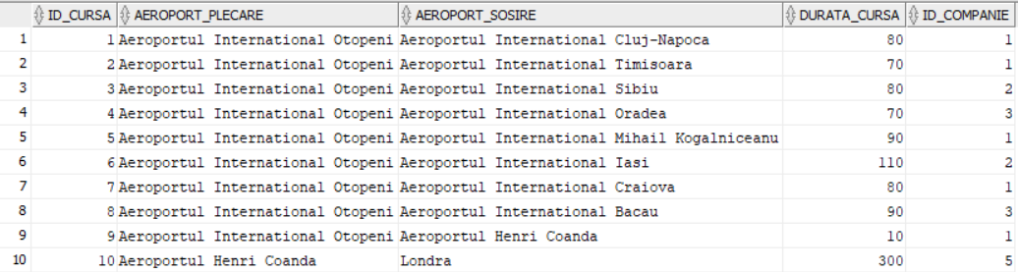

CREATE TABLE ZBORURI (

Id_zbor NUMBER(3) CONSTRAINT PK_zboruri PRIMARY KEY,

Nume_zbor VARCHAR2(200) NOT NULL,

Data_plecarii DATE NOT NULL,

Data_sosirii DATE NOT NULL,

Id_cursa NUMBER(3) NOT NULL,

CONSTRAINT FK_curse FOREIGN KEY (Id_cursa) REFERENCES CURSE (Id_cursa)

);

INSERT INTO ZBORURI (Id_zbor, Nume_zbor, Data_plecarii, Data_sosirii, Id_cursa)

VALUES (1, 'Tarom Zbor 841', TO_DATE('01-06-2020','dd-mm-yyyy'), TO_DATE('02-06-2020','dd-mm-yyyy'), 1);

INSERT INTO ZBORURI (Id_zbor, Nume_zbor, Data_plecarii, Data_sosirii, Id_cursa)

VALUES (2, 'Tarom Zbor 842', TO_DATE('02-06-2020','dd-mm-yyyy'), TO_DATE('03-06-2020','dd-mm-yyyy'), 1);

INSERT INTO ZBORURI (Id_zbor, Nume_zbor, Data_plecarii, Data_sosirii, Id_cursa)

VALUES (3, 'Wizz Air Zbor 801', TO_DATE('03-06-2020','dd-mm-yyyy'), TO_DATE('04-06-2020','dd-mm-yyyy'), 2);

INSERT INTO ZBORURI (Id_zbor, Nume_zbor, Data_plecarii, Data_sosirii, Id_cursa)

VALUES (4, 'Wizz Air Zbor 802', TO_DATE('04-06-2020','dd-mm-yyyy'), TO_DATE('05-06-2020','dd-mm-yyyy'), 2);

INSERT INTO ZBORURI (Id_zbor, Nume_zbor, Data_plecarii, Data_sosirii, Id_cursa)

VALUES (5, 'Blue Air Zbor 861', TO_DATE('05-06-2020','dd-mm-yyyy'), TO_DATE('06-06-2020','dd-mm-yyyy'), 3);

INSERT INTO ZBORURI (Id_zbor, Nume_zbor, Data_plecarii, Data_sosirii, Id_cursa)

VALUES (6, 'Blue Air Zbor 862', TO_DATE('06-06-2020','dd-mm-yyyy'), TO_DATE('07-06-2020','dd-mm-yyyy'), 3);

INSERT INTO ZBORURI (Id_zbor, Nume_zbor, Data_plecarii, Data_sosirii, Id_cursa)

VALUES (7, 'Lufthansa Zbor 831', TO_DATE('07-06-2020','dd-mm-yyyy'), TO_DATE('08-06-2020','dd-mm-yyyy'), 4);

INSERT INTO ZBORURI (Id_zbor, Nume_zbor, Data_plecarii, Data_sosirii, Id_cursa)

VALUES (8, 'Lufthansa Zbor 832', TO_DATE('08-06-2020','dd-mm-yyyy'), TO_DATE('09-06-2020','dd-mm-yyyy'), 4);

INSERT INTO ZBORURI (Id_zbor, Nume_zbor, Data_plecarii, Data_sosirii, Id_cursa)

VALUES (9, 'KLM Zbor 871', TO_DATE('09-06-2020','dd-mm-yyyy'), TO_DATE('10-06-2020','dd-mm-yyyy'), 5);

INSERT INTO ZBORURI (Id_zbor, Nume_zbor, Data_plecarii, Data_sosirii, Id_cursa)

VALUES (10, 'KLM Zbor 872', TO_DATE('10-06-2020','dd-mm-yyyy'), TO_DATE('11-06-2020','dd-mm-yyyy'), 5);

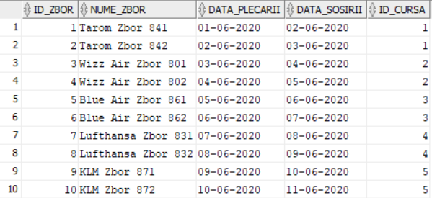

CREATE TABLE PASAGERI (

Id_pasager NUMBER(3) CONSTRAINT PK_pasageri PRIMARY KEY,

Nume_pasager VARCHAR2(200) NOT NULL,

Prenume_pasager VARCHAR2(200) NOT NULL,

Varsta_pasager NUMBER(3) NOT NULL);

INSERT INTO PASAGERI (Id_pasager, Nume_pasager, Prenume_pasager, Varsta_pasager)

VALUES (1, 'Popescu', 'Ion', 32);

INSERT INTO PASAGERI (Id_pasager, Nume_pasager, Prenume_pasager, Varsta_pasager)

VALUES (2, 'Popescu', 'Maria', 28);

INSERT INTO PASAGERI (Id_pasager, Nume_pasager, Prenume_pasager, Varsta_pasager)

VALUES (3, 'Ionescu', 'Vasile', 37);

INSERT INTO PASAGERI (Id_pasager, Nume_pasager, Prenume_pasager, Varsta_pasager)

VALUES (4, 'Ionescu', 'Ana', 42);

INSERT INTO PASAGERI (Id_pasager, Nume_pasager, Prenume_pasager, Varsta_pasager)

VALUES (5, 'Andrei', 'Alexandru', 25);

INSERT INTO PASAGERI (Id_pasager, Nume_pasager, Prenume_pasager, Varsta_pasager)

VALUES (6, 'Andrei', 'Adriana', 27);

INSERT INTO PASAGERI (Id_pasager, Nume_pasager, Prenume_pasager, Varsta_pasager)

VALUES (7, 'Vasilescu', 'Mihai', 33);

INSERT INTO PASAGERI (Id_pasager, Nume_pasager, Prenume_pasager, Varsta_pasager)

VALUES(8, 'Vasilescu', 'Cristina', 29);

INSERT INTO PASAGERI (Id_pasager, Nume_pasager, Prenume_pasager, Varsta_pasager)

VALUES (9, 'Dumitrescu', 'Ion', 36);

INSERT INTO PASAGERI (Id_pasager, Nume_pasager, Prenume_pasager, Varsta_pasager)

VALUES (10, 'Dumitrescu', 'Elena', 40);

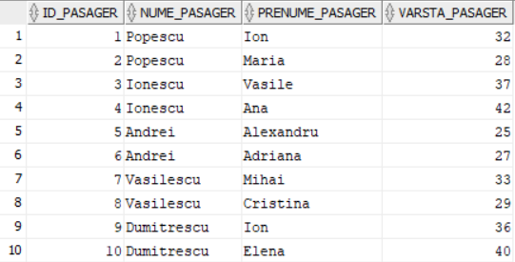

CREATE TABLE BILETE (

Id_bilet NUMBER(3) CONSTRAINT PK_bilete PRIMARY KEY,

Id_zbor NUMBER(3) NOT NULL,

Id_pasager NUMBER(3) NOT NULL,

Tip_bilet VARCHAR2(200) NOT NULL,

Pret NUMBER(4) NOT NULL,

CONSTRAINT FK_zboruri FOREIGN KEY (Id_zbor) REFERENCES ZBORURI (Id_zbor),

CONSTRAINT FK_pasageri FOREIGN KEY (Id_pasager) REFERENCES PASAGERI (Id_pasager));

INSERT INTO BILETE (Id_bilet, Id_zbor, Id_pasager, Tip_bilet, Pret) VALUES (1, 1, 1, 'business', 200);

INSERT INTO BILETE (Id_bilet, Id_zbor, Id_pasager, Tip_bilet, Pret) VALUES (2, 1, 2, 'business', 200);

INSERT INTO BILETE (Id_bilet, Id_zbor, Id_pasager, Tip_bilet, Pret) VALUES (3, 2, 3, 'first', 250);

INSERT INTO BILETE (Id_bilet, Id_zbor, Id_pasager, Tip_bilet, Pret) VALUES (4, 2, 4, 'first', 250);

INSERT INTO BILETE (Id_bilet, Id_zbor, Id_pasager, Tip_bilet, Pret) VALUES (5, 3, 5, 'economic', 150);

INSERT INTO BILETE (Id_bilet, Id_zbor, Id_pasager, Tip_bilet, Pret) VALUES (6, 3, 6, 'business', 200);

INSERT INTO BILETE (Id_bilet, Id_zbor, Id_pasager, Tip_bilet, Pret) VALUES (7, 4, 7, 'first', 250);

INSERT INTO BILETE (Id_bilet, Id_zbor, Id_pasager, Tip_bilet, Pret) VALUES (8, 4, 8, 'business', 200);

INSERT INTO BILETE (Id_bilet, Id_zbor, Id_pasager, Tip_bilet, Pret) VALUES (9, 5, 9, 'economic', 150);

INSERT INTO BILETE (Id_bilet, Id_zbor, Id_pasager, Tip_bilet, Pret) VALUES (10, 5, 10, 'first', 250);

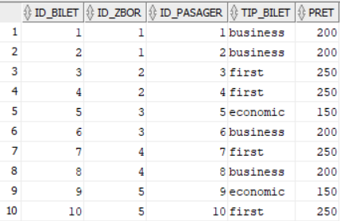

CREATE TABLE ECHIPAJ (

Id_echipaj NUMBER(3),

Id_zbor NUMBER(3) NOT NULL,

Id_membru NUMBER(3) NOT NULL CONSTRAINT PK_membru_echipaj PRIMARY KEY,

Nume_membru VARCHAR2(200) NOT NULL,

Functie VARCHAR2(200) NOT NULL,

Experienta NUMBER(2) NOT NULL,

Id_superior NUMBER(2),

CONSTRAINT FK_zbr FOREIGN KEY (Id_zbor) REFERENCES ZBORURI (Id_zbor));

INSERT INTO ECHIPAJ (Id_echipaj, Id_zbor, Id_membru, Nume_membru, Functie, Experienta)

VALUES (1, 1, 1, 'Gheorghe', 'pilot', 10);

INSERT INTO ECHIPAJ (Id_echipaj, Id_zbor, Id_membru, Nume_membru, Functie, Experienta, Id_superior) VALUES (1, 1, 2, 'Ion', 'copilot', 5, 1);

INSERT INTO ECHIPAJ (Id_echipaj, Id_zbor, Id_membru, Nume_membru, Functie, Experienta, Id_superior) VALUES (1, 1, 3, 'Mihai', 'steward', 3, 2);

INSERT INTO ECHIPAJ (Id_echipaj, Id_zbor, Id_membru, Nume_membru, Functie, Experienta, Id_superior) VALUES (1, 1, 4, 'Ioana', 'steward', 3, 2);

INSERT INTO ECHIPAJ (Id_echipaj, Id_zbor, Id_membru, Nume_membru, Functie, Experienta)

VALUES (2, 2, 5, 'Vasile', 'pilot', 10);

INSERT INTO ECHIPAJ (Id_echipaj, Id_zbor, Id_membru, Nume_membru, Functie, Experienta, Id_superior) VALUES (2, 2, 6, 'Marius', 'copilot', 6, 5);

INSERT INTO ECHIPAJ (Id_echipaj, Id_zbor, Id_membru, Nume_membru, Functie, Experienta, Id_superior) VALUES (2, 2, 7, 'Valentin', 'steward', 5, 6);

INSERT INTO ECHIPAJ (Id_echipaj, Id_zbor, Id_membru, Nume_membru, Functie, Experienta, Id_superior) VALUES (2, 2, 8, 'Iulia', 'steward', 4, 6);

INSERT INTO ECHIPAJ (Id_echipaj, Id_zbor, Id_membru, Nume_membru, Functie, Experienta)

VALUES (3, 3, 9, 'Alexandru', 'pilot', 9);

INSERT INTO ECHIPAJ (Id_echipaj, Id_zbor, Id_membru, Nume_membru, Functie, Experienta, Id_superior) VALUES (3, 3, 10, 'Cristian', 'copilot', 8, 9);

INSERT INTO ECHIPAJ (Id_echipaj, Id_zbor, Id_membru, Nume_membru, Functie, Experienta, Id_superior) VALUES (3, 3, 11, 'Gheorghita', 'steward', 7, 10);

INSERT INTO ECHIPAJ (Id_echipaj, Id_zbor, Id_membru, Nume_membru, Functie, Experienta, Id_superior) VALUES (3, 3, 12, 'Roxana', 'steward', 7, 10);

INSERT INTO ECHIPAJ (Id_echipaj, Id_zbor, Id_membru, Nume_membru, Functie, Experienta)

VALUES (4, 4, 13, 'Gheorghe', 'pilot', 8);

INSERT INTO ECHIPAJ (Id_echipaj, Id_zbor, Id_membru, Nume_membru, Functie, Experienta, Id_superior) VALUES (4, 4, 14, 'Adrian', 'copilot', 3, 13);

INSERT INTO ECHIPAJ (Id_echipaj, Id_zbor, Id_membru, Nume_membru, Functie, Experienta, Id_superior) VALUES (4, 4, 15, 'Iulia', 'steward', 4, 14);

INSERT INTO ECHIPAJ (Id_echipaj, Id_zbor, Id_membru, Nume_membru, Functie, Experienta, Id_superior) VALUES (4, 4, 16, 'Anca', 'steward', 4, 14);

INSERT INTO ECHIPAJ (Id_echipaj, Id_zbor, Id_membru, Nume_membru, Functie, Experienta)

VALUES (5, 5, 17, 'Alexandru', 'pilot', 9);

INSERT INTO ECHIPAJ (Id_echipaj, Id_zbor, Id_membru, Nume_membru, Functie, Experienta, Id_superior) VALUES (5, 5, 18, 'Vasile', 'copilot', 6, 17);

INSERT INTO ECHIPAJ (Id_echipaj, Id_zbor, Id_membru, Nume_membru, Functie, Experienta, Id_superior) VALUES (5, 5, 19, 'Valentin', 'steward', 5, 18);

INSERT INTO ECHIPAJ (Id_echipaj, Id_zbor, Id_membru, Nume_membru, Functie, Experienta, Id_superior) VALUES (5, 5, 20, 'Ioana', 'steward', 3, 18);

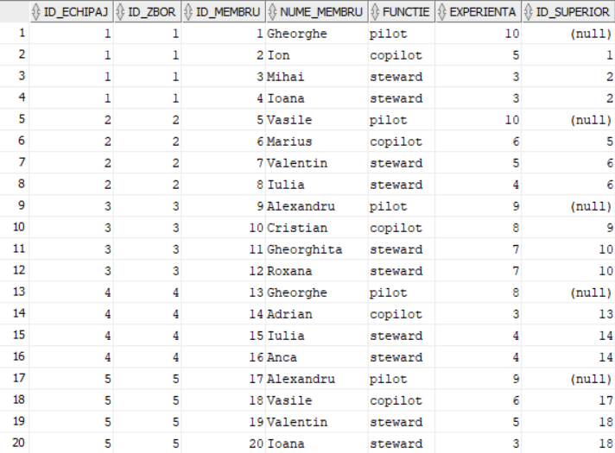

# **Realizati 12 interogari in care sa folositi comenzile alter, select, update, delete**

ALTER TABLE TARI_2 ADD(Limbi_vorbite VARCHAR(50));

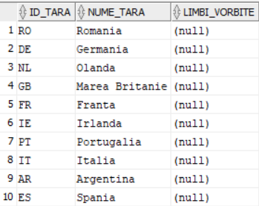

ALTER TABLE ZBORURI ADD(Numar_pasageri NUMBER(3));

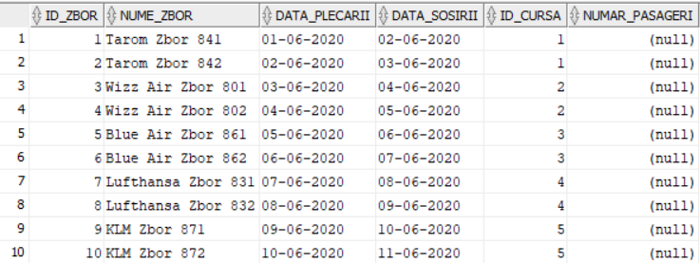

ALTER TABLE CURSE ADD(Tip_avion VARCHAR(50));

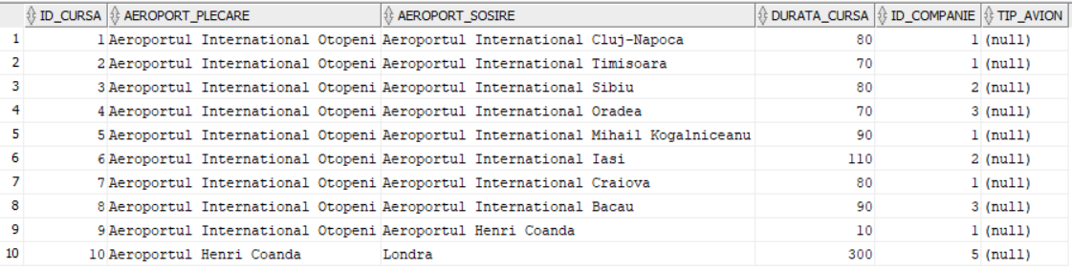

SELECT Nume_companie, An_fondare FROM COMPANII_AERIENE WHERE Nume_tara = 'Romania';

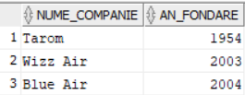

SELECT Nume_zbor, Data_plecarii, Data_sosirii FROM ZBORURI WHERE Id_cursa = 3;

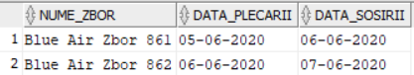

SELECT Nume_aeroport, Oras, Id_tara FROM AEROPORTURI WHERE Cod_aeroport = 'BIB';



UPDATE CURSE SET Durata_cursa = 70 WHERE Id_cursa = 6;



UPDATE PASAGERI SET Varsta_pasager = 35 WHERE Id_pasager = 10;



UPDATE COMPANII_AERIENE SET An_fondare = '1935' WHERE Id_companie = 9;



DELETE FROM BILETE WHERE Id_bilet = 8;

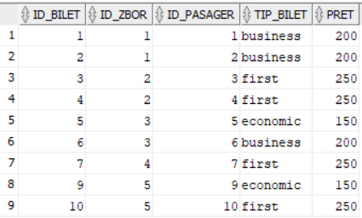

DELETE FROM aeroporturi WHERE Id_aeroport = 4;

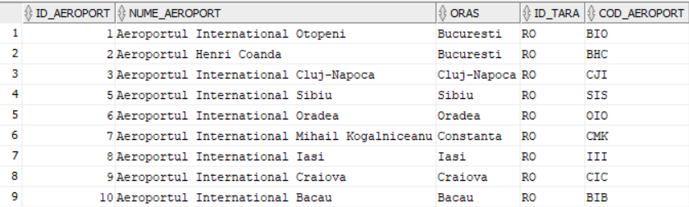

DELETE FROM TARI_2 WHERE Id_tara = 'ES';

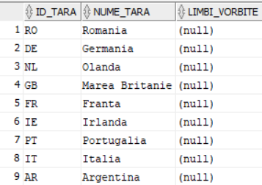

# **Realizati 8 interogari in care sa folositi cele 4 tipuri de jonctiuni: left join, right join, inner join, outer join**

SELECT Z.Nume_zbor, B.Tip_bilet, C.Durata_cursa, B.Pret FROM BILETE B

LEFT JOIN ZBORURI Z ON B.Id_zbor = Z.Id_zbor

LEFT JOIN CURSE C ON Z.Id_cursa = C.Id_cursa;

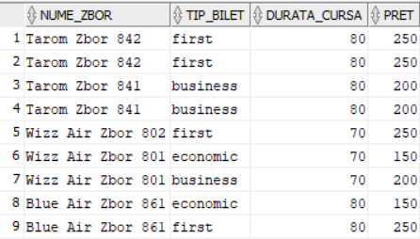

SELECT A.Cod_aeroport, A.Nume_aeroport, T.Nume_tara FROM Aeroporturi A

LEFT JOIN Tari_2 T ON A.Id_tara = T.Id_tara;

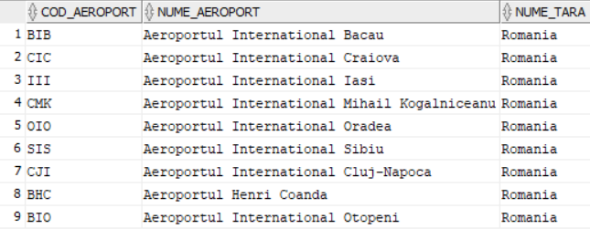

SELECT TARI_2.Nume_tara, AEROPORTURI.Oras,

AEROPORTURI.Nume_aeroport FROM TARI_2

RIGHT JOIN AEROPORTURI ON TARI_2.Id_tara = AEROPORTURI.Id_tara;

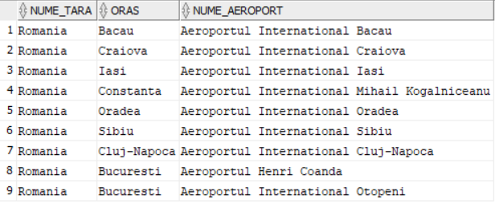

SELECT PASAGERI.Nume_pasager, PASAGERI.Prenume_pasager,

ZBORURI.Nume_zbor, ZBORURI.Data_plecarii FROM PASAGERI

RIGHT JOIN BILETE ON PASAGERI.Id_pasager = BILETE.Id_pasager

LEFT JOIN ZBORURI ON BILETE.Id_zbor = ZBORURI.Id_zbor;

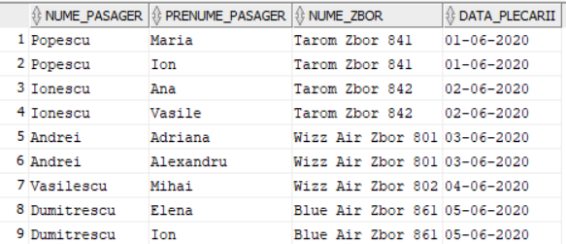

SELECT CURSE.Aeroport_plecare, CURSE.Aeroport_sosire,

COMPANII_AERIENE.Nume_companie FROM CURSE

INNER JOIN COMPANII_AERIENE ON CURSE.Id_companie =

COMPANII_AERIENE.Id_companie;

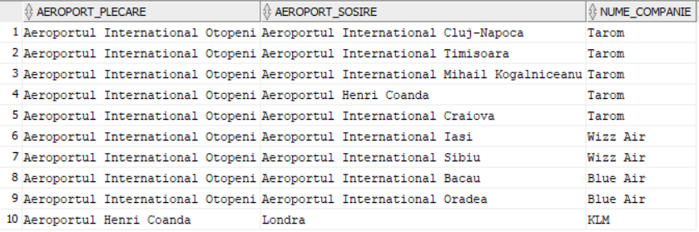

SELECT COMPANII_AERIENE.Nume_tara,

COMPANII_AERIENE.Nume_companie, ZBORURI.Nume_zbor,

ZBORURI.Data_plecarii, ZBORURI.Data_sosirii FROM COMPANII_AERIENE

INNER JOIN CURSE ON COMPANII_AERIENE.Id_companie =

CURSE.Id_companie

INNER JOIN ZBORURI ON CURSE.Id_cursa = ZBORURI.Id_cursa;

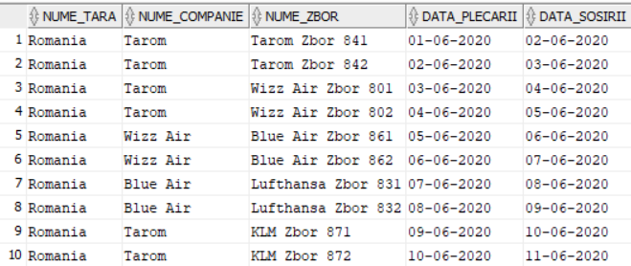

SELECT T.Nume_tara, A.Nume_aeroport FROM TARI_2 T

RIGHT OUTER JOIN AEROPORTURI A ON T.Id_tara = A.Id_tara;

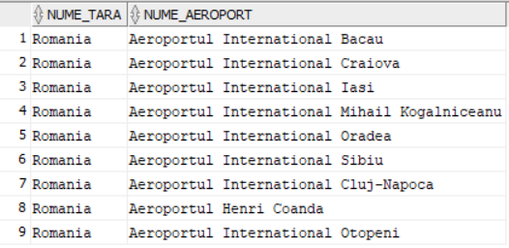

SELECT Z.Nume_zbor, P.Nume_pasager, B.Pret FROM ZBORURI Z

LEFT OUTER JOIN BILETE B ON Z.Id_zbor = B.Id_zbor

RIGHT OUTER JOIN PASAGERI P ON P.Id_pasager = B.Id_pasager;

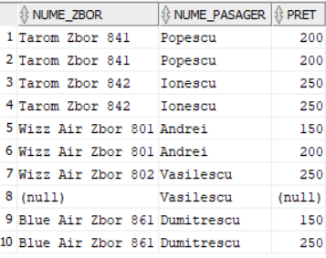

#### **Realizati 6 interogari in care sa folositi functiile de grup**

SELECT AVG(Durata_cursa) AS Durata_medie_a_curselor FROM CURSE

WHERE Id_companie in (1, 3)

GROUP BY Id_companie

HAVING AVG(Durata_cursa) < 90;

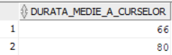

SELECT Id_companie, COUNT(Id_cursa) AS NR_CURSE FROM CURSE

GROUP BY Id_companie

ORDER BY Id_companie;

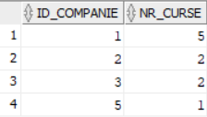

SELECT Nume_tara, MAX(An_fondare) AS An_max

FROM COMPANII_AERIENE

GROUP BY Nume_tara

ORDER BY An_max DESC;

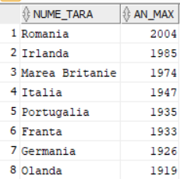

SELECT MIN(Pret) AS Pret_minim, Nume_companie FROM Bilete

JOIN Curse ON Bilete.Id_zbor = Curse.Id_cursa

JOIN Companii_aeriene ON Companii_aeriene.Id_companie = Curse.Id_companie

WHERE Tip_bilet = 'business'

GROUP BY Nume_companie

ORDER BY Pret_minim;

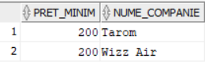

SELECT Tip_bilet, SUM(Pret) AS Pret_total FROM Bilete

GROUP BY Tip_bilet;

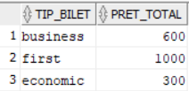

SELECT PASAGERI.Nume_pasager, PASAGERI.Prenume_pasager,

SUM(BILETE.Pret) AS Suma_totala_preturi FROM PASAGERI

INNER JOIN BILETE ON BILETE.Id_pasager = PASAGERI.Id_pasager

GROUP BY PASAGERI.Nume_pasager, PASAGERI.Prenume_pasager;

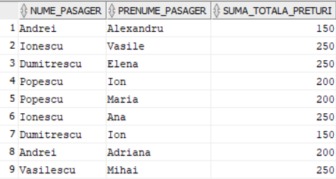

# **Realizati 6 interogari in care sa folositi structurile ierarhice**

SELECT Id_membru, Nume_membru, Id_superior, LEVEL FROM ECHIPAJ

CONNECT BY PRIOR Id_membru = Id_superior

START WITH Id_membru in (1,5,9,13,17)

ORDER BY LEVEL, Id_membru;

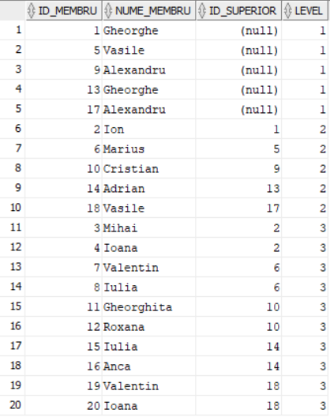

SELECT LEVEL, LPAD(' ',LEVEL)||Nume_membru AS NUME FROM ECHIPAJ

CONNECT BY PRIOR Id_membru = Id_superior

START WITH Id_membru in (1,5,9,13,17)

ORDER BY LEVEL, Id_membru;

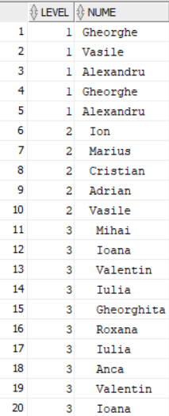

SELECT Id_membru, Nume_membru, level-1 NUMAR_SUPERIORI,

SYS_CONNECT_BY_PATH(Id_membru, ',') ID_SUPERIORI FROM ECHIPAJ

START WITH Id_membru in (1,5,9,13,17)

CONNECT BY PRIOR Id_membru = Id_superior;

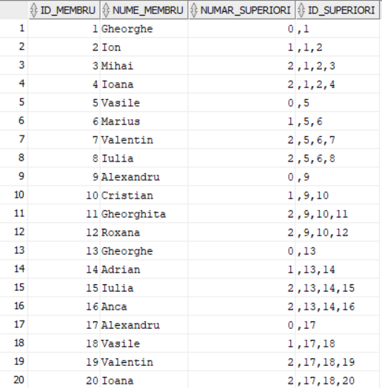

SELECT Id_zbor, AVG(Experienta) AS MEDIE_EXPERIENTA

FROM ECHIPAJ

START WITH Id_membru IN (1,5,9,13,17)

CONNECT BY PRIOR Id_zbor = Id_zbor

AND PRIOR Id_membru = Id_superior

GROUP BY Id_zbor;

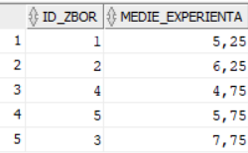

SELECT Id_zbor, COUNT(*) NR_MEMBRI_ECHIPAJ FROM ECHIPAJ

START WITH Id_superior IS NULL

CONNECT BY PRIOR Id_membru = Id_superior

GROUP BY Id_zbor;

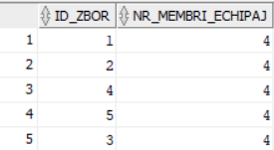

SELECT Nume_membru, Id_superior, COUNT(DISTINCT Id_zbor)

ZBORURI_DIFERITE FROM ECHIPAJ

CONNECT BY PRIOR Id_membru = Id_superior

START WITH Id_membru in (1,5,9,13,17)

GROUP BY Nume_membru, Id_superior

ORDER BY ZBORURI_DIFERITE;

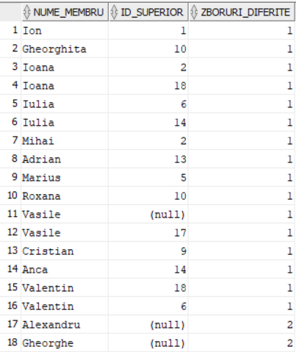

# **Realizati 4 interogari in care sa folositi comanda CASE/ DECODE**

SELECT Nume_pasager, Varsta_pasager, CASE

WHEN Tip_bilet = 'economic' THEN 'Bilet economic'

WHEN Tip_bilet = 'business' THEN 'Bilet business'

WHEN Tip_bilet = 'first' THEN 'Bilet first'

END AS Tip_bilet

FROM PASAGERI

JOIN BILETE ON BILETE.Id_pasager = PASAGERI.Id_pasager;

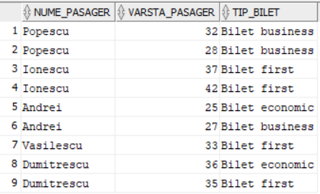

SELECT Nume_companie, Nume_tara, An_fondare, CASE

WHEN Nume_tara = 'Romania' THEN 'Companie aeriana romaneasca'

ELSE 'Companie aeriana straina'

END AS Natura_companie

FROM COMPANII_AERIENE;

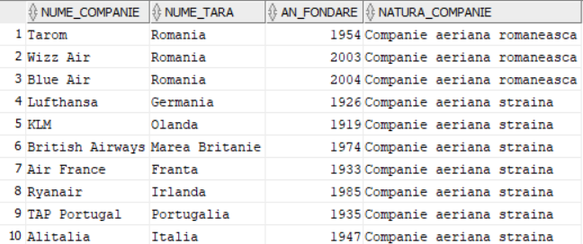

SELECT DECODE(COMPANII_AERIENE.Nume_tara, 'Romania', 'RO',

'Germania', 'DE', 'Olanda', 'NL', 'Marea Britanie', 'GB', 'Franta', 'FR', 'Irlanda', 'IE',

'Portugalia', 'PT', 'Italia', 'IT', 'Argentina', 'AR', 'Spania', 'ES') AS "NUME TARA",

COMPANII_AERIENE.Nume_companie, COMPANII_AERIENE.An_fondare

FROM COMPANII_AERIENE;

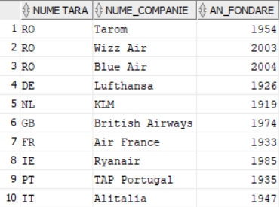

SELECT DECODE(CURSE.Id_companie, 1, 'Tarom', 2, 'Wizz Air', 3, 'Blue Air',

4, 'Lufthansa', 5, 'KLM', 6, 'British Airways', 7, 'Air France', 8, 'Ryanair', 9, 'TAP

Portugal', 10, 'Alitalia') AS "NUME COMPANIE", CURSE.Aeroport_plecare,

CURSE.Aeroport_sosire, CURSE.Durata_cursa

FROM CURSE;

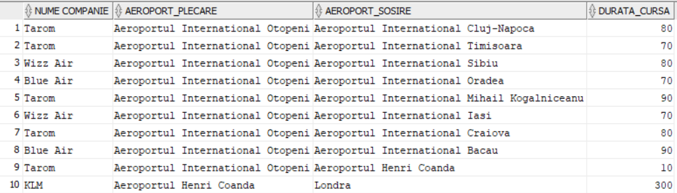

# **Realizati 3 interogari in care sa folositi operatorii MINUS, INTERSECT, UNION, cate una cu fiecare**

SELECT Nume_companie FROM COMPANII_AERIENE

MINUS

SELECT Nume_companie FROM COMPANII_AERIENE

WHERE Nume_tara = 'Romania';

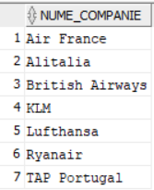

SELECT Nume_aeroport FROM AEROPORTURI

WHERE Id_tara = 'RO'

INTERSECT

SELECT Aeroport_plecare FROM CURSE;

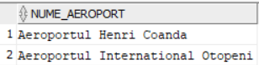

SELECT Nume_pasager FROM PASAGERI

WHERE Varsta_pasager < 30

UNION

SELECT Nume_pasager FROM PASAGERI

WHERE Varsta_pasager >= 40;

