# The_Klein-Gordon_equation project

In this project, a code for numerical solving the initial-boundary problem

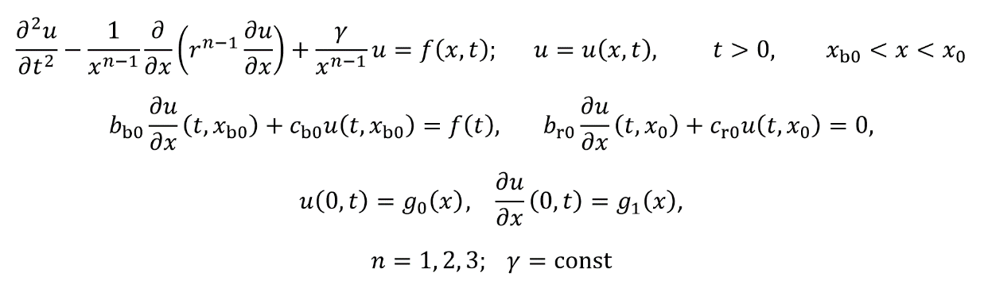

was developed. This problem is related to the Klein-Gordon equation (<https://en.wikipedia.org/wiki/Numerical_analysis>) and is important for testing the so-called open boundary conditions for equations that describe electromagnetic or acoustic waves in various media.

The code implements a family of explicit and implicit finite difference methods (<https://en.wikipedia.org/wiki/Finite_difference_method>). For the latter, an iterative algorithm was utilized to obtain the numeric solution.