PE Project- Part2

For point a)

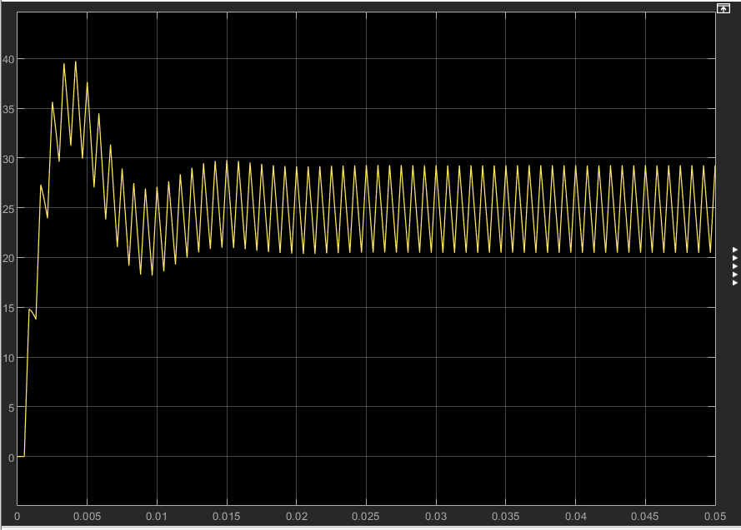
The ripple has values of 32% of I_out_max which is smaller than the given value of 35%

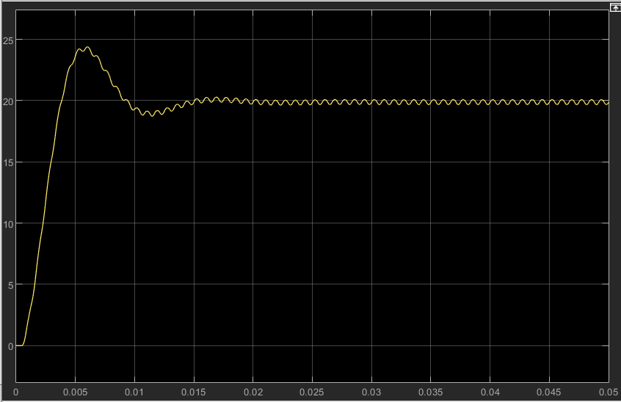
The voltage ripple has a value of ~0.37 V which is smaller but very close to the given value of 0.4 V ( 10⁻⁴ * 400 V)

For b)
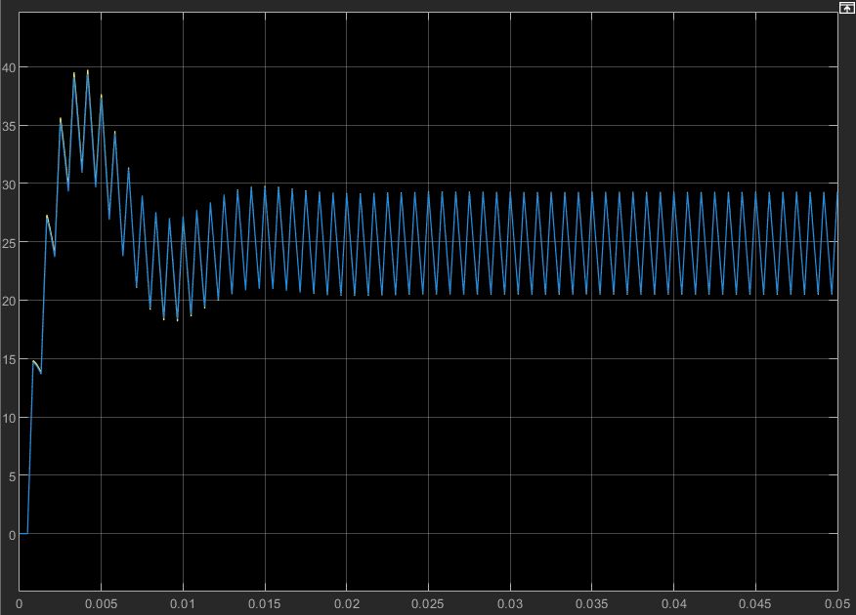

The coil current ripple is very similar because the difference between the inductances is 0.00001 H. <1% difference
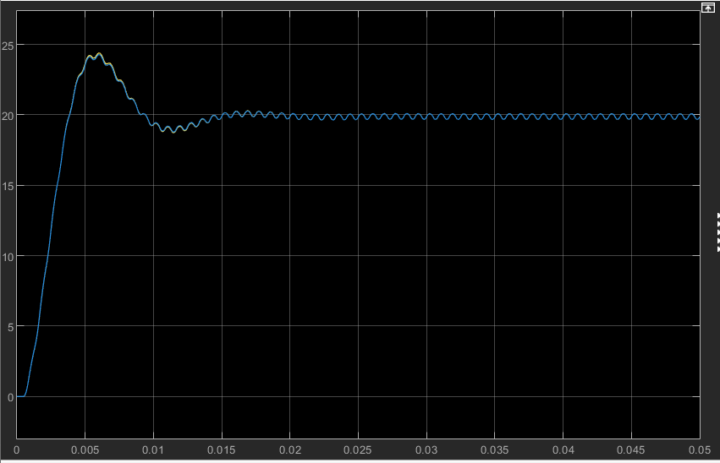
The same is true for capacitor voltage, difference between capacitances is only 0.00004F

For c)
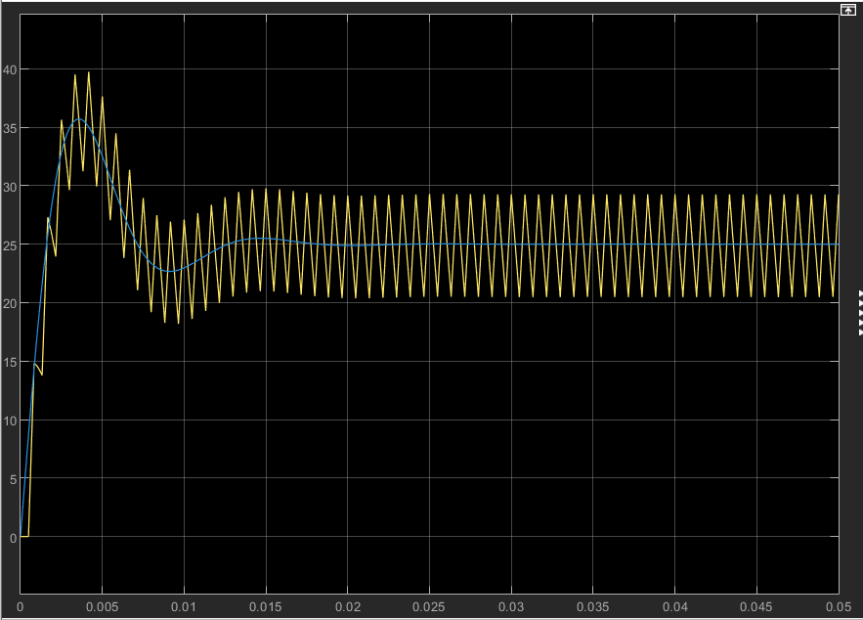

When using the constant (value of the duty cycle), the coil current and the capacitor voltage maintain the same shape but have no ripple. The overshoot is 42% and the settling time is 0.022 seconds for the coil current.
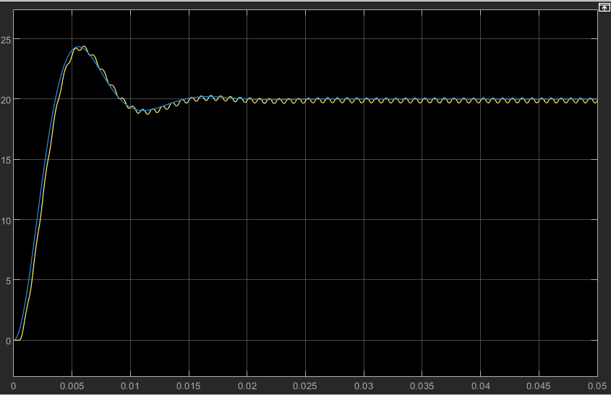

The capacitor voltage is identical in both cases for this simulink simulation. The overshoot is 21% and the settling time is 0.0135 seconds.

