PE Project- Part 3

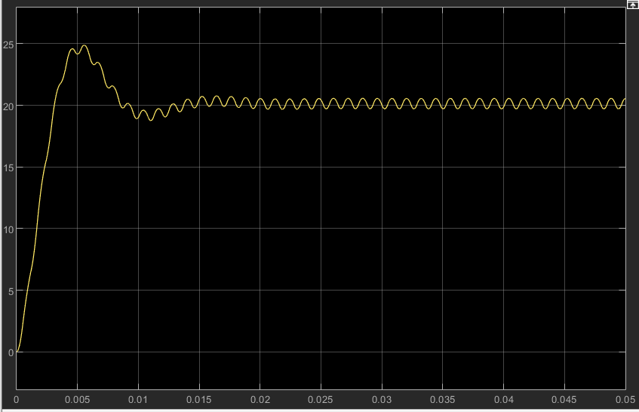
Part2 output

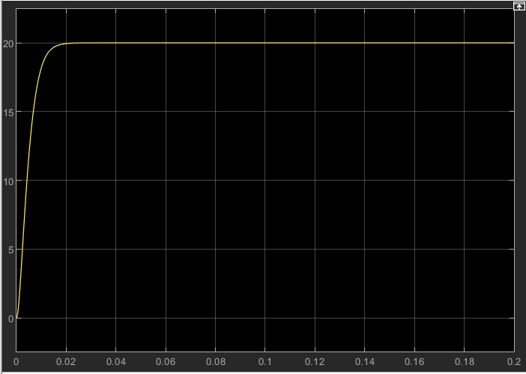
Part3 output for “Zero-Order Hold” block period to the (PWM period)/10
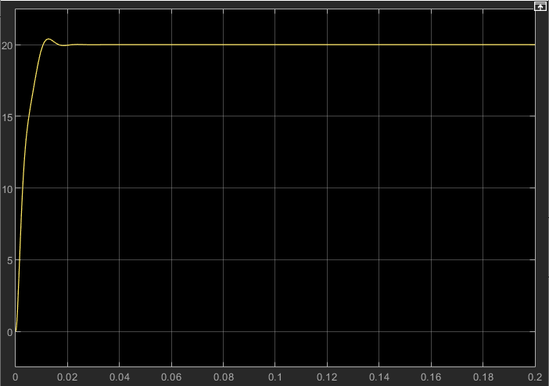
In Part 2 I have a settling time of 0.0133s and a noticeable overshoot of 21.5% and for the output in Part 3 I have 0 overshoot and a response time of 0.01s, when I lowered the settling time of the second order element to 0.007s

Part3 output for “Zero-Order Hold” block period to the PWM period (before readjusting settling time)

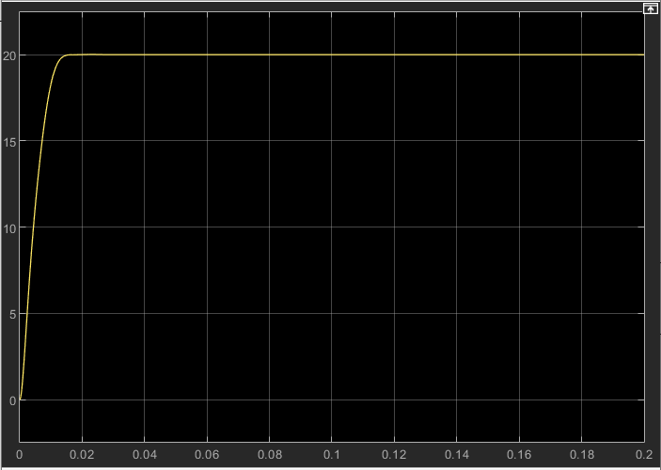
Part3 output for “Zero-Order Hold” block period to the PWM period (after readjusting settling time)

When I set the “Zero-Order Hold” block period to PWM period I can observe an overshoot appearing, so I readjust the settling time of the second order element from 0.007s to 0.01s in order to get the desired result. In the last graph I have a settling time of the output of 0.0125s.

