Power Electronics-Part4

For this part I wanted to observe better the difference between the a) ideal case and b) the real case, so I doubled the schematic in Simulink ( the top one for a), the bottom one for b) ). ( the yellow signal is for a) and the blue one is for b) )

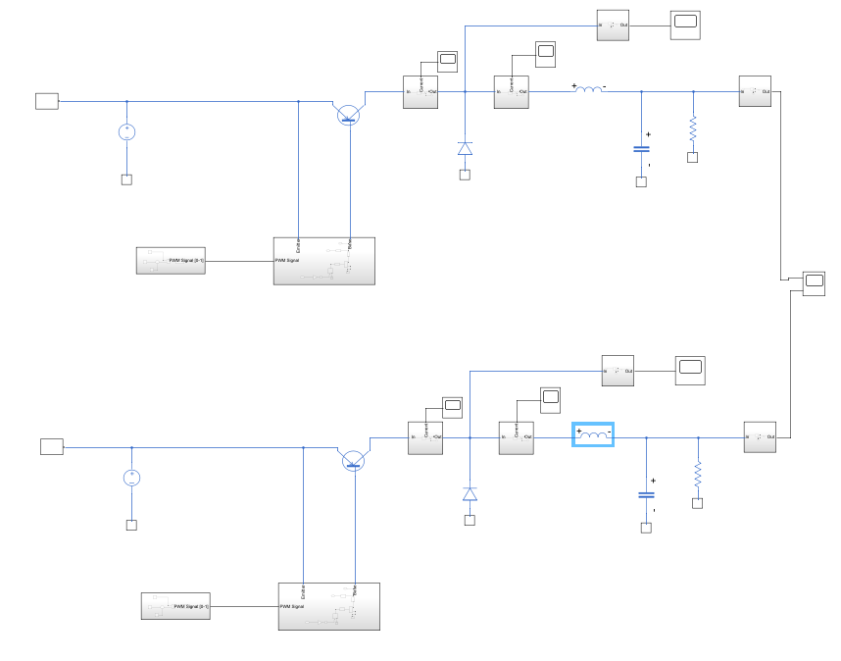
- Ideal simulation
In this case the 2 signals overlap perfectly because I haven’t introduced the residual properties, nor the tolerances.
This is the output voltage in the ideal case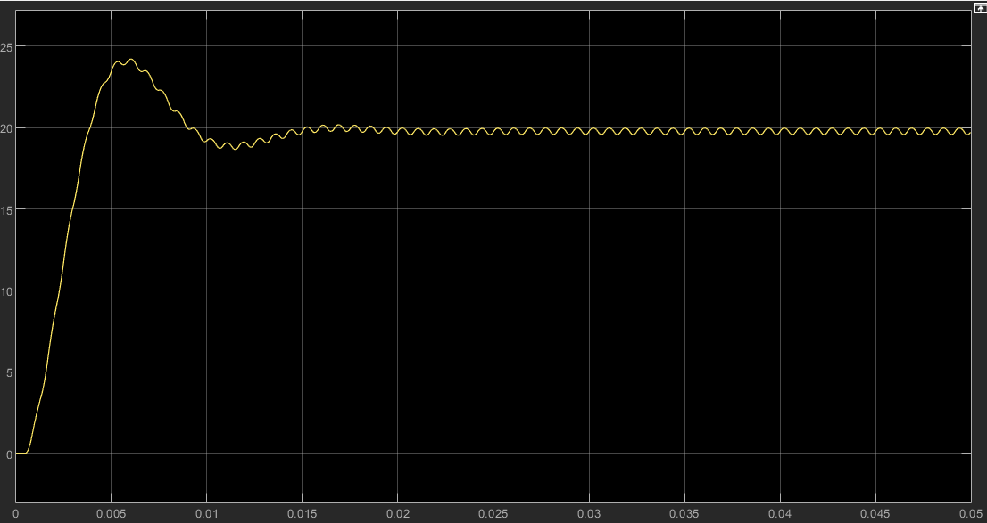
It has a steady state value of about 19.8 V with a $±$0.2V ripple and a 21% overshoot

- With residual elements
Now I will start introducing the changes from the datasheet one by one and compare them with the ideal case

- Diode – Forward voltage of 1.5 V ( > 0.1 V from a) )
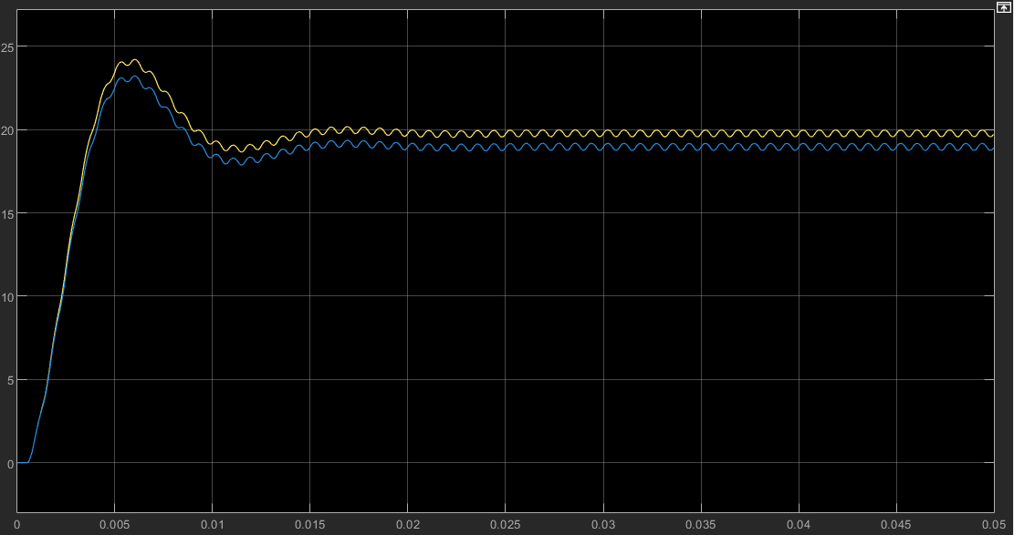
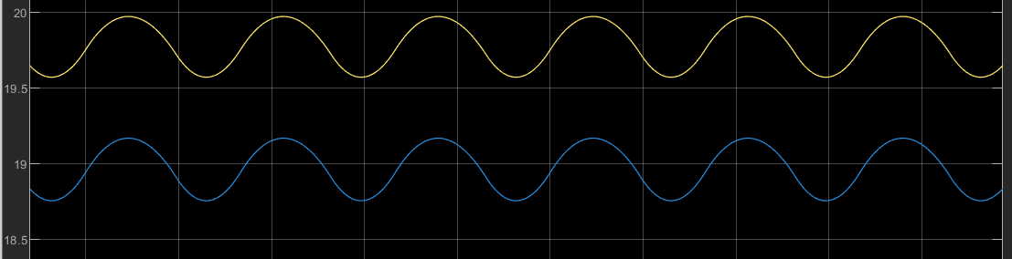
The signal keeps its shape but is 0.8V smaller.

- Capacitor: Series resistance: ESR (I used the formula below)
$$ESR=\frac{tan\left(τ\right)}{2*π*f_{test}*C}$$
$$tan(τ)=0.25 (max value)$$
$f_{test}=120 Hz$ => $ESR=0.1461 Ω$
$$C=2.27 mF$$
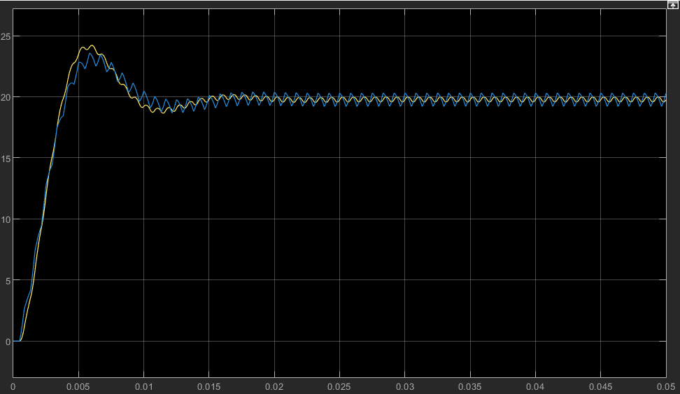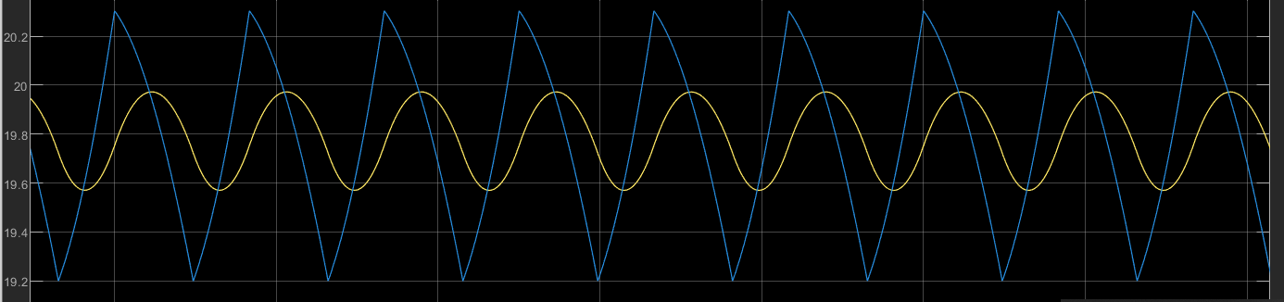
We can clearly see the capacitor charging and discharging. The output is slightly shifted, has a $±0.3$V variation from the original and a smaller ~ 16% overshoot.

- Inductor: Series resistance: DC resistance = 6.9 m$Ω$ (from datasheet)
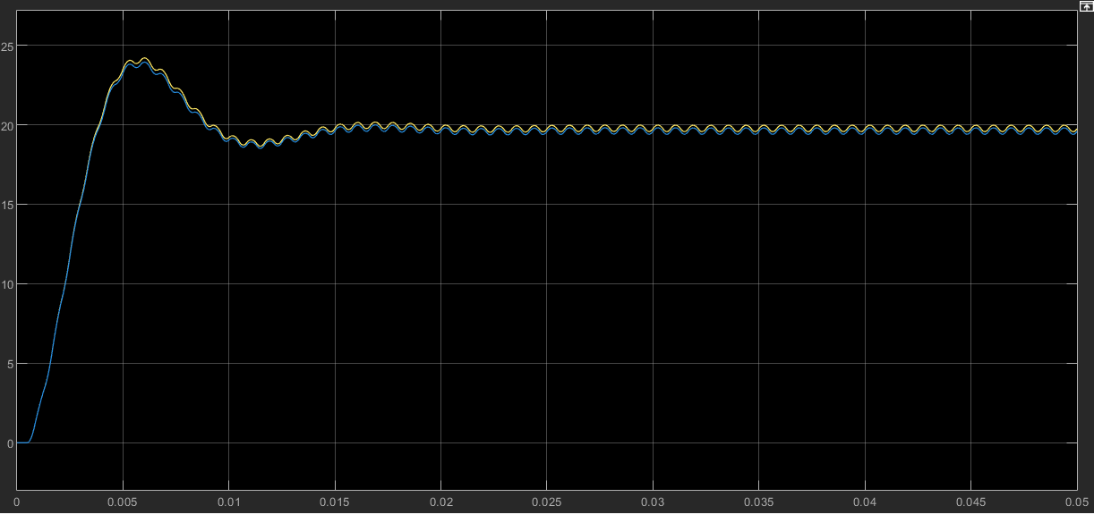
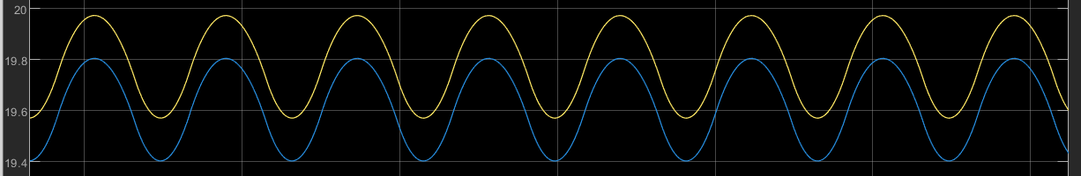
The shape and phase remain the same, only a 0.1 V drop in the overall output voltage

- Capacitor: Tolerance application = 20% (from datasheet)
I applied the minimum value, so I ended up with 80% of the initial capacitance
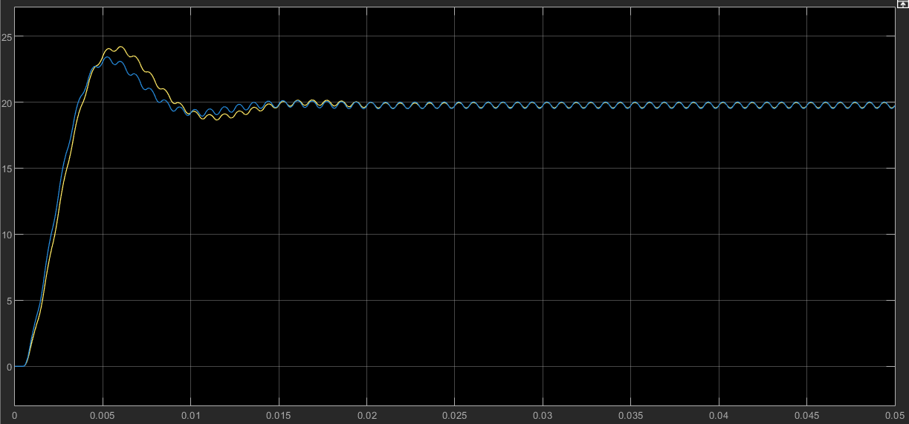
The output has a smaller overshoot of about 17% and $±$0.05 V in comparison to the ideal output
- Inductor: Tolerance application - Apply minimum tolerance value
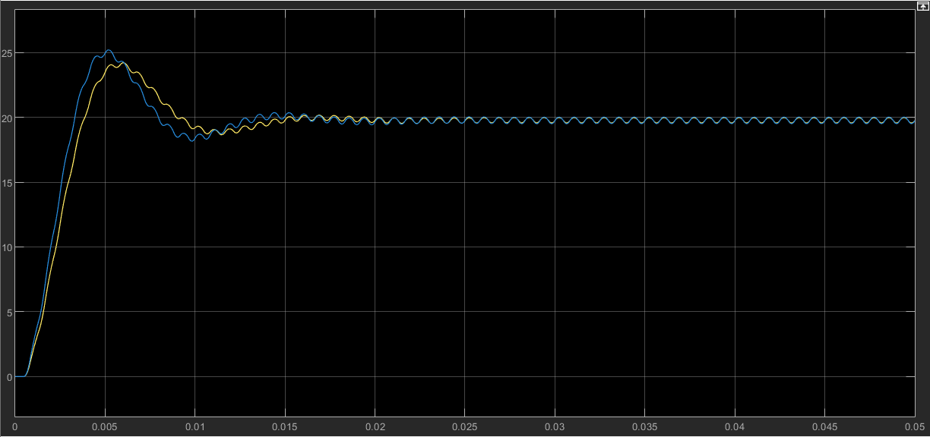
In this case the overshoot is bigger of about 26% and the same steady state difference as in the previous case.
Now I will implement all these residual elements at once
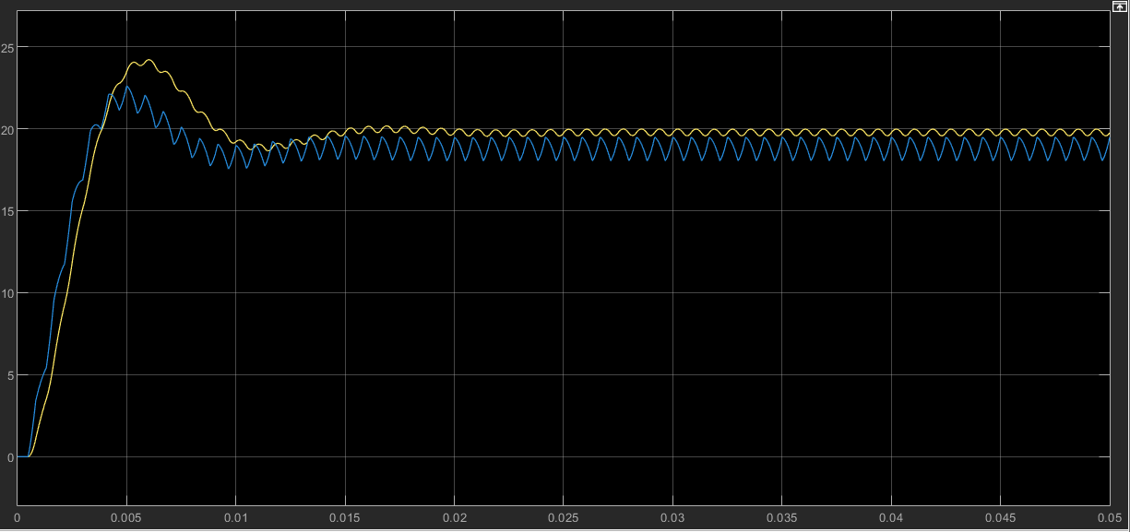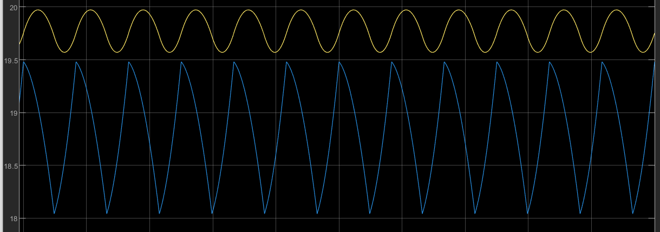
The obtained output has a smaller overshoot of 11% and has the shape induced by the capacitor series resistance . In steady state there is a 1 V drop and a slight phase shift.

